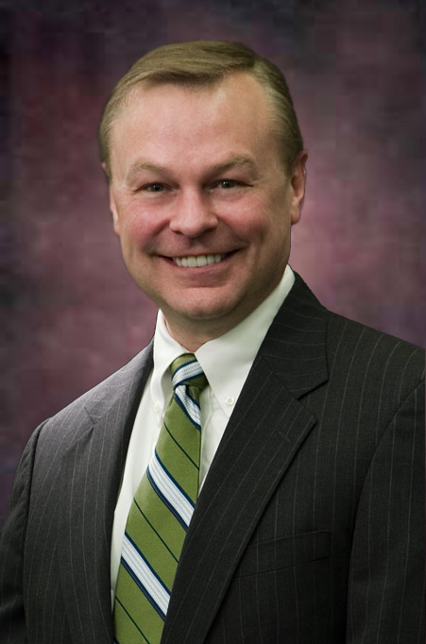


Professional Biography

Dr. William “Bill” MacElroy
Chairman
Socratic Technologies, Inc.

Bill MacElroy brings more than 30 years of marketing management and research experience to Socratic Technologies. His career has included both agency and client-side managerial positions with Corning Glass Works, Memorex/Unisys Corp., Cheskin+Masten, MACRO, Autodesk and Modalis Research.

Dr. MacElroy has extensive experience in strategic planning and marketing research, in both the consumer packaged goods and high-tech/industrial markets. In 1994, he co-founded Socratic Technologies, Inc., a San Francisco-based research agency focused on computer-based and interactive marketing research. Within a few years, the company grew from a two-person operation to one of the top 100 research firms in the United States.

Bill holds a doctorate in Management Technology & Business Administration from Golden Gate University, San Francisco; an M.B.A. with a concentration in Marketing and a Master's Certificate in Applied Statistics from The Pennsylvania State University; and a B.A. in Economics from the State University of New York. He also spent an undergraduate term at the Universität Würzburg in Germany.

Dr. MacElroy has taught New Product Development and Marketing Research for UC Berkeley Extension, San Francisco. He has been a guest lecturer at MIT, UC Berkeley, The Pennsylvania State University, University of San Francisco, and the Notre Dame-AMA School of Marketing Research.

He has given papers and presentations in association with the following groups: American Marketing Association (AMA), American Association for Public Opinion Research (AAPOR), Business Marketing Association (BMA), Council of American Survey Research Organizations (CASRO), Council of Marketing and Opinion Research (CMOR), European Society for Opinion and Marketing Research (ESOMAR), Frost & Sullivan Conferences, Institute for International Research (IIR), International Productivity and Quality Center (IPQC), Marketing Research Association (MRA), Public Relation Society of America (PRSA), Society for Marketing Advances (SMA), Western Decision Sciences, and World Research Conferences.

Bill is a past-president of the Interactive Marketing Research Organization (IMRO/MRA) and served as Committee Chairperson for IMRO’s Journal of Online Research (iJOR). He also served on the Governmental Affairs committee of CMOR. He is a past president of the San Francisco Bay Area Chapter of the AMA.

In November of 2008 he was named “Research Business Executive of the Year” by RFL Communications’ Research Business Report publication. In November of 2011, he was honored with the NGMRG's "Market Research Disruptive Innovator Award."

