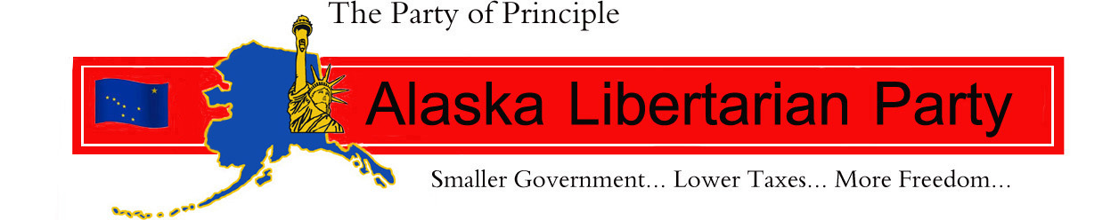

Affiliate funding request PLAN:

National LP,
The Alaska Libertarian Party currently has ballot access. We certainly understand the importance as Alaska happens to have the most stringent requirements regarding this access. In the upcoming election cycle we must secure 3% in the governor's race in order to maintain this access. We intend to recruit a candidate for governor who can secure this 3% based on a "populist platform."
I must say, that ballot access is virtually of no regard if you do not have excellent libertarian candidates who are willing to run. As Libertarians we must be able to attract potential candidates by offering them a "party plan" which assists them in their journey to victory. This is our plan, this is our request:

Action Plan: based on 2 identified candidates of excellence, and one Gubernatorial candidate.

Direct door Knocking:
Consists of two paid professional door knockers @ $10.00 hr. ( sub-contractors )
August: 64 direct contact hours $640.00
September: 128 direct contact hours $1,280.00
October: 128 direct contact hours $1,280.00
Total hours: 320 $3,200.00
times two: Total hours: 640 Total cost: $6,400.00

Printed material: $1,200.00 x two $2,400.00
Mailers: $1,200.00 x two $2,400.00
Phone Banks:
2 @ 4 hours x 5days @ 10.00 hr ( subcontractors ) $4,800.00
160 contacts per session ( 20 per hour per person )
800 per week
3200 per month
9600 contacts per 3 months ( Aug. Sept. Oct. )

Data Bank: $250.00 per month $750.00 ( 3 month )

Subtotal: $16, 750.00
Additional $3,250 allocated to the Gubernatorial race $3,250.00

Total : $20,000.00

As you know, Alaska is unique in that we are the "birthplace" of the Libertarian party regarding an elected representative, and recognized as District #1for this reason. We have the largest concentration of libertarians per capita in the country. Of the 10 state representatives elected to office Alaska has had 3.
With this plan we are submitting, we can boldly make an assertion that we have a strong opportunity to elect two state representatives to the house. The two candidates we have in mind ran as republicans last election cycle and received 41% and 44% of the votes in their respective districts. Both of their districts are approximately 65% registered libertarian and independent. These are excellent candidates and with the assistance of the National LP and Alaska Libertarian Party, we believe they will be elected. Consider the impact this will have on the national perspective. We ask you to consider a wise investment. We ask you to consider investing in Alaska.

my high regards,
Michael Chambers
Chair-ALP

