Region 4 / California Report

by LNC Regional Representative Daniel Wiener (12/7/2014)

The Libertarian Party of California’ voter registration continues to grow, with the most recent count at 120,804. This has increased by 36,342 over the past five years, as indicated in the graph below. Among other things, this means that the Libertarian Party will remain a qualified minor party in California for the foreseeable future, so that our Presidential candidate will always be on the general election ballot. Unfortunately, Top Two keeps our candidates out of most of the other down-ticket partisan races, so there is more of an effort being put into local non-partisan races.

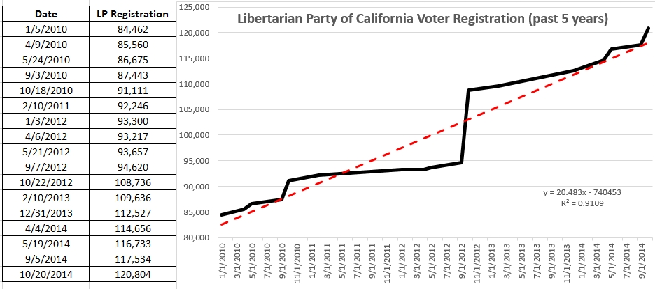

On December 6th the LPC Executive Committee held a joint meeting with the Nevada LP followed by its separate meeting, and among other things authorized its Operations Committee to negotiate with hotels to hold the 2015 state convention (tentatively scheduled for April 16-19) in Las Vegas. The LPC Executive Committee now includes two elected officials: Calimesa Councilman Jeffrey Hewitt and West Valley County Water District President Jim Hoerricks.

Numerous county LP organizations are active and holding meetings, holiday parties, and in many cases elections for new officers. Details are available on the LPC web site (ca.lp.org).