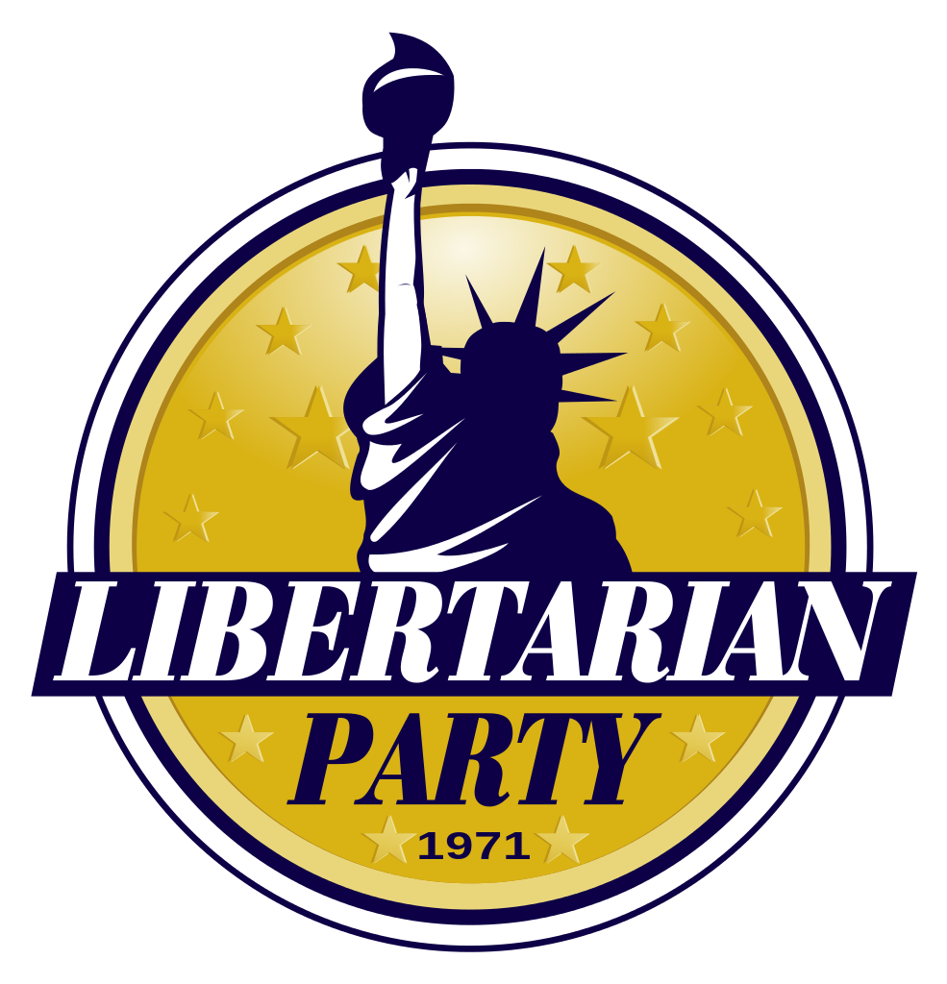

**Region 3 Report**

(Indiana, Kentucky, Michigan, Ohio)

## Indiana

The 2015 Libertarian Party of Indiana Convention will be April 24 – 26, 2015

at the Union Club Hotel & Memorial Union 101 North Grant Street, West Lafayette, Indiana

The agenda includes:

Welcome Reception in the West Main Lounge of the Purdue Memorial Union.

Don Barriger, Brown County LP Chairman and Specialty Court Advocate; on Veterans’ Courts in Indiana

Pepper Hulette Snyder, Media personality and co-owner of Indiana Talks News/Talk Network; on Pitching a Libertarian Message to Women in Media

Michael Yoder, Managing Partner, Premier Family Medicine; on The Impact of the Patient Protection and Affordable Care Act on Medical Practices

Paul Ogden, Retired Attorney and Political Columnist; on Civil Asset Forfeiture in Indiana

Lunch with Judge James Gray, 2012 Libertarian Party candidate for vice president

Awards Banquet & Entertainment featuring Tony Stiles

Candidate Training hosted by LNCC Executive Director Evan McMahon.

## Kentucky

The Kentucky LP State convention was held February 28, 2015 and had 4 guest speakers. The ACLU of Kentucky, Take Back Kentucky (a paleo-con activist group), 2016 LP Presidential Candidate Dr. Marc Allan Feldman, and Brett Bittner from the LNC (Region 3 Alternate).

The leadership team for LPKY:

State Chair: Dave Capano – dave.capano@LPKY.org

State Vice-Chair: Bryan Shumate Short – bryan.short@LPKY.org

State Secretary: Cyrus Eckenberg – cyrus.eckenberg@LPKY.org

State Treasurer: James Bozman – james.bozman@LPKY.org

At-Large 1: Mark Gailey – mark.gailey@LPKY.org

At-Large 2: John Will Allender – john.allender@LPKY.org

At-Large 3: Dan Hull – dan.hull@LPKY.org

At-Large 4: Frank Harris – frank.harris@LPKY.org

1st District Chair: David Watson – david.watson@LPKY.org

2nd District Chair: Joe Redmon – joseph.redmon@LPKY.org

3rd District Chair: Chris Roberts – chris.roberts@LPKY.org

4th District Chair: Bill Mitchell – bill.mitchell@LPKY.org

5th District Coordinator: Krystal Freeman – krystal.freeman@LPKY.org

6th District Chair: Micki Bowling – micki.bowling@LPKY.org

A Judicial Committee was also created. The Judicial Committee must be divorced of all other party activities. The initial Judicial Committee is:

JC 1. Ken Moellman – ken.moellman@LPKY.org

JC 2. Chris Robinson – chris.robinson@LPKY.org

JC 3. James Fahringer – james.fahringer@LPKY.org

JC 4. Joseph Szeremet ** – joe.szeremet@LPKY.org

JC 5. David Patterson – david.patterson@LPKY.org

## Michigan

The Libertarian Party of Michigan 2015 State Convention will be held in the original home of Gibson guitars and the modern American craft beer movement: Kalamazoo.

Convention speakers include:

C. Michael Pickens—keynote: current chair of the LP of Washington, author: Libertarian Leadership: Planting the seed for a Libertarian future.

Darryl W. Perry—banquet: award-winning author of Duopoly: How the Republicrats control the electoral process.

Brian R. Wright—breakout: LPM Webmaster and author, will be discussing his new book, Satyagraha Liberty, as it relates to practical Libertarian strategies.

This is the ‘in between’ convention year, with officers and bylaws/platform up for reconfiguration.

## Ohio

The Libertarian Party of Ohio 2015 Conference will take place Friday May 1, 2015 - Saturday May 2, 2015 at the Deer Creek State Park Lodge, 22300 State Park Road 20, Mount Sterling, OH 43143

Bill Redpath will be presenting as our Keynote Speaker at the banquet lunch on Saturday afternoon.

Ohio Legal News

February 11, the Tuscarawas County Board of Elections refused to certify the petition of Jonathan Gentsch, software engineer and LP candidate for New Philadelphia council, citing instructions from the office of Ohio Secretary of State John Husted, a Republican, that the Libertarian Party of Ohio was not a recognized political party, according to Mark Brown, the LPO lead attorney.

SB 193, passed as an emergency action in 2013 by statehouse Republicans and signed by Governor John Kasich, strips ballot access from the LPO and other challenger parties.

On Monday, March 16 it was announced that Judge Michael Watson of the United States District Court for the Southern District of Ohio ruled that Senate Bill 193 “does not impose severe burdens on the right of minor parties to associate or the right of electors to cast meaningful votes.” The judge added that the law’s requirements “rationally serve important state interests.”

In another important case, Maurice A. Thompson, executive director of the 1851 Center for Constitutional Law filed suit on behalf of Citizens in Charge, Cincinnati for Pension Reform and Ohioans for Workplace Freedom against a 2013 measure — Senate Bill 47 — declaring that circulators of initiative petitions must be Ohio residents.

Judge Watson said that even if Husted assumed the law were constitutional, “a reasonable official would have understood that enforcement of the residency requirement would violate plaintiffs’ First Amendment right to engage in political speech despite the presumptive validity of the statute.” The judge ruled that Husted could be held personally liable for civil damages. Thompson said the sum is relatively modest: less than $10,000.

“If public officials from the governor down through the police know that they will be liable for enforcing an unconstitutional law, they are far more likely to take Ohioans’ constitutional rights seriously. We would like to end the ‘I don’t make the law; I just enforce it’ mentality that many public officials use to escape liability for the harm they cause.”

The question of whether Husted must actually pay that is the only one remaining. Husted can either appeal Watson’s decision or proceed to a hearing to see what damages are merited.