Libertarian National Committee

Region I Report

Submitted by Norm Olsen & Ron Windeler
July 13. 2015
Overview
- The nine affiliates which comprise Region 1 are: Alaska, Arizona, Colorado, Hawaii, Kansas, Montana, Utah, Washington, and Wyoming.
- Aggressive election activity has produced continued ballot access for the 2016 general election in eight (AK, AZ, CO, HI, KS, MT, UT, WY) of the nine states in the region are currently ballot qualified for 2016.
- Ballot access in Washington State requires 1,000 valid signatures; a rather reasonable threshold compared to other states. Over the years, the Washington State affiliate has routinely obtained ballot access without assistance from the national committee.
- Significant increases in voters registering as Libertarian have been experienced in several of the states in the Region. This trend of several years remains strong in the region.
- Due to the geographic nature of this region, which spans five time zones and extends from 19 to 71 degrees north latitude (some 3,000 x 3,000 miles), personal contact between the Regional and Alternate Representatives and the individual affiliates is quite rare.
- Region statistic update appears on the next page in landscape orientation.

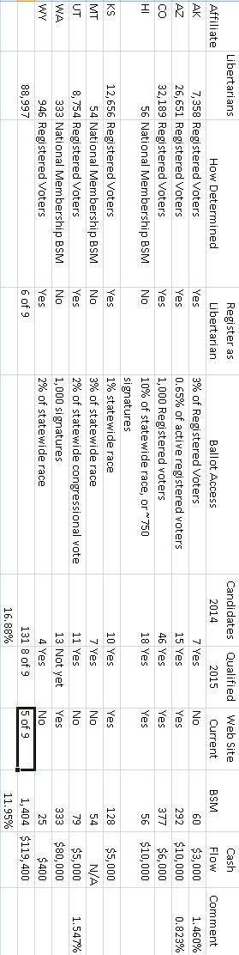

Alaska
Rob Clift, State Chair

Arizona
Michael Kielsky, State Chair

Colorado
Lily Tang WIlliams, State Chair

Hawaii
Tracy Ryan, State Chair

Kansas
Rob Hodgkinson, State Chair
Montana
Mike Fellows, State Chair
On the 4th of July we traveled up north to the Kalispell 4th parade. Next week we'll have a booth at the Gallatin County fair in Bozeman. Other events include the Missoula Gun Show, the Western Montana Fair and the Ravalli County Fair. Along the way we'll do some parades and such. Parades, for the most part don't cost much except transportation costs and do give us some PR. We just need a better parade vehicle.
One of the concerns we have as a state is getting liability or event insurance. These fairs asking for liability insurance even for non-profits. In haven't found a policy cheap enough to afford. Have you run across this problem? This effects all state groups and it would be nice if we had a reasonable place to go to purchase this insurance for these events.

Utah
Mark Hilgenberg, State Chair

Washington
Steven Nielson, State Chair

Wyoming
Lawrence Strumpf, State Chair

