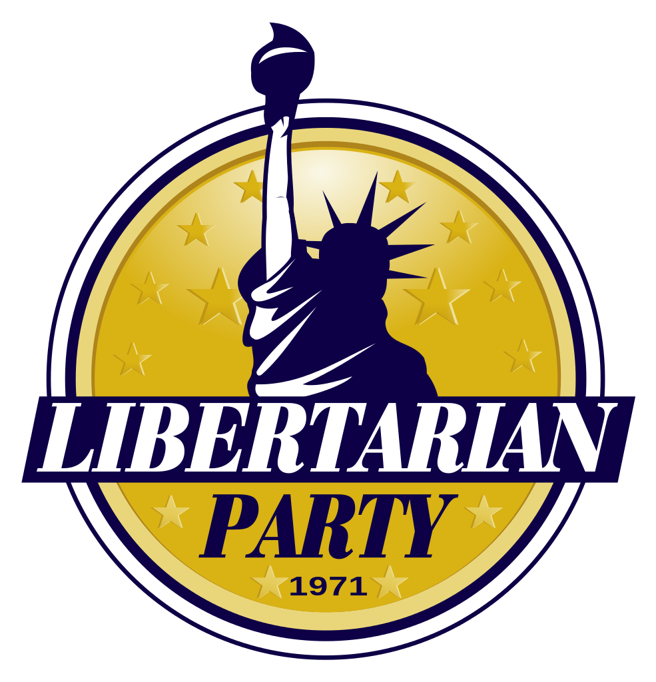

**Region 3 Report**

(Indiana, Kentucky, Michigan, Ohio)

## Indiana

Libertarian Party of Indiana State Chairman Joe Hauptmann had called for the governor’s veto of HB 1432, a bill that put in place strict regulations targeting small businesses in the manufacturing and sale of e-liquids used in the emerging vaping industry. Indiana Governor Pence signed HB 1432 and it took effect July 1st, 2015. July 1 is also the date that Indiana's RFRA legistlation took effect. Also notable is that the Mayor of South Bend came out as the states highest openly gay elected official.

Chairman: Joe Hauptmann, Boone County

Contact: chair@lpin.org

Vice Chairman:

Karl Tatgenhorst, Porter County

Contact: vicechair@lpin.org

Treasurer:

Michael Schultheiss, Marion County

Contact: treasurer@lpin.org

Secretary:

Frank Rossa, Johnson County

Contact: secretary@lpin.org2015

## Kentucky

State Chair: Dave Capano – dave.capano@LPKY.org

State Vice-Chair: Bryan Shumate Short – bryan.short@LPKY.org

State Secretary: Cyrus Eckenberg – cyrus.eckenberg@LPKY.org

State Treasurer: James Bozman – james.bozman@LPKY.org

LPKY and CPKY are looking to file a lawsuit against Kentucky against the recent addition of a "can't sign two petitions" provision to the petitioning process. Both LPKY and CPKY are asking their national organizations to join in this suit, as well. The attorney feels very good about this case and is offering to do this case for the filing fees (and the 88 fees after a win). They are looking to get $100 from each organization and have them sign-on as well.

There has been a motion and several responses filed to switch the KET lawsuit over to a civil trial. The judge hasn't ruled on that motion yet, even though it was filed in December. There are several options being considered.

## Michigan

Kimberly Moore, Chair: chair@michiganlp.org

Karl Jackson, Vice Chair: vicechair@michiganlp.org

Mary Buzuma, Secretary: secretary@michiganlp.org

Jonathan Osment, Treasurer: treasurer@michiganlp.org

Incoming Chair Kimberly Moore has proposed structural changes to state party leadership to improve organization, increase communication, and enhance public image.

## Ohio

Due to family issues Sarah Bevins has stepped down from LPO Chair.

Paul Hugenberg III has assumed the duties of Chair.

paul.hugenberg@lpo.org

chair@lpo.org.