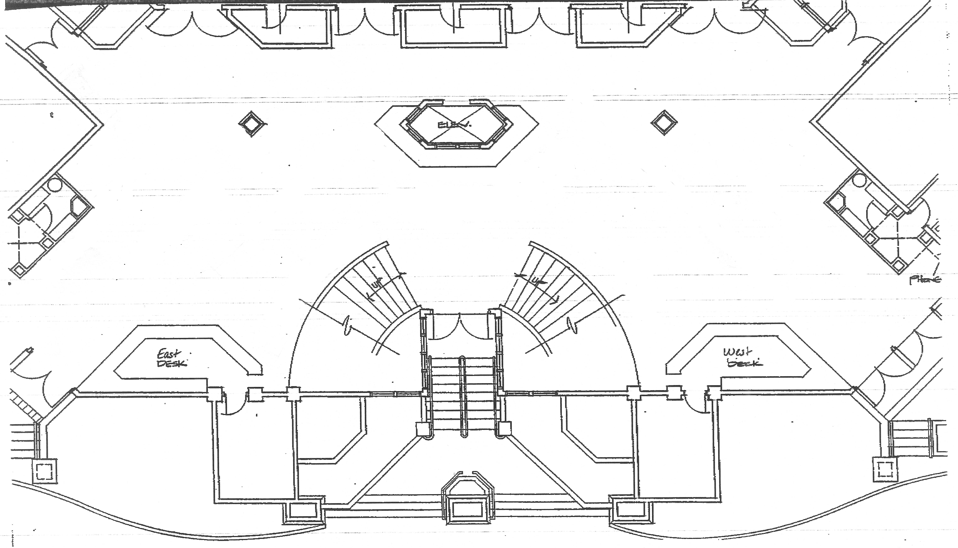
Reg 1A

A
B
C
D
Reg1B 1B
Ladies Room
Men’s Room
Back Room
Back Room

