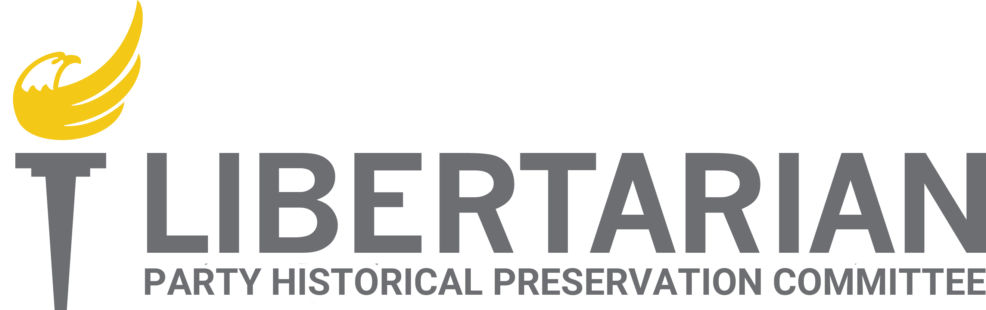

Report
Libertarian National Committee April 21-22, 2018

Committee Members
Caryn Ann Harlos (Chair)
Dr. Joe Buchman
Joe Dehn
Ed Fochler
James Gholson

SUBMITTED BY COMMITTEE CHAIR CARYN ANN HARLOS

Table of Contents
Committee Overview 3
Meetings and Communications 3
Meetings conducted since the last report: 3
Motions Considered 3
Volunteers and Interns 4
Volunteers 4
Interns 4
Document Preservation Status 6
Storage Unit 6
Lyrasis 6
Digitization 6
Documents and papers 6
Audio/Video/Electronic Data Materials 6
Update on Acquisitions 7
David Nolan Archive 7
Original Draft of Statement of Principles with Hospers’ Notes 7
Pre-LP (1971) Reel to Reels “Shaping the Future Libertarian Conference” 7
LP EMAILS 7
Other Archives 7
Status of LPedia 8
Background 8
Completed and Ongoing Projects 8
User Statistics 9
Document/Record Maintenance 9
Inventory and Management 9
Data Back-Ups 9
Budget 9
Earmarked Funds 9
Recurring Expenses 9
2018 NOLA Convention 10
LP News 10
Committee Re-formation 11

Committee Overview
The purpose of the Libertarian Party Historical Preservation Committee (hereinafter “Committee” or “LPHPC”) as per the LNC Policy Manual, Section 2.02, is as follows:
11) Historical Preservation Committee
The HPC shall be responsible for directing the preservation and publication of Party historical documents and the administration of LPedia.org. A report of its decisions and activities shall be delivered at each LNC meeting.
The current work of the Committee is divided into two major parts: physical archive organization and electronic archive management. The anticipated time frame for the initial scope concerning the physical archive is five years with just over one year being already invested. After that point, the electronic archive (LPedia) will need to be maintained and updated.

Meetings and Communications
The Committee is committed to transparency and conducts open meetings every two weeks (or as close as practicable) via Zoom electronic meetings. Committee discussions are also conducted via email with a read-only subscription option available to all Party members by sending a message to lphpc-request@lists.dehnbase.net with “subscribe” in the subject line. The minutes and other records from its proceedings are preserved on LPedia (http://lpedia.org/Historical_Preservation_Committee).

Meetings conducted since the last report:
- December 20, 2017
- January 8, 2018
- January 24, 2018
- February 7, 2018
- March 21, 2018 (minutes not yet finalized)
- April 4, 2018 (minutes not yet finalized)

Motions Considered

Caryn Ann Harlos moved to authorize Tom Sprague to convert the two remaining helical videotapes. This passed without objection.

Volunteers and Interns
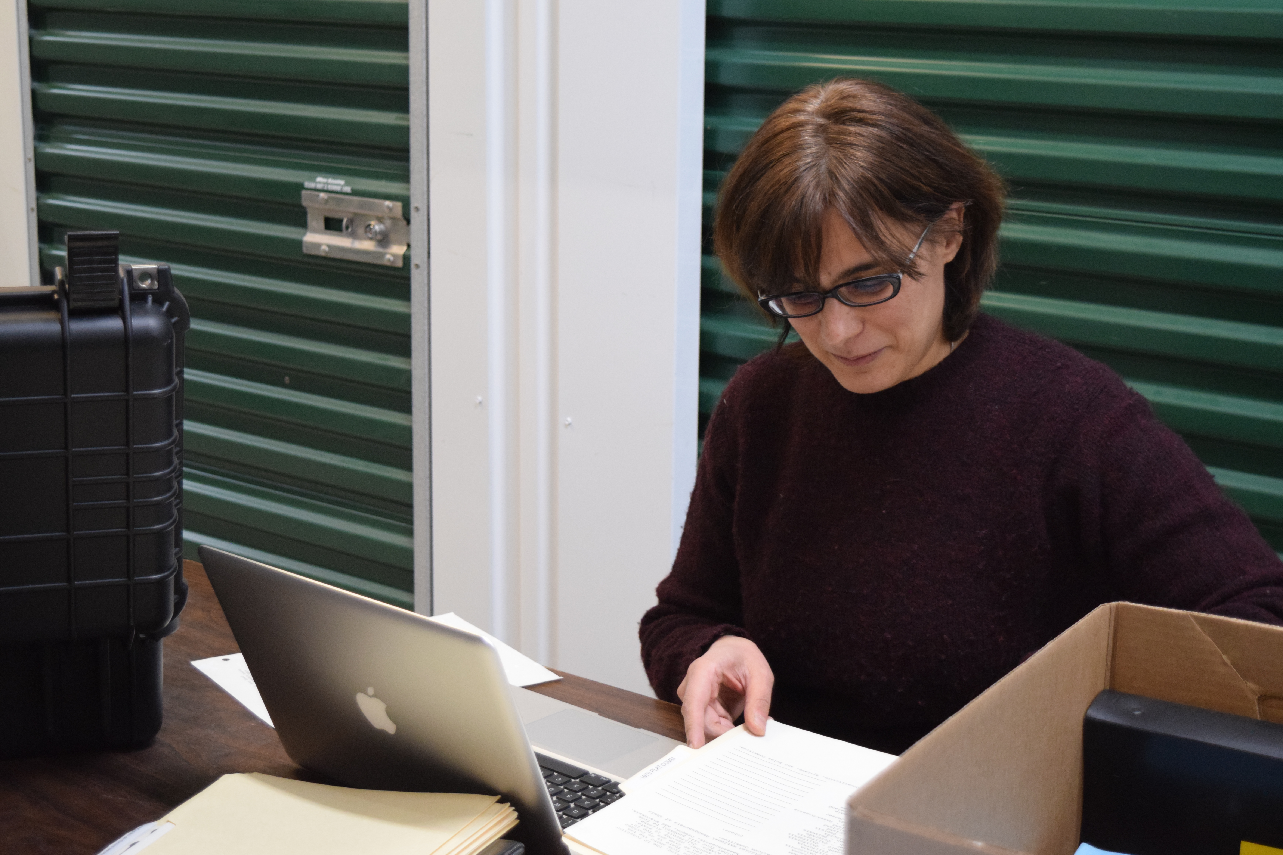 | Volunteers  In addition to the Committee, there are multiple dedicated volunteers who have worked on this project as well as regular editors who have taken an interest in maintaining their state pages and updating candidate pages. There have been at least 700 hours of volunteer time invested as a conservative estimate, including Committee meetings. One of the volunteers spends nearly every Saturday for a full day organizing and cataloguing with me at the Parker, Colorado storage facility.

Interns
The prior request for interns generated multiple applicants including persons who were more interested in a volunteer rather than an intern position. One such person was Marta Palazzi from Italy (pictured above). Below is a short article submitted for LP News regarding Marta:
There are many people who volunteer in the background for the cause of the liberty that so often go unnoticed. Earlier this year, the Historical Preservation Committee may have had the volunteer holding the longest commute record. Marta Palazzi traveled all the way from Italy to spend several months working on the ongoing historical archive project in Colorado with Committee Chair Caryn Ann Harlos and Colorado volunteer Sarah Ellsworth. Marta has been involved with libertarian political movements in Italy including the Radical Party of Italy. In her professional life, she works as a medieval document archivist and learned of the LP project through a call for volunteers on LP.org and remembered meeting Harlos at the last convention while vacationing in Orlando. Liberty is not just an American goal; there are fellow workers for liberty all over the world, and the Libertarian Party extends its deepest appreciation to Marta for spending time volunteering to preserve the history of this movement. There are very few people who would travel thousands of miles to give up months of time selflessly and have the courage to tackle immersion in records that are not in their primary language. Marta is a hero of liberty.

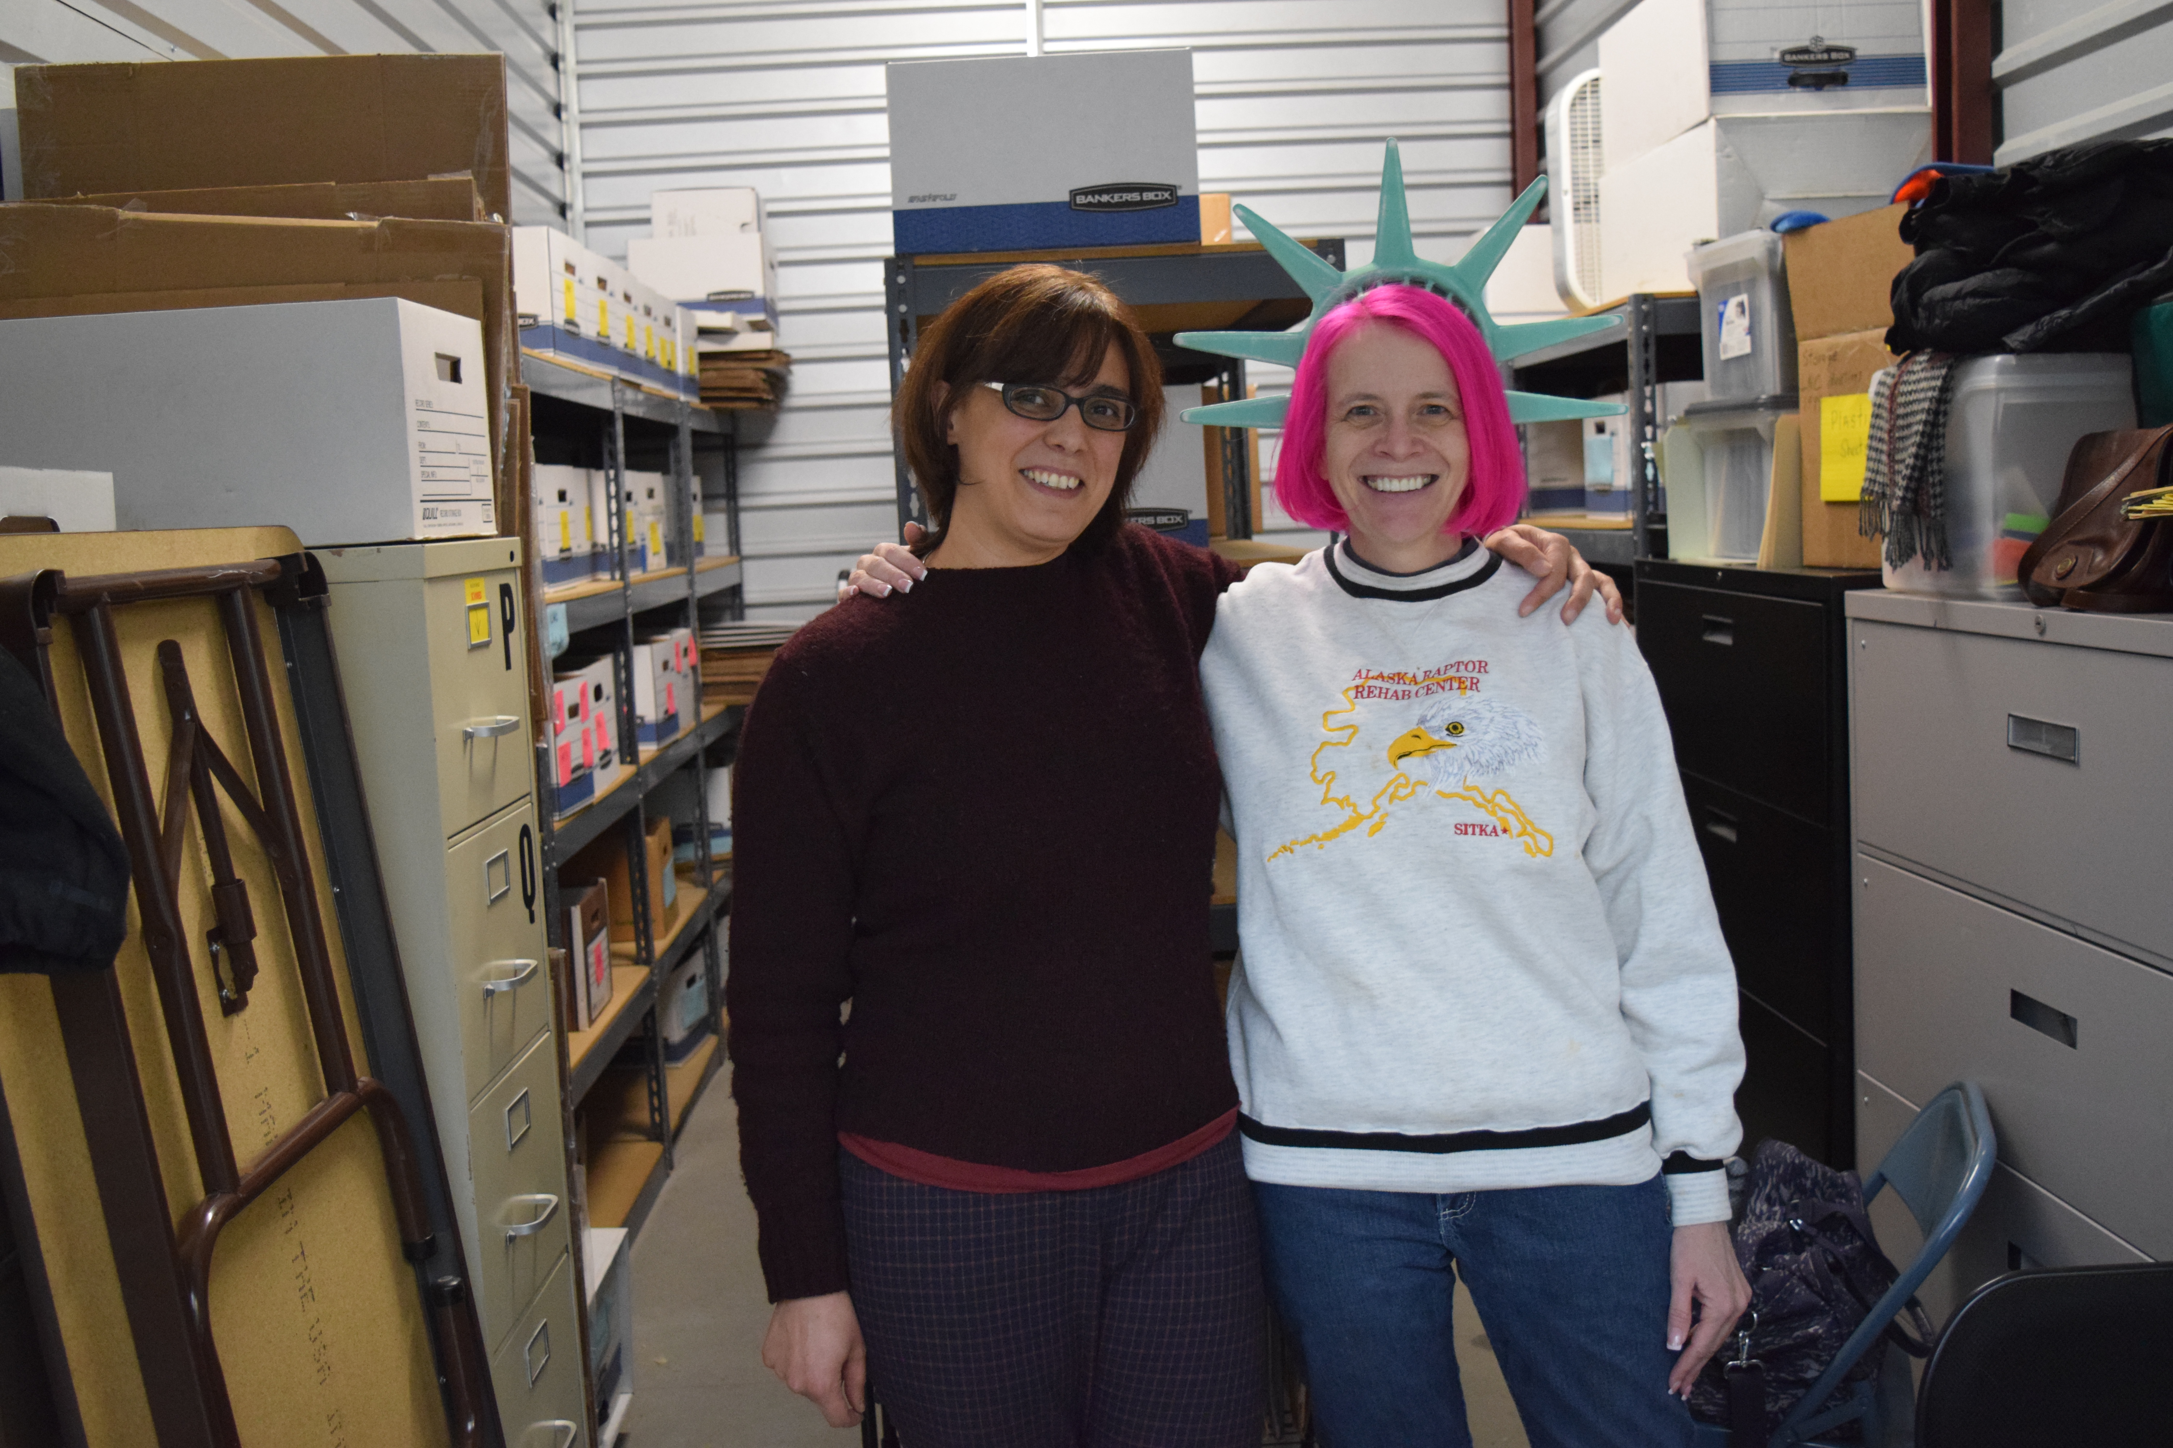
Additionally, in the week prior to this meeting, Michael Chastain and Jennifer volunteered multiple half-days to assist in the archive organization.

Document Preservation Status

Storage Unit
I and a volunteer (Sarah Ellsworth-Colorado) have committed nearly every Saturday to sorting and organizing the records in the storage unit. This has been a monumental task. Some records were very neatly organized and others were basically thrown into the boxes as the equivalent of “junk drawers.” Also due to age, some labels, rubber bands, and other materials had crumbled which need to be re-done.
The “first pass” of documents has been completed with sorting the information into broad accessible categories such as “LNC Minutes,” “Conventions,” “Training Guides,” and the like. We have now begun the next step of organizing within those categories. This will be the most lengthy (multi-year) part of the project. There is some downtime presently as I am travelling to conventions every single weekend through June and Sarah needed to take some time off for family responsibilities.

Lyrasis
Lyrasis is a digitization collaborative which coordinates discounted services for libraries and other cultural heritage projects. The first batch of LP News was done through Lyrasis with the member discount so that we could test their services. The work was excellent, and the Committee joined Lyrasis through July 2018.

Digitization

Documents and papers
As reported previously, the first priority for the Committee was items of most general Party membership interest which have been determined to comprise newsletters such as Liberty Pledge and LP News. All of these have been scanned and are being inventoried, electronically sorted with a standard naming convention, and are being uploaded to LPedia.
The next phase of digitization has begun with segregating out other large format documents that need to be done professionally and other high-interest items such as brochures. These documents have been inventoried and sent to Lyrasis for digitization.
Some training manuals and official records such as minutes and governing documents have been digitized and uploaded.

Audio/Video/Electronic Data Materials
There are voluminous audio/video/electronic data materials on multiple formats spanning the gamut of technology from the 1970s forward including: 2-inch quadraplex broadcast reels; audio cassettes; audio reels; Betacam tapes; VHS tapes; U-matic cartridges; 5 ¼ inch discs; 3 ½ inch discs; and ZIP drive disks. A great deal of these items can be digitized/converted by volunteers and arrangements are being made for the audio cassettes, Betacam tapes, audio reels, and 3 ½ inch discs.
All of the “odd” format and very aged items have been converted included all of the 1970s helical reels. These items are being made available on the Committee’s YouTube channel.
Keith Thompson has been converting VHS tapes in batches.
Among digitized items was footage of Alternative 1980.

Update on Acquisitions
As word of this project spreads, opportunities have arisen to supplement the Party’s institutional memory and acquire important early documents. Several prolific editors have joined LPedia to supplement the information found there.

David Nolan Archive
Committee member Dr. Buchman has been sorting through these boxes now that his congressional run is over. Critical items will be moved to the Parker storage facility.

Original Draft of Statement of Principles with Hospers’ Notes
This has been donated to the National Party and in my possession to bring to NOLA.

Pre-LP (1971) Reel to Reels “Shaping the Future Libertarian Conference”
These tapes were obtained from Dan Karlan and digitized by Dr. Buchman and are being uploaded to LPedia.

LP EMAILS
The gmail address for the Committee has been subscribed to National emails as well as state party emails where available. Ken Moellman indicated that he has archives of past National emails.

Other Archives
The online catalogue for the University of Virginia holdings proved to be incorrect. It was decided that it would be useful for volunteers in the areas of the various archives to go and take a look-this is a pending item. Joe Dehn related that when he last visited the UVA archives there were about eighty boxes of items that were not inventoried or catalogued.
Joe Dehn has been visiting and cataloguing the Hoover archives in California.
It has also been discovered that Susan Nolan (David Nolan’s first wife and the first Chair of the Party) is still in Denver and meeting arrangements are being made.
Exploration has begun into preserving archives of old Yahoo discussion lists, particularly those in which David Nolan had been active.

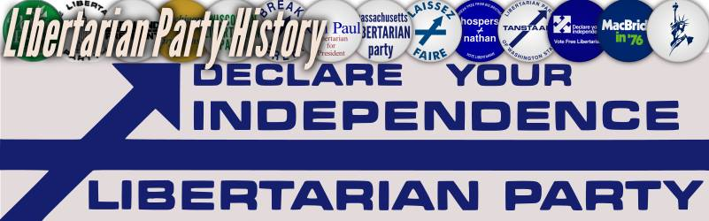

Status of LPedia

Background
LPedia is a collaborative history wiki of the Libertarian Party started in February 2005 by Shane Cory as a replacement for the older archive.lp.org. Since June 2013, the site had fallen into technical disrepair as the MediaWiki engine went through version upgrades which were not installed on LPedia primarily due to the fact that there simply was not enough staff time to keep the site updated ;and new account creation was leading to potential security risks as it was installed on the same server as the main LP.org website and thus had to be disabled. During the IT infrastructure cleanup, LPedia was moved to a fully hosted wiki-farm host; however, the database was bloated with over 2o gigabytes of spam and required serious cleaning in addition to the desperately needed updates to the MediaWiki software. Volunteer Bonnie Scott (Vermont) spent dozens of hours over the course of over a month doing this cleanup work which was successfully transferred to the new host. LPedia was re-opened for general account creation and restoration to its purpose as a crowd-sourced collaborative effort on March 31, 2017.

Completed and Ongoing Projects
In order to keep LPedia functional and useful (as well as easier to maintain for successive custodians) a great deal of infrastructure work has been done with much more to come. Following is a bullet-list of project with explanatory notes as needed.
- Categories
  - Focused effort is now being made on properly categorizing all of the biographies.
- Development of Policies and Page Naming Conventions
  - The policies continued to be developed as the need arises.
- Templates and Extensions
  - An image template is being developed so that images can be properly catalogued.
- Site Statistics
  - Solutions for gathering site statistics are being explored
- PDF preview
  - A generic pdf icon is shown on search results where a thumbnail is preferred.

User Statistics
Last Report: 2,314 Articles / 1,579 Uploads
Present Report: 2,515 Articles / 1,823 Uploads

Document/Record Maintenance

Inventory and Management
As boxes are sorted, basic inventories are being created. The final inventory will identify what items are preserved on LPedia with a location coding system so that they can be easily retrieved from the physical archives. Standard naming conventions will also make them easily retrievable in the electronic archives. Duplicates are being noted and culling recommendations made.

Data Back-Ups
The expanding e-archive of documents is backed up when it hits LPedia and is also backed up at my home. Periodically a copy of the archive is taken to an off-site safe deposit box as a last-ditch failsafe.

Budget
The 2018 budget is $5,000 with an expectation that these funds will be raised to even out the ledger. A fundraising email will be sent at some time in the future.
Following are the current expenditures and revenue:
Total Expenses Booked: $1,322.25
Total Revenue: $760.00

Earmarked Funds
Up to $400 was dedicated from special donations for the framing of the Statement of Principles. A donor will be giving funds for t-shirts if the LPHPC wishes to fund-raise using these at Convention.

Recurring Expenses
- MyWikis hosting and maintenance: $310/year – this is charged off to the IT budget.
  - This is a fully supported option. The host installs all upgrades and resolved trouble tickets.
- Amazon server: up to $25/month
  - Some files are too large to upload directly to the wiki host (audios, videos, large graphics) and are hosted on a separate server. The Amazon server also hosts LPedia database backups.
- Dropbox: $100/year (this has been an in-kind donation so far)
  - This is the portal for volunteers to upload and retrieve documents for assignments by the LPHPC. It also contains backups of other maintenance documentation and a redundant copy of the database backups.

2018 NOLA Convention
A table has been reserved for the Committee at the Convention. Items of interest will be brought and displayed.

LP News
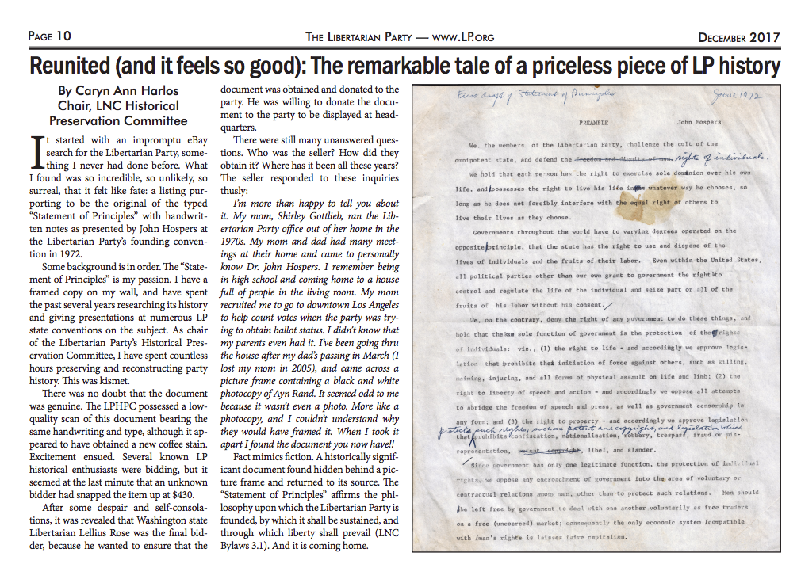

Committee Re-formation
This Committee’s term ends with the final LNC meeting prior to the 2018 convention. If the current members are willing, I recommend that they be appointed for another term as we are in the middle of projects with specialized knowledge and skills that would set back progress if handed off mid-stream.

