Libertarian National Committee

Region 1 Report

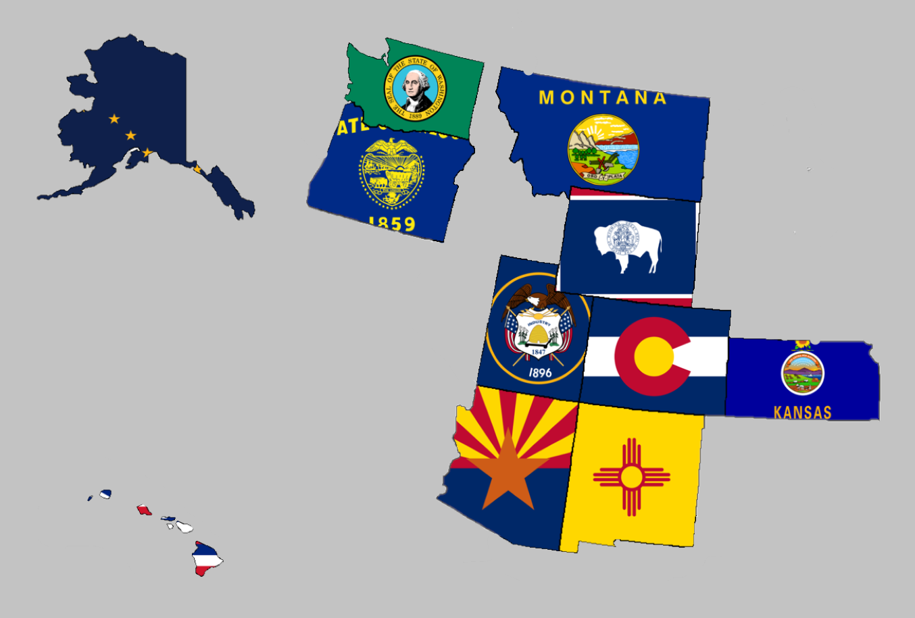

Regional Report for Region 1

Alaska, Arizona, Colorado, Hawaii, Kansas, Montana,

New Mexico, Oregon, Utah, Washington, and Wyoming

Libertarian National Committee Meeting  
September 29-30, 2018

**Region 1 Representative**

Mr. Richard Longstreth, Arizona

Libertarian National Committee

**T:** 931.538.9300 **E:** Richard.Longstreth@LP.org

**Region 1 Alternate**

Mr. Craig Bowden, Utah  
Libertarian National Committee **T:** 801.882.6472 **E:** Craig.Bowden@LP.org

# Region 1 Overview

As of the 2018 National Libertarian Convention in New Orleans, the eleven affiliates that comprise Region 1 are: Alaska, Arizona, Colorado, Hawaii, Kansas, Montana, New Mexico, Oregon, Utah, Washington, and Wyoming. At the Convention, Richard Longstreth, Arizona, was elected to serve as the Region 1 Representative and Craig Bowden, Utah, was elected to serve as the Region 1 Alternate. Both positions will be re-elected at the 2020 National Libertarian Convention.

Due to the geographical nature of this region, spanning five time zones and extending from 19 to 71 degrees north latitude (some 3,000 x 3,000 miles), in-person contact between the Regional and Alternate Representatives and the individual affiliates will be infrequent. It is my intention to attend 2019/2020 affiliate conventions in each affiliate. Regular contact is attempted with the affiliates and members through email, telephone, a dedicated Facebook discussion group and page, and informational website.

For the purposes of this report, State Chairs were emailed one week prior to the report submission deadline as well as several times during the week as reminders to get information to me so that it could be included with this report. Any notes or updates they submitted are included as well as any requests they have of the LNC. Contact information is supplied so that direct contact may be made by any member seeking clarification directly from the State Chair.

Your Region 1 Representative,

Richard Longstreth

# Alaska



Chair: Jon Watts

Email: [joelhadley907@gmail.com](mailto:joelhadley907@gmail.com)

Phone: (907) 687-4884

Website: <http://www.alaskalp.org>

Facebook: <https://www.facebook.com/pg/AlaskaLiberty/>

From the Chair: Nothing submitted by the Chair for this report.

Requests to the LNC: No requests at this time.

# Arizona



Chair: Howard Blitz

Email: [chairman@azlp.org](mailto:chairman@azlp.org)

Phone: 833-THE-AZLP

Website: <https://www.azlp.org/>

Facebook: <https://www.facebook.com/LParizona/>

From the Chair: Nothing submitted by the Chair for this report.

Requests to the LNC: No requests at this time.

# Colorado



Chair: Wayne Harlos

Email: [statechair@lpcolorado.org](mailto:statechair@lpcolorado.org)

Phone: (303) 837-9393

Website: <https://www.lpcolorado.org/>

Facebook: <https://www.facebook.com/pg/lpcolorado/>

From the Chair: Nothing submitted by the Chair for this report.

Requests to the LNC: No requests at this time.

# Hawaii

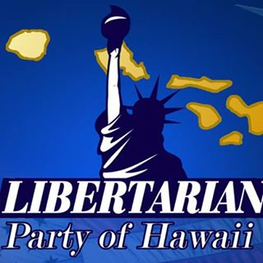

Chair: Tracy Ryan

Email: [tracyar@hawaiiantel.net](mailto:tracyar@hawaiiantel.net)

Phone: (808) 927-1126

Website: <http://www.libertarianpartyofhawaii.org>

Facebook: <https://www.facebook.com/pg/LibertarianPartyOfHawaii/>

From the Chair: Nothing submitted by the Chair for this report.

Requests to the LNC: No requests at this time.

# Kansas

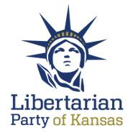

Chair: Kris Logan

Email: [Chair@lpks.org](mailto:Chair@lpks.org)

Phone: (913) 240.9008

Website: <http://www.LPKS.org>

Facebook: <https://www.facebook.com/pg/KansasLP/>

From the Chair: Nothing submitted by the Chair for this report.

Requests to the LNC: No requests at this time.

# Montana

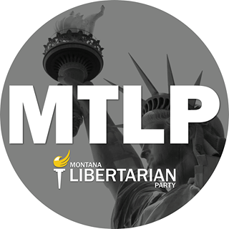

Chair: Francis Wendt

Email: [francis.wendt@mtlp.org](mailto:francis.wendt@mtlp.org)

Phone: (406) 404-6453

Website: <https://www.mtlp.org/>

Facebook: <https://www.facebook.com/pg/MontanaLibertarianParty/>

From the Chair: The Chair submitted an extensive report. These are some of the highlights. Francis has indicated that I may share the report in entirety with the LNC for internal use and I will do so upon request.

* Website: Candidates page is up-to-date with some good information but other areas of the website need updating.
* County Growth Project: The MTLP is working to establish a county growth program. They currently have model Constitution and Bylaws and will be trying to get something going in Missoula, Cascade, and Lewis and Clark Counties by the end of October. Francis is working on seeing how this project goes in MT and will then work with me to try and share with the Region to grow membership throughout the Region.
* 2019 Outlook: Working on finding candidates for local offices for 2019 as well as internal offices and bylaw updates for their upcoming Convention.
* 2018 Elections: 20 Candidates are running, which works out to about 1 candidate per 50,000 people. General praise for all three ballot access races.
* Debate exclusion: Montana PBS is denying participation for LP candidates to take part in upcoming debates. Senate candidate Breckenridge is preparing to file an FEC complaint and the MTLP would like to see support from the LNC.

Requests to the LNC:

* Join the candidates of the MTLP and the MTLP itself in appealing to the FEC regarding debate inclusion and Montana PBS. I suggested that the text of the complaint be sent to myself and the LNC for review.
* Consider a lifetime membership for David Merrick who recently received a press review about his years of service for the Libertarian movement. The article can be found [HERE](https://ravallirepublic.com/news/local/article_a034458c-63cf-572b-b08f-6dda7670753a.html). I have inquired as to how this could be done by the LNC and if any such procedure is in place outside of convention.
* When the LNC considers the Spring or Summer meeting location Montana would like to be considered and perhaps a joint event be coordinated.

# New Mexico



Chair: Chris Luchini

Email: [chair@lpnm.us](mailto:chair@lpnm.us)

Phone: 888-LPNM-NOW

Website: <https://lpnm.us/>

Facebook: <https://www.facebook.com/LPNewMexico/>

From the Chair: Nothing submitted by the Chair for this report.

Requests to the LNC: No requests at this time.

# Oregon



Chair: Kyle Markley

Email: [chair@lporegon.org](mailto:chair@lporegon.org)

Phone: (971) 266-0028

Website: <https://lporegon.org/>

Facebook: <https://www.facebook.com/pg/LibertarianPartyOfOregon/>

From the Chair: Oregon will have 23 partisan Libertarian candidates on the general election ballot, and 10 of those have placed statements in the Oregon Voters' Pamphlet.

Requests to the LNC: No requests at this time.

# Utah

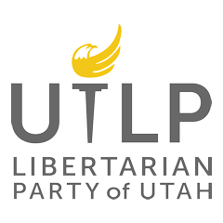

Chair: Joseph Buchman

Email: [chair@libertarianutah.org](mailto:chair@libertarianutah.org)

Phone: 801-742-1163

Website: <http://www.libertarianutah.org/>

Facebook: <https://www.facebook.com/lputah/>

From the Chair: Joe submitted a detailed report of Utah and I have decided to share it verbatim through [THIS LINK](https://drive.google.com/file/d/18Pib5u_nFNK-JVkx-APWx16Vp0ue2bQ4/view?usp=sharing). He also included some pictures, see below.

* 

Requests to the LNC: No requests at this time.

# Washington



Chair: Randy McGlenn

Email: [info@lpwa.org](mailto:info@lpwa.org)

Website: <https://lpwa.org/>

Facebook: <https://www.facebook.com/pg/libertarianpartyofWA/>

From the Chair: The best place to stay updated on all things Washington is through the Facebook page which is well-maintained by the Communications Director.

Requests to the LNC: No requests at this time.

# Wyoming



Chair: Dee Cozzens

Email: [rdeecozzens@outlook.com](mailto:rdeecozzens@outlook.com)

Phone: 307-250-6892

Website: <https://lpwy.org/>

Facebook: <https://www.facebook.com/libertariansWY/>

From the Executive Director: The outlook in Wyoming is positive. they have 6 candidates running for office this election cycle which is the most they have had in at least 10 years. Wyoming is excited to have their first candidate for a State house seat. They are expecting to put at least one and possibly 2 candidates in office though I did not catch the names. If everything keeps going as it is the Affiliate hopes to be a major party next election cycle.

Requests to the LNC: No requests at this time.