Libertarian National Committee
Region 1 Report

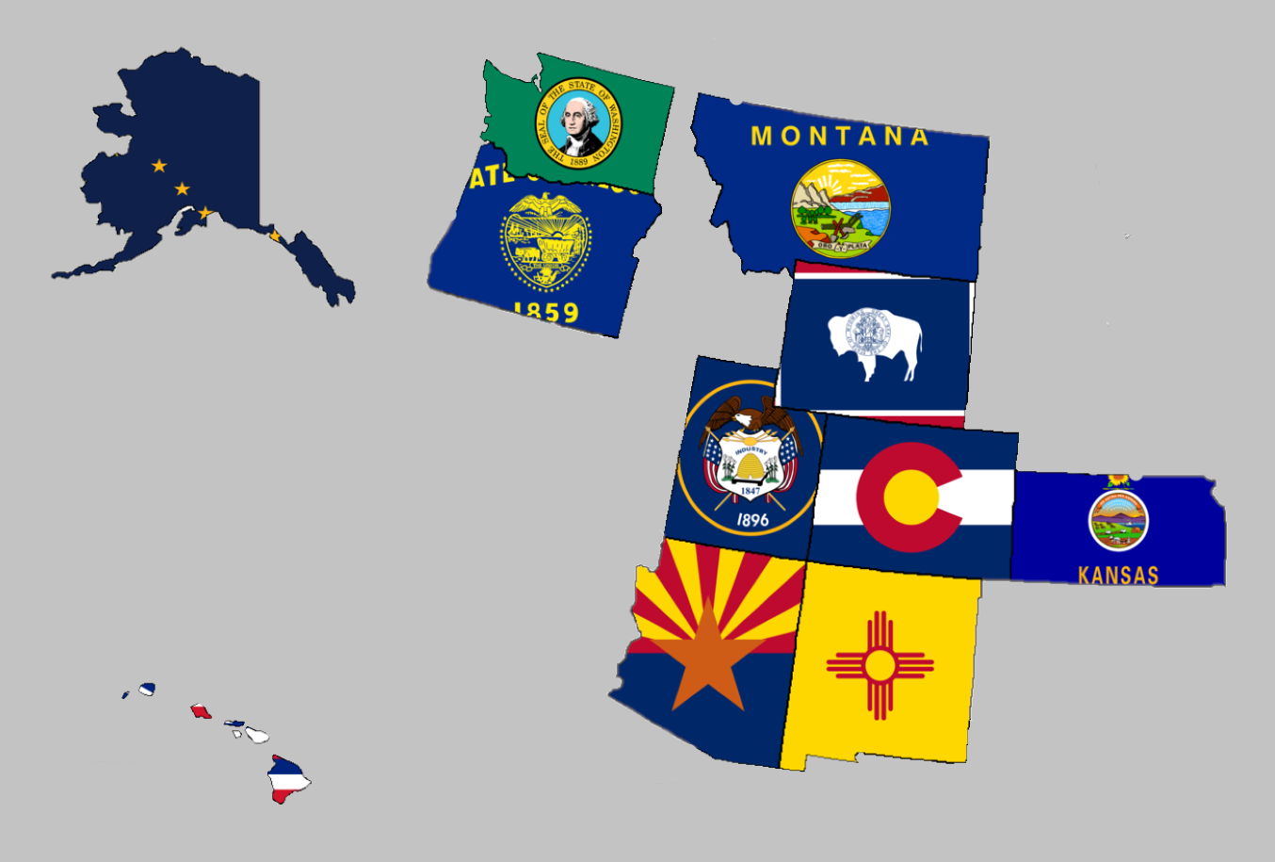
Regional Report for Region 1
Alaska, Arizona, Colorado, Hawaii, Kansas, Montana,
New Mexico, Oregon, Utah, Washington, and Wyoming
Libertarian National Committee Meeting
September 29-30, 2018

Region 1 Representative
Mr. Richard Longstreth, Arizona
Libertarian National Committee
T: 931.538.9300 E: Richard.Longstreth@LP.org

Region 1 Alternate
Mr. Craig Bowden, Utah
Libertarian National Committee T: 801.882.6472 E: Craig.Bowden@LP.org

Region 1 Overview

As of the 2018 National Libertarian Convention in New Orleans, the eleven affiliates that comprise Region 1 are: Alaska, Arizona, Colorado, Hawaii, Kansas, Montana, New Mexico, Oregon, Utah, Washington, and Wyoming. At the Convention, Richard Longstreth, Arizona, was elected to serve as the Region 1 Representative and Craig Bowden, Utah, was elected to serve as the Region 1 Alternate. Both positions will be re-elected at the 2020 National Libertarian Convention.
Due to the geographical nature of this region, spanning five time zones and extending from 19 to 71 degrees north latitude (some 3,000 x 3,000 miles), in-person contact between the Regional and Alternate Representatives and the individual affiliates will be infrequent. It is my intention to attend 2019/2020 affiliate conventions in each affiliate. Regular contact is attempted with the affiliates and members through email, telephone, a dedicated Facebook discussion group and page, and informational website.
For the purposes of this report, State Chairs were emailed one week prior to the report submission deadline as well as several times during the week as reminders to get information to me so that it could be included with this report. Any notes or updates they submitted are included as well as any requests they have of the LNC. Contact information is supplied so that direct contact may be made by any member seeking clarification directly from the State Chair.
Your Region 1 Representative,

Richard Longstreth

Alaska

Chair: Jon Watts
Email: joelhadley907@gmail.com
Phone: (907) 687-4884
Website: http://www.alaskalp.org
Facebook: https://www.facebook.com/pg/AlaskaLiberty/

From the Chair: Nothing submitted by the Chair for this report.
Requests to the LNC: No requests at this time.

Arizona

Chair: Howard Blitz
Email: chairman@azlp.org
Phone: 833-THE-AZLP
Website: https://www.azlp.org/
Facebook: https://www.facebook.com/LParizona/

From the Chair: Nothing submitted by the Chair for this report.
Requests to the LNC: No requests at this time.

Colorado

Chair: Wayne Harlos
Email: statechair@lpcolorado.org
Phone: (303) 837-9393
Website: https://www.lpcolorado.org/
Facebook: https://www.facebook.com/pg/lpcolorado/

From the Chair: Nothing submitted by the Chair for this report.
Requests to the LNC: No requests at this time.

Hawaii
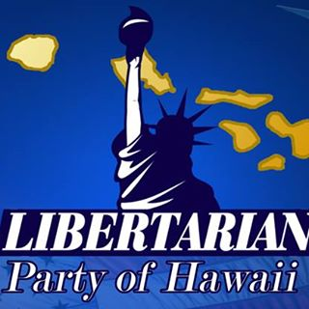
Chair: Tracy Ryan
Email: tracyar@hawaiiantel.net
Phone: (808) 927-1126
Website: http://www.libertarianpartyofhawaii.org
Facebook: https://www.facebook.com/pg/LibertarianPartyOfHawaii/

From the Chair: Nothing submitted by the Chair for this report.
Requests to the LNC: No requests at this time.

Kansas
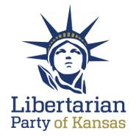
Chair: Kris Logan
Email: Chair@lpks.org
Phone: (913) 240.9008
Website: http://www.LPKS.org
Facebook: https://www.facebook.com/pg/KansasLP/

From the Chair: Nothing submitted by the Chair for this report.
Requests to the LNC: No requests at this time.

Montana
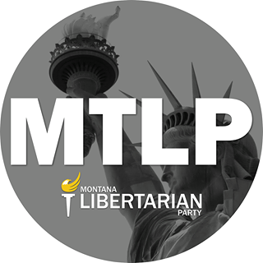
Chair: Francis Wendt
Email: francis.wendt@mtlp.org
Phone: (406) 404-6453
Website: https://www.mtlp.org/
Facebook: https://www.facebook.com/pg/MontanaLibertarianParty/

From the Chair: The Chair submitted an extensive report. These are some of the highlights. Francis has indicated that I may share the report in entirety with the LNC for internal use and I will do so upon request.
- Website: Candidates page is up-to-date with some good information but other areas of the website need updating.
- County Growth Project: The MTLP is working to establish a county growth program. They currently have model Constitution and Bylaws and will be trying to get something going in Missoula, Cascade, and Lewis and Clark Counties by the end of October. Francis is working on seeing how this project goes in MT and will then work with me to try and share with the Region to grow membership throughout the Region.
- 2019 Outlook: Working on finding candidates for local offices for 2019 as well as internal offices and bylaw updates for their upcoming Convention.
- 2018 Elections: 20 Candidates are running, which works out to about 1 candidate per 50,000 people. General praise for all three ballot access races.
- Debate exclusion: Montana PBS is denying participation for LP candidates to take part in upcoming debates. Senate candidate Breckenridge is preparing to file an FEC complaint and the MTLP would like to see support from the LNC.
Requests to the LNC:
- Join the candidates of the MTLP and the MTLP itself in appealing to the FEC regarding debate inclusion and Montana PBS. I suggested that the text of the complaint be sent to myself and the LNC for review.
- Consider a lifetime membership for David Merrick who recently received a press review about his years of service for the Libertarian movement. The article can be found HERE. I have inquired as to how this could be done by the LNC and if any such procedure is in place outside of convention.
- When the LNC considers the Spring or Summer meeting location Montana would like to be considered and perhaps a joint event be coordinated.

New Mexico

Chair: Chris Luchini
Email: chair@lpnm.us
Phone: 888-LPNM-NOW
Website: https://lpnm.us/
Facebook: https://www.facebook.com/LPNewMexico/
From the Chair: Nothing submitted by the Chair for this report.
Requests to the LNC: No requests at this time.

Oregon

Chair: Kyle Markley
Email: chair@lporegon.org
Phone: (971) 266-0028
Website: https://lporegon.org/
Facebook: https://www.facebook.com/pg/LibertarianPartyOfOregon/

From the Chair: Oregon will have 23 partisan Libertarian candidates on the general election ballot, and 10 of those have placed statements in the Oregon Voters' Pamphlet.
Requests to the LNC: No requests at this time.

Utah
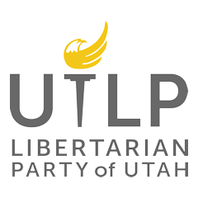
Chair: Joseph Buchman
Email: chair@libertarianutah.org
Phone: 801-742-1163
Website: http://www.libertarianutah.org/
Facebook: https://www.facebook.com/lputah/

From the Chair: Joe submitted a detailed report of Utah and I have decided to share it verbatim through THIS LINK. He also included some pictures, see below.
- 
Requests to the LNC: No requests at this time.

Washington

Chair: Randy McGlenn
Email: info@lpwa.org
Website: https://lpwa.org/
Facebook: https://www.facebook.com/pg/libertarianpartyofWA/

From the Chair: The best place to stay updated on all things Washington is through the Facebook page which is well-maintained by the Communications Director.
Requests to the LNC: No requests at this time.

Wyoming
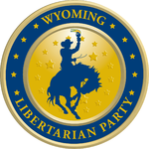
Chair: Dee Cozzens
Email: rdeecozzens@outlook.com
Phone: 307-250-6892
Website: https://lpwy.org/
Facebook: https://www.facebook.com/libertariansWY/

From the Executive Director: The outlook in Wyoming is positive. they have 6 candidates running for office this election cycle which is the most they have had in at least 10 years. Wyoming is excited to have their first candidate for a State house seat. They are expecting to put at least one and possibly 2 candidates in office though I did not catch the names. If everything keeps going as it is the Affiliate hopes to be a major party next election cycle.
Requests to the LNC: No requests at this time.

