

Report
Libertarian National Committee
September 29-30, 2018

Committee Members
Caryn Ann Harlos (Chair)
Joe Dehn
Ed Fochler
James Gholson
Andrew Kolstee

SUBMITTED BY COMMITTEE CHAIR CARYN ANN HARLOS

Table of Contents
Committee Overview 3
Committee Composition 3
Meetings and Communications 3
Meetings conducted since the last report: 3
Motions Considered 3
Request for Policy Manual Amendment 3
Volunteers 4
Status of Document Preservation 4
Storage Unit 4
Digitization 5
Documents and papers 5
Audio/Video/Electronic Data Materials 5
YouTube Channel 5
Update on Acquisitions 5
David Nolan Archive 5
Original Draft of Statement of Principles with Hospers’ Notes 5
Pre-LP (1971) Reel to Reels “Shaping the Future Libertarian Conference” 5
New york affiliate archives 6
YAHOO DISCUSSION LISTS 6
ED CLARK RECORDS 6
PAST NATIONAL EMAILS 6
Other Archives 6
Status of LPedia 6
Completed and Ongoing Projects 6
General Statistics 7
Document/Record Maintenance 7
Inventory and Management 7
Data Back-Ups 7
Accounting for Calendar Year 2018 7
Recurring Expenses 8
2018 NOLA Convention Recap 8
Press Mentions 9
Meeting Minutes 12

Committee Overview
As per the Policy Manual (Standing Rules), the Committee is defined thusly:
Section 2.02 SCOPE AND RESPONSIBILITIES
11) Historical Preservation Committee
The HPC shall be responsible for directing the preservation and publication of Party historical documents and the administration of LPedia.org. A report of its decisions and activities shall be delivered at each LNC meeting.
The scope of the initial organizing work will last well into several years (the estimate is five years), and LPedia will need to be maintained for the time of its existence.

Committee Composition
Caryn Ann Harlos (CO) was appointed as the 2018-2020 Committee Chair at the July 3, 2018, LNC meeting. Dr. Joe Buchman (UT) indicated that he did not wish to serve another term, and Ms. Harlos appointed Andrew Kolstee (NY) to fill that vacancy. Joe Dehn was appointed as the Committee Secretary.

Meetings and Communications
The Committee is committed to transparency and conducts open meetings every two weeks (or as close as practicable) via Zoom. Committee discussion is also conducted via email with a read-only subscription option available to all Party members by sending a message to lphpc-request@lists.dehnbase.net with “subscribe” in the subject line. The minutes and other records from its proceedings are preserved on LPedia (http://lpedia.org/Historical_Preservation_Committee) and are attached to this report

Meetings conducted since the last report:
May 9, 2018
May 23, 2018
June 6, 2018
June 20, 2018
July 18, 2018
August 8, 2018
August 22, 2018
September 5, 2018
September 19, 2018 (minutes not yet finalized)

Motions Considered

Reimbursements were approved for convention expenses (copies, booth supplies—supported by receipts) for Caryn Ann Harlos.

Request for Policy Manual Amendment
The Committee members have tended to specialize in particular areas of this project, and there is a need for a few more areas of responsibility to cover. Therefore, the Committee requests this Policy Manual change in order to accomplish these tasks:
Amend Section 1.03 COMMITTEE APPOINTMENTS AND TERMS OF OFFICE (pages 16-17-Special Rules of Order)
Committee Name | Size | Member Selection | Chair Selection
Historical Preservation Committee | Up to Five Seven Members | Committee Chair selected by LNC; remaining four members selected by the Committee Chair | LNC Selected

Volunteers
In addition to the Committee, multiple dedicated volunteers have worked on this project as well as regular editors who have taken an interest in maintaining their state pages and updating candidate pages. There have been at least 1,000 hours of volunteer time invested as a conservative estimate, including Committee meetings. One of the volunteers spends nearly every Saturday for a full day organizing and cataloging with Harlos at the Parker, Colorado storage facility.
A request for interns was put out on the National website, and multiple applications were received. As often happens, many who started soon dropped out, but it was during this search that Marta Palazzi of Italy reached out to volunteer. Her extraordinary volunteer efforts were the subject of the below LP News article in May 2018. Additionally, long-time Party activist and donor Michael Chastain visited and volunteered prior to the LNC meeting in Denver.
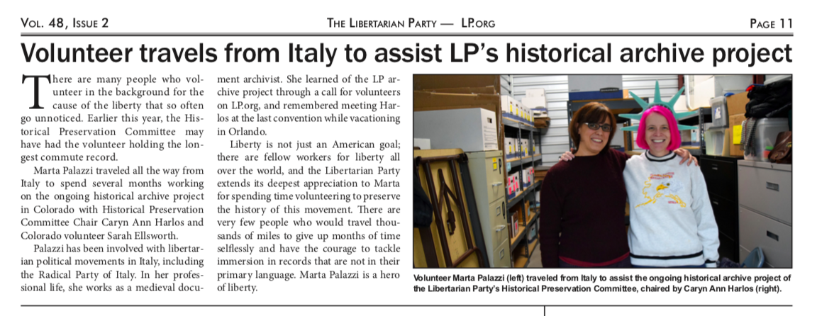

Status of Document Preservation

Storage Unit
Harlos and a volunteer (Sarah Ellsworth-CO) have committed nearly every Saturday to sort and organize the records in the storage unit. This has been a monumental task. Some records were very neatly organized, and others were basically thrown into the boxes as the equivalent of "junk drawers." Also due to age, some labels, rubber bands, and other materials had crumbled which need to be re-done.
The “first pass” of documents has been completed with sorting the information into broad, accessible categories such as "LNC Minutes," "Conventions," "Training Guides," and the like. The next step of organizing within those categories has begun. This will be the most lengthy (multi-year) part of the project. Harlos is continuing work on the affiliate records as members have made inquiries as to the availability of old newsletters, governing documents, and similar items, and Ellsworth is sorting candidate materials.

Digitization

Documents and papers
As reported previously, the first priority for the Committee was items of most general Party membership interest which have been determined to comprise newsletters such as Liberty Pledge and LP News. All of these have been scanned and are being inventoried, electronically sorted with a standard naming convention.
The next phase of digitization comprised segregating out other large format documents that need to be done professionally and other high-interest items such as brochures. These documents were professionally scanned.
Some training manuals and official records such as minutes and governing documents have been digitized and uploaded.
Presently there is a backlog of scanned items that need to be uploaded and categorized on LPedia.

Audio/Video/Electronic Data Materials
All of the 1970s obscure-format videotapes have been digitized and are being added to the YouTube channel and LPedia. Work continues on the more current formats such as VHS and cassette audiotapes.

YouTube Channel
In order to take advantage of free storage space and to provide an attractive embedding option on LPedia, a YouTube account (lphistoricalpreservation) was created to host the digitized audio and video tapes. Categorized playlists have been created as content was added.

Update on Acquisitions
As word of this project spreads, opportunities have arisen to supplement the Party’s institutional memory and acquire important early documents. Several prolific editors have joined LPedia to supplement the information found there.

David Nolan Archive
Former Committee member Dr. Buchman has committed to continue with his curatorship of these items.

Original Draft of Statement of Principles with Hospers’ Notes
This item has been on display at various conventions and will be transferred to the national office in December.

Pre-LP (1971) Reel to Reels “Shaping the Future Libertarian Conference”
These tapes were obtained from Dan Karlan and digitized by Dr. Buchman and are being uploaded to LPedia.

New york affiliate archives
Committee member Andrew Kolstee has obtained numerous early records and is in the process of digitizing and putting on LPedia.

YAHOO DISCUSSION LISTS
A strategy is being formulated to preserve these old discussions as it is likely that these will go down the Internet memory hole in the not-distant future and there are groups where David Nolan participated regularly.

ED CLARK RECORDS
At some point in the past, the national headquarters had loaned out its collection of materials from the Ed Clark campaign that was just recently returned and sent to the Committee.

PAST NATIONAL EMAILS
The Committee is gathering archives of past member electronic mailings for preservation.

Other Archives
The online catalog for the University of Virginia holdings proved to be incorrect. It was decided that it would be useful for volunteers in the areas of the various archives to go and take a look. Joe Dehn related that when he last visited the UVA archives, there were about eighty boxes of items that were not inventoried or cataloged. He has been reviewing and cataloging the Hoover archives in California.

Status of LPedia

Completed and Ongoing Projects
In order to keep LPedia functional and useful (as well as easier to maintain for successive custodians) a great deal of infrastructure work has been done with much more to come. Following is a bullet-list of projects with explanatory notes as needed.
- Categories
  - The former categorization system suffered from over-specificity and unwieldiness. The Committee is in the process of a long re-categorization project which has made significant progress in a manner similar to the records in the storage facility, i.e., items were first grouped into several simple main categories and then sub-categorized further as we drill down into the category tree. This is a massive multi-year task.
- Development of Policies and Page Naming Conventions
  - The policies continued to be developed as the need arises.
- Templates and Extensions
  - Standard templates are being categorized, and new ones are being developed.
  - Userboxes are being added to all biography pages.
  - Templates and tags are being developed for images.
- Featured Articles
  - A protocol and schedule was developed and is being maintained.
- Site Statistics
  - The Committee has begun monitoring daily site statistics through Google analytics.
- National Reports
  - All of the available past membership and monthly financial reports were obtained and uploaded by a volunteer. It is the goal of the Committee for LPedia to be the repository for these routine reports.
- Training
  - A “Getting Started as a Contributor” page was created to assist new users.

General Statistics
Last Report: 2,314 Articles / 1,579 Uploads / 34 Active Users
This Report: 2,730 Articles / 2,489 Uploads / 18 Active Users

Document/Record Maintenance

Inventory and Management
As boxes are sorted, basic inventories are being created. The final inventory will identify what items are preserved on LPedia with a location coding system so that they can be easily retrieved from the physical archives. Standard naming conventions will also make them easily retrievable in the electronic archives. Duplicates are being noted and culling recommendations made.

Data Back-Ups
The expanding e-archive of documents is backed up when it hits LPedia and is also backed up at the Harlos residence. Periodically a copy of the archive is taken to an off-site safe deposit box as a last-ditch failsafe. The LPedia database itself is regularly backed up on a separate server as part of an automatic process.

Accounting for Calendar Year 2018
Total Expenses Booked: $4,208
Total Revenue: $2,143

Recurring Expenses
- MyWikis hosting and maintenance: $310/year
  - This is a fully supported service in which the host installs all upgrades and resolves trouble tickets.
- Amazon server: up to $25/month
  - Some files are too large to upload directly to the wiki host (audios, videos, large graphics) and are hosted on a separate server. The Amazon server also hosts LPedia database backups.

2018 NOLA Convention Recap
The Committee sponsored a table with an exhibit of selected historical documents and also prepared “gift bags” of selected historical items (either duplicates or copies) for each state affiliate that were left at their delegation tables. Further, retro-style t-shirts were given as a gift for donations of $25 or more to the Committee. The shirts remaining from that purchase are being used as current donor gifts. The original Statement of Principles was on display and generated a lot of interest.
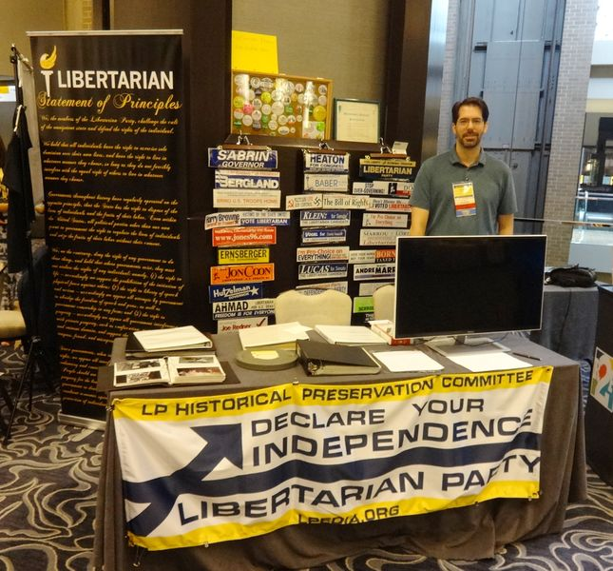 | 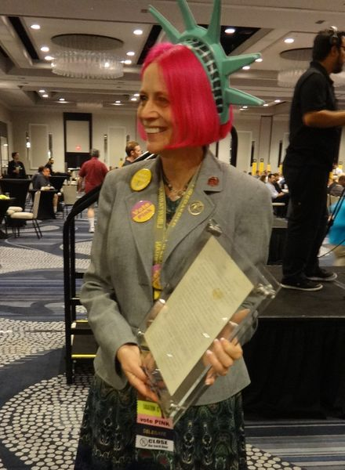

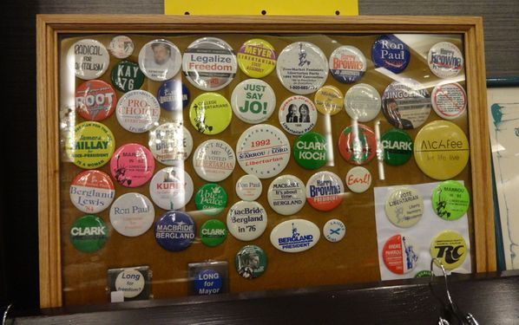 | 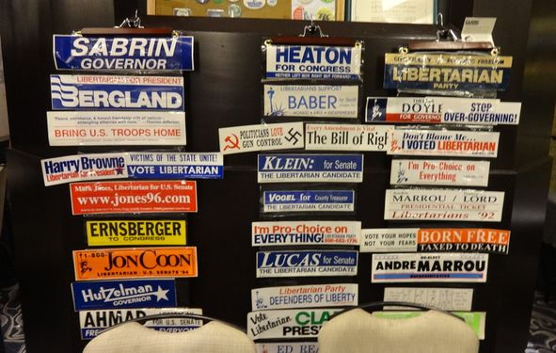

Press Mentions
Items and information about this project are regularly used internally in LP News and Liberty Pledge. The Washington Times ran a story about the acquisition of the original Statement of Principles draft (following).
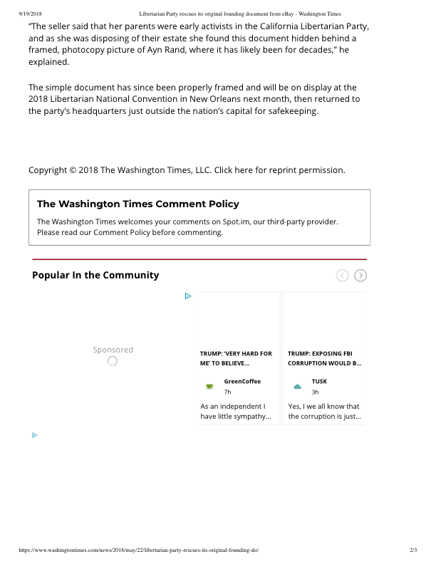

Meeting Minutes
Attached.

