Libertarian National Committee

Region 1 Report

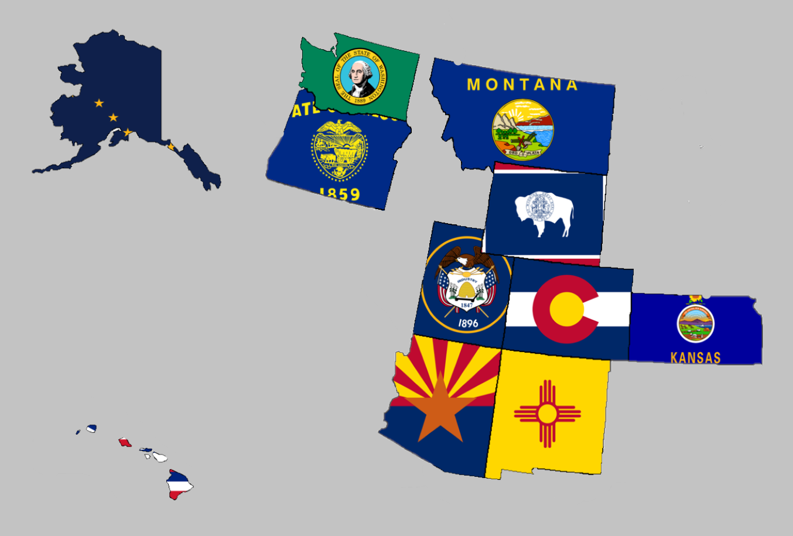

Regional Report for Region 1

Alaska, Arizona, Colorado, Hawaii, Kansas, Montana,

New Mexico, Oregon, Utah, Washington, and Wyoming

Libertarian National Committee Meeting  
December 1-2, 2018

**Region 1 Representative**

Mr. Richard Longstreth, Arizona

Libertarian National Committee

**T:** 931.538.9300 **E:** Richard.Longstreth@LP.org

**Region 1 Alternate**

Mr. Craig Bowden, Utah  
Libertarian National Committee **T:** 801.882.6472 **E:** Craig.Bowden@LP.org

# Region 1 Overview/ Representative Report

As of the 2018 National Libertarian Convention in New Orleans, the eleven affiliates that comprise Region 1 are: Alaska, Arizona, Colorado, Hawaii, Kansas, Montana, New Mexico, Oregon, Utah, Washington, and Wyoming. At the Convention, Richard Longstreth, Arizona, was elected to serve as the Region 1 Representative and Craig Bowden, Utah, was elected to serve as the Region 1 Alternate. Both positions will be re-elected at the 2020 National Libertarian Convention.

Due to the geographical nature of this region, spanning five time zones and extending from 19 to 71 degrees north latitude (some 3,000 x 3,000 miles), in-person contact between the Regional and Alternate Representatives and the individual affiliates will be infrequent. It is my intention to attend 2019/2020 affiliate conventions in each affiliate. Regular contact is attempted with the affiliates and members through email, telephone, a dedicated Facebook discussion group and page, and informational website. I make myself available by appointment as necessary whenever I am approached about scheduling some time to talk.

For the purposes of this report, State Chairs were emailed shortly after the November 6th election requesting election results, effects on ballot access, convention dates, and any other updates/ goings on in their affiliates. A reminder email and social media contact was made a week later, just prior to the Thanksgiving holiday. On Friday 11/23/18, I sent a reminder to the State Chairs again asking for updates. While I did not receive a response from everyone, any responses I received will be reflected in the Region 1 Report. If a State Chair chose to not respond I have attempted to pull data from other sources to give a high-level overview of what is happening in the state. Contact information is supplied so that direct contact may be made by any member seeking any clarification directly from that specific State Chair.

As a final check, I also sent a draft copy to State Chairs in advance of this publication in case they wanted to add, change, or correct anything. Their suggestions and updates have been incorporated into this final version.

Activities of the Region 1 Representative since the last Quarterly Report:

* Had several conversations with candidates, state chairs, and general membership in relation to the 2018 Elections.
* Co-Sponsored a motion to call an E-Meeting to discuss LNC goals for this term. The motion passed but the meeting has not been scheduled. It may be scheduled following the LNC meeting in December if it is not resolved as an agenda item at that meeting.
* Appointed Martin Buchanan of Wyoming to serve on the LNC Blockchain Committee as Region 1’s Representative to the Committee.
* Encouraged State Chairs to participate in Membership Week (11/7-14) to bolster membership numbers for their Affiliates and the National Party.
* Spoke with Brian Doherty of Reason in clarifying remarks from Montana’s Senate Candidate regarding the endorsement of his opponent.
* Assisted Wyoming in getting feedback on appealing results of Bethany Baldes’s race. Ultimately, the Wyoming Party nor the Ms. Baldes decided to appeal or move forward with contesting the results.
* Participated in several discussions regarding the marketing proposal heard at the last LNC meeting (“Give them ‘L’” and “What the ‘L’”)
* Encouraged all affiliates to submit to LP News by deadline.
* Helped the LP Colorado chair troubleshoot why he was not receiving emails from Eric regarding LP News.
* Inquired about an Issues Committee forming to update our Issues section on the LP.org website. This consideration was met with minor resistance and little discussion among the LNC.
* Spoke with Roger Barris, Colorado, who encouraged the LNC to consider doing some serious data research to advance our strategies in the future. I brought Lauren D. and Nick S. into the conversations to determine if staff already did something like this and/or how to best present the idea to the LNC as a whole. Lauren responded and mentioned some consideration points regarding funding and that she was meeting with a pollster the week after Thanksgiving. This consideration is ongoing pending her discussion with the pollster. Nick did not have input.
* Brought forward an idea from the Database Manager in Colorado to the LNC in which the Affiliate requests funding or input on an idea to do a mailer to people who have changed their registration from Libertarian to something else. While funding is unlikely, there is some discussion on the email thread.

I encourage all members to regularly review the Regional Agreement for Region 1 to keep myself and Craig diligent to our duties. This agreement is what was put out as the expectation for us in terms of what you all wanted from leadership on the LNC. Follow the link below to a pdf version on Google Drive to review. If you have trouble with the link, please let me know.

[2018 REGIONAL AGREEMENT](https://drive.google.com/file/d/0B2iKd8j9elY0bE45alZwWmdDT2JmeUJEYmIyR3Q3VElFOFFN/view?usp=sharing)

Current and Past Membership Reports can be accessed at any time via a Google Drive folder. I have not edited these reports at all because I believe it is important to maintain our national perspective as individual affiliates, not just as Regional members. Please let me know if you have trouble or questions when accessing the link or any of the reports.

[MEMBERSHIP REPORTS](https://drive.google.com/drive/folders/1dzb_INbTAAcFHCr91sHKutbZKrScdKjp?usp=sharing)

Your Region 1 Representative,

Richard Longstreth

# Region 1 Alternate Report

Activities of the Region 1 Alternate since the last Quarterly Report:

* Assisted candidates with advice in Colorado, Wyoming, Arizona, and Utah on request
* Assisted with county party formation in Alaska.
* Attended two Executive Committee meetings in Utah.
* Maintained and updated website for Utah candidate Lee Ann Walker
* Utilized social media to raise awareness of candidates and causes.
* Assisted in efforts for legalization of medical cannabis in Utah.
* Utilized social media and internet sources to spread news stories of candidates and causes within Region 1.
* Ran campaign for US Senate in Utah, received over 27,000 votes.
* Did service project with Libertarian Party of Weber County on their Adopt A Highway

Your Region 1 Alternate,

Craig Bowden

# Alaska



Chair: Jon Watts

Email: [joelhadley907@gmail.com](mailto:joelhadley907@gmail.com)

Phone: (907) 687-4884

Website: <http://www.alaskalp.org>

Facebook: <https://www.facebook.com/pg/AlaskaLiberty/>

From the Chair: Nothing submitted by the Chair for this report.

Requests to the LNC: No requests at this time.

Election Results:

* Mark Fish received nearly 11 percent in his race for the state house in a three-way race against both a Republican and a Democrat.
* Other election results may be found by reviewing [THIS REPORT](http://www.elections.alaska.gov/results/18GENR/data/results17.pdf) from the Alaska Division of Elections.

2019 Convention:

* According to the best information I’ve found, while discussing with local residents via social media, there will be no Convention in Alaska for 2019. If I am mistaken, please let me know as soon as possible.

# Arizona



Chair: Howard Blitz

Email: [chairman@azlp.org](mailto:chairman@azlp.org)

Phone: 833-THE-AZLP

Website: <https://www.azlp.org/>

Facebook: <https://www.facebook.com/LParizona/>

From the Chair:

“AZLP is planning its state convention to be held January 26, 2019 in Phoenix with a specific location to be determined. The theme is "Coming Together - Building a Libertarian Future." Nicholas Sarwark, Chairman of the National Libertarian Committee along with Evan McCahan will be the keynote speakers. There will also be a panel discussion concerning the border issue. Bylaws changes and election of officers will also take place.

Nicholas Sarwark failed in his bid to win the Phoenix mayoral race.

AZLP has had many inquiries by individuals in support of its efforts to get a libertarian elected.”

Requests to the LNC: No requests at this time.

Election Results:

* Levi Tappan was elected mayor of Page City.
* Libertarian National Committee Chair Nicholas Sarwark received 11.2 percent of the vote in a four-way special election for mayor of Phoenix, Arizona.
* Proposition 126 Passed. This was a Constitutional Amendment which prohibits the state and each county, city, town, district, or other political subdivision in Arizona from imposing a new or increased tax on services that was not already in effect on December 31, 2017.
* Other election results may be found by reviewing [THIS WEBSITE](https://results.arizona.vote/#/ballotmeasure/4/0) from the Arizona Secretary of State.

2019 Convention:

When: January 26, 2019

Where: Phoenix, AZ (Exact Location TBD)

Website: TBD

Theme: Coming Together – Building a Libertarian Future

Notable Speakers: Nicholas Sarwarck, Evan McCahan

**The Region 1 Representative has made plans to attend this convention in 2019.**

# Colorado



Chair: Wayne Harlos

Email: [statechair@lpcolorado.org](mailto:statechair@lpcolorado.org)

Phone: (303) 837-9393

Website: <https://www.lpcolorado.org/>

Facebook: <https://www.facebook.com/pg/lpcolorado/>

From the Chair: The State Chair encouraged a call at any time for updates but did not supply a written statement for this report.

Requests to the LNC: No requests at this time.

Election Results:

* Amendment A passed. The Amendment changes the Colorado constitution to prohibit slavery and involuntary servitude as punishment for a crime and thereby prohibits slavery and involuntary servitude in all circumstances
* Other election results may be found by reviewing [THIS WEBSITE](https://results.enr.clarityelections.com/CO/91808/Web02-state.222648/#/) from the Colorado Secretary of State.

2019 Convention:

When: April 26-28, 2019

Where: Hotel Elegante, 2886 S Circle Dr, Colorado Springs, CO 80906

Website: TBD

Theme: Retro Liberty

Notable Speakers: TBD

**The Region 1 Representative has made plans to attend this convention in 2019.**

# Hawaii

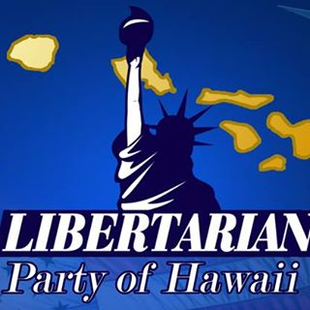

Chair: Tracy Ryan

Email: [tracyar@hawaiiantel.net](mailto:tracyar@hawaiiantel.net)

Phone: (808) 927-1126

Website: <http://www.libertarianpartyofhawaii.org>

Facebook: <https://www.facebook.com/pg/LibertarianPartyOfHawaii/>

From the Chair:

“This was the weakest field and results in several years. Only five candidates Tippens in US House I, Arianoff in State Senate 1 and Last in State Senate 2, and two folks for State House….Fogel in district 3 and Yim in district 17. None of these people spent more than a few hundred dollars or did a lot of campaigning. About the only positive is Tippens finishing ahead of two other candidates. Our ballot access is not at issue this year as we qualified for five elections after the result in 2016. If it had been we’d have lost it.

On the results posted above [linked in the Election Results section] do note that the percentages include all ballots cast in the district and not just votes cast in the election for the particular office. So you will see blank votes from the folks who may have voted for some other office, but not the one listed. Add them in to get 100%. With the blank votes deleted the LPH percentage would obviously appear higher.”

Requests to the LNC: No requests at this time.

Election Results:

* Election results may be found by reviewing [THIS PDF](https://elections.hawaii.gov/wp-content/results/histatewide.pdf) from the Hawaii Office of Elections.

2019 Convention:

All information is currently TBD. I have not been given any information to date about a Convention in Hawaii for 2019.

# Kansas

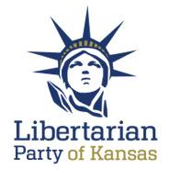

Chair: Kris Logan

Email: [Chair@lpks.org](mailto:Chair@lpks.org)

Phone: (913) 240.9008

Website: <http://www.LPKS.org>

Facebook: <https://www.facebook.com/pg/KansasLP/>

From the Chair: Nothing submitted by the Chair for this report.

Requests to the LNC: No requests at this time.

Election Results:

* Election results may be found by reviewing [THIS WEBSITE](https://ent.sos.ks.gov/kssos_ent.html) from the Kansas Secretary of State.

2019 Convention:

All information is currently TBD. I have not been given any information to date about a Convention in Kansas for 2019.

# Montana

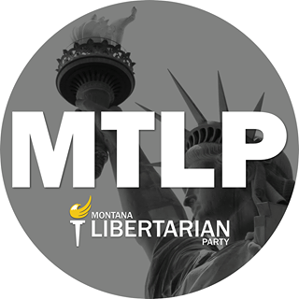

Chair: Francis Wendt

Email: [francis.wendt@mtlp.org](mailto:francis.wendt@mtlp.org)

Phone: (406) 404-6453

Website: <https://www.mtlp.org/>

Facebook: <https://www.facebook.com/pg/MontanaLibertarianParty/>

From the Chair: The Chair submitted an extensive report. These are some of the highlights, paraphrased. Francis has indicated that I may share the report in entirety with the LNC for internal use and I will do so upon request.

* Election Results and Recap: I encourage each LNC member to request the report for an extensive analysis. From Francis: “Across the state, the MTLP and its candidates performed admirably. Despite the confusion surrounding Rick Breckenridge’s statements about his opponent Matt Rosendale and dark money, I believe that the party has gained significant ground this year. During the election questions were raised about pursuit of legal action against Montana PBS, the Secretary of State, and other parties. It is my conclusion that we should let these matters rest, and focus our attention, time, energy, and resources on strengthening the party. It won’t benefit our future candidates if we are fighting old battles, so I strongly suggest that we concentrate on the upcoming 2019 and 2020 elections. This year we beat most expectations, but the MTLP cannot rest on its laurels.”
* County Growth Project: The MTLP is working to establish a county growth program. They currently have model Constitution and Bylaws and are continuing to focus on party growth. Francis is perpetually working on this project and making adjustments as necessary. It is his and my intent to his share model, once fully functional, with the Region to grow membership in other states.
* 2019 Goals: Working on finding candidates for local offices for 2019 as well as internal offices and bylaw updates for their upcoming Convention. Most of the candidate recruitment work will be on county leadership with state support as needed.
* 2019 Convention and Officer Elections: Convention is in the planning stages for their convention. Details are listed below for what they have so far. The MTLP requests that the LNC consider having their Summer meeting in MT this year on the same weekend as their convention (projected June). They are beginning to populate committees to plan the details.
* Information Technology: The MTLP is attempting to get access to all leaders in the party for their membership database (CiviCRM).
* Final Notes: “In this report I had detailed my analysis, perspective, ideas, plans, and goals for the MTLP to affect the political landscape in Montana. The most critical factor to implementing these strategies is getting more people into the mix. That is our primary goal above all else. Please feel free to contact me with any questions concerning this report via email at chair@mtlp.org.”

Requests to the LNC:

* When the LNC considers the Summer meeting location Montana would like to be considered and perhaps a joint event be coordinated.

Election Results:

* Ballot Access is retained through 2022.
* Election results may be found by reviewing [THIS WEBSITE](http://mtelectionresults.gov/) from the Montana Secretary of State.

2019 Convention:

When: June 2019 (Exact Date TBD)

Where: TBD

Website: TBD

Theme: TBD

Notable Speakers: TBD

# New Mexico



Chair: Chris Luchini

Email: [chair@lpnm.us](mailto:chair@lpnm.us)

Phone: 888-LPNM-NOW

Website: <https://lpnm.us/>

Facebook: <https://www.facebook.com/LPNewMexico/>

From the Chair: Nothing submitted by the Chair for this report.

Requests to the LNC: No requests at this time.

Election Results:

* Two-term New Mexico Governor Gary Johnson, the Libertarian Party’s presidential nominee in 2012 and 2016, received more than 15 percent of the votes in a three-way race for the U.S. senate.
* Constitutional Amendment 2 Passed. The Amendment adds language to Article 5 of the Constitution of New Mexico to create an independent State Ethics Commission with jurisdiction to investigate, adjudicate and issue advisory opinions concerning civil violations of laws governing ethics, standards of conduct and reporting requirements as provided by law.
* Election results may be found by reviewing [THIS WEBSITE](http://electionresults.sos.state.nm.us/) from the New Mexico Secretary of State.

2019 Convention:

When: March 23, 2019

Where: Albuquerque, NM (Exact Location TBD)

Website: <https://lpnm.us/2019-convention/>

Theme: TBD

Notable Speakers: TBD

**The Region 1 Representative has made plans to attend this convention in 2019.**

# Oregon

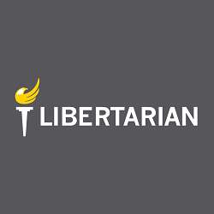

Chair: Kyle Markley

Email: [chair@lporegon.org](mailto:chair@lporegon.org)

Phone: (971) 266-0028

Website: <https://lporegon.org/>

Facebook: <https://www.facebook.com/pg/LibertarianPartyOfOregon/>

From the Chair: Nothing submitted by the Chair for this report.

Requests to the LNC: No requests at this time.

Election Results:

* Election results may be found by reviewing [THIS WEBSITE](http://results.oregonvotes.gov/) from the Oregon Secretary of State.

2019 Convention:

All information is currently TBD. I have not been given any information to date about a Convention in Oregon for 2019.

# Utah

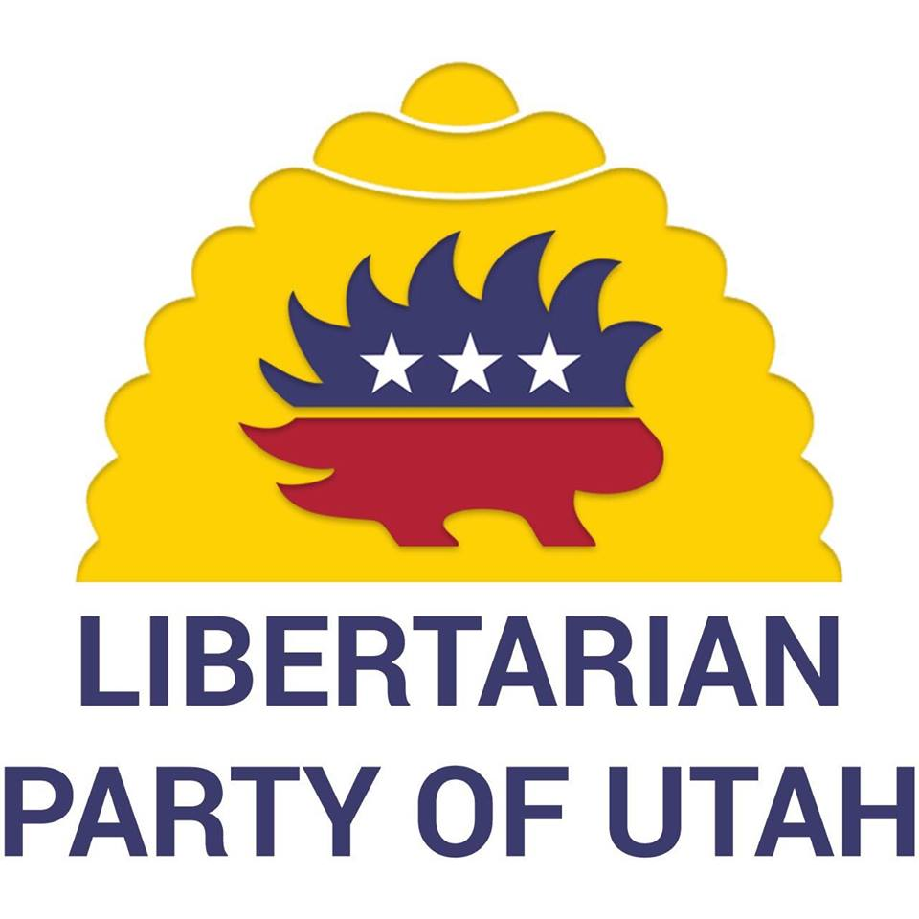

Chair: Joseph Buchman

Email: [chair@libertarianutah.org](mailto:chair@libertarianutah.org)

Phone: 801-742-1163

Website: <http://www.libertarianutah.org/>

Facebook: <https://www.facebook.com/lputah/>

From Utah State Leadership:

“The 2018 election was notable in a few ways:

* Daniel Holloway, running for House District 74, received 23.75% in his race.
* Craig Bowden, running for the US Senate, was able to extend Utah ballot access until 2024. Craig also raised more money than any other third party candidate in Utah history from individual donors.
* Several candidates running for either Utah's House or Senate exceeded 7%.

Utah is planning on holding its annual convention in April of 2019. At this time, no date has been selected but will be finalized at the next Executive Committee meeting. Utah is very active in outreach and social events.

Of note, Utah has had a 26% increase in voters affiliating as Libertarians on their voter registration. Monthly donors have increased exponentially.

Utah has taken a priority in getting individuals elected into municipal positions. A new committee has been created to focus on this effort. Other priorities for the Libertarian Party of Utah include continued county party formation, and those counties that have formed parties, organizing into the precinct level.”

Requests to the LNC: No requests at this time.

Election Results:

* Proposition 2 Passed. Proposition 2 legalizes the medical use of marijuana for individuals with qualifying medical illnesses.
* Election results may be found by reviewing [THIS WEBSITE](https://electionresults.utah.gov/elections/) from the Utah’s Office of Elections.

2019 Convention:

When: April 2019

Where: Salt Lake City, UT (Exact Location TBD)

Website: TBD

Theme: TBD

Notable Speakers: TBD

# Washington

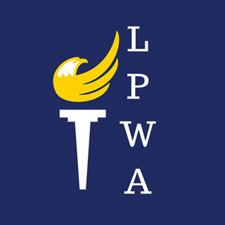

Chair: Randy McGlenn

Email: [info@lpwa.org](mailto:info@lpwa.org)

Website: <https://lpwa.org/>

Facebook: <https://www.facebook.com/pg/libertarianpartyofWA/>

From the Chair: Nothing submitted by the Chair for this report.

Requests to the LNC: No requests at this time.

Election Results:

* Brian Luke received 27 percent of the vote in his run for the U.S. house in the 2nd District
* Allen Acosta garnered 30 percent for state House, 22nd District.
* Washington Initiative 1634 Passed. Initiative 1634 prohibits local governments from enacting taxes on groceries.
* Election results may be found by reviewing [THIS WEBSITE](https://results.vote.wa.gov/results/current/) from the Washington Secretary of State.

2019 Convention:

When: March 29-31, 2019

Where: Issaquah, WA (Exact Location TBD)

Website: TBD

Theme: TBD

Notable Speakers: TBD

**The Region 1 Representative has tentatively made plans to attend this convention in 2019, however, there may be a job conflict. The Regional Alternate has been asked to see if his schedule is available to attend.**

# Wyoming

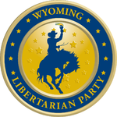

Chair: Dee Cozzens

Email: [rdeecozzens@outlook.com](mailto:rdeecozzens@outlook.com)

Phone: 307-250-6892

Website: <https://lpwy.org/>

Facebook: <https://www.facebook.com/libertariansWY/>

From the Chair: Nothing submitted by the Chair or Executive Director for this report.

Requests to the LNC: No requests at this time.

Election Results:

* Bethany Baldes lost by a mere 53 votes after having been prematurely declared the winner of her race against the Republican incumbent in Wyoming’s state House, 55th District. Before the absentee ballots were counted, yielding her result of 49.2 percent, the media had reported widely about her supposed 194-vote margin of victory, prompting an eventual apology from the CEO of media company PitchEngine along with his kudos on Baldes’s “great campaign.”
* Ballot Access was secured for the next election cycle.
* Election results may be found by reviewing [THIS WEBSITE](https://soswy.state.wy.us/Elections/ElectionResults.aspx) from the Wyoming Secretary of State.

2019 Convention:

When: March 2019

Where: TBD

Website: TBD

Theme: TBD

Notable Speakers: TBD