Libertarian National Committee

Region 1 Report

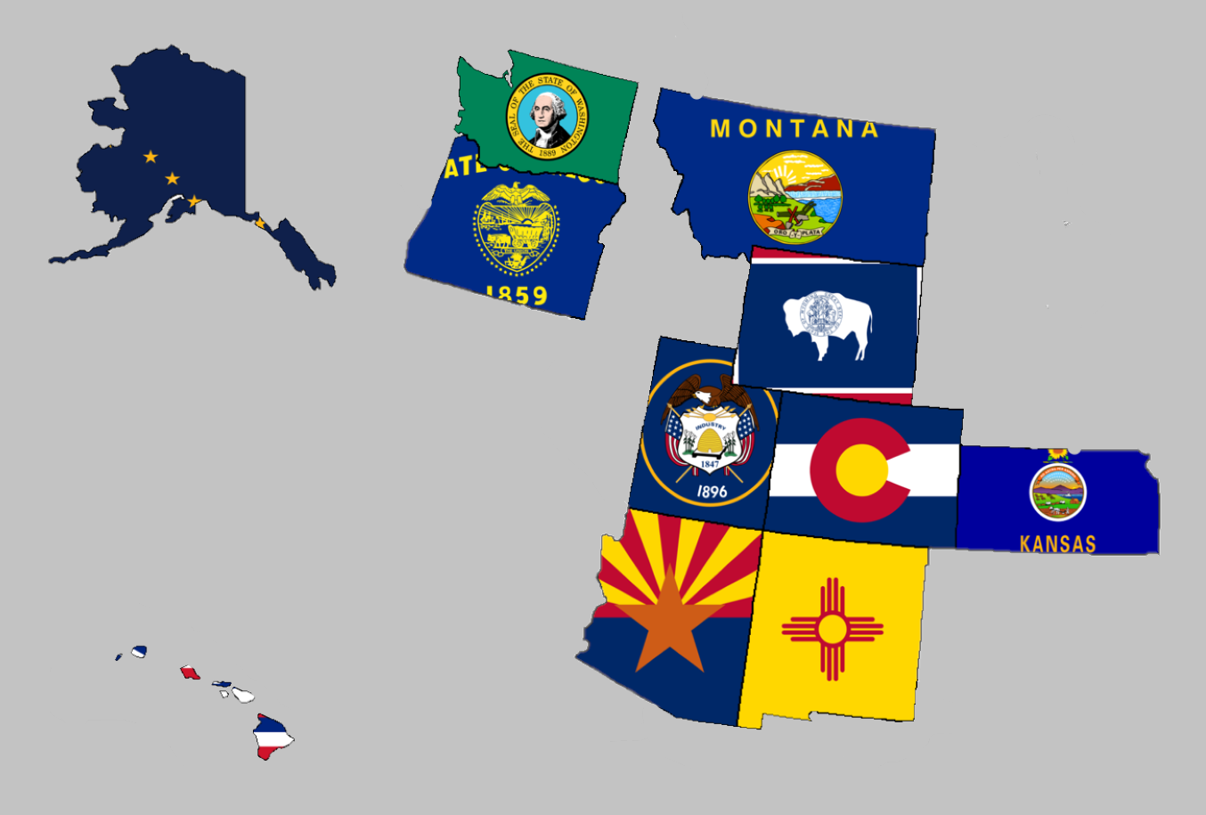

Regional Report for Region 1

Alaska, Arizona, Colorado, Hawaii, Kansas, Montana,

New Mexico, Oregon, Utah, Washington, and Wyoming

Libertarian National Committee Meeting  
March 9-10, 2019

**Region 1 Representative**

Mr. Richard Longstreth, Arizona

Libertarian National Committee

**T:** 931.538.9300 **E:** Richard.Longstreth@LP.org

**Region 1 Alternate**

Vacant

# Region 1 Overview/ Representative Report

As of the 2018 National Libertarian Convention in New Orleans, the eleven affiliates that comprise Region 1 are: Alaska, Arizona, Colorado, Hawaii, Kansas, Montana, New Mexico, Oregon, Utah, Washington, and Wyoming. At the Convention, Richard Longstreth, Arizona, was elected to serve as the Region 1 Representative and Craig Bowden, Utah, was elected to serve as the Region 1 Alternate. As of February 2019, Craig resigned his position and an application process is in place to fill his vacancy. Both the Region 1 Representative and the Alternate will be re-elected at the 2020 National Libertarian Convention.

Due to the geographical nature of this region, spanning five time zones and extending from 19 to 71 degrees north latitude (some 3,000 x 3,000 miles), in-person contact between the Regional and Alternate Representatives and the individual affiliates will be infrequent. It is my intention to attend 2019/2020 affiliate conventions in each affiliate. Regular contact is attempted with the affiliates and members through email, telephone, a dedicated Facebook discussion group and page, and informational website. I make myself available by appointment as necessary whenever I am approached about scheduling some time to talk.

For the purposes of this report, State Chairs were emailed on February 7th requesting convention information, goals, and any other updates/ goings on in their affiliates. Regular follow-up was done to remind State Chairs to submit a written report and encouraged them to schedule a time to talk if they preferred. While I did not receive a response from everyone, any responses I received will be reflected in the Region 1 Report. If a State Chair chose to not respond I have attempted to pull data from other sources to give a high-level overview of what is happening in the state. Contact information is supplied so that direct contact may be made by any member seeking any clarification directly from that specific State Chair.

Any updates or modifications to this report will occur at the next LNC meeting.

Activities of the Region 1 Representative since the last Quarterly Report:

* Had several conversations with candidates, state chairs, and general membership in relation to reflecting on the 2018 Elections and plans for 2019 and 2020 elections.
* Answered and addressed questions about the National Party’s State CRM Project.
* Joined the Policy Manual Committee by invitation of the Libertarian Party of Colorado which aims to create a policy manual for their board of directors.
* Ran a write-in campaign for my HOA but did not win.
* Participated in LNC E-Meeting on January 6, 2019. The purpose of the meeting was to wrap up agenda items left over from the December LNC meeting in Alexandria, VA.
* Reminded State Chairs that October 31, 2019 is the cutoff on national membership numbers to count for delegate allocation and National Convention related committee seat determinations.
* Encouraged State Chairs and libertarians across the country in participating in the park clean efforts during the partial government shutdown.
* Attended the Arizona Libertarian Party’s Annual Convention.
* Reached out several times to Wyoming’s leadership regarding their website and how it seems to have gone offline. I have received no responses or updated web addresses.
* Stood in opposition to a resolution before the LNC regarding Governor Ralph Northam.
* Stood in favor of a resolution before the LNC condemning a border wall between the United States and Mexico and affirming the natural right of the freedom of movement for all people.
* Accepted the resignation of Craig Bowden, Region 1 Alternate, and began assisting the State Chairs with electing a replacement for the remainder of the term. Information regarding this and an application for the position are available [HERE](https://www.lp.org/application-for-region-1-alternate-libertarian-national-committee/). State Chairs aim to elect a new Alternate by the end of March 2019.

I encourage all members to regularly review the Regional Agreement for Region 1 to keep myself and the Region 1 Alternate diligent to our duties. This agreement is what was put out as the expectation for us in terms of what you all wanted from leadership on the LNC. Follow the link below to a pdf version on Google Drive to review. If you have trouble with the link, please let me know.

[2018 REGIONAL AGREEMENT](https://drive.google.com/file/d/0B2iKd8j9elY0bE45alZwWmdDT2JmeUJEYmIyR3Q3VElFOFFN/view?usp=sharing)

Current and Past Membership Reports can be accessed at any time via a Google Drive folder. I have not edited these reports at all because I believe it is important to maintain our national perspective as individual affiliates, not just as Regional members. Please let me know if you have trouble or questions when accessing the link or any of the reports.

[MEMBERSHIP REPORTS](https://drive.google.com/drive/folders/1dzb_INbTAAcFHCr91sHKutbZKrScdKjp?usp=sharing)

Your Region 1 Representative,

Richard Longstreth

# Region 1 Alternate Report

It has been the greatest honor of my life to be able to represent you as the Alternate for Region 1 on the Libertarian National Committee. I am heartbroken that circumstances in my life changed to where I could no longer execute my duties representing all of you.

Effective today, February 23rd, I sent in my resignation to the LNC. Know that I will not stop fighting the good fight. Although I may no longer be on the LNC, I will never stop fighting until we see a world set free in our lifetime.

I was inspired by many of you and the dedication you have to our cause. Thank you for being such excellent examples and carrying the flame of liberty forward. You are all my heroes.

I hope that the Region is able to find someone more capable to continue this charge and be more than I was able.

With great admiration,

Craig Bowden

# Alaska



Chair: Jon Watts

Email: [joelhadley907@gmail.com](mailto:joelhadley907@gmail.com)

Phone: (907) 687-4884

Website: <http://www.alaskalp.org>

Facebook: <https://www.facebook.com/pg/AlaskaLiberty/>

From the Chair: Nothing submitted by the Chair for this report.

Requests to the LNC: No requests at this time. **Region 1 Representative Note: This state will need to earn ballot access prior to 2020.**

2019 Convention:

* According to the best information I’ve found, while discussing with local residents via social media, there will be no Convention in Alaska for 2019. If I am mistaken, please let me know as soon as possible.

# Arizona



Chair: Howard Blitz

Email: [chairman@azlp.org](mailto:chairman@azlp.org)

Phone: 833-THE-AZLP

Website: <https://www.azlp.org/>

Facebook: <https://www.facebook.com/LParizona/>

From the Chair:

“We voted on a change in the bylaws on how AZLP determines delegates to the national convention and we elected officers for the two years of 2019-2020. Nick Sarwark and Evan McMahan shared some thoughts on how to approach individuals about libertarianism and Zach Foster shared what is happening in Cuba and Venezuela and how libertarians can help support the Libertarian Party in those two countries.”

Requests to the LNC: No requests at this time.

2019 Convention:

I attended the Arizona Libertarian Party’s Convention on January 26, 2019 in Phoenix, AZ. It was a wonderful event complete with a raffle, business, and guest speakers. Howard was re-elected as the chairman and one change was made to the Affiliate’s bylaws regarding how delegates will be elected for future National Conventions.

# Colorado



Chair: Wayne Harlos

Email: [statechair@lpcolorado.org](mailto:statechair@lpcolorado.org)

Phone: (303) 837-9393

Website: <https://www.lpcolorado.org/>

Facebook: <https://www.facebook.com/pg/lpcolorado/>

From the Chair: The State Chair encouraged a call at any time for updates but did not supply a written statement for this report. Below is a recap of some of the things we talked about:

The affiliate is focused on working on consistent messaging and believes that the National Party should also focus on its messaging.

The Membership Director position has opened up but the Board intends to leave position open until their convention where it will be voted on by party members.

Development and Affiliate group expansion projects are going very well. There are now 5 active affiliates and 4 active Development Groups on their way to affiliate status. In Colorado, they have a system setup where development group is akin to an interest group. Only after certain requirements are met do these interest groups become affiliates within the state party and Colorado’s Secretary of State. Their aim is to expand the total number of groups to 13 (from the current 9) by June.

Requests to the LNC: No requests at this time.

2019 Convention:

When: April 26-28, 2019

Where: Hotel Elegante, 2886 S Circle Dr, Colorado Springs, CO 80906

Website: <https://lpcolorado.org/event/2019-lp-colorado-state-convention-2019-04-26/>

Theme: Retro Liberty

Notable Speakers: TBD

**The Region 1 Representative has made plans to attend this convention in 2019.**

# Hawaii

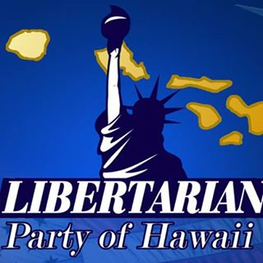

Chair: Tracy Ryan

Email: [tracyar@hawaiiantel.net](mailto:tracyar@hawaiiantel.net)

Phone: (808) 927-1126

Website: <http://www.libertarianpartyofhawaii.org>

Facebook: <https://www.facebook.com/pg/LibertarianPartyOfHawaii/>

From the Chair: Nothing submitted by the Chair for this report.

Requests to the LNC: No requests at this time.

2019 Convention:

All information is currently TBD. I have not been given any information to date about a Convention in Hawaii for 2019.

# Kansas

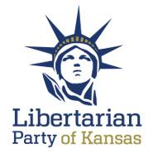

Chair: Kris Logan

Email: [Chair@lpks.org](mailto:Chair@lpks.org)

Phone: (913) 240.9008

Website: <http://www.LPKS.org>

Facebook: <https://www.facebook.com/pg/KansasLP/>

From the Chair: Nothing submitted by the Chair for this report.

Requests to the LNC: No requests at this time.

2019 Convention:

When: April 12-14 2019

Where: TBD

Website: TBD

Theme: TBD

Notable Speakers: TBD

# Montana

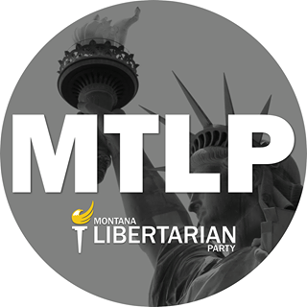

Chair: Francis Wendt

Email: [francis.wendt@mtlp.org](mailto:francis.wendt@mtlp.org)

Phone: (406) 404-6453

Website: <https://www.mtlp.org/>

Facebook: <https://www.facebook.com/pg/MontanaLibertarianParty/>

From the Chair: The State Chair encouraged a call at any time for updates but did not supply a written statement for this report. Below is a recap of some of the things we talked about:

There is not much to report on Montana at this time. They are continuing to focus on local expansion. I encouraged Francis to reach out to Regional peers in New Mexico and Colorado as they have the same focus. The affiliate is also gearing up for their convention where all officers are up for election.

Requests to the LNC: No Requests at this time.

2019 Convention:

When: June 2019 (Exact Date TBD)

Where: TBD

Website: TBD

Theme: TBD

Notable Speakers: TBD

# New Mexico



Chair: Chris Luchini

Email: [chair@lpnm.us](mailto:chair@lpnm.us)

Phone: 888-LPNM-NOW

Website: <https://lpnm.us/>

Facebook: <https://www.facebook.com/LPNewMexico/>

From the Chair: The State Chair encouraged a call for updates but did not supply a written statement for this report. Below is a recap of some of the things we talked about:

A lot of the leadership was worn down following the elections but they are shifting tactics in trying to recruit new members. They found electronic communicaitons were not yielding great results so they have begun working on developing local groups thorugh in person meetings in order to grow their numbers and it is having some success. One group improved their attendance 57% due to this approach and two new affiliates have also formed since November.

The group is working on obtaining non-profit status to assist with mailers and for other reasons.

The affiliate notes that a lot of blue-wave style bills are being introduced and is carefully monitoring their legislature for opportunities to speak out on government overreach and injustice.

Chris recognizes that their volunteer network needs to be expanded in order to avoid some burnout and he believes, I agree, that this new approach to expansion and personalized contact will continue to yield successful results.

The affiliates is hoping to run 10-15 candidates in local elections for 2019 and already believes that two of those campaigns stand a strong chance.

Requests to the LNC: No requests at this time.

2019 Convention:

When: March 22-23, 2019

Where: UNM School of Law, 1117 Stanford NE MSC11 6070, 1 University of New Mexico, Room 2401, Albuquerque, NM 87131-0001

Website: <https://lpnm.us/2019-convention/>

Notable Speakers: Jeff Hewitt, Elected Official, California

**The Region 1 Representative has made plans to attend this convention in 2019.**

# Oregon

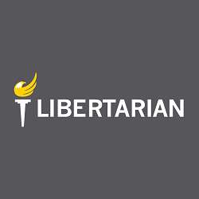

Chair: Kyle Markley

Email: [chair@lporegon.org](mailto:chair@lporegon.org)

Phone: (971) 266-0028

Website: <https://lporegon.org/>

Facebook: <https://www.facebook.com/pg/LibertarianPartyOfOregon/>

From the Chair:

“Oregon had adopted a policy regarding county-level affiliates, which had been on our long-term to-do list for many years, but only recently got traction. This enables a number of members around the state to begin the process of creating county affiliate organizations. We have also determined a time and place for our convention, June 1st in Wilsonville.”

Requests to the LNC: No requests at this time.

2019 Convention:

When: June 1, 2019

Where: Wilsonville, OR (Exact Location TBD)

Website: TBD

Theme: TBD

Notable Speakers: TBD

# Utah

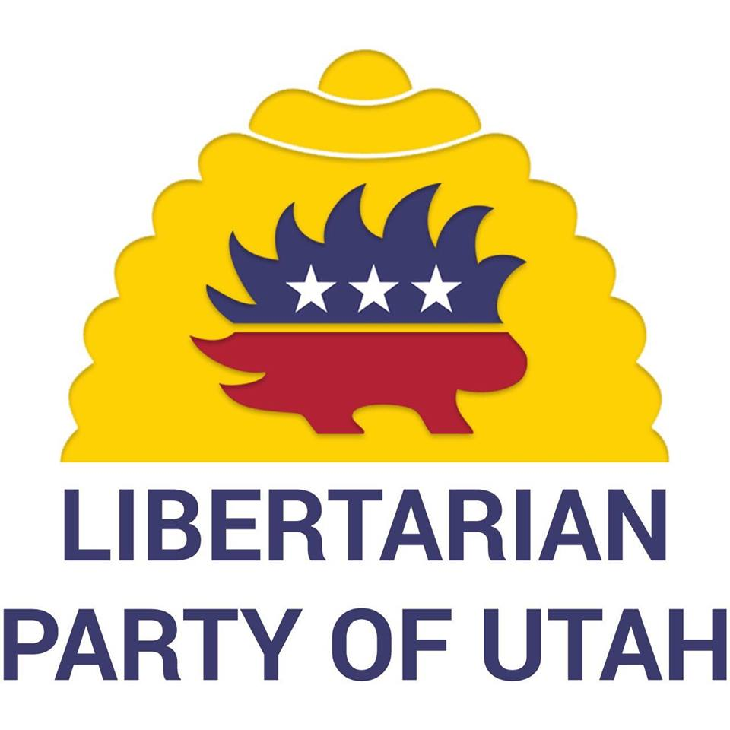

Chair: Joseph Buchman

Email: [chair@libertarianutah.org](mailto:chair@libertarianutah.org)

Phone: 801-742-1163

Website: <http://www.libertarianutah.org/>

Facebook: <https://www.facebook.com/lputah/>

From Utah State Chair: The State Chair chatted with me briefly on social media but did not supply a written statement for this report. Below is a recap of some of the things we talked about:

Utah is primarily focused on getting their convention planned. There will be officer elections at that time. There are not any other projects or things to note at this time.

Requests to the LNC: No requests at this time.

2019 Convention:

When: April 20,2019

Where: Bingham Canyon Lions Club, 320 Hillcrest Street, Copperton, UT 84006

Website: <https://www.eventbrite.com/e/utah-libertarian-party-2019-convention-tickets-54567262150>

# Washington

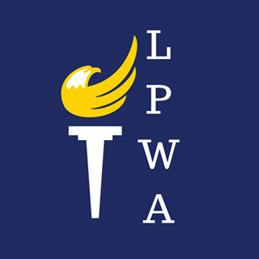

Chair: Randy McGlenn

Email: [info@lpwa.org](mailto:info@lpwa.org)

Website: <https://lpwa.org/>

Facebook: <https://www.facebook.com/pg/libertarianpartyofWA/>

From the Chair (via Facebook):

“I wanted to take a moment to talk about what has been happening with LPWA, touch on a couple of topics of interest in the discussion groups and talk about the upcoming state committee elections.

Right now we are busy working to put the final touches on the Cascade Liberty Summit 2019, located in Issaquah. I am excited for the lineup of great speakers especially our keynote speaker Maj Toure with Black Guns Matter.

Our new Treasurer Brett Borden is diligently working with our auditor to begin filing regular reports and update information to the PDC on our organization.

We will soon have exciting new material to promote the party with t-shirts and other party swag that Emily, our Community Relations Director, has collaborated on with a talented graphic designer to bring the libertarian message to people across the state.

With convention just a month away, if you haven't already renewed your membership dues, please take a moment to do so today. It's easy to do just visit www.lpwa.org and click the menu to contribute.”

Requests to the LNC: No requests at this time.

2019 Convention:

When: March 29-31, 2019

Where: Holiday Inn Seattle-Issaquah, 1801 12th Avenue Nw, Issaquah, Washington 98027

Website: <https://lpwa.org/convention/>

Notable Speakers: Maj Toure, Black Guns Matter

**The Region 1 Representative has tentatively made plans to attend this convention in 2019, however, there may be a job conflict. This conflict should be resolved within a week of the March LNC Meeting and participation will be determined at that time.**

# Wyoming

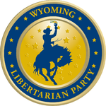

Chair: Dee Cozzens

Email: [rdeecozzens@outlook.com](mailto:rdeecozzens@outlook.com)

Phone: 307-250-6892

Website: <https://lpwy.org/>

Facebook: <https://www.facebook.com/libertariansWY/>

From the Chair: Nothing submitted by the Chair or Executive Director for this report.

Requests to the LNC: No requests at this time.

2019 Convention:

When: March 2019

Where: TBD

Website: TBD

Theme: TBD

Notable Speakers: TBD