Region 6 report, 1st quarter 2019.  
  
Iowa:

The LPIA is currently engaged in lobbying against efforts that would place additional hurdles to Iowa ballot access for the LP and other minor parties. House File 335 would set our filing deadlines to the primary election deadlines of the major parties, despite the LPIA not having primary privileges, this would move minor party filing deadlines up five months and require us to use substitution in ensuring a LP candidate on the ballot. The bill would also prevent other minor parties from forming if their national parties have a summer convention as only the Green and Libertarian Parties can currently use substitution. We have bipartisan support on the state government committee against the bill and our registered lobbyist, Jake Porter, has discussed with Governor Reynold's staff. We have partnered with the Green Party in rallying our base to communicate with their legislators on this issue and received some press in our fight to maintain broad ballot access.   
  
The LPIA has reorganized into a divisional structure, communications, political and county development, which should help our party better maintain institutional knowledge and build the party committee term to term. In the past, the state committee members were assigned roles, which they will continue to assist with. However a divisional structure will allow us to bring in volunteers that are experts in marketing, relationship management and communications rather than relying solely on committee members that may have limited knowledge and experience in these areas.

North Dakota:

There’s quite a bit going on with the state party at the moment. Essentially in the last year and a half all the state officers but the treasurer have been replaced. In order to make the state party more functional they have decided to update our bylaws and update the state platform. All quarterly meetings for the year have been scheduled as has the convention. They also recently secured funding from a local business owner for 12 LPND local outreach meets throughout the year. The goal of these meets is to reconnect with past members, connect with new potential members, contact candidate interviews, establish points of contact across the state/assign state rep positions or help establish local city or county affiliates, and collect as much general feedback as possible from local libertarians. As for ballot access they have contracted Scott Kohlhaas who’s is currently raising funds so that we can pay petitioners to gather to gather signatures. The goal was to raise $25000 and last report (about a month ago) they were sitting at about $15,000. They have also reached out to quite a few state groups that are libertarian leaning such as the North Dakota Cannabis Caucus, Committee for Compassionate Care, ND Liberty PAC, and Stand Your Ground ND. All groups now have members within the party. They have also been in contact with a cannabis lobbyist in Bismarck for some time that keeps them updated on events at the capital. He intends to lobby for libertarians during the next legislative session. As far as candidates go there is little to report so far. We have two candidates running in local city races in Alexander, one for mayor, the other city council. There are also rumors that a libertarian wants to run against our Attorney General. She’s yet to reach out to us but some of her family has reached out. Also they feel you should know that many local libertarians I’ve talked to aren’t happy with the direction of the LNC. They think the left leaning libertarians are starting to run the show and see us as an extension of nationals. I’ve explained to them that the LPND isn’t there to tell them what to do but support the goals they already have in their communities.  
They are also working hard on getting their data integrated with national, but are running into some technical difficulties.  
  
Minnesota:

After much counsel with our driven and capable chairman Christopher Holbrook along with the Executive Committee, Cara Shulz and under the tutelage of certain LPMN Legacy members we have made a strong push to develop single-issue coalitions with like-minded organizations where our views intersect in Liberty. By pooling our efforts with these organizations we have made some major headway in 'shining a light' and bringing much attention and press to Liberty issues. We are focusing not on what divides us but what unites us, and it's paying off in dividends. We are a positive party, we are a welcoming party and our influence and passion for self-ownership spreads with every coalition we build, and with each friendship we make.

Our Bipartisan Ballot Access Inclusion has really gained steam. We even were blessed with having the LNC Chairman Nicholas Sarwark to fight alongside us. Cara Schulz has been very active, with testimonies to state hearings on opiod issues, guns, and an appearance on Brietbart. We have formed coalitions related to marijuana legalization with MN Normal, Minnesotans For Full Legalization, LMN, Cannabis Grass Roots and many more! The LPMN has teamed up with MN Gun Owners Caucus and their political director, Rob Doar. This organization is the real deal when it comes to limiting the government’s power on your second amendment rights.

We have more coalitions coming your way in healthcare, taxation, law enforcement accountability and we are deep in the trenches of Ballot Access battle  
  
Illinois:  
  
The Libertarian Party of Illinois launched a new Lifetime Membership program. Those who make a large donation to become Lifetime Membership of the Libertarian Party of Illinois are able to attend annual Illinois state conventions for free for life. They are recognized at State Conventions and are also given a Lifetime Member pin, similar to what is offered by the National organization. Illinois had a legacy Lifetime Membership program that hadn't been offered in decades. Those original Lifetime Members are recognized in this new program, which is an excellent way to re-engage with our older members.

Illinois is in the process of hiring an Executive Director. This Executive Director role will be a paid fundraiser whose pay will be entirely commission based. Illinois has hired paid fundraisers in the past to fund ballot access drives. Rather than exclusively using paid fundraisers before petitioning, the Libertarian Party of Illinois will soon have a paid fundraiser year-round.

The Libertarian Party of Illinois Archivist Kate Nadolski has done an outstanding job acquiring and organizing records, documents, and artifacts from members and chapters around the state. She has arranged the Libertarian Party of Illinois collection to be professionally maintained by the University of Illinois - Chicago. While Kate has had a lot of fun meeting people and collecting historical items from all over Illinois, she looks forward to getting the collection out of her basement and accessible to the public through the UIC Library this Spring.  
  
The big news is ballot access legislation proposed by democrat state senator Andy Manar that would substantially lower ballot access requirements for third parties and independents in Illinois. Lower them to be equivalent to that of D’s and R’s, so instead of 25000 minimum signatures for statewide races it would be 5000, and all the way down to the smallest partisan races being equivalent to the D and R counterparts. This is the first time such legislation has been proposed by a democrat in Illinois. Members are already organizing in support, and have succeeded in getting this bill some initial bipartisan support, and a companion bill started in the House. The state executive board is meeting on the 5th to hopefully pass a resolution in support, and make some action to help better organize the support of this bill.  
  
The resolution passed, lobbying has already begun.

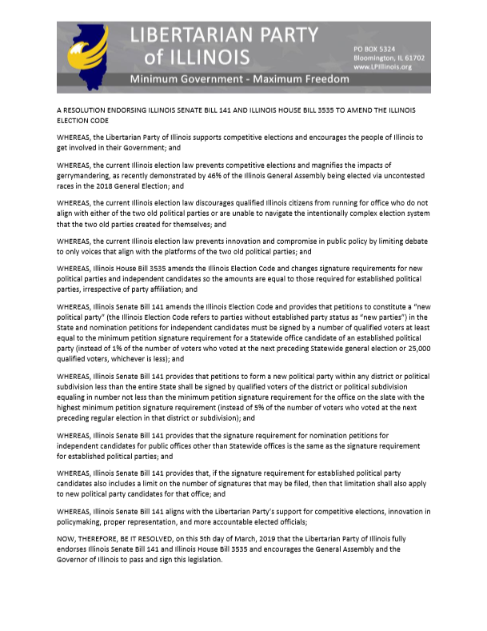  
  
  
Missouri:

“We have a golden opportunity in Missouri. We have an opportunity to change our elections and thereby our politics in a way that will rid of ourselves of the idiocy we have in politics today.

The golden opportunity is this. One of the members of the Missouri House of Representatives, Dan Stacy, has introduced two Bills enabling Ranked Choice Voting (RCV) in Missouri. I am not overstating the case when I say that RCV is the key to breaking the gridlock in our politics today by enabling third parties to be competitive in general elections. RCV will give voters more choice and once and for all do away with the spoiler scenario. HB 27 requires elections for all Federal and State Offices to use RCV. HB 28 requires all local elections to use RCV. “

Nebraska:  
  
Our big thing is helping James Herrold with his Lincoln City Council campaign at the moment. The primary is April 9th. He’s the first Libertarian to be endorsed by the Lincoln Independent Business Association (LIBA) for a city race. So he’s got a lot of momentum.

I also held a state/county leadership meeting via zoom and Cara Schulz attended that. We went over our state 2020 strategy and set up or state convention plan for next year.

South Dakota:  
  
here really hasn't been much going on here following the Election. We held our annual Food Drive in December. We have a pre-convention meeting planned for April 11th at 6:30 pm @ The Source coffee roastery & taproom in Sioux Falls, SD.

And our annual state convention is on June 15th at 2pm in Rapid City, SD. As of now we haven't really reached out to any guest speakers for the event. After the election, our state funds are pretty depleted, so we are focusing on local advocacy groups come speak, like SD Gun Owners, New Approach SD (cannabis reform group) and Americans for Prosperity.  At our convention this year all Executive Committee positions are open, terms run from 2019-2021. So after convention there will be some new leadership onboard.