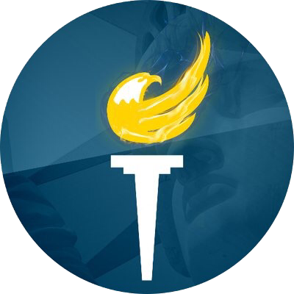

Vice Chair Report #3

By Alex Merced

12/1/2018 - 3/01/19

Have been active in contributing to the LP facebook page and twitter page with the social media team.

“Meet the Libertarians” now on iTunes/Stitcher/Google Play continues regularly including interviews with 2019 special election candidates William Hunt (RI) and Jeff Prezch (CT), Dutch LP Chair Robert Velentine and Ohio LP Member, Kryssi Wichers. Also MTP has been added to Spotify, TuneIn and iHeartRadio directories.

Scheduled to be at several state conventions including but not limited to PA, IA, FL, MO, MN, etc.

Created LPedia Page for Blockchain Committee and setup structure for crowdsourcing information the committee aims to collect and make available.