Libertarian National Committee

Region 1 Report

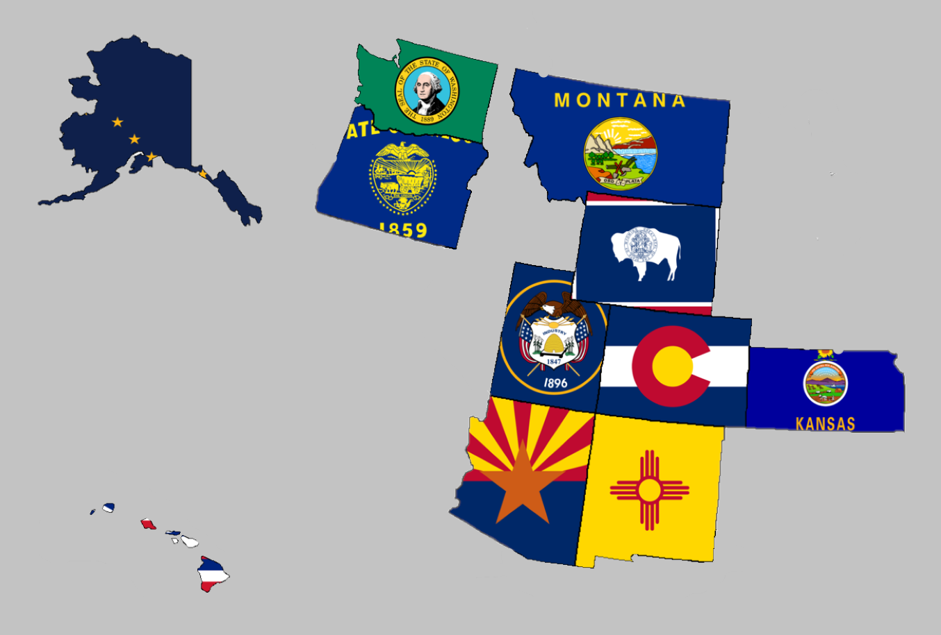

Regional Report for Region 1

Alaska, Arizona, Colorado, Hawaii, Kansas, Montana,

New Mexico, Oregon, Utah, Washington, and Wyoming

Libertarian National Committee Meeting  
July 27-28, 2019

**Region 1 Representative**

Mr. Richard Longstreth, Arizona

Libertarian National Committee

**T:** 931.538.9300 **E:** Richard.Longstreth@LP.org

**Region 1 Alternate**

Mr. Johnny “Rocket” Adams  
Libertarian National Committee

**T:** 253.625.3854 **E:** Johnny.Adams@lp.org

# Region 1 Overview/ Representative Report

As of the 2018 National Libertarian Convention in New Orleans, the eleven affiliates that comprise Region 1 are: Alaska, Arizona, Colorado, Hawaii, Kansas, Montana, New Mexico, Oregon, Utah, Washington, and Wyoming. At the Convention, Richard Longstreth, Arizona, was elected to serve as the Region 1 Representative and Craig Bowden, Utah, was elected to serve as the Region 1 Alternate. As of February 2019, Craig resigned his position and Johnny “Rocket” Adams filled his vacancy in April 2019. Both the Region 1 Representative and the Alternate positions will be re-elected at the 2020 National Libertarian Convention.

Due to the geographical nature of this region, spanning five time zones and extending from 19 to 71 degrees north latitude (some 3,000 x 3,000 miles), in-person contact between the Regional and Alternate Representatives and the individual affiliates will be infrequent. It is my intention to attend 2019/2020 affiliate conventions in each affiliate as feasible. Regular contact is attempted with the affiliates and members through email, telephone, a dedicated Facebook discussion group and page, and informational website. I make myself available by appointment as necessary whenever I am approached about scheduling some time to talk.

For the purposes of this report, State Chairs were emailed on July 2nd requesting updates/ goings on in their affiliates and convention recaps. Regular follow-up was done to remind State Chairs to submit a written report and encouraged them to schedule a time to talk if they preferred. While I did not receive a response from everyone, any responses I received will be reflected in the Region 1 Report. If a State Chair chose to not respond I have attempted to pull data from other sources to give a high-level overview of what is happening in the state. Contact information is supplied so that direct contact may be made by any member seeking any clarification directly from that specific State Chair.

Any updates or modifications to this report will occur at the next LNC meeting.

Activities of the Region 1 Representative since the last Quarterly Report:

* Facilitated applications, voting, and discussions among State Chairs to elect a new Region 1 Alternate. Appendix A contains summaries from each round of voting.
* Had several conversations with candidates, state chairs, and general membership in relation to plans for 2019 and 2020 elections.
* Answered and addressed questions about the National Party’s State CRM Project.
* Answered some questions from various media outlets in the last few months regarding a variety of topics.
* Submitted an article to the Libertarian Party of Colorado for their newsletter.
* Encouraged state chairs to submit to LP News.
* Began some social media work with the Launch Pad Media, a libertarian podcast network.
* Completed work with the Libertarian Party of Colorado’s Policy Manual Committee which aimed to create a policy manual for their board of directors.
* Spoke to members of libertarian media and heard their wishes to have presidential debates linked on the LP.org website. This has been submitted as an agenda item for our meeting.
* Discussed the idea of the LNC Chair becoming a paid fundraising contractor with several members of the LNC and Party.
* Attended the Libertarian Party of Colorao’s Annual Convention in Colorado Springs, CO.
* Attended the Libertarian Party of New Mexico’s Convention by electronically streaming in.
* Participated in regular meetings of the LNC’s Affiliate Support Committee. My focus on this committee is to develop a guide to help establish local county groups. I welcome any input from any state affiliate on tips that they have found to be successful.
* Stood in abstention to a resolution to censure Benjamin Leder.

I encourage all members to regularly review the Regional Agreement for Region 1 to keep myself and the Region 1 Alternate diligent to our duties. This agreement is what was put out as the expectation for us in terms of what you all wanted from leadership on the LNC. Follow the link below to a pdf version on Google Drive to review. If you have trouble with the link, please let me know.

[2018 REGIONAL AGREEMENT](https://drive.google.com/file/d/0B2iKd8j9elY0bE45alZwWmdDT2JmeUJEYmIyR3Q3VElFOFFN/view?usp=sharing)

Current and Past Membership Reports can be accessed at any time via a Google Drive folder. I have not edited these reports at all because I believe it is important to maintain our national perspective as individual affiliates, not just as Regional members. Please let me know if you have trouble or questions when accessing the link or any of the reports.

[MEMBERSHIP REPORTS](https://drive.google.com/drive/folders/1dzb_INbTAAcFHCr91sHKutbZKrScdKjp?usp=sharing)

Your Region 1 Representative,

Richard Longstreth

# Region 1 Alternate Report

No report was submitted at the time of preparing this document.

# Alaska



Chair: Jon Watts

Email: [jon.watts@alaskan.com](mailto:jon.watts@alaskan.com)

Phone: (907) 687-4884

Website: <http://www.alaskalp.org>

Facebook: <https://www.facebook.com/pg/AlaskaLiberty/>

From the Chair: Nothing submitted by the Chair for this report.

Requests to the LNC: No requests at this time. **Region 1 Representative Note: This state will need to earn ballot access prior to 2020.**

2019 Convention:

* According to the best information I’ve found, while discussing with local residents via social media, there will be no Convention in Alaska for 2019. If I am mistaken, please let me know as soon as possible.

# Arizona



Chair: Howard Blitz

Email: [chairman@azlp.org](mailto:chairman@azlp.org)

Phone: 833-THE-AZLP

Website: <https://www.azlp.org/>

Facebook: <https://www.facebook.com/LParizona/>

From the Chair:

“AZLP Goals:

1. Increase the number of registered voters as libertarians.

2. Raise funds to promote candidates.

3. Find Libertarians to run for office.

4. Communicate with libertarians and Libertarians on a regular basis to generate interest in the AZLP.

This is what AZLP is focusing on.”

Requests to the LNC: No requests at this time.

2019 Convention:

**The Regional Representative attended the Arizona Libertarian Party’s Convention in January 2019 in Phoenix, AZ. It was a wonderful event complete with a raffle, business, and guest speakers. Howard was re-elected as the chairman and one change was made to the Affiliate’s bylaws regarding how delegates will be elected for future National Conventions.**

# Colorado



Chair: Victoria Reynolds

Email: [statechair@lpcolorado.org](mailto:statechair@lpcolorado.org)

Phone: (720) 933-6900

Website: <https://www.lpcolorado.org/>

Facebook: <https://www.facebook.com/pg/lpcolorado/>

From the Chair:

“Colorado State Convention was held in April of this year and we elected several new board members, including a new state chairman.

Our last convention encountered difficulties when the board discharged the convention chair in February, but fortunately, Ms. Harlos was able to pick up the tasks at the last minute to provide a successful convention. To avoid having the same issues in the future, the bylaws were amended to give full responsibility for the annual conventions to the fundraising director who has already assembled a team that is working on the 2020 convention.

The new board has decided to continue to treat the LPCO as a professional organization and the political party that it was founded to be.

For this purpose, we have had a strategic planning session with members of the board and and we have continuing education planned in areas of messaging, fundraising and leadership.

We had Marc Goddard, our parliamentarian, teach a class on Roberts Rules of Order to the board and affiliate leadership or would be leaders, since we use them for our assemblies.

We have been present at several outreach events such as Cinco de Mayo, Pride Fest and Rally for Our Rights and have other events coming up. 

We've had several articles published and our goal is to publish at least four articles a month giving us visibility in the press.

The “Drinking and Shenanigans” fundraising & phone banking events continue to have good turnout and results.

Some things we would like to accomplish this year:

* Identify winnable races and concentrate efforts on those races without discounting line holder and education races.
* Work to get a full slate of candidates for 2020
* Several fundraiser events such as a fun shoot event, wine tastings and the possibility of a poker run
* Add 2 affiliates or development groups
* Get affiliates active in reaching out to their membership including selecting a membership person in each affiliate to perform this task.
* Work on issues, such as informing people about the danger of amendment CC as it is on the ballot to revoke the Taxpayers bill of rights from the Colorado Constitution.
* We will continue to work with Rally for Our Rights on stopping legislature from infringing even more on our right to defend ourselves.

In closing, the new board is energized in collaboration for a productive end goal at spreading our message. With the ever increasing importance of working to identify our strengths and capitalizing on those, while redirecting our weaknesses into great strengths, we feel confident that leadership is absolutely headed in the right direction! “

Requests to the LNC: No requests at this time.

2019 Convention:

**The Region 1 Representative attended this convention in April 2019. The convention went very well and was very professional. Highlights included several libertarian-leaning vendors, guest speakers, and business sessions, and a wonderful pie fundraiser for dessert. Unfortunately, I was unable to attend the second day, however, new leadership was elected and I am confident that they will continue to motivate and inspire libertarian ideals in Colorado.**

# Hawaii

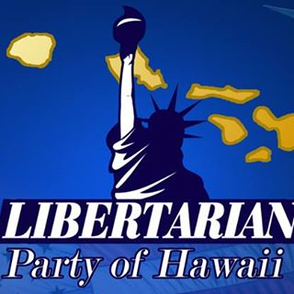

Chair: Tracy Ryan

Email: [tracyar@hawaiiantel.net](mailto:tracyar@hawaiiantel.net)

Phone: (808) 927-1126

Website: <http://www.libertarianpartyofhawaii.org>

Facebook: <https://www.facebook.com/pg/LibertarianPartyOfHawaii/>

From the Chair:

The Chair submitted a full page document listing some of the upcoming activities and movement in the Libertarian Party of Hawaii. That document can be linked by following [THIS LINK](https://drive.google.com/open?id=0B2iKd8j9elY0VllsdG83dHFJM09QNzAzZnZsamVMZHVYVVAw) to a Google Drive document.

Requests to the LNC: No requests at this time.

2019 Convention:

When: 9am – 5pm, November 23, 2019

Where: Ala Moana Hotel, 410 Atkinson Dr, Honolulu, HI 96814

Website: <https://www.libertarianpartyofhawaii.com/>

Notable Speakers: Larry Sharpe, Dr. Kyle Varner

**The Region 1 Representative does not have plans to attend in person due to costs, however, he does plan to attend remotely.**

# Kansas

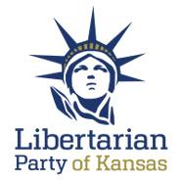

Chair: Ned Kelley

Email: [Chair@lpks.org](mailto:Chair@lpks.org) Alt Email: [ned.kelley1@gmail.com](mailto:ned.kelley1@gmail.com)

Phone: 816.810.5818

Website: <http://www.LPKS.org>

Facebook: <https://www.facebook.com/pg/KansasLP/>

From the Chair: Nothing submitted by the Chair for this report.

Requests to the LNC: No requests at this time.

2019 Convention:

**The state held their main convention in April 2019. The state also held a mini convention in July 2019. The Region Representative was unable to attend either of these events.**

# Montana

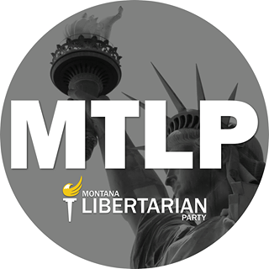

Chair: Sid Daoud

Email: [Sid.daoud@rspike.com](mailto:Sid.daoud@rspike.com)

Phone: 406.471.6723

Website: <https://www.mtlp.org/>

Facebook: <https://www.facebook.com/pg/MontanaLibertarianParty/>

From the Chair:

Nothing submitted by the Chair for this report. There is a high likelihood that I will have an update at our meeting.

Requests to the LNC: No Requests at this time.

2019 Convention:

**The Region Representative was unable to attend this convention in June 2019.**

# New Mexico



Chair: Chris Luchini

Email: [chair@lpnm.us](mailto:chair@lpnm.us)

Phone: 888-LPNM-NOW

Website: <https://lpnm.us/>

Facebook: <https://www.facebook.com/LPNewMexico/>

From the Chair:

“Since April we have treated three more county affiliates, with the hope that after the next three or four months we have a stable nucleus of people meeting once a month with the goal of increasing membership and assisting candidates for November of 19 elections.

We have started a three touch direct mail campaign with non-profit status through the US postal service. Our costs are about $0.185 per business class envelope and single sided black and white letter. Initial results show that first touch first letter gets virtually no response but the second one is about 6% this is for in-reach to people newly registered as libertarians.

We are attempted to find a source of funds to do [outreach] to people who had been registered as D's or RS and switch to no party.”

Requests to the LNC: No requests at this time.

2019 Convention:

When: March 22-23, 2019

Where: UNM School of Law, 1117 Stanford NE MSC11 6070, 1 University of New Mexico, Room 2401, Albuquerque, NM 87131-0001

Website: <https://lpnm.us/2019-convention/>

Notable Speakers: Jeff Hewitt, Elected Official, California

**The Region 1 Representative was only able to attend this convention remotely. Overall, it looked to be a success and the party seems to be doing well.**

# Oregon

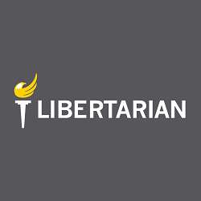

Chair: Timothy Perkins

Email: [chair@lporegon.org](mailto:chair@lporegon.org)

Phone:

Website: <https://lporegon.org/>

Facebook: <https://www.facebook.com/pg/LibertarianPartyOfOregon/>

From the Chair:

Nothing submitted by the Chair for this report.

Requests to the LNC: No requests at this time.

2019 Convention:

**The Region Representative was unable to attend this convention in June 2019.**

# Utah

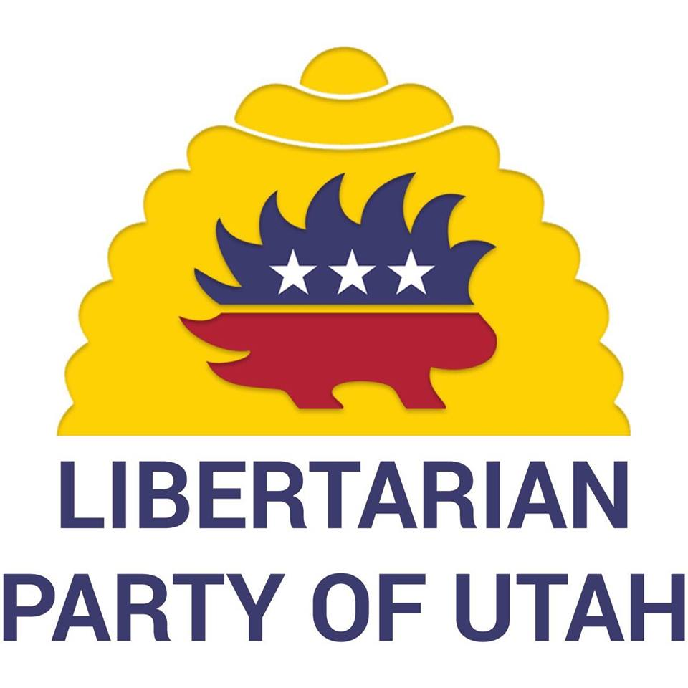

Chair: Amber Beltran

Email: [chair@libertarianutah.org](mailto:chair@libertarianutah.org)

Phone: 801.613.8034

Website: <http://www.libertarianutah.org/>

Facebook: <https://www.facebook.com/lputah/>

From Utah State Chair:

“We completed a [[Halloween in Summer] outreach booth](https://drive.google.com/open?id=0B2iKd8j9elY0Nkt3MEpMeDA0dExRSFctQ295cWczOHRYMFdR) in June.

We have a Pride event in August and two primaries in municipal races, [which] will provide more for me to update for August.”

Requests to the LNC: No requests at this time.

2019 Convention:

**The Region Representative was unable to attend this convention in April 2019.**

# Washington

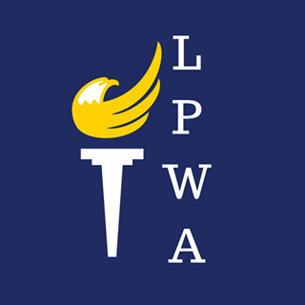

Chair: Randy McGlenn

Email: [info@lpwa.org](mailto:info@lpwa.org)

Website: <https://lpwa.org/>

Facebook: <https://www.facebook.com/pg/libertarianpartyofWA/>

From the Chair:

Nothing submitted by the State Chair for this report.

Requests to the LNC: No requests at this time.

2019 Convention:

**The Region 1 Representative was unable to attend this convention in March 2019.**

# Wyoming

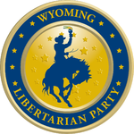

Chair: Shawn Johnson

Email: [shjohnson310@hotmail.com](mailto:shjohnson310@hotmail.com)

Website: <https://lpwy.org/>

Facebook: <https://www.facebook.com/libertariansWY/>

From the Chair:

“At our last state convention, we elected new leadership. I was elected as the party chair, Richard Brubaker was elected as vice chair, Tammy Porambo was elected as treasurer, Joe Porambo was elected as executive director.

We now have Bethany Baldes set up to start taking donations to her campaign for the Wyoming state legislature next election cycle. As you remember, she ran a very successful campaign last time and almost won. The Fremont County Party has been officially established and Bethany is the Chair of that County party. We are working on getting Natrona County set up next. Once Natrona County is official, myself and Joe Porambo will fill in as chair and vice chair respectively until we can get someone else. I do have a couple prospects in mind one of whom is running for a local nonpartisan office next election.

We are working with Apollo Pazell on getting everything set up for Natrona County as far as finance is concerned so we can start accepting donations to the county party. He is also instrumental in helping me since I’m new to the party and my position and I call on him for advice in whatever i have questions about. He had been a huge help for all of us in Wyoming.

We are still in infancy in some things but we’re moving right along rather quickly. We are excited in Wyoming for 2020 with Bethany running again for her house seat and I will also be running for my house seat. There is real potential for 2 libertarians to be elected to the Wyoming house.

We have an executive committee meeting on 7/22/19 and we will be discussing what we’ve accomplished since the convention as well as where we need to go next.”

Requests to the LNC: No requests at this time.

2019 Convention:

**The Regional Representative was unable to attend this Convention in March 2019.**

# Appendix A - Region 1 Alternate Election

In February 2019, Craig Bowden resigned his seat as Region 1 Alternate for personal reasons. Per the Regional Agreement, the state chairs were asked to elect a new alternate. It was determined that the best process would be to solicit applications and then operate elections based on the rules of approval voting. Several round were conducted and Johnny “Rocket” Adams from Arizona ultimately won the seat. Below are the results of each ballot. Unfortunately, the ballots themselves were deleted by the third party website. If any member retained these documents, I would appreciate you reaching out and sharing them with me so that I may maintain a complete record of the election.

==========

Round 1 contained all applicants and occurred between March 17, 2019 at 12:00 am HST and ended March 31, 2019 at 23:59 HST. This voting period was intentionally long to give state chairs time to talk with each candidate and thoroughly review their applications.

==========

Region 1 Alternate Election – Round 1 Results

There are 10 candidates competing for 1 seats. The number of voters is 11 and there were 7 valid votes.

Votes were submitted by: AZ, CO, KS, MT, NM, OR, WA

Missing ballots: AK*, HI, UT, WY

Counting votes using Approval Voting.

Candidate | Count

===============================

Adams, Johnny (AZ) | 3

Burke, Richard (OR) | 0

Daniels, Jeff (AZ) | 1

Dunn, A. Blair (NM) | 1

Layda, Drew (OR) | 4

McFarland, Michael (AZ) | 3

Mulder, Eric (CO) | 0

Olivi, Jim (AZ) | 0

Treibert, James (CO) | 0

None of the Above | 0

Count of all approvals.

* Alaska’s vote was submitted by email, not the agreed to medium. Had their vote counted, Johnny Adams would have received 4 votes.

==========

Because a majority of state chairs (6) did not elect any of the candidates, the State Chairs proceeded to a second ballot. For the next ballot, all applicants who did not receive any votes in round one were removed. The new ballot was available for one week beginning on April 2nd at 12:01 HST and ended April 9 at 23:59 HST.

==========

Region 1 Alternate Election - Round 2

There are 6 candidates competing for 1 seats. The number of voters is 11 and there were 9 valid votes.

Votes were submitted by: AK, AZ, CO, HI, KS, MT, NM, OR, WA

Missing ballots: UT, WY

Counting votes using Approval Voting.

Candidate | Count

===============================

Adams, Johnny (AZ) | 5

Daniels, Jeff (AZ) | 2

Dunn, A. Blair (NM) | 1

Layda, Drew (OR) | 4

McFarland, Michael (AZ) | 2

None of the Above | 1

Count of all approvals.

==========

Because a majority of state chairs (6) did not elect any of the candidates, the State Chairs proceeded to a third ballot. For the next ballot, only the top two vote receivers were retained for a runoff. The new ballot was available for one week beginning on April 11, 2019 at 12:01 HST and ended April 18, 2019 at 23:59 HST.

==========

Region 1 Alternate Election - Round 3

There are 3 candidates competing for 1 seats. The number of voters is 11 and there were 10 valid votes.

Votes were submitted by: AK, AZ, CO, HI, KS, MT, NM, OR, UT, WA

Missing ballots: WY

Counting votes using Plurality.

Candidate | Count

==========================

Adams, Johnny (AZ) | 5

Layda, Drew (OR) | 5

None of the Above | 0

Count of all votes.

==========

Because a majority of state chairs (6) did not elect any of the candidates, the State Chairs proceeded to a fourth ballot. For the next ballot, the same two candidates were available. A conference call was created and available for all of the state chairs to interview candidates prior to the ballot expiration. Of the 11 states, only Utah, Washington, Alaska, and Oregon attended the call. The new ballot was available for four days beginning on April 22, 2019 at 12:01 HST and ended April 25, 2019 at 23:59 HST.

==========

Region 1 Alternate Election - Round 4

There are 3 candidates competing for 1 seats. The number of voters is 11 and there were 10 valid votes.

Votes were submitted by: AK, AZ, CO, HI, KS, MT, NM, OR, UT, WA

Missing ballots: WY

Counting votes using Plurality.

Candidate | Count

==========================

Adams, Johnny (AZ) | 6

Layda, Drew (OR) | 4

None of the Above | 0

Winner is Adams, Johnny (AZ).

==========

Johnny Adams was elected to fulfill the role as the Alternate until the 2020 Convention in Austin. I am very confident in his abilities to help me and you all advance our Region.