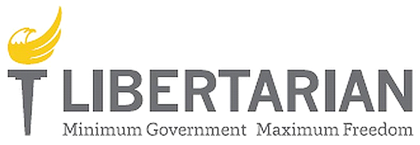

**Region 8 Report**

*Submitted on 7.24.2019 by Regional Representative Justin O'Donnell*

**Regional Representative:**  Justin O’Donnell

**Regional Alternate:** Jeff Lyons

Notable events from Affiliates are reported below.

**Massachusetts:** The Libertarian Party of Massachusetts held its annual convention in Somerville Massachusetts, and elected a New State Committee, led by newly elected chair Marc Mercier. They also hosted several candidates for the LP Presidential Nomination to partake in a debate prior to the convention, which was live streamed on facebook, and is currently in post production to be published as a High Quality video debate highlighting the Candidates.

**New Hampshire:** The Libertarian Party of New Hampshire has announced that they will be self funding and hosting their own Presidential Preference Primary, to run in conjunction with the First in the Nation Primary events run on behalf of the Republican and Democratic parties by the Secretary of State in New Hampshire. There will be a $25 filing fee for placement on the ballot of Candidates in the Libertarian Primary, as opposed to the $1000 filing fee charged by the state. Ballots will be conducted by mail, and be made available to any resident in New Hampshire who would be eligible to serve as a Libertarian Party Delegate, through membership in either the National or State Party.

**Maine:** The Libertarian Party of Maine is scheduling a candidate training with LNC Candidate support staff on the weekend of September 14th, and plan to begin organizing active campaigns for 2020, including a renewed voter registration drive to secure ballot access for the 2020 Election.

**New York:** The Libertarian Party of New York is continuing to build off successes in 2018, by leveraging the infrastructure built by the Sharpe campaign, with the assistance and lead of Larry Sharpe and his campaign staff, to organize affiliates in the remaining counties of New York. At their last convention, the party adopted drastic changes to their bylaws, in order to come into compliance with NYS Election Law, and regulations imposed by the Board of Elections. Registrations continue to grow for LPNY, and the party aims to continue capitalizing on momentum from 2018, and build towards more growth and success in 2020.   
Notably, the Duane Whitmer Campaign for US Congress in NY27 is utilizing tools, resources, and staff from 2018 to build a groundbreaking campaign in Western NY, Duane having committed $35,000 of personal funds to compliment fundraising already.

**New Jersey:** 2019 is an election year for the Libertarian Party of New Jersey. Ballot access requirements for partisan Libertarian candidates in New Jersey are relatively simple, and there are multiple candidates seeking office this year, including Jeff Hetrick for State Assembly, and a number of Candidates for city and municipal offices.