Libertarian National Committee

Region 1 Report

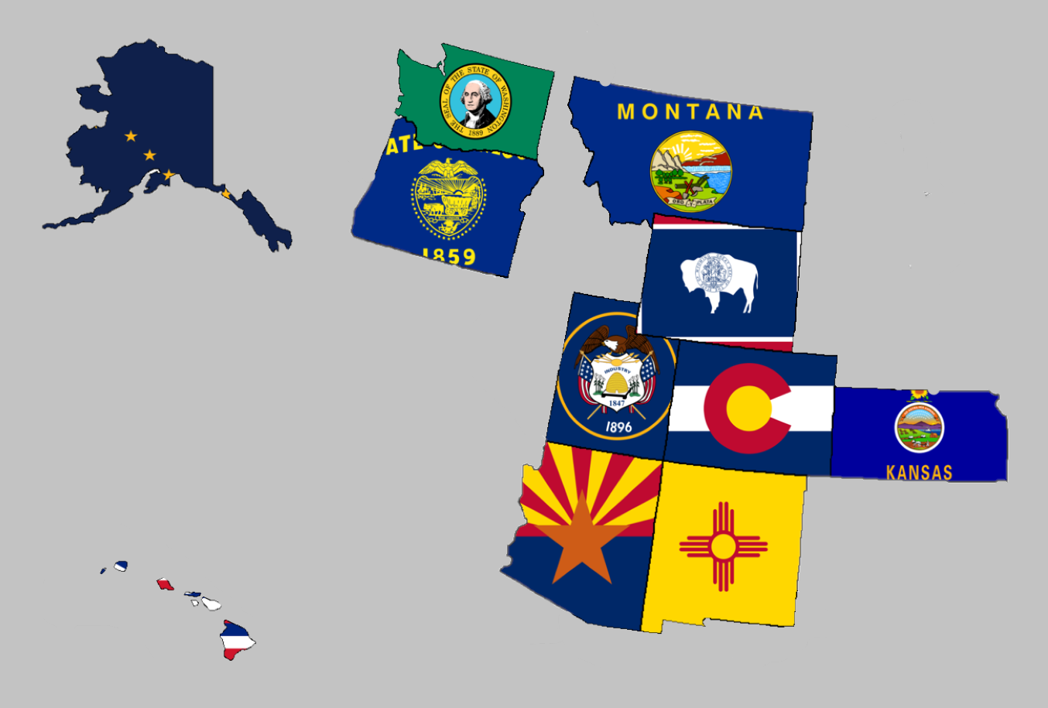

Regional Report for Region 1

Alaska, Arizona, Colorado, Hawaii, Kansas, Montana,

New Mexico, Oregon, Utah, Washington, and Wyoming

Libertarian National Committee Meeting  
November 16-17, 2019

**Region 1 Representative**

Mr. Richard Longstreth, Arizona

Libertarian National Committee

**T:** 931.538.9300 **E:** Richard.Longstreth@LP.org

**Region 1 Alternate**

Mr. Johnny “Rocket” Adams  
Libertarian National Committee

**T:** 253.625.3854 **E:** Johnny.Adams@lp.org

# Region 1 Overview/ Representative Report

As of the 2018 National Libertarian Convention in New Orleans, the eleven affiliates that comprise Region 1 are: Alaska, Arizona, Colorado, Hawaii, Kansas, Montana, New Mexico, Oregon, Utah, Washington, and Wyoming. At the Convention, Richard Longstreth, Arizona, was elected to serve as the Region 1 Representative and Craig Bowden, Utah, was elected to serve as the Region 1 Alternate. As of February 2019, Craig resigned his position and an application process is in place to fill his vacancy. Both the Region 1 Representative and the Alternate will be re-elected at the 2020 National Libertarian Convention.

Due to the geographical nature of this region, spanning five time zones and extending from 19 to 71 degrees north latitude (some 3,000 x 3,000 miles), in-person contact between the Regional and Alternate Representatives and the individual affiliates will be infrequent. It is my intention to attend 2019/2020 affiliate conventions in each affiliate. Regular contact is attempted with the affiliates and members through email, telephone, a dedicated Facebook discussion group and page, and informational website. There is also a chat group open for quick communications between the Regional Representatives and the Chairs of each state. I make myself available by appointment as necessary whenever I am approached about scheduling some time to talk.

For the purposes of this report, State Chairs were emailed on October 20th requesting convention information, goals, and any other updates/ goings on in their affiliates. Regular follow-up was done to remind State Chairs to submit a written report and encouraged them to schedule a time to talk if they preferred. Reminders were sent out on October 31st and November 8. While I did not receive a response from everyone, any responses I received will be reflected in the Region 1 Report. If a State Chair chose to not respond I have attempted to pull data from other sources to give a high-level overview of what is happening in the state. Contact information is supplied so that direct contact may be made by any member seeking any clarification directly from that specific State Chair.

Any updates or modifications to this report will occur at the next LNC meeting.

Activities of the Region 1 Representative since the last Quarterly Report:

* Had several conversations with candidates, state chairs, and general membership in relation to plans for 2019 and 2020 elections. There is a lot of interest in local elections especially given the presidential election year in 2020. I am encouraging people to really focus on local elections were possible as this helps build a stronger ground game for the future.
* Answered and addressed questions about the National Party’s State CRM Project.
* Participated in the following committees for the Libertarian National Party:
  + Affiliate Support Committee
  + Candidate Support Committee
  + Bylaws and Rules Committee
* Participated in LNC E-Meeting on October 26, 2019. The purpose of the meeting was to elect the Bylaws and Rules Committee members. The members elected were as follows:
  + 2020 National Bylaws & Rules Committee (alphabetical by last name):
    - Joe Bishop-Henchman (DC)
    - Andy Craig (MD/AR/WI)
    - Cris Crawford (MA)
    - Richard Longstreth (AZ)
    - Alicia Mattson (CA)
    - Chuck Moulton (PA)
    - Kenneth Brent Olsen (CA)
    - Mark Rutherford (IN) (interim chair)
    - Paige Sexton (TN)
    - Chris Thrasher (RI)
  + Alternates (in ranked order):
    - Chris Wiest (KY)
    - David Blau (MA)
    - Alex DiBenedetto (AZ)
    - Shawn Levasseur (ME)
* Reminded State Chairs and General Membership that October 31, 2019 is the cutoff on national membership numbers to count for delegate allocation and National Convention related committee seat determinations. Each state did their part to push for more members. Colorado specifically had an impressive gain of more than 30 members in the month of October.
* Attended the Frontier Summit in Cheyenne, WY where I witnessed impressive candidate training hosted by Bethany Baldes (WY) and Libertarian Party Contractor Apollo Pazell.
* Introduced a member submitted resolution regarding balancing the budget. The resolution did not receive enough cosponsors.
* Asked questions, along with several peers, from concerned party members of our National Chair. The email exchange can be found [HERE](http://hq.lp.org/pipermail/lnc-business/2019/055348.html) and links to original letters with questions.

I encourage all members to regularly review the Regional Agreement for Region 1 to keep myself and the Region 1 Alternate diligent to our duties. This agreement is what was put out as the expectation for us in terms of what you all wanted from leadership on the LNC. Follow the link below to a pdf version on Google Drive to review. If you have trouble with the link, please let me know.

I will be working with the State Chairs in the next several months to finalize the 2020 Regional Agreement. All suggestions are encouraged and it is my sincere hope to have this complete well before the 2020 National Convention in Austin, TX.

[2018 REGIONAL AGREEMENT](https://drive.google.com/file/d/0B2iKd8j9elY0bE45alZwWmdDT2JmeUJEYmIyR3Q3VElFOFFN/view?usp=sharing)

Current and Past Membership Reports can be accessed at any time via a Google Drive folder. I have not edited these reports at all because I believe it is important to maintain our national perspective as individual affiliates, not just as Regional members. Please let me know if you have trouble or questions when accessing the link or any of the reports.

[MEMBERSHIP REPORTS](https://drive.google.com/drive/folders/1dzb_INbTAAcFHCr91sHKutbZKrScdKjp?usp=sharing)

Your Region 1 Representative,

Richard Longstreth

# Region 1 Alternate Report

No report was submitted by the Region 1 Alternate.

# Alaska



Chair: Jon Watts

Email: [joelhadley907@gmail.com](mailto:joelhadley907@gmail.com)

Phone: (907) 687-4884

Website: <http://www.alaskalp.org>

Facebook: <https://www.facebook.com/pg/AlaskaLiberty/>

From the Chair: Nothing submitted by the Chair for this report.

Requests to the LNC: No requests at this time. **Region 1 Representative Note: This state will need to earn ballot access prior to 2020.**

2020 Convention:

TBD

# Arizona



Chair: Howard Blitz

Email: [chairman@azlp.org](mailto:chairman@azlp.org)

Phone: 833-THE-AZLP

Website: <https://www.azlp.org/>

Facebook: <https://www.facebook.com/LParizona/>

From the Chair:

“Arizona libertarians make up about .85% of all the registered voters in the state.

Unfortunately, Yuma County did not meet the threshold of .67% of all registered voters in the county in order to run candidates for the 2020 election cycle. The Recorders office is researching the question on whether when Yuma County meets that threshold that it will have ballot access in the next election cycle of 2022.

The AZLP was represented recently in the AZ Clean Elections Commission conference October 26, 2019 where the state chairs of the Republican, Democrat, Green, and Libertarian Party sat on a panel fielding questions about their respective parties, the impact they will have on the 2020 election, how independents fit into the mix, and other topics. About 70 people are in the audience.

Several county affiliates participated in fairs and other events to do outreach to communities trying to get individuals to register to vote as libertarians.

The thrust of the AZLP, though, so far has been to develop communication with the 32,000 plus libertarians around the state by developing a newsletter called "48th and Liberty". There is a mass email list setup that is trying to be enlarged. However, AZLP is trying to get on the CRM put out by LNC.

AZLP is also planning its State Convention for January 25, 2020 at the Sea of Glass Center for the Arts in Tucson, AZ from 8am - 5:30 pm. The program for the convention includes a business meeting with possible changes to bylaws and platform and hearing committee reports along with three major speakers, a presidential candidate debate, and the selection of delegates to the National Convention in Austin, May 21-25, 2020.”

Requests to the LNC: The AZLP may need assistance with the CRM project. If contact has not already happened, I will attempt to facilitate this weekend.

2020 Convention:

When: January 25, 2020 (8-530)

Where: The Sea of Glass Center for the Arts, 332 E 7th St, Tucson, AZ 85705

Pending Agenda: Accessible via Google Drive [LINK](https://drive.google.com/file/d/0B2iKd8j9elY0MlBxdmt0MXVsTk1zRWNFUUhHOENTNzZadklF/view?usp=sharing)

Further Details TBD

# Colorado



Chair: Victoria Reynolds

Email: [statechair@lpcolorado.org](mailto:statechair@lpcolorado.org)

Phone: (720) 933-6900

Website: <https://www.lpcolorado.org/>

Facebook: <https://www.facebook.com/pg/lpcolorado/>

From the Chair:

“October was an exceptional month for the LPCO with over $6,000 raised and national membership increased to over 500 thanks to an incredible donation of money and resources by Joe Johnson and Bette Rose Ryan. They graciously provided the resources and path for the LPCO to utilize a marketing firm to reach out to Libertarians across the state. Oftentimes, it is difficult to know the benefits of an endeavor like this for months to come, but if the early results are any indication, the LPCO will receive residual benefits from this for years to come. We would also like to thank the national party for assisting in this effort.

To start our November, Kevin Gulbranson and Michele Poague graciously hosted another event at their home where we brought together Libertarian volunteers to make convention sales calls. On top of having a productive evening, we also had a fun party afterwards where we raised over $350.00. A special thanks to donors, volunteers, and attendees.

At the ballot box, Proposition CC failed, proving once again that despite having many elected Democrats, Colorado remains an anti-tax state. We also are proud to report that Craig Hurst was re-elected to the Commerce City Council following an appointment in May. Congratulations to Craig Hurst and Paul James for winning their respective elections!!!”

Ms. Reynolds also provided a link to Colorado’s most recent newsletter: [Colorado Liberty](https://drive.google.com/file/d/0B2iKd8j9elY0ZnRyMWd1SVZ6Vy00Mjk5XzZ3S1FfdHJvN0tJ/view?usp=sharing)

Requests to the LNC: No requests at this time.

2020 Convention:

TBD

# Hawaii

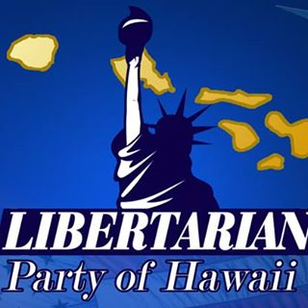

Chair: Tracy Ryan

Email: [tracyar@hawaiiantel.net](mailto:tracyar@hawaiiantel.net)

Phone: (808) 927-1126

Website: <http://www.libertarianpartyofhawaii.org>

Facebook: <https://www.facebook.com/pg/LibertarianPartyOfHawaii/>

From the Chair: Nothing submitted by the Chair for this report.

Requests to the LNC: No requests at this time.

2019 Convention:

When: 9am – 5pm, November 23, 2019

Where: Ala Moana Hotel, 410 Atkinson Dr, Honolulu, HI 96814

Website: https://www.libertarianpartyofhawaii.com/

Notable Speakers: Larry Sharpe, Dr. Kyle Varner

2020 Convention

TBD

# Kansas

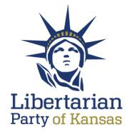

Chair: Ned Kelley

Email: [Chair@lpks.org](mailto:Chair@lpks.org) Alt Email: [ned.kelley1@gmail.com](mailto:ned.kelley1@gmail.com)

Phone: (816) 810-5818

Website: <http://www.LPKS.org>

Facebook: <https://www.facebook.com/pg/KansasLP/>

From the Chair: Nothing submitted by the Chair for this report.

Requests to the LNC: No requests at this time.

2020 Convention:

When: April 18, 2020

Further Details TBD

# Montana

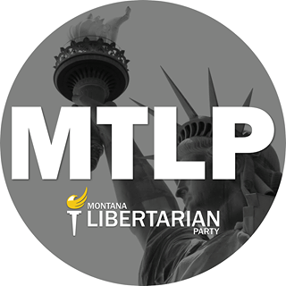

Chair: Sid Daoud

Email: [Chair@mtlp.org](mailto:Chair@mtlp.org) Alt. Email: [Sid.daoud@rspike.com](mailto:Sid.daoud@rspike.com)

Phone: (406) 471-6723

Website: <https://www.mtlp.org/>

Facebook: <https://www.facebook.com/pg/MontanaLibertarianParty/>

From the Chair: Nothing submitted by the Chair for this report.

Requests to the LNC: No Requests at this time.

2020 Convention:

When: February 22, 2020

Further Details TBD

# New Mexico



Chair: Chris Luchini

Email: [chair@lpnm.us](mailto:chair@lpnm.us)

Phone: 888-LPNM-NOW

Website: <https://lpnm.us/>

Facebook: <https://www.facebook.com/LPNewMexico/>

From the Chair:

“We elected 5 out of 9 candidates for non-partisan office, including Robin Dunn, someone who is of strategic importance to the national LP.”

[Election Results](https://drive.google.com/file/d/0B2iKd8j9elY0X2lJc3pKMFFONi1MMmY3bnlyRmEyWlE2eUFv/view?usp=sharing)

Requests to the LNC: No requests at this time.

2020 Convention:

TBD

# Oregon

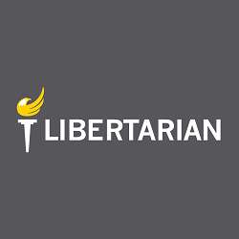

Chair: Timothy Perkins

Email: [chair@lporegon.org](mailto:chair@lporegon.org)

Website: <https://lporegon.org/>

Facebook: <https://www.facebook.com/pg/LibertarianPartyOfOregon/>

From the Chair: Nothing submitted by the Chair for this report.

Requests to the LNC: No requests at this time.

2020 Convention:

TBD

# Utah

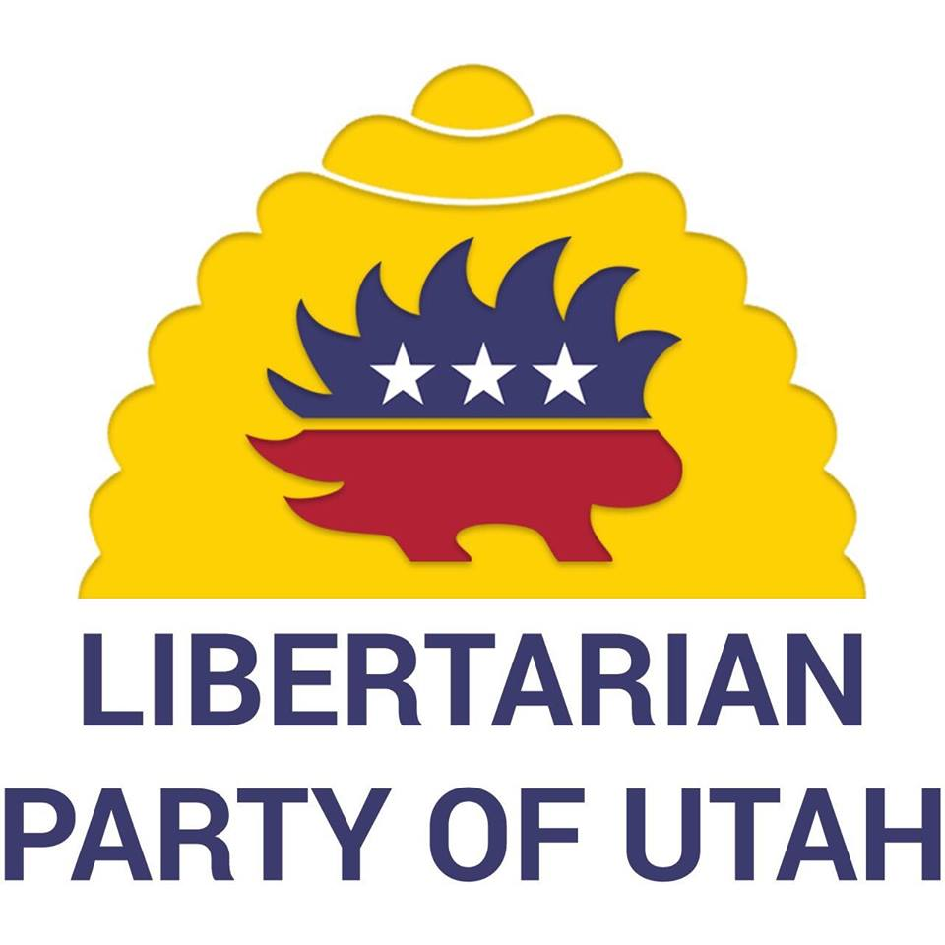

Chair: Amber Beltran

Email: [chair@libertarianutah.org](mailto:chair@libertarianutah.org)

Phone: (801) 613-8034

Website: <http://www.libertarianutah.org/>

Facebook: <https://www.facebook.com/lputah/>

From Utah State Chair:

“2019 Election news: Utah had 5 Candidates run in municipal races. We had one win, Tessa Stitzer. She will be serving on Copperton City Council.

Recruitment for 2020 State Legislature races have begun. We learned that more volunteers are needed to help. We did a big push through social media advertising and direct emails to lapsed members to increase our membership prior to October 31 st. We had 13 new members officially join the UTLP. We are excited to see how many new registered LP voters we have in Utah.

Utah Chair, Amber Christiansen Beltran, attended the Frontier Summit in Cheyenne, Wyoming over Labor Day weekend.

UTLP had a booth at Provo Pride in September.

Had several new attendees at our Open Executive Committee meeting in September. Individuals who were interested in learning more and willing to share their insights. We discussed the location of our upcoming convention and the desire to hold additional fundraiser/camaraderie building events.

2020 Convention will be held April 25 th in Ogden, Utah.”

Requests to the LNC: No requests at this time.

2020 Convention:

When: April 25, 2020

Where: Ogden, UT

# Washington



Chair: Randy McGlenn

Email: [info@lpwa.org](mailto:info@lpwa.org)

Website: <https://lpwa.org/>

Facebook: <https://www.facebook.com/pg/libertarianpartyofWA/>

From the Chair: Nothing submitted by the Chair for this report.

Requests to the LNC: No requests at this time.

2020 Convention:

TBD

# Wyoming

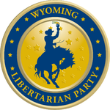

Chair: Shawn Johnson

Email: [shjohnson310@hotmail.com](mailto:shjohnson310@hotmail.com)

Website: <https://lpwy.org/>

Facebook: <https://www.facebook.com/libertariansWY/>

From the Chair: Nothing submitted by the Chair for this report.

Requests to the LNC: No requests at this time.

2020 Convention:

TBD