Libertarian National Committee

Region 7

*Region Representative - Whitney Bilyeu*

*Region Alternate - Erin Adams*

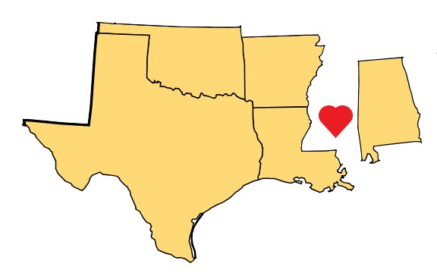

November 16-17, 2019

MIAMI, FL

### ALABAMA - **Laura Lane**

#### STATE ORGANIZATION

* + - Elijah Boyd - Vice Chair; Paul Frankel - Secretary; Scott Hammond - Treasurer; Noah Rhys - Region 1; Scott Neighbors - Region 2; Ash Jennings - Region 3; Anthony Peebles - Region 4; Frank Dillman - At-Large; Richard Fast - At-Large

#### MEMBERSHIP

* + - We have approximately 200 national members, and a little over 100 state party members, with some overlap. Paul Frankel is in the process of clearing up the membership records to show both membership types where applicable.

#### COUNTY NEWS

* + - Lee County affiliated on 11/6, and a few others are in the works. There are a few other county affiliates active to various extents.

#### ELECTIONS

* + - We had one write-in candidate in a special election on 11/5 - Doug Ward. While this campaign had a lot of potential, in the end the state screwed us out of ballot access, and the write-in campaign was not nearly as active as we had hoped. We learned a lot from the campaign, and plan to build on efforts in that area, applying what we learned to future elections. We are recruiting 2020 candidates now.

#### BALLOT ACCESS

* + - Very concerned. Our ballot access laws are the worst of the worst, and a major inhibitor to our growth and survival as a state party.

#### EVENTS

* + - We had a gun range day - shooting competition in October, which we hope will become an annual event.
    - We continue working on plans for ballot access and other lobbying opportunities.

#### FINANCE/FUNDRAISING

* + - We recently did a snail mail fundraising letter for the first time in a long while, with the help of an LP volunteer from a nearby state. I'm working on getting commission folks or volunteers to follow up with phone calls.

#### IT

* + - Continuing to work to learn our new national website and CRM back end and integrate it into our operations.

#### MEDIA

* + - The State Chair, Laura Lane, co-authored an article about the proposed Mobile Bay toll bridge project, which may have been instrumental in killing that massive boondoggle.
    - Our write-in candidate got a nice article in his local newspaper the day before the election.

#### OTHER

* + - Our state party has had success with Facebook video ads, which have been shared by many other pages, and adopted by other state parties and candidates.

### ARKANSAS - **Michael Pakko**

#### STATE ORGANIZATION

* + - William Brackeen resigned as Second District Rep to the Executive Committee and moved to Ohio. Chris Stephens has filled the spot.

#### STATE LEVEL MEMBERSHIP

* + - Dues-paying state party membership is up from 85 to 89 since February. National membership has declined over the same period, but may come back up with the October push.

#### ELECTIONS

* + - Candidates needed to file during a "party filing period" Nov 4-12. We held a statewide preliminary nominating convention, and selected 13 candidates. All will have filed by Nov 12. Candidates include U.S. Senate, two (2) U.S. House, four (4) State House, and five (5) county-level offices.

#### BALLOT ACCESS

* + - We have ballot access under an injunction from a federal court. The state is appealing that injunction. The case will be heard by the 8th Circuit Court of Appeals on December 11.

#### FINANCE & FUNDRAISING

* + - Funds are back to normal after a costly fundraising/ballot access surge.

#### EVENTS

* + - Annual Convention - February 22, 2020….Details to come.

#### MEDIA

* + - Our declared Senate Candidate, Ricky Harrington, Jr., received good media coverage of his announcement. The political news media did brief introduction articles about him, and he appeared in a segment of a local Sunday morning news show.
    - A reporter did cover our convention, for Arkansas Talk Business & Politics.

### LOUISIANA - **Rufus Craig**

#### STATE ORGANIZATION

* + - Michael Dodd - VC; Shannon Thomas - Secretary; Matt Fotsch - Treasurer; Marcel Graugnard - Membership Coordinator; Eric Hailar - Elections Officer; Keith Thompson - Communications Officer

#### MEDIA

* + - Rufus Craig, the Chairman, was featured in an article in The Advocate related to his run for Senate District 6:
      * <https://www.theadvocate.com/baton_rouge/news/politics/elections/article_f8acd766-e0e6-11e9-a5f0-eb1b82468751.html>

### OKLAHOMA - **Chad Williams**

#### STATE ORGANIZATION

* + - Kevin Hobbie - Vice Chair; Cherise Norton - Secretary; Treasurer - Vacant. We are looking to nominate an interim until one can be elected at convention.

#### ELECTIONS

* + - We have 3 Libertarians currently in office, and one running for Bethany City Council Ward 1 with an election on November 12. Indications suggest our candidate is in the lead.

#### BALLOT ACCESS

* + - We are secure until 2022.

#### COUNTY NEWS

* + - We will be voting to approve the charter of Canadian Co on Nov 17th.

#### MEMBERSHIP

* + - We have 12 Lifetime Members, 49 current members, and 58 lapsed members.

#### FINANCE/FUNDRAISING

* + - Fundraising has been lower than expected. Regional activity has been down this year causing lower interest.

#### EVENTS

* + - North Central Region is planning to do an Adopt-A-Highway program for passive outreach.

#### INFORMATION TECHNOLOGY

* + - We have increased the amount and frequency of content being uploaded to our website, and our social media is very active.

### TEXAS - **John Wilford**

#### STATE ORGANIZATION

* + - Treasurer - Cassie Villela, Vice Chair - Steven Harris, Secretary - Gary Johnson

#### COUNTY NEWS

* + - Affiliating new counties all the time.

#### ELECTIONS

* + - Texas voters passed a Constitutional Amendment to prohibit state income tax.

#### EVENTS

* + - LPTexas will hold its 2020 convention April 17 - 19
      * McAllen Convention Center - McAllen, TX

#### BALLOT ACCESS

* + - We recently had a hearing in federal court over the preliminary injunction on the new candidate filing fees for third parties in Texas, as well as the state’s motion to dismiss. We are awaiting rulings on those two matters.
    - A separate lawsuit was filed in Harris County by individual prospective candidates and voters, which also targets the candidate filing fees recently instituted by the state.