
MEETING MINUTES
LIBERTARIAN NATIONAL COMMITTEE
NOVEMBER 16-17, 2019
MIAMI, FLORIDA

current status: | DRAFT
version #: | 4
LAST REVISION DATE: | 1/5/20
APPROVAL DATE: | XXXX

PREPARED BY CARYN ANN HARLOS, LNC SECRETARY

TABLE OF CONTENTS

OPENING CEREMONY 6
CALL TO ORDER 6
OPPORTUNITY FOR PUBLIC COMMENT 6
HOUSEKEEPING 6
ATTENDANCE 6
CREDENTIALS AND PAPERWORK CHECK 6
ADOPTION OF THE AGENDA 7
REPORT OF POTENTIAL CONFLICTS OF INTEREST 11
OFFICER REPORTS 11
CHAIR’S REPORT 11
VICE-CHAIR’S REPORT (STRUCK FROM AGENDA) 12
TREASURER’S REPORT 12
POLICY MANUAL AMENDMENT 12
PROSPECTIVE 2022 CONVENTION SITE PRESENTATIONS 13
RENO PRESENTATION 13
REPORTS OF STANDING COMMITTEES 13
AUDIT COMMITTEE 13
STAFF REPORTS 13
EXECUTIVE SESSION 14
SPECIAL COUNSEL’S REPORT 15
PROSPECTIVE 2022 CONVENTION SITE PRESENTATIONS CONT’D 15
INDIANAPOLIS PRESENTATION 15
MOTIONS ARISING OUT OF EXECUTIVE SESSION 16
REPORTS OF STANDING COMMITTEES 17
AFFILIATE SUPPORT COMMITTEE 17
PROSPECTIVE 2024 CONVENTION SITE PRESENTATION 17
DC HILTON PRESENTATION 17
REPORTS OF STANDING COMMITTEES CONT’D 17
CANDIDATE SUPPORT COMMITTEE 17
CONVENTION OVERSIGHT COMMITTEE 18
NEW BUSINESS WITH PREVIOUS NOTICE 20
NOMINATIONS FOR PLATFORM, BYLAWS, AND AWARDS COMMITTEES 20
EXECUTIVE SESSION 20
APPROVAL OF 2020 BUDGET 20
ADJOURNMENT 20
SUNDAY MORNING SESSION 20
CALL TO ORDER 20
OPPORTUNITY FOR PUBLIC COMMENT 20
NEW BUSINESS WITH PREVIOUS NOTICE (cont’d) 21
APPROVAL OF 2020 BUDGET 21
2020 BUDGET PROVISOS 28
NEW BUSINESS WITH PREVIOUS NOTICE cont’d 28
ELECTION OF AWARDS, CREDENTIALS, AND PLATFORM COMMITTEES 28
ELECTION OF AWARDS COMMITTEE 29
ELECTION OF CREDENTIALS COMMITTEE 29
ELECTION OF PLATFORM COMMITTEE 31
ELECTION OF ALTERNATES TO THE CREDENTIALS COMMITTEE 35
APPOINTMENT OF INTERIM CHAIR OF THE CREDENTIALS COMMITTEE 35
APPOINTMENT OF INTERIM CHAIR OF THE PLATFORM COMMITTEE 35
OFFICER REPORTS cont’d 35
SECRETARY’S REPORT 36
REPORTS OF STANDING COMMITTEES cont’d 36
HISTORICAL PRESERVATION COMMITTEE 36
EMPLOYMENT POLICY AND COMPENSATION COMMITTEE 36
IT COMMITTEE 36
BALLOT ACCESS COMMITTEE 36
REPORTS OF SPECIAL COMMITTEES 37
YOUTH ENGAGEMENT COMMITTEE 37
MEMBERSHIP SUPPORT COMMITTEE 37
NEW BUSINESS WITH PREVIOUS NOTICE (cont’d) 38
POLICY MANUAL STYLE UPDATES 38
RECONSIDERATION OF PRESIDENTIAL WEBSITE REQUIREMENTS 39
POLICY MANUAL AMENDMENT – RESERVE REQUIREMENTS 40
POLICY MANUAL AMENDMENT – MAKE CONVENTIONS SPECIAL EVENTS 41
REGIONAL REPORTS – REMOVED FROM AGENDA 42
REGION 1 REPORT SUBMITTED BY MR. LONGSTRETH ATTACHED AS APPENDIX S 42
REGION 2 REPORT SUBMITTED BY MR. NEKHAILA ATTACHED AS APPENDIX T 42
REGION 3 REPORT SUBMITTED BY MS. VAN HORN ATTACHED AS APPENDIX U 42
REGION 4 REPORT SUBMITTED BY MR. HEWITT AS APPENDIX V 42
REGION 5 REPORT SUBMITTED BY DR. LARK AS APPENDIX W 42
REGION 6 REPORT SUBMITTED BY MR. PHILLIPS AS APPENDIX X 42
REGION 7 REPORT SUBMITTED BY MS. BILYEU AS APPENDIX Y 42
REGION 8 REPORT SUMBITTED MR. O’DONNELL AS APPENDIX Z 42
ADJOURNMENT 42
TABLE OF NUMBERED MOTIONS/BALLOTS 42
TABLE OF APPENDICES 43
APPENDIX A - PUBLIC ATTENDANCE ROSTER AND COMMENTS 46
APPENDIX B – UPDATED CONFLICTS OF INTEREST 48
APPENDIX C – CHAIR’S REPORT 51
APPENDIX D – VICE-CHAIRS REPORT 52
APPENDIX E – TREASURER’S REPORT 53
APPENDIX F – SECRETARY’S REPORT 66
APPENDIX G – STAFF REPORTS 72
APPENDIX H – SPECIAL COUNSEL’S REPORT 115
APPENDIX I – AFFILIATE SUPPORT COMMITTEE REPORT 121
APPENDIX J – AWARDS COMMITTEE REPORT 122
APPENDIX K – BALLOT ACCESS COMMITTEE REPORT 127
APPENDIX L – CAMPUS ORGANIZING REPORT 132
APPENDIX M – CONVENTION OVERSIGHT COMMITTEE REPORT 134
APPENDIX N – EMPLOYMENT POLICY AND COMPENSATION COMMITTEE REPORT 154
APPENDIX O – HISTORICAL PRESERVATION COMMITTEE REPORT 156
APPENDIX P – INFORMATION TECHNOLOGY (IT) COMMITTEE REPORT 162
APPENDIX Q – INTERNATIONAL REPRESENTATIVE REPORT 163
APPENDIX R – MEMBERSHIP SUPPORT COMMITTEE REPORT 167
APPENDIX S – REGION 1 REPORT 169
APPENDIX T – REGION 2 REPORT 186
APPENDIX U – REGION 3 REPORT 187
APPENDIX V – REGION 4 REPORT 200
APPENDIX W – REGION 5 REPORT 201
APPENDIX X – REGION 6 REPORT 206
APPENDIX Y – REGION 7 REPORT 208
APPENDIX Z – REGION 8 REPORT 214
APPENDIX AA – OCTOBER MEMBERSHIP REPORT 215
APPENDIX BB – TABLE OF PROPOSED POLICY MANUAL STYLE CHANGES 223
APPENDIX CC – DRAFT BUDGET SUBMITTED PRIOR TO MEETING 243
APPENDIX DD – MEMBERSHIP GRAPHICS 248
APPENDIX EE – ELECTION OF AWARDS COMMITTEE 249
APPENDIX FF – ELECTION OF CREDENTIALS COMMITTEE 254
APPENDIX GG – ELECTION OF PLATFORM COMMITTEE 263

LEGEND: text to be inserted, text to be deleted, unchanged existing text, substantive final main motions.

All main substantive motions will be set off by bold and italics in green font (with related subsidiary and incidental motions set off by highlighted italics) and will be assigned a motion number comprising the date and a sequential number to be recorded in the Secretary's Main Motion/Ballot Tally record located at https://tinyurl.com/lncvotes2019.

All vote results, challenges, and rulings will be set off by bold italics.

The Secretary produces an electronic One Note notebook for each meeting that contains all reports submitted as well as supplementary information. The notebook for this meeting can be found at https://tinyurl.com/LNCOneNoteNov2019

The LPedia article for this meeting (including recordings) can be found at: http://lpedia.org/LNC_Meeting_16-17_November_2019

.

OPENING CEREMONY

CALL TO ORDER

Chairman Nicholas J. Sarwark called the meeting to order at 9:05 a.m. (all times EST).

OPPORTUNITY FOR PUBLIC COMMENT

Brief abstracts of issues mentioned during public comment are attached as Appendix A.

HOUSEKEEPING

ATTENDANCE

The following were in attendance:

Officers: Nicholas J. Sarwark (Chair), Caryn Ann Harlos (Secretary), Tim Hagan (Treasurer)

At-Large Representatives: Joseph Bishop-Henchman, Sam Goldstein, Alicia Mattson, Bill Redpath, Joshua Smith

Regional Representatives: Richard T. Longstreth (Region 1), Steven Nekhaila (Region 2), Elizabeth Van Horn (Region 3), Jeff Hewitt (Region 4), Jim Lark (Region 5), John Phillips (Region 6), Whitney Bilyeu (Region 7), Justin O’Donnell (Region 8)

Regional Alternates: Paige Sexton (Region 2), Dustin Nanna (Region 3), Susan Hogarth (Region 5), Erin Adams (Region 7), Pat Ford (Region 8)

Absent: Johnny Adams (Region 1), Phillip Anderson (Region 6), Alex Merced (Vice-Chair), Brent Olsen (Region 4),

Staff: Affiliate Development Director Andy Burns, Executive Director Daniel Fishman, Operations Director Robert Kraus, Campaigns Support Specialist Apollo Pazell

The gallery contained many attendees as noted in the Attendance Roster attached hereto as Appendix A comprising attendees who signed the attendance book circulated by the Secretary.

CREDENTIALS AND PAPERWORK CHECK

Ms. Harlos verified that all attendees were aware that all supporting documentation is available in the electronic One Note notebook (“One Note”). Mr. Fishman had previously confirmed that all LNC members were current members of the national Party.

ADOPTION OF THE AGENDA

The Chair previously submitted a proposed agenda as follows:

Opening Ceremony
 | Call to Order | 9:00 a.m.
 | Opportunity for Public Comment | 10 minutes
Housekeeping
 | Credentials and Paperwork Check | 2 minutes
 | Adoption of Agenda | 10 minutes
 | Report of Potential Conflicts of Interest (Harlos) | 3 minutes
Officer Reports
 | Chair’s Report (Sarwark) | 15 minutes
 | Vice-Chair’s Report (Merced) | 15 minutes
 | Treasurer’s Report (Hagan) | 15 minutes
 | Secretary’s Report (Mattson) | 15 minutes
Recess |  | 10 minutes
Staff Reports |  | 90 minutes
Adjourn (Lunch) |  | 12:15 p.m.-  1:30 p.m.
Special Counsel’s Report (portions may be in Executive Session) |  | 30 minutes
Reports of Standing Committees
 | Audit Committee | 10 minutes
 | Affiliate Support Committee | 15 minutes
 | Convention Oversight Committee | 120 minutes
 | Candidate Support Committee | 5 minutes
Recess |  | 10 minutes
Reports of Standing Committees (cont’d)
 | Employment Policy & Compensation Committee | 5 minutes
 | Historical Preservation Committee | 15 minutes
 | IT Committee | 15 minutes
 | Ballot Access Committee | 15 minutes
New Business with Previous Notice
 | Adoption of 2020 Budget | 30 minutes
Evening Adjournment
Sunday Morning Session (9:00 a.m.)
 | Opportunity for Public Comment | 10 minutes
Reports of Special Committees
 | Blockchain Committee | 15 minutes
 | Youth Engagement Committee | 15 minutes
 | Convention Voting Process Committee | 15 minutes
 | Membership Support Committee | 15 minutes
New Business with Previous Notice (cont’d)
 | Adoption of 2020 Budget (cont’d) | 90 minutes
 | Policy Manual Style Updates (Harlos) | 30 minutes
Recess |  | 10 minutes
New Business with Previous Notice (cont’d)
 | Reconsideration of Presidential Candidate Website Policy (Harlos) | 10 minutes
 | Definition of Reserve Requirement in Policy Manual (Mattson) | 10 minutes
 | Making Conventions Special Events (Mattson) | 10 minutes
 | Selection of February LNC Meeting Location | 5 minutes
 | Election of Platform Committee | 20 minutes
 | Election of Credentials Committee | 20 minutes
 | Appointment of Awards Committee Members | 10 minutes
New Business without Previous Notice
Regional Reports (supplements to printed reports)
 | Region 1 | 5 minutes
 | Region 2 | 5 minutes
 | Region 3 | 5 minutes
 | Region 4 | 5 minutes
 | Region 5 | 5 minutes
 | Region 6 | 5 minutes
 | Region 7 | 5 minutes
 | Region 8 | 5 minutes
Announcements |  | 10 minutes
 | TOTAL: | 790 minutes

Without objection, Mr. Goldstein moved to allot thirty (30) minutes for the convention site presentation from the representative for the Nugget in Reno immediately after the first (1st) recess and concurrently remove thirty (30) minutes from the time allotted for the Convention Oversight Committee.

Without objection, the Vice-Chair’s report was stricken as Mr. Merced is not present, and the notation for the Secretary’s report was amended to show Ms. Harlos instead of Ms. Mattson.

Without objection, Ms. Harlos moved to postpone the Secretary’s report and the Historical Preservation Committee report as the first item of business on Sunday morning.

Ms. Bilyeu moved to strike the time allotted for regional reports. This motion PASSED by a show of hands with a vote count of 8-4.

Without objection, Mr. Goldstein moved to strike the time allotted for the Blockchain Committee and the Convention Voting Process Committee reports and reduce the time allotted for the Youth Engagement Committee from fifteen (15) minutes to five (5) minutes.

Without objection, Ms. Harlos moved to have fifteen (15) minutes allotted for the nominations for the Platform, Credentials, and Awards committees immediately prior to the adoption of the 2020 budget (part one) set for today so that OpaVote ballots can be emailed overnight with a concurrent reduction in the time allotted tomorrow for the elections for a total of five (5) minutes each. The time allotted for nominations would include opportunities to speak for any candidates for a maximum of one (1) minute per speaker.

Without objection, a Sunday 10:00 a.m. deadline was set for the submission of the OpaVote ballots.

The amended agenda was adopted without objection as follows:

Opening Ceremony
 | Call to Order | 9:00 a.m.
 | Opportunity for Public Comment | 10 minutes
Housekeeping
 | Credentials and Paperwork Check | 2 minutes
 | Adoption of Agenda | 10 minutes
 | Report of Potential Conflicts of Interest (Harlos) | 3 minutes
Officer Reports
 | Chair’s Report (Sarwark) | 15 minutes
 | Treasurer’s Report (Hagan) | 15 minutes
 | Secretary’s Report (Harlos) | 15 minutes
Recess |  | 10 minutes
Convention Site Presentation for the Nugget in Reno |  | 30 minutes
Staff Reports |  | 90 minutes
Adjourn (Lunch) |  | 12:15 p.m.-  1:30 p.m.
Special Counsel’s Report (portions may be in Executive Session) |  | 30 minutes
Reports of Standing Committees
 | Audit Committee | 10 minutes
 | Affiliate Support Committee | 15 minutes
 | Convention Oversight Committee | 90 minutes
 | Candidate Support Committee | 5 minutes
Recess |  | 10 minutes
Reports of Standing Committees (cont’d)
 | Employment Policy & Compensation Committee | 5 minutes
 | Historical Preservation Committee | 15 minutes
 | IT Committee | 15 minutes
 | Ballot Access Committee | 15 minutes
Nominations for Platform, Credentials, and Awards committees |  | 15 minutes
New Business with Previous Notice
 | Adoption of 2020 Budget | 30 minutes
Evening Adjournment
Sunday Morning Session (9:00 a.m.)
 | Opportunity for Public Comment | 10 minutes
Reports of Special Committees
 | Youth Engagement Committee | 5 minutes
 | Membership Support Committee | 15 minutes
Note: | Deadline to submit OpaVote ballots is 10:00 a.m.
New Business with Previous Notice (cont’d)
 | Adoption of 2020 Budget (cont’d) | 90 minutes
 | Policy Manual Style Updates (Harlos) | 30 minutes
Recess |  | 10 minutes
New Business with Previous Notice (cont’d)
 | Reconsideration of Presidential Candidate Website Policy (Harlos) | 10 minutes
 | Definition of Reserve Requirement in Policy Manual (Mattson) | 10 minutes
 | Making Conventions Special Events (Mattson) | 10 minutes
 | Selection of February LNC Meeting Location | 5 minutes
 | Election of Platform Committee | 5 minutes
 | Election of Credentials Committee | 5 minutes
 | Appointment of Awards Committee Members | 5 minutes
New Business without Previous Notice
Announcements |  | 10 minutes
 | TOTAL: | 675 minutes

REPORT OF POTENTIAL CONFLICTS OF INTEREST

Ms. Harlos had placed a list of the currently disclosed conflicts in the OneNote and asked for updates. The updated list of conflicts of interests is attached hereto as Appendix B. Ms. Harlos further asked the LNC to let her know their departure times on Sunday so that it can be known when quorum will be lost.

OFFICER REPORTS

CHAIR’S REPORT

Mr. Sarwark had submitted a written report in advance (see Appendix C) and supplemented with a brief oral report. He advised that he inadvertently omitted his participation in the Cato Unbound series.

Mr. Sarwark concluded by fielding questions and comments. He clarified that the WRLR appearance was a radio show in Illinois. The invitation to Dr. Ron Paul to our convention included a convention ticket (with banquet) plus one (1). Additionally, Daniel Hayes (LA) added that Michael Chastain (TX) offered to fund a suite for Dr. Paul should he attend.

The LNC took no action.

VICE-CHAIR’S REPORT (STRUCK FROM AGENDA)

Mr. Merced had submitted a written report in advance (see Appendix D).

TREASURER’S REPORT

Mr. Hagan submitted the October monthly end-of-month financial report in advance (see Appendix E) and noted that the reserve at the end of October was $112,537.00; however, that included $151,000.00 in deferred convention revenues.

POLICY MANUAL AMENDMENT

Mr. Hagan moved to amend Section 2.03.3 of the Policy Manual as follows:

No budget shall be submitted to the LNC for approval that exceeds 110% of the actual revenue over the immediate past 12 months prior to the date of the budget approval. No budget for an odd-numbered year shall be submitted to the LNC for approval that exceeds 110% of the actual revenue of the most previous odd-numbered year. No budget for a Presidential-election year shall be submitted to the LNC for approval that exceeds 110% of the actual revenue of the most previous Presidential-election year. No budget for a Presidential-midterm year shall be submitted to the LNC for approval that exceeds 110% of the actual revenue of the most previous Presidential-midterm year.

Ms. Mattson moved to amend by striking the proposed new language and replacing with the following:

No budget shall be submitted to the LNC for approval that exceeds 115% of the actual revenue of the year four years prior.

Dr. Lark moved to amend the Mattson amendment by striking 115% and replacing with 120%. This amendment was accepted without objection. The Mattson amendment, as amended, was subsequently adopted without objection making the main motion read as follows:

No budget shall be submitted to the LNC for approval that exceeds 110% of the actual revenue over the immediate past 12 months prior to the date of the budget approval. No budget shall be submitted to the LNC for approval that exceeds 120% of the actual revenue of the year four years prior.

The main motion PASSED without objection. [191116-1]

Mr. Redpath requested confirmation concerning the financial statements that the 2019 numbers are for the ten (10) months of January through October while the prior figures cover twelve (12) month periods. Robert Kraus confirmed and stated that he will be clearer in future reports to avoid confusion.

The LNC took a ten (10) minute recess to allow the representative from the Nugget to set up for his presentation.

PROSPECTIVE 2022 CONVENTION SITE PRESENTATIONS

The LNC returned from recess at 9:55 a.m. Ms. Mattson distributed handouts detailing historical data on convention sites compared with today’s proposals. Convention Oversight Committee Chair Daniel Hayes provided introductory remarks about the Reno bid including their promptness in responding to requests and that Oliver Hall referred to their contract as a “pleasure.”

RENO PRESENTATION

The representative from the Reno Nugget gave a visual presentation, distributed written materials, and fielded questions and answers.

The LNC took no action.

The LNC stood at ease for five (5) minutes while Dan Fishman set up for the staff reports.

As Mr. Fishman needed an additional five (5) minutes to set up, Mr. Redpath moved to amend the agenda to take up the Audit Committee report out of order, which PASSED without objection.

REPORTS OF STANDING COMMITTEES

AUDIT COMMITTEE

Julie Fox, as Chair of the Audit Committee, informed the LNC that there were no tasks for the Audit Committee until this meeting, thus, no report was submitted. Ms. Fox noted that since the convention is earlier next year than the previous convention, the audit will also need to be completed earlier with an audit report submitted no later than mid-April, 2019. Mr. Kraus will be speaking with Mark Frye about the needed time frame.

The LNC took no action.

The LNC stood at ease for several minutes as Mr. Fishman finalized the set-up for the staff reports.

STAFF REPORTS

Staff members had submitted written reports in advance (see Appendix G) with Mr. Fishman providing oral supplements and explanations highlighting the following:

- The member portal is ready for launch, which is a distinct value-added benefit for membership
- A distance learning program is in development for candidates and their staff (HQ staff is evaluating both the LearnPress and the Moodle platforms)
- The engagement of Meltwater (a news aggregator service) and Wiland (a direct mail provider) to assist in targeting issues and donors
- A refocus on membership has turned the tide on declining numbers, and the evidence shows this is a more opportunity-rich area for fundraising rather than one-time donors
- Revamping the Spanish language offerings of our materials
- $60,000 in donor matches was obtained with a goal to pay off the mortgage in a year or less
- Creation of a video and audio studio in the basement for more professional productions
- Promotion of issues-based websites
- Converting LPStore to utilize more drop-shipping of merchandise

Mr. Fishman yielded the remaining time to other staff members as follows:

Andy Burns discussed issues related to the member portal and the CRM project.

Apollo Pazell distributed a confidential handout to supplement his discussion on the Frontier Project. There are ten (10) to twenty (20) races targeted with a goal of winning five (5). The budget request is for an additional $40,000 to be added to the campaign support budget line. He further discussed the potential of a test contract with Ecanvasser involving unlimited data to one hundred (100) candidates at a total cost of $3,100.00 (50% less in non-election years).

The gavel was turned over to Mr. Hagan for a brief period in which Mr. Sarwark was absent.

Without objection, Mr. Redpath moved to extend time for this item until 12:15 p.m.

Mr. Sarwark resumed the gavel. Without objection, time was extended for an additional five (5) minutes in order to finish out the staff reports.

After the meeting, Mr. Fishman sent several membership graphics to the LNC Business List which are attached hereto as Appendix DD.

EXECUTIVE SESSION

Without objection, Mr. Phillips moved to go into Executive Session for the purpose of discussing staff compensation issues after a brief recess for lunch.

The LNC moved into a brief recess for lunch with instructions to return at 12:45 p.m. to enter into Executive Session.

The LNC arose out of Executive Session at 2:02 p.m. and took a brief recess until 2:15 p.m.

SPECIAL COUNSEL’S REPORT

LNC Special Counsel Oliver Hall joined the meeting by telephone and submitted a written report with addendum in advance (see Appendix H).

Mr. Hall supplemented with an oral report and fielded questions and answers.

Mr. Longstreth moved to file amicus brief in US v Salgodo if practicable.

Mr. Longstreth moved to amend by adding “with a cap of $2,500.00 absent action by the Executive Committee” to the end of the original motion.

This amendment PASSED without objection.

Mr. Hagan moved to amend to add “Further, budget line item 75 (Litigation) to be increased to $7,500.00 to cover this cost.”

This amendment PASSED without objection.

The main motion then read:

Move to file amicus brief in US v. Salgodo if practicable, with a cap of $2,500.00 absent action by the Executive Committee. Further, budget line item 75 (Litigation) to be increased to $7,500.00 to cover this cost.

The main motion, as amended, PASSED without objection. [191116-2]

PROSPECTIVE 2022 CONVENTION SITE PRESENTATIONS CONT’D

Without objection, Mr. Goldstein moved to amend the agenda to immediately hear the presentation from the representative for the JW Marriot Indianapolis.

The LNC stood at ease while the AV equipment was set up for the presentation.

INDIANAPOLIS PRESENTATION

The representative from the Indiana JW Marriot Indianapolis gave a visual presentation, distributed written materials, and fielded questions and answers.

Mr. Hagan took the gavel while Mr. Sarwark stepped out of the room briefly.

Without objection, Ms. Van Horn moved for time to be extended for an additional eight (8) minutes.

Mr. Sarwark resumed the gavel.

The LNC took no action.

MOTIONS ARISING OUT OF EXECUTIVE SESSION

Mr. Longstreth moved the following:

The LNC directs the Executive Director to review our current employee benefits and explore options that would allow coverage on a broader, more national scale. The LNC requests a report of preliminary findings and progress on this to be reported to the EPCC by February 2020. The LNC encourages looking for options that include all types of coverage opportunities including cash and free market opportunities.

This motion PASSED without objection. [191116-3]

Mr. Longstreth moved the following:

The LNC directs the EPCC to review hiring practices and procedures in the Policy Manual and bring forward suggestions no later than the 2020 February LNC meeting.

This motion PASSED without objection. [191116-4]

Mr. Longstreth moved the following:

The LNC directs the Executive Director to submit measurable metric profiles and organization structure for Libertarian Party Headquarters to the EPCC by February 2020.

Without objection, Mr. Longstreth moved to amend by striking “February” and replacing with “January.”

This motion PASSED without objection. [191116-5]

Before moving on to other items of business, Ms. Van Horn was recognized without objection to ask that Party volunteers be given due credit for their efforts. For example, Indiana Development Director Evan McMahon had provided substantial ideas for the vaping issue initiative as well as donating trademarked graphics, yet he was not mentioned during the staff reports when this issue was discussed.

Without objection, the agenda was amended to take up the Affiliate Support Committee report at this time and then hear a presentation from a representative for a prospective 2024 convention site in Washington D.C. for thirty (30) minutes. After that presentation, the first part of the budget discussion would be taken up and the report of the Convention Oversight Committee would be deferred until Sunday, with the possibility of getting to that item today if time allows.

REPORTS OF STANDING COMMITTEES

AFFILIATE SUPPORT COMMITTEE

Joshua Smith, as Chair of the Affiliate Support Committee, had submitted a written report in advance (see Appendix I) and supplemented with an oral report on the progress of the #LPANYWHERE contest and promotion. The final voting for the winners of this contest will be done by the membership, and Mr. Smith is working with Mr. Fishman to set this up so that only unique member votes will be counted. The committee is also planning on creating an affiliate development manual. Ms. Harlos asked Mr. Smith to get with her as there are many historical examples from which he can draw.

The LNC took no action.

The LNC went into recess for five (5) minutes.

PROSPECTIVE 2024 CONVENTION SITE PRESENTATION

DC HILTON PRESENTATION

The representative from the Washington DC Hilton gave a visual presentation, distributed written materials, and fielded questions and answers.

The LNC took no action.

Without objection, Mr. Redpath moved to amend the agenda to take up the remainder of the Convention Oversight Committee presentation, then the first part of the budget discussion, followed by the nominations for the Bylaws, Platform, and Awards committees.

Without objection, the LNC entered recess for ten (10) minutes.

REPORTS OF STANDING COMMITTEES CONT’D

Without objection, the Candidate Support Committee report was taken up while the Convention Committee presentation was being set up.

CANDIDATE SUPPORT COMMITTEE

Sam Goldstein, as Chair of the Candidate Support Committee, did not submit a written report. There has been no direct activity required of the committee, but he noted that Candidate Recruitment Specialist Cara Schulz is doing follow-ups with the candidates from the last election.

The LNC took no action.

CONVENTION OVERSIGHT COMMITTEE

Daniel Hayes, as Chair of the Convention Oversight Committee, had submitted a written report in advance (see Appendix M) and supplemented with an oral report, noting that this convention is so far a financial success with over twice as much in sales compared to the same time period for the 2018 convention. The lesson to be learned is that starting early works. In response to an inquiry by Dr. Lark, Mr. Hayes agreed to speak with C-SPAN about the timing of our nominations and try to find out if there are going to be any issues.

The removal of Maj Toure (PA) as keynote speaker was confirmed.

Mr. Longstreth moved to go into Executive Session in order to discuss the sensitive topic of the keynote speaker as it may touch legal and strategic matters.

Mr. Bishop-Henchman objected on the basis of transparency.

As there was no second, Mr. Longstreth withdrew his motion.

Mr. Goldstein moved to extend time for fifteen (15) minutes for the purpose of discussing site selection.

Mr. Goldstein moved to select the Washington DC Hilton for the 2024 convention providing that an acceptable contract can be negotiated. [191116-6]

Without objection, Mr. Hagan moved to end debate.

A roll call vote was conducted with the following results:

Member/Alternate | Aye | Nay | Abst.
Bilyeu | X
Bishop-Henchman |  | X
Goldstein | X
Hagan | X
Harlos |  | X
Hewitt | X
Lark |  | X
Longstreth |  | X
Mattson |  | X
Nekhaila | X
O’Donnell |  | X
Phillips | X
Redpath | X
Smith | X
Sarwark |  |  | X
Van Horn | X
TOTALS | 9 | 6 | 1

This motion PASSED with a roll call vote of 9-6-1. [191116-6]

Without objection, Mr. Redpath moved to extend time for fifteen (15) minutes.

Ms. Harlos requested that Mr. Sarwark alternate sides of the table for gavel banging.

Ms. Mattson moved to select the Nugget Casino in Reno for the 2022 convention. [191116-7]

A roll call vote was conducted with the following results:

Member/Alternate | Aye | Nay | Abst.
Bilyeu | X
Bishop-Henchman | X
Goldstein |  | X
Hagan | X
Harlos | X
Hewitt | X
Lark | X
Longstreth | X
Mattson | X
Nekhaila | X
O’Donnell | X
Phillips | X
Redpath | X
Smith | X
Sarwark |  |  | X
Van Horn |  | X
TOTALS | 13 | 2 | 1

This motion PASSED with a roll call vote of 9-6-1. [191116-7]

Mr. Longstreth moved to set the location for the February 2020 LNC meeting for Reno. This motion PASSED without objection. [191116-8]

NEW BUSINESS WITH PREVIOUS NOTICE

NOMINATIONS FOR PLATFORM, BYLAWS, AND AWARDS COMMITTEES

Without objection, all persons who had submitted prior applications were nominated. [see Ballots 191117-6, 191117-7, and 191117-8]

Dr. Lark also nominated Mr. Hayes for the Awards Committee.

After today’s session, Ms. Harlos will send out electronic ballots via OpaVote with the voting method being approval voting and a majority required to elect. The deadline for return of the ballots was set for the following morning at 10:00 a.m.

EXECUTIVE SESSION

APPROVAL OF 2020 BUDGET

Without objection, the LNC entered into Executive Session to discuss confidential matters related to the budget and personnel issues.

ADJOURNMENT

The LNC arose out of executive session and adjourned for the day without objection at 6:35 p.m.

SUNDAY MORNING SESSION

CALL TO ORDER

Chairman Nicholas J. Sarwark called the meeting back to order at 9:02 a.m. on Sunday, November 17, 2019. Ms. Harlos previously notified the LNC that she had left the fundraiser the evening prior ill, and was having difficulties with medication, and would be late to the meeting this morning. Without objection, Ms. Mattson assumed the role of Secretary pro tem in her absence.

OPPORTUNITY FOR PUBLIC COMMENT

Following public comments, business resumed.

Ms. Mattson suggested that the LNC delay until noon the existing 10:00 a.m. deadline to vote on Platform Committee, Credentials Committee, and Awards Committee elections since the electronic ballots had not been distributed until the middle of the night, leaving little opportunity for LNC members to cast their votes. There was consensus to postpone the deadline, but Mr. Phillips noted that instructions received with the ballots suggested that OpaVote may have been configured to automatically end at 10:00 a.m., and the Secretary was not present to alter the scheduled end time.

Without objection, the LNC entered a fifteen (15) minute recess at 9:08 a.m. to allow time to cast those votes.

Mr. Sarwark called the meeting back to order at 9:23 a.m.

NEW BUSINESS WITH PREVIOUS NOTICE (cont’d)

APPROVAL OF 2020 BUDGET

Mr. Hagan moved to suspend the rules and combine the two (2) agenda items for budget adoption into a single one hundred and twenty (120) minute item to be taken up immediately. There was no objection to the motion. The draft budget previously circulated to the LNC is attached hereto as Appendix CC.

Mr. Hagan presented the proposed budget to the LNC. Upon inquiry from Dr. Lark, Mr. Hagan added $6,500 to the proposed 2020 capital expenditures for half of the cost to replace the air conditioning unit at LP headquarters (second tab, column M, row 204), with the other half planned to be spent this year.

Following that adjustment, Mr. Hagan moved to adopt the budget as presented. [191117-1]

Ms. Harlos joined the meeting at 8:45 a.m. and resumed secretarial duties.

Mr. Hewitt moved the following multi-part amendment:

- Reduce line 7380-10 (Ballot Access Petitioning) by $15,000 from $250,000 to $235,000;

- Reduce line 7340 (LP News) by one issue from five issues to four issues, and by $8,000.00 from $54,000 to $46,000;

- Reduce line 7310 (Affiliate Development) by $7,000 from $90,000 to $83,000;

- Reduce line 7106-10 (Campus Outreach) by $10,000 from $10,000 to $0;

- Increase line 7360-40 (Candidate Support & Training) by $40,000 from $102,400 to $142,400; and

- Encumber $85,000 from line 7360-40 (Candidate Support & Training) for the Libertarian Frontier Project. [191117-2]

A roll call vote was conducted with the following results:

Member/Alternate | Aye | Nay | Abst.
Bilyeu | X
Bishop-Henchman | X
Goldstein | X
Hagan | X
Harlos |  |  | X
Hewitt | X
Lark | X
Longstreth | X
Mattson | X
Nekhaila | X
O’Donnell | X
Phillips | X
Redpath | X
Smith | X
Sarwark |  |  | X
Van Horn | X
TOTALS | 14 | 0 | 2

This motion PASSED with a roll call vote of 14-0-2. [191117-2]

Mr. Phillips moved the following:

Increase line 4020-10 (Board Solicitation Revenue) by $42,000, from $600 to $42,600, through establishment of a Give or Get requirement of $1,000 for LNC members and $500 for alternates for existing LNC members through the end of the term, and $1,000 for LNC members and $500 for alternates elected at the 2020 convention through the end of the year.

Increase line 7360-40 (Candidate Support & Training) by $40,800, from $102,400 to $143,200, to increase hours for Ms. Schulz from 20 hours to 40 hours, and for Mr. Pazell from 20 hours to 30 hours. [191117-3]

Mr. Sarwark noted that there is no enforcement provision other than the LNC’s power to suspend its own members as provided by the bylaws which does not include regional representatives and alternates.

Without objection, Mr. Phillips was permitted to strike the word “requirement” and add the word “goal.”

Mr. Sarwark left the room, and Mr. Hagan assumed the gavel.

During debate, Mr. Sarwark returned and resumed the gavel.

Mr. Nekhaila moved to divide the question with the increase to line 4020-10 as its own motion, and the increase to line 7360-40 as its own motion.

Mr. Nekhaila’s motion FAILED by a show of hands with a vote count of 3-11.

Mr. O’Donnell moved to amend by striking the entirety of the “give or get” language beginning after the figure of $42,600.

The O’Donnell amendment FAILED by a show of hands with a vote count of 1-11.

Ms. Mattson moved to amend to add a proviso that the budget expenditure increase will go into effect once the Board has raised $21,300.

Mr. Sarwark ruled the Mattson amendment OUT OF ORDER as it would create an increase in the 2020 budget that isn’t really on the budget or off the budget until actual cash revenue comes in and is attached to the other budget line.

Ms. Mattson APPEALED from the ruling of the Chair.

Without objection, Mr. Redpath moved to extend time for this item for fifteen (15) minutes immediately following a twenty (20) minutes recess so that LNC members can go check out with the hotel leaving all questions pending.

Prior to recess commencing, Mr. Fishman gave a brief announcement that member Zachary Taylor (NE) donated a high-quality webcam so that the livestreams can be improved.

As the meeting was called back to order following a recess, in the absence of Ms. Harlos who was delayed in the hotel check-out process, Ms. Mattson served as secretary pro tem.

Without objection, Mr. Smith moved to end debate on the appeal from the ruling of the chair.

The ruling of the chair was SUSTAINED by a show of hands with a vote total of 8-4, thus the Mattson proviso motion was judged to be OUT OF ORDER.

Mr. Phillips moved to amend the first (1st) paragraph of the main motion as follows:

Increase 4020-10 (Board Solicitation Revenue) 4020-20 (Chair Solicitation Revenue) by $42,000, from $600 to $42,600, through establishment of a “give or get” goal of $1,000 for LNC members and $500 for alternates for existing LNC members through the end of the term, and $1,000 for LNC members and $500 for alternates elected at the 2020 convention through the end of the year.

Ms. Harlos entered the room and resumed secretarial duties with many thanks to Ms. Mattson.

During debate on the amendment, Mr. Phillips objected to a request to hear input from Mr. Starr. A motion to allow Mr. Starr to speak PASSED by a show of hands.

Following debate, the vote on the Phillips amendment to replace board solicitation revenue with chair solicitation revenue proceeded as follows:

Member/Alternate | Aye | Nay | Abst.
Bilyeu |  |  | X
Bishop-Henchman |  | X
Goldstein | X
Hagan |  | X
Harlos | X
Hewitt | X
Lark | X
Longstreth |  | X
Mattson |  | X
Nekhaila |  | X
O’Donnell | X
Phillips | X
Redpath | X
Smith |  | X
Sarwark |  |  | X
Van Horn |  |  | X
TOTALS | 7 | 6 | 3

This motion PASSED with a roll call vote of 7-6-3. [191117-4]

This returned the body to the Phillips motion, as amended, which now read:

Increase line 4020-20 (Chair Solicitation Revenue) by $42,000.

Increase line 7360-40 (Candidate Support & Training) by $40,800, from $102,400 to $143,200, to increase hours for Ms. Schulz from 20 hours to 40 hours, and for Mr. Pazell from 20 hours to 30 hours. [191117-3]

A roll call vote was conducted with the following results:

Member/Alternate | Aye | Nay | Abst.
Bilyeu | X
Bishop-Henchman | X
Goldstein | X
Hagan | X
Harlos | X
Hewitt | X
Lark | X
Longstreth |  | X
Mattson |  | X
Nekhaila | X
O’Donnell | X
Phillips | X
Redpath | X
Smith | X
Sarwark |  |  | X
Van Horn | X
TOTALS | 13 | 2 | 1

This motion PASSED with a roll call vote of 13-2-1. [191117-3]

Ms. Mattson moved for an extension of five (5) minutes in order to consider the following proviso concerning ballot access:

Ballot access encumbrances for 2020 may only be authorized by a two-thirds vote of the Executive Committee, and the total expended shall not exceed the amount authorized in the budget. [191117-5]

The motion for extension of time PASSED by a show of hands with a vote count of 11-1.

Mr. Sarwark yielded the gavel to Mr. Hagan in order to participate in debate.

Mr. Sarwark moved to amend to strike two-thirds and replace with simple majority.

Dr. Lark moved to amend the Sarwark amendment by adding “entire” before “Executive Committee.”

Mr. Goldstein moved to end all debate and proceed to vote on all pending questions. Mr. Redpath noted that time has expired anyway.

Voting proceeded on the Lark amendment which FAILED by a show of hands with a vote count of 5-7.

Voting proceeded on the Sarwark amendment which PASSED by a show of hands with a vote count of 12-2.

The Mattson proviso, as amended, now read:

Ballot access encumbrances for 2020 may only be authorized by a simple majority vote of the Executive Committee, and the total expended shall not exceed the amount authorized in the budget. [191117-5]

A roll call vote was conducted with the following results:

Member/Alternate | Aye | Nay | Abst.
Bilyeu | X
Bishop-Henchman | X
Goldstein | X
Hagan |  |  | X
Harlos | X
Hewitt | X
Lark | X
Longstreth |  |  | X
Mattson | X
Nekhaila | X
O’Donnell | X
Phillips | X
Redpath | X
Smith | X
Sarwark |  |  | X
Van Horn | X
TOTALS | 13 | 0 | 3

This motion PASSED with a roll call vote of 13-0-3. [191117-5]

[ REMAINDER OF PAGE LEFT INTENTIONALLY BLANK]
Mr. Sarwark resumed the gavel. At this time, the budget, as amended, reads as follows:

Support and Revenue  20-Membership Dues | 2020  Budget Proposal  727,500 | Amendments | 2020  Budget As Amended  727,500
21-Donations | 413,400 |  | 413,400
22-Recurring Gifts | 367,100 |  | 367,100
23-Board Solicitation Major Gifts | 96,700 | 42,000 | 138,700
24-Convention Revenue | 352,000 |  | 352,000
25-Project Program Revenue | 44,900 |  | 44,900
26-Brand / Political Materials | 192,000 |  | 192,000
27-Ballot Access Voter Reg Donations | 149,800 |  | 149,800
28-Member Communications | 0 |  | 0
29-Other Revenue & Offsets | 0 |  | 0
Total Support and Revenue | 2,343,400 | 42,000 | 2,385,400
Cost of Support and Revenue  32-Fundraising Costs | 332,300 | 1,100 | 333,400
33-Membership Fundraising Costs | 161,400 |  | 161,400
35-Convention | 352,000 |  | 352,000
36-Ballot Access Fundraising Exp | 10,000 |  | 10,000
37-Building Fundraising Exp | 0 |  | 0
Total Cost of Support and Revenue  Net Support Available for Programs | 855,700  1,487,700 | 1,100  40,900 | 856,800  1,528,600
Program Expense  40-Administrative Costs | 326,200 |  | 326,200
45-Compensation | 418,000 |  | 418,000
50-Affiliate Support | 90,000 | (7,000) | 83,000
55-Brand / Political Materials | 192,000 |  | 192,000
58-Campus Outreach | 10,000 | (10,000) | 0
60-Candidate, Campaign & Initiatives | 102,400 | 80,800 | 183,200
70-Ballot Access Petitioning Related Exp | 250,000 | (15,000) | 235,000
75-Litigation | 15,900 |  | 15,900
80-Media | 18,200 |  | 18,200
85-Membership Communications Exp | 54,000 | (8,000) | 46,000
88-Outreach | 8,500 |  | 8,500
90-Project Program Other | 2,500 |  | 2,500
Total Program Expenses  Net Operating Surplus (or Deficit) | 1,487,700  0 | 40,800  100 | 1,528,500  100
Capital Exp. & Release to Pay Off Mort | 33,734 | 6,500 | 40,234
Bequest Receivable | 48,546 |  | 48,546
Hyatt Regency Convention Bill | 0 |  | 0
Unrestricted Operating Surplus (or Deficit) | (15,000) |  | (24,000)
Net Surplus (or Deficit) After Capital Expenses & Bequest | 14,812 | (6,400) | 8,412

2020 BUDGET PROVISOS

Ballot access encumbrances for 2020 may only be authorized by a simple majority vote of the Executive Committee, and the total expended shall not exceed the amount authorized in the budget.

As there were no motions for an extension of time, a roll call vote was conducted on the adoption of the entire budget, as amended, as follows:

Member/Alternate | Aye | Nay | Abst.
Bilyeu | X
Bishop-Henchman | X
Goldstein | X
Hagan | X
Harlos |  |  | X
Hewitt | X
Lark | X
Longstreth |  | X
Mattson |  | X
Nekhaila | X
O’Donnell | X
Phillips | X
Redpath | X
Smith | X
Sarwark |  |  | X
Van Horn | X
TOTALS | 12 | 2 | 2

This motion PASSED with a roll call vote of 12-2-2. [191117-1]

Without objection, Mr. Redpath moved to suspend the rules and hear the results of the election ballots for the Platform, Credentials, and Awards committees and conduct a second ballot if necessary for five (5) minutes.

NEW BUSINESS WITH PREVIOUS NOTICE cont’d

ELECTION OF AWARDS, CREDENTIALS, AND PLATFORM COMMITTEES

The ballot results were read in the order of smallest committee to largest.

ELECTION OF AWARDS COMMITTEE

Ms. Harlos reported the OpaVote ballot results as follows:

Candidate | Count
====================
Daniel Hayes | 15
Larry Gillis | 11
Steve Ravet | 7
NOTA | 0

See Appendix EE for reproductions of the individual ballot results along with a sample ballot.

Ballot Summary:

CANDIDATE | WB | JBH | SG | TH | CAH | JH | JL | RTL | AM | SN | JO | JP | BR | NS | JS | EVH
Hayes | X | X | X | X | X | X | X | X | X | X | X |  | X | X | X | X
Gillis | X | X |  |  | X | X |  | X | X | X | X | X | X | X
Ravet | X |  | X | X |  |  |  | X |  |  | X | X |  |  | X
NOTA

The following were elected as the two (2) non-LNC members of the Awards Committee (see Policy Manual 1.03.1): [191117-6]

- Daniel Hayes
- Larry Gillis

ELECTION OF CREDENTIALS COMMITTEE

Ms. Harlos reported the OpaVote ballot results as follows:

Candidate | Count
===========================
Kenneth Burgess | 0
Anthony Bush | 0
Joseph Davis | 0
Andrew Forrester | 0
Nathan Gall | 7
Gary Gerstein | 3
Art Gibson | 0
Susan Hogarth | 16
Leigh LaChine | 8
James Marsh | 0
Ronald Miller | 0
Peter Moulds | 5
Margo Nyman | 0
Cy Perry | 0
Elspheth Pompanio | 3
Mark Potwora | 5
Steven Ravets | 3
Emily Salvette | 15
Paul Schleifer | 0
Michael R. Seeto | 1
Rick Tucker | 0
Susan Wilson | 0
Arlen Lawson Wright | 0
Bo Zimmerman | 8
NOTA | 0

See Appendix FF for reproductions of the individual ballot results along with a sample ballot.

CANDIDATE | WB | JBH | SG | TH | CAH | JH | JL | RTL | AM | SN | JO | JP | BR | NS | JS | EVH
Burgess
Bush
Davis
Forrester
Gall |  |  | X | X | X |  | X |  |  |  |  | X |  | X | X
Gerstein |  | X |  |  |  |  | X |  |  |  |  |  |  | X
Gibson
Hogarth | X | X | X | X | X | X | X | X | X | X | X | X | X | X | X | X
LaChine | X | X | X | X |  |  | X |  | X |  |  |  | X | X
Marsh
Miller
Moulds |  |  |  |  | X |  | X | X | X |  |  |  |  | X
Nyman
Perry
Pompanio |  |  |  | X |  |  |  |  |  |  |  |  |  | X | X
Potwora |  |  |  | X | X |  | X |  |  |  |  |  |  | X | X
Ravets |  |  |  |  | X |  | X |  |  |  |  | X
Salvette | X | X | X | X | X | X | X | X | X | X | X | X | X | X |  | X
Schleifer
Seeto. |  |  |  |  |  |  |  |  |  |  |  |  |  | X
Tucker
Wilson
Wright
Zimmerman | X | X | X | X |  |  | X |  | X |  |  | X |  | X
NOTA

The following candidates received a majority and were thus elected as two (2) of the five (5) LNC appointees to the Credentials Committee (see Bylaws 11.4): [191117-7]

- Susan Hogarth
- Emily Salvette

Without objection, Mr. Hagan moved to accept the next three (3) top vote getters as the remaining members of the LNC appointees to the Credentials Committee as follows:

- Nathan Gall (7 votes)
- Leigh LaChine (8 votes)
- Bo Zimmerman (8 votes)

ELECTION OF PLATFORM COMMITTEE

Ms. Harlos reported the OpaVote ballot results as follows:

Candidate | Count
===========================
Geoffrey Adams | 2
William Adin | 0
Richard Albrecht | 0
Sonia Carmen Arcelay | 0
David Colborne | 5
Joseph Davis | 0
Laura Ebke | 13
Robert Ehrlich | 0
Richard Fast | 9
Larry Frey | 0
Chris Gannon | 2
Lorenzo Gaztanga | 5
Patrick Glasgow | 3
Dennis Grace | 0
Paul Grindle | 2
David Grover | 1
Todd Hagopian | 2
Charles Hall | 0
Caryn Ann Harlos | 9
Robert Haseloff | 3
Hank Holland | 1
Dave Jones | 1
Thomas Knapp | 9
William Kovacs | 1
Joe Leavengood | 2
Elishiva Levin | 1
Brian Lindenmeyer | 0
Richard Longstreth | 9
Frank Lozano | 3
Alicia Mattson | 6
Max McFarlin | 0
David Moran | 3
Dustin Nanna | 5
Andrew Olding | 5
Steve Perkins | 4
Darryl Perry | 6
John Robertson | 0
John Robinson | 0
Douglas Schell | 0
Mike Seebeck | 3
Robert Blair Smith | 0
Jose Soto | 1
James Stevens | 0
Clark Stinson | 0
Mark Suarez | 0
Andrey Swystun | 0
Curry Taylor | 3
Joseph Trojano | 1
Duke Van Horn | 9
Albert Veldhuyzen | 3
Carolyn Wade | 3
Brendan West | 0
Sarah Whitaker | 0
Kenneth Yost | 0
NOTA | 0

See Appendix GG for reproductions of the individual ballot results along with a sample ballot.

CANDIDATE | WB | JBH | SG | TH | CAH | JH | JL | RTL | AM | SN | JO | JP | BR | NS | JS | EVH
Adams | X |  |  | X
Adin
Albrecht
Arcelay
Colbourne |  | X |  | X |  |  | X |  |  |  |  |  |  | X |  | X
Davis
Ebke | X | X | X | X |  | X | X | X | X | X |  |  | X | X | X | X
Ehrlich
Fast | X |  | X | X | X | X | X |  |  | X |  | X |  | X
Frey
Gannon |  |  |  |  |  |  |  |  |  |  | X |  |  |  | X
Gaztanga |  |  | X | X |  |  | X |  |  |  |  |  | X | X
Glasgow |  |  |  |  |  |  |  |  |  |  |  |  | X | X |  | X
Grace
Grindle |  | X |  |  |  |  |  |  |  |  |  |  |  | X
Grover |  |  |  |  |  |  |  |  |  |  |  |  |  | X
Hagopian |  | X |  |  |  |  | X
Hall
Harlos |  |  |  | X | X |  | X | X |  | X | X | X | X |  | X
Haseloff |  |  |  |  |  |  |  |  |  | X |  |  |  |  | X | X
Holland |  |  |  |  |  |  |  |  |  |  |  |  |  | X
Jones |  |  |  |  |  |  |  |  |  |  |  |  |  | X
Knapp |  | X | X | X | X |  | X | X |  | X |  |  |  | X | X
Kovacs |  |  |  |  |  |  |  |  |  |  |  |  |  | X
Leavengood |  |  |  |  |  |  |  |  | X |  |  |  |  | X
Levin |  |  |  |  |  |  |  |  |  |  |  |  |  | X
Lindenmeyer
Longstreth |  | X |  |  | X | X | X | X |  | X |  | X |  | X | X
Lozano | X |  |  |  |  |  | X |  |  |  |  |  |  | X
Mattson |  | X |  |  |  | X | X | X | X |  |  |  | X
McFarlin
Moran |  |  |  |  |  |  | X |  |  |  |  |  | X | X
Nanna |  |  |  |  | X |  | X |  |  |  |  | X | X |  |  | X
Olding | X |  |  |  |  |  | X | X |  |  | X |  |  | X
Perkins | X |  |  |  |  |  |  |  | X |  |  |  |  | X |  | X
Perry |  |  | X |  | X |  | X |  |  | X |  | X |  | X
Robertson
Robinson
Schell
Seebeck |  |  |  |  | X |  |  | X |  |  | X
Smith
Soto |  |  |  |  |  |  |  |  |  |  |  |  |  | X
Stevens
Stinson
Suarez
Swystun
Taylor | X |  |  |  |  |  | X |  |  |  |  |  |  | X
Trojano |  |  |  |  |  |  |  |  | X
Van Horn |  | X |  | X |  | X | X |  | X |  |  | X | X | X |  | X
Veldhuyzen |  |  |  |  |  |  | X |  | X |  |  |  | X
Wade |  | X |  | X |  |  |  |  | X
West
Whitalker
Yost
NOTA

Laura Ebke received thirteen (13) votes as the highest vote-getter with second place resulting in a tie amongst Richard Fast, Caryn Ann Harlos, Thomas Knapp, Richard Longstreth, and Duke Van Horn all with nine (9) votes each.

After Richard Longstreth agreed to break the tie by agreeing to take the first (1st) alternate seat, the following were elected to fill the five (5) appointments as per the Party Bylaws Article 11.3: [191117-8]

• Laura Ebke
• Richard Fast
• Caryn Ann Harlos
• Tom Knapp
• Duke Van Horn

The next two (2) highest vote-getters were Alicia Mattson and Darryl Perry. Ms. Harlos inquired if Ms. Mattson would be amenable to being appointed as the LNC 3rd alternate as she has previously been elected as the California 1st alternate with then Darryl Perry being the LNC 2nd alternate. Ms. Mattson was not amenable since it was very likely that Mr. Perry would end up being the primary appointee from New Hamphire. Mr. Sarwark inquired if there would be an objection to appointing Ms. Mattson and Mr. Perry as alternates with the ranking order to be determined separately. Mr. Bishop-Henchman objected stating that three (3) alternates were too many.

Mr. Redpath moved to extend time for three (3) minutes. This motion FAILED by a show of hands with a vote count of 5-6.

There were no further alternates appointed other than Richard Longstreth.

Without objection, Mr. Hagan moved to extend time for three (3) minutes in order to appoint alternates for the Credentials Committee and to appoint the interim chairs for the Credentials and the Platform Committees.

ELECTION OF ALTERNATES TO THE CREDENTIALS COMMITTEE

Mr. Smith moved to appoint Peter Moulds and Mark Potwora as the next top two (2) vote-getters as the alternates to the LNC appointees to the Credentials Committee. [191117-7]

Mr. Goldstein moved to amend by adding “with the rank to be determined by a coin toss.”

There were no objections to the Goldstein amendment or to the Smith motion as amended.

Mr. Moulds was appointed as 1st alternate and Mr. Potwora was appointed as 2nd alternate after a coin toss.

APPOINTMENT OF INTERIM CHAIR OF THE CREDENTIALS COMMITTEE

Mr. Goldstein moved to appoint Ms. Hogarth as the interim chair of the Credentials Committee. [191117-7]

Ms. Van Horn suggested that Ms. Salvette be considered as well. Without objection, Ms. Hogarth inquired with Ms. Salvette if she would seek that appointment. Ms. Salvette informed the LNC that she would prefer the appointment go to Ms. Hogarth.

Without objection, Ms. Hogarth was appointed as the interim chair of the Credentials Committee. [191117-7]

APPOINTMENT OF INTERIM CHAIR OF THE PLATFORM COMMITTEE

Mr. Phillips moved to appoint Caryn Ann Harlos as the interim chair of the Platform Committee. [191117-8]

Mr. Goldstein moved to appoint Senator Ebke as the interim chair of the Platform Committee. [191117-8]

A vote by show of hands resulted in a 7-7 tie between Ms. Harlos and Senator Ebke. Mr. Sarwark chose to vote to break the tie and voted for Ms. Harlos.

Ms. Harlos was appointed as the interim chair of the Platform Committee. [191117-8]

OFFICER REPORTS cont’d

SECRETARY’S REPORT

Mr. Sarwark left the room, and Mr. Hagan assumed the gavel.

Ms. Harlos had submitted a written report in advance (see Appendix F) and inquired with the LNC if there were any objections to her adding an index to the online copy of the bylaws.

Ms. Mattson moved to strike the first paragraph under the heading of “Convention” in the Secretary’s Report beginning on page three (3) as it contains a personal dispute and doesn’t belong in the minutes. [191117-9]

The Mattson motion FAILED by a show of hands with a vote count of 5-5.

REPORTS OF STANDING COMMITTEES cont’d

HISTORICAL PRESERVATION COMMITTEE

Caryn Ann Harlos, as Chair of the Historical Preservation Committee, had submitted a written report in advance (see Appendix O) and supplemented with an oral report.

Ms. Harlos concluded by fielding questions and comments.

The LNC took no action.

EMPLOYMENT POLICY AND COMPENSATION COMMITTEE

Jim Lark, as Chair of the Employment Policy and Compensation Committee, had submitted a written report in advance (see Appendix N). Dr. Lark further fieldied questions and comments.

The LNC took no action.

Mr. Sarwark resumed the gavel.

IT COMMITTEE

Ken Moellman was not available to present an oral update, but a written report had been submitted in advance (see Appendix P).

The LNC took no action and without objection, moved on to the next agenda item.

BALLOT ACCESS COMMITTEE

Bill Redpath, as Chair of the Ballot Access Committee, had submitted a written report in advance (see Appendix K). Mr. Redpath concluded by fielding questions and comments with supplements added by Mr. Sarwark regarding issues with ongoing litigation in Connecticut.

Mr. O’Donnell moved for the LNC to join as a Plaintiff in the ongoing Connecticut litigation in state court. [191117-10]

The O’Donnell motion PASSED without objection.

Mr. Sarwark asked for the indulgence of the body to recognize Mr. Kraus as the recipient of the 2018 Planner of the Year award from the Association of Meeting Planners. This announcement was met with a round of applause.

The LNC went into a recess for ten (10) minutes.

REPORTS OF SPECIAL COMMITTEES

YOUTH ENGAGEMENT COMMITTEE

Paige Sexton spoke regarding the Youth Engagement Committee in the absence of both the Committee Chair Aeris Stewart and a written report. There has not been a meeting in more than nine (9) months and some dissension on the committee regarding unilateral actions taken by the committee chair. Further, Matthew Geiger (MD) has resigned leaving only four (4) remaining committee members. Dustin Nanna provided supplementary details on the nature of the dissension.

Mr. Phillips moved to appoint Dr. Lark to fill the vacancy on the Youth Engagement Committee. [191117-11]

The Phillips motion PASSED without objection.

Mr. Phillips moved to extend time for five (5) minutes in order to make a motion appointing Dr. Lark as the new interim chair of the Youth Engagement Committee.

Mr. Sarwark ruled the Phillips motion OUT OF ORDER as outside the purview of the LNC.

MEMBERSHIP SUPPORT COMMITTEE

Omar Recuero, as Chair of the Membership Support Committee, had submitted a written report in advance (see Appendix R) and supplemented with an oral report. There is a vacancy with the resignation of Jeff Lyons.

Mr. Hagan moved to authorize the Membership Support Committee to fill the vacancy on the committee. [191117-12]

The Hagan motion PASSED without objection.

Mr. O’Donnell yielded his place at the table to his alternate Mr. Ford.

Mr. Ford moved to suspend the rules to take up a public discussion on the issue of the convention keynote speaker for seven (7) minutes.

The Ford motion FAILED by a show of hands with a vote count of 9-5.

NEW BUSINESS WITH PREVIOUS NOTICE (cont’d)

POLICY MANUAL STYLE UPDATES

Ms. Harlos refreshed the LNC’s memory regarding the past history of this item.

Ms. Harlos moved to approve all of the proposed style changes that are highlighted in purple which are to indicate full names/terms for items presently only listed as abbreviations or acronyms. [191117-13a]

Ms. Mattson indicated she had seen no response to her feedback on these
proposals and inquired if these proposals are different from the ones previously sent. Ms. Harlos clarified that they are not.

Ms. Mattson moved to postpone indefinitely so that it can be considered piecemeal over the LNC business list.

It was noted that Souraya Faas (FL) had kindly provided lunch for the LNC at their convenience.

Without objection, Mr. Goldstein moved to end debate.

The motion to postpone indefinitely FAILED by a show of hands with a vote count of 5-8.

Mr. Bishop-Henchman moved a substitute motion to direct Ms. Harlos and Ms. Mattson to present a joint Policy Manual style proposal for the February 2020 LNC meeting. [191117-13b]

Ms. Harlos moved to amend to add Mr. Phillips so that the review can be conducted in a true committee fashion.

Without objection, Ms. Harlos withdrew her amendment.

Without objection, Mr. Smith moved to end debate.

Mr. Bishop-Henchman’s substitute motion PASSED without objection. [191117-13b]

RECONSIDERATION OF PRESIDENTIAL WEBSITE REQUIREMENTS

Ms. Harlos moved to rescind the policy decided at the last LNC meeting under Ballot 190727-7 regarding requirements for presidential candidates to be listed on any LP platform as being violative of Policy Manual section 2.08.2 that the expending of party resources to provide information or services to any candidate for public office is prohibited unless such information or services are available and announced on an equal basis to all Libertarians who have declared they are seeking that nomination. [191117-14a]

Mr. Goldstein moved a substitute motion as follows:

No LP presidential candidate or vice-presidential candidate shall be listed on any LP-managed or owned media pre-nomination except for paid ads on the convention app, page, or LP News. [191117-14b]

A roll call vote was conducted on the Goldstein substitute motion with the following results:

Member/Alternate | Aye | Nay | Abst.
Bilyeu | X
Bishop-Henchman |  | X
Goldstein | X
Hagan | X
Harlos | X
Hewitt | X
Lark |  | X
Longstreth |  | X
Mattson | X
Nekhaila |  | X
O’Donnell |  | X
Phillips |  | X
Redpath | X
Smith |  | X
Sarwark |  |  | X
Van Horn |  |  | X
TOTALS | 7 | 7 | 2

This motion FAILED with a roll call vote of 7-7-2. [191117-14b]

A roll call vote was conducted on the Harlos motion with the following results:

Member/Alternate | Aye | Nay | Abst.
Bilyeu |  | X
Bishop-Henchman |  | X
Goldstein |  | X
Hagan | X
Harlos | X
Hewitt |  | X
Lark | X
Longstreth | X
Mattson |  | X
Nekhaila |  | X
O’Donnell |  |  | X
Phillips |  |  | X
Redpath |  | X
Smith |  | X
Sarwark |  |  | X
Van Horn |  | X
TOTALS | 4 | 9 | 3

This motion FAILED with a roll call vote of 4-9-3. [191117-14a]

POLICY MANUAL AMENDMENT – RESERVE REQUIREMENTS

Ms. Mattson moved to amend the “Terms and Conditions” section of the Policy Manual as follows: [191117-15]

“Reserve” is calculated as the total cash balance less the sum of all restricted funds and accounts payable at month end.

“Reserve” is calculated as the total cash balance less the sum of:
• restricted funds,
• accounts payable,
• accrued expenses, and
• deferred revenue in excess of corresponding prepaid expense.

Mr. Hagan moved to amend the third bullet point to add “not including vacations.”

Without objection, Mr. Bishop-Henchman moved to end debate on the amendment.

The Hagan amendment PASSED by a show of hand with a vote count of 10-4.

Mr. Sarwark left the room and passed the gavel to Mr. Hagan.

Without objection, Mr. Nekhaila moved to end debate on the main motion as amended.

The Mattson motion, as amended, PASSED, without objection. [191117-15]

Ms. Harlos asked for the indulgence of the body to give out the Mountweazel prizes to Mr. Goldstein and Dr. Lark for their careful proofreading of the prior minutes and discovery of the nihilartikels.

Mr. Sarwark resumed the gavel.

POLICY MANUAL AMENDMENT – MAKE CONVENTIONS SPECIAL EVENTS

Ms. Mattson moved to amend Policy Manual section 2.03.12 as follows: [191117-16]

12) Special Events

The LNC or the Executive Committee may designate certain Party efforts as "special events". All revenues for special events must be directly promptly deposited into "Special Events" accounts dedicated for that purpose. All disbursements for special events must be made from these same accounts to the extent their balances permit. Other party funds shall not be dispensed for these events without prior approval of the Chair, nor shall special events funds be used for other purposes until all obligations relating to that event have been discharged. National conventions are special events.

Mr. Longstreth moved to extend time for two (2) minutes in order to offer an amendment adding the following sentence to follow after “National conventions are special events”:

The LNC may, by a 2/3 vote, redirect funds from these funds as it seems necessary for the good of the Party.

The request to extend time PASSED by a show of hands with a vote count of 11-2.

Mr. Redpath moved to amend the Longstreth amendment by striking “LNC” and replacing with “Executive Committee.”

The Redpath amendment PASSED by a show of hands with a vote count of 8-5.

The Longstreth amendment, as amended, PASSED by a show of hands with a vote count of 13-0.

A roll call vote was conducted on the Mattson motion with the following results:

Member/Alternate | Aye | Nay | Abst.
Bilyeu | X
Bishop-Henchman |  | X
Goldstein | X
Hagan | X
Harlos | X
Hewitt | X
Lark | X
Longstreth | X
Mattson | X
Nekhaila | X
O’Donnell | X
Phillips | X
Redpath | X
Smith | X
Sarwark |  |  | X
Van Horn |  | X
TOTALS | 13 | 2 | 1

This motion PASSED with a roll call vote of 13-2-0. [191117-16]

REGIONAL REPORTS – REMOVED FROM AGENDA

REGION 1 REPORT SUBMITTED BY MR. LONGSTRETH ATTACHED AS APPENDIX S
Alaska, Arkansas, Colorado, Hawaii, Kansas, Montana, New Mexico, Oregon, Utah, Washington, Wyoming

REGION 2 REPORT SUBMITTED BY MR. NEKHAILA ATTACHED AS APPENDIX T
Florida, Georgia, Tennessee

REGION 3 REPORT SUBMITTED BY MS. VAN HORN ATTACHED AS APPENDIX U
Indiana, Kentucky, Michigan, Ohio

REGION 4 REPORT SUBMITTED BY MR. HEWITT AS APPENDIX V
California, Nevada

REGION 5 REPORT SUBMITTED BY DR. LARK AS APPENDIX W
Delaware, District of Columbia, Maryland, North Carolina, Pennsylvania, South Carolina, Virginia, West Virginia

REGION 6 REPORT SUBMITTED BY MR. PHILLIPS AS APPENDIX X
Illinois, Iowa, Minnesota, Missouri, Nebraska, North Dakota, South Dakota, Wisconsin

REGION 7 REPORT SUBMITTED BY MS. BILYEU AS APPENDIX Y
Alabama, Arkansas, Louisiana, Oklahoma, Texas

REGION 8 REPORT SUMBITTED MR. O’DONNELL AS APPENDIX Z
Connecticut, Maine, Massachusetts, New Hampshire, New Jersey, New York, Rhode Island, Vermont

ADJOURNMENT

Ms. Mattson resumed secretary pro tem duties as Ms. Harlos needed to depart for the airport, but there were no remaining agenda items. Following announcements, the LNC adjourned at 3:06 p.m.

TABLE OF NUMBERED MOTIONS/BALLOTS

ID# | Motion/Ballot | Result
191116-1 | Amend Policy Manual 2.03.3. | PASSED
191116-2 | File amicus brief in US v. Salgodo and increase budget to cover. | PASSED
191116-3 | ED to explore benefits plans with more national scope. | PASSED
191116-4 | ED to review hiring practices and procedures in Policy Manual and suggest changes. | PASSED
191116-5 | ED to submit measurable metric profiles and organization structure. | PASSED
191116-6 | Select Washington DC Hilton for 2024 convention. | PASSED
191116-7 | Select Nugget Casino in Reno for 2022 convention. | PASSED
191116-8 | Set location for February 2020 LNC meeting for Reno. | PASSED
191117-1 | Motion to adopt entire amended budget. | PASSED
191117-2 | Amend budget in order to fund Libertarian Frontier Project. | PASSED
111917-3 | Amend budget line for Chair Solicitation Revenue to fund additional contractor hours. | PASSED
111917-4 | Amend “give or get” motion to change from Board Solicitation Revenue to Chair Solicitation Revenue. | PASSED
111917-5 | Proviso to budget concerning ballot access expenditures. | PASSED
111917-6 | Election of Awards Committee appointees. | SEE BALLOTS
111917-7 | Election of Credentials Committee appointees. | SEE BALLOTS
111917-8 | Election of Platform Committee appointees. | SEE BALLOTS
111917-9 | Strike portion of Secretary’s report. | FAILED
111917-10 | Join in Connecticut state court litigation. | PASSED
111917-11 | Appoint Dr. Lark to Youth Engagement Committee. | PASSED
111917-12 | Authorize Membership Support Committee to fill its own vacancy. | PASSED
111917-13a | Move to approve all of the proposed style changes that are highlighted in purple which are to indicate full names/terms for items presently only listed as abbreviations or acronyms. | PASSED
111917-13b | Move to direct Ms. Harlos and Ms. Mattson to present policy manual style proposals for Feb meeting. | PASSED
111917-14a | Rescind prior requirements for listing presidential and vice-presidential candidates on LP-owned platforms. | FAILED
111917-14b | Allow only paid advertising to list presidential and vice-presidential candidates pre-nomination. | FAILED
111917-15 | Definition of reserve. | PASSED
111917-16 | Make convention special events. | PASSED

TABLE OF APPENDICES

Appendix | Title | Author
A | Public Attendance Roster and Comments | Caryn Ann Harlos
B | Updated Conflicts of Interest | Caryn Ann Harlos
C | Chair’s Report | Nicholas J. Sarwark
D | Vice-Chair’s Report | Alex Merced
E | Treasurer’s Report (Oct 2019 End-of-Month Financial Reports) | Robert Kraus
F | Secretary’s Report | Caryn Ann Harlos
G | Staff Reports | Staff
H | Special Counsel’s Report | Oliver Hall
I | Affiliate Support Committee Report | Joshua Smith
J | Awards Committee Report | Jim Lark
K | Ballot Access Committee Report | Bill Redpath
L | Campus Organizing Report | Jim Lark
M | Convention Oversight Committee Report | Daniel Hayes
N | Employment Policy and Compensation Committee Report | Jim Lark
O | Historical Preservation Committee Report | Caryn Ann Harlos
P | Information Technology (IT) Report | Alex Merced
Q | International Representative Report | Jim Lark
R | Membership Support Committee Report | Omar Recuero
S | Region 1 Report | Richard T. Longstreth
T | Region 2 Report | Steven Nekhaila
U | Region 3 Report | Elizabeth Van Horn
V | Region 4 Report | Brent Olsen
W | Region 5 Report | Jim Lark
X | Region 6 Report | John Phillips
Y | Region 7 Report | Whitney Bilyeu
Z | Region 8 Report | Justin O’Donnell
AA | October Membership Report | Robert Kraus
BB | Table of Proposed Policy Manual Style Changes | Caryn Ann Harlos
CC | Draft Budget Submitted Prior to Meeting | Tim Hagan
DD | Membership Graphics | Robert Kraus
EE | Awards Committee Ballots | Caryn Ann Harlos
FF | Credentials Committee Ballots | Caryn Ann Harlos
GG | Platform Committee Ballots | Caryn Ann Harlos

Respectfully submitted,
Caryn Ann Harlos
LNC Secretary ~ Secretary@LP.org ~ 561.523.2250

With many thanks to Ms. Mattson for covering for me while I was ill and moving slower than usual.

APPENDIX A - PUBLIC ATTENDANCE ROSTER AND COMMENTS

GALLERY ATTENDANCE SHEET

NAME | STATE
Ethan Bishop-Henchman | DC
Denise Bosmans | NV
Lincoln Chafee | WY
Andy Craig | MD
Alexander DeBenedetto | AZ
Souraya Faas | FL
Julie Fox | IL
Bishop Hayes | LA
Daniel Hayes | LA
John Hudak | FL
Lee Korotzer | FL
Evan McMahon | IN
Ken Moellman | KY
Omar Recuero | FL
Tony Sellers | FL
David Sexton | TN
Aaron Starr | CA
Christopher Thrasher | CT
Jim Turney | FL
Greg Weinbender | NV

BRIEF SUMMARIES OF ISSUES RAISED DURING PUBLIC COMMENT

Alexander DiBenedetto: Thanked the LNC for his appointment as an alternate to the Bylaws and Rules Committee.

Region 5 Representative Jim Lark: Recognized former Party chair and currently elected Libertarian Jim Turney. Chairman Sarwark noted that Mr. Turney was re-elected unopposed for his seat as Altamonte Springs Commissioner.

Region 1 Representative Steve Nekhaila: Passed out literature about the history of the Conch Republic and gave a brief oral account of same.

Chairman Nicholas Sarwark: At last count we had 74 elected Libertarians, but that number was not yet final, so we have definitely exceeded our goal of 75 or more elected Libertarians.

Aaron Starr: His organizing efforts have achieved the submission of 62,000 signatures in Oxnard, California, resulting in multiple new ballot measures to be qualified for inclusion on the November ballot.

Christopher Thrasher: Thanked the LNC for his appointment to the Bylaws and Rules Committee and introduced new Libertarian and former Rhode Island governor Lincoln Chafee, who said a few words about his pleasure at being involved with a party concerned with freedom and prosperity.

APPENDIX B – UPDATED CONFLICTS OF INTEREST

Cumulative LNC Potential Conflicts of Interest
As of November 14, 2019

Erin Adams
- Board Member, The Feldman Foundation
- Co-host of the Crossover TV show
- Elected Chair of the Libertarian State Leadership Alliance 2018
- Networking Director for Roads to Freedom Foundation

Johnny Adams
- Ex-Wife Kim Ruff, is presidential candidate
- Owns LaunchPad media

Phil Anderson
(none)

Whitney Bilyeu
- Member, Steering Committee of the Foreign Policy Alliance
- Husband is Vice-Chair of the Harris County Libertarian Party
- Candidate for LP Texas Chair

Joe Bishop-Henchman
- Employer law firm (McDermott Will & Emery) has added the LNC to its conflicts database. No conflicts were identified at present.

Sam Goldstein
(none)

Tim Hagan
- Treasurer, Libertarian Party of Nevada

Caryn Ann Harlos
- Social Media Volunteer, national Libertarian Party
- Page Owner/Admin multiple FB groups/Pages, largest of which is Libertarian Party USA
- Runs a liberty activist YouTube channel (Pink Flame of Liberty)
- Runs a LP-centric podcast (The Big L Podcast)
- Communications Director, Libertarian Party of Douglas County
- Declared candidate for 2020 National Secretary

Jeff Hewitt
- Mayor, Calimesa, California
- Member, Libertarian Millennial Caucus
- Member, West Riverside County Council of Governments

Susan Hogarth
- State Chair, Libertarian Party of North Carolina
- Board member, Libertarian Party Radical Caucus

Jim Lark
- Secretary, Board of Directors, Liberty International (formerly known as International Society for Individual Liberty)
- Board of Advisors, Students For Liberty
- Board of Advisors, Freedom and Entrepreneurship Foundation (Fundacja Wolnosci I Przedsiebiorczosci) in Poland
- Secretary, Jefferson Area Libertarians
- Member, Faculty Network, Foundation for Economic Education
- Secretary, Libertarian Party of Virginia

Richard Longstreth
- Works for Lowe's Home Improvement
- Member of the Libertarian Party Radical Caucus
- Arizona Libertarian Party Platform Committee and Arizona Libertarian Party County Development Committee

Alicia Mattson
- Secretary, Libertarian National Campaign Committee

Alex Merced
- Senior Policy Advisor for the Larry Sharpe for Governor Campaign
- Media Director of Manhattan LP

Dustin Nanna
(none)

Steven Nekhaila
- Treasurer, Libertarian Party of the Florida Keys
- Chair, Libertarian Party of Florida
- At-large director, Libertarian Party of Florida
- Alumni member, Young Americans for Liberty

Justin O’Donnell
- Manager of Event Speaker Coordination for the Free State Project directly working on the organization of the Annual New Hampshire Liberty Forum

Brent Olsen
- Vice-Chair, Libertarian Party of California
- At-Large Representative, Kings County affiliate in the Libertarian Party of California
- Employee, California Department of Corrections and Rehabilitation
- Wife is Treasurer of Libertarian Party of Kings County and Alternate At-Large Member for Libertarian Party of California
- Campaign Manager, Kalish Morrow for Hanford City Council campaign

John Phillips
- Candidate for VP
- County Chair
- Gas Station Owner/Operator
- Executive Board (CFO) of Decatur Defenders - an anti-violence organization
- Secretary Libertarian Unity Caucus
- Incorrigible Smart Ass

Bill Redpath
- Treasurer of Fairvote (formerly the Center for Voting and Democracy)
- Treasurer, Citizens in Charge Foundation
- Treasurer, Citizens in Charge
- In charge of running Illinois petition drive

Nick Sarwark
- Ex-officio member of the Executive Committee of the State Committee of the Arizona Libertarian Party

Victoria Paige Sexton
- Healthcare policy advisor- Larry Sharpe campaign
- Tennessee liaison- The Feldman Foundation
- Carroll County Chair- Libertarian Party of Tennessee

Elizabeth Van Horn
(none)

APPENDIX C – CHAIR’S REPORT

Chair’s Report – 7/28/2019 – 11/10/2019

  - Met with major donors in person and on the phone to keep them updated on Libertarian Party progress and plans.
  - Attended and spoke at fundraising event in Houston.
  - Participated in a Soho Forum Debate in New York City and met with New York Libertarians.
  - Attended a panel discussion at St. Anselm’s Center for Ethics in Business and Governance on “Is Shared Ownership a Better Model?”.
  - Participated in a potential amicus conference call re: U.S. v. Salgado, a civil asset forfeiture case being appealed to the Supreme Court by the Institute for Justice.
  - Gave media interviews, including Majority Report with Sam Seder, All Rise with Judge Jim Gray, the Bob Zadek Show, Part of the Problem podcast, WRLR, Vox, and others.
  - Worked with staff to put out timely press releases and statements on issues.
  - Consulted with Oliver Hall on legal issues, including lawsuits, appeals, and amicus briefs.
  - Engaged with candidates and LP members on social media.
  - Appeared on live Libertarian Party Election Night coverage and called candidates to thank and congratulate them after election day.
  - Responded to LP member correspondence regarding official positions and concerns.
  - Attended a Ron Paul Symposium in Lake Jackson as a guest of Guy McLendon and invited Dr. Paul to attend the 2020 National Convention in Austin.
Assisted the Executive Director with the development department search process.

APPENDIX D – VICE-CHAIRS REPORT


Vice Chair Report #5
By Alex Merced
07/27/19 - 11/16/19

- Been Acting as Chair of IT Committee which has biweekly meetings on Thursdays at 7:30pm

- Been acting as Vice Chair of Membership Committee which meets Bi-Weekly on Sundays at 9:30pm

- Was interviewed on Nationally Syndicated radio show, The Neil Haley Show regarding School Choice and the LP.

APPENDIX E – TREASURER’S REPORT

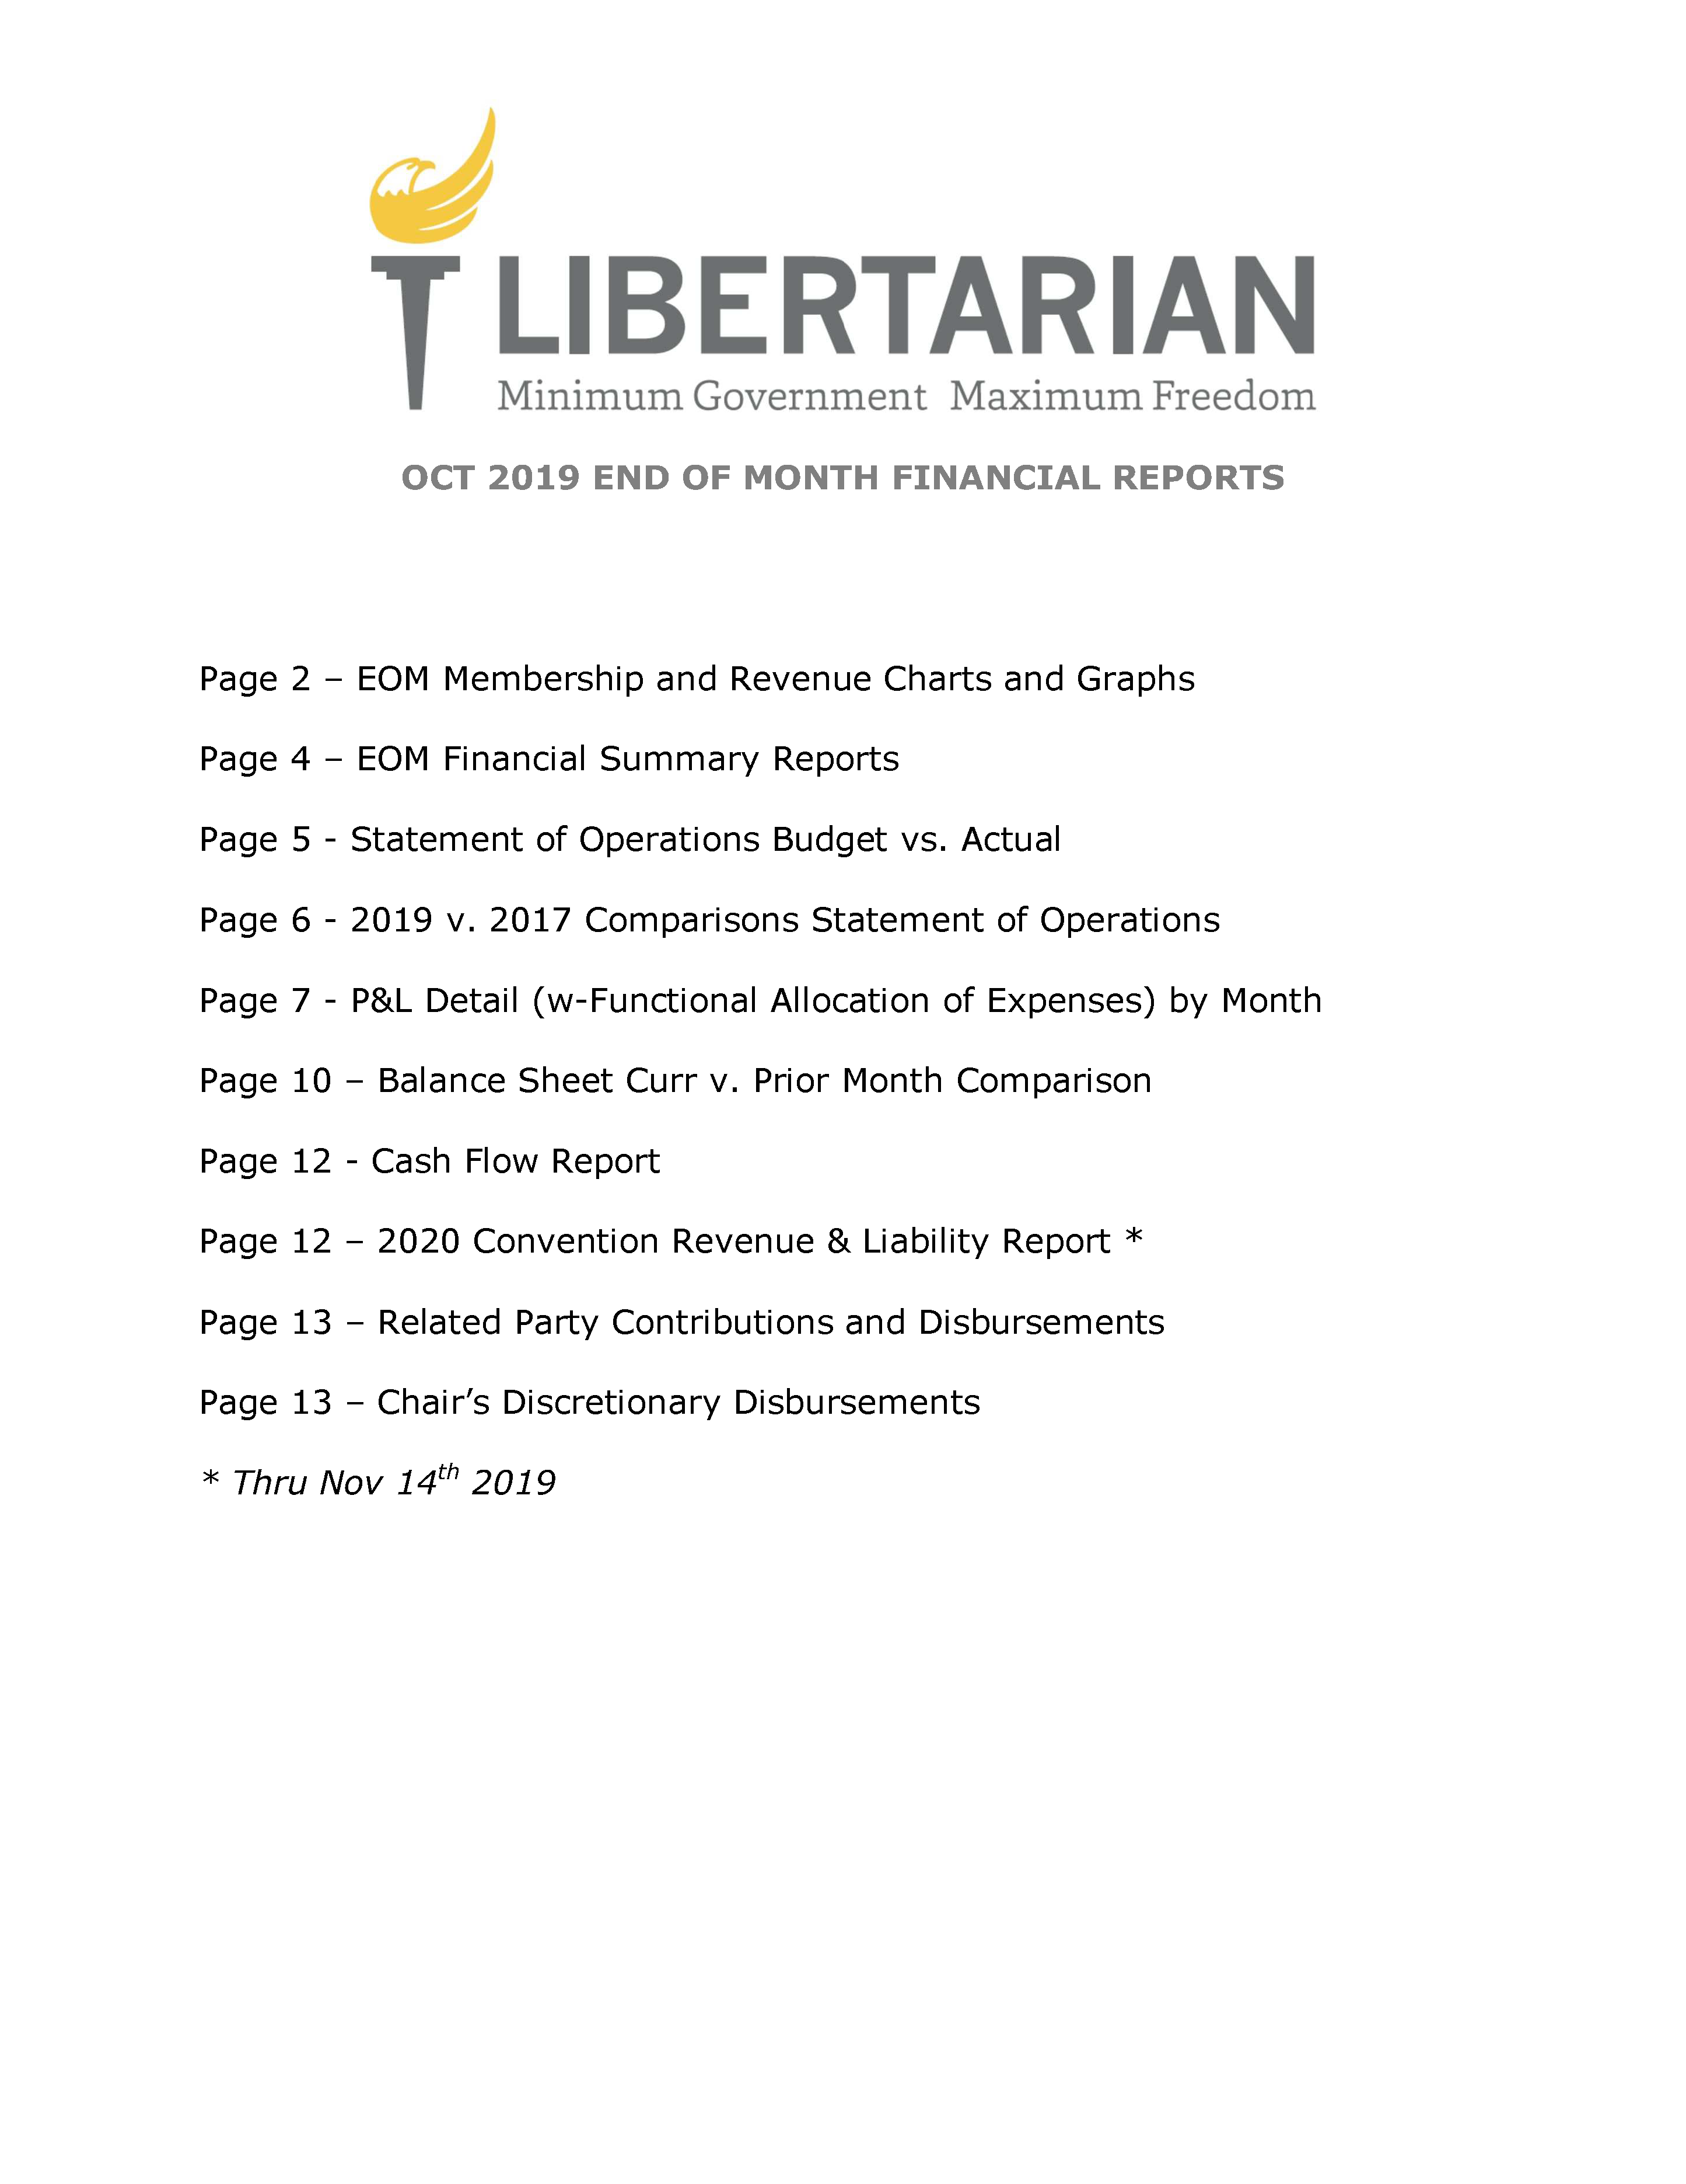

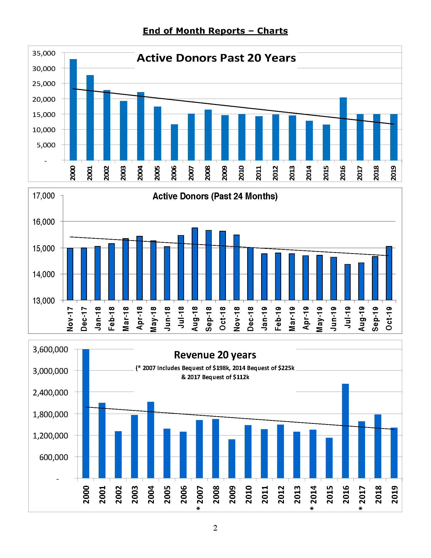

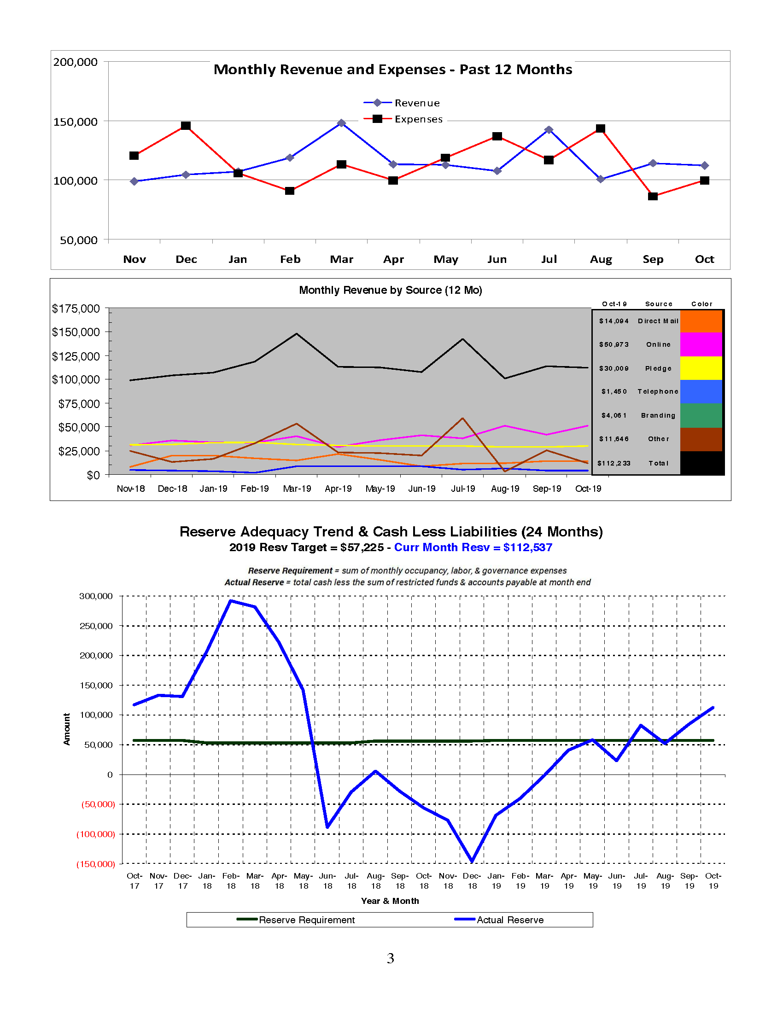

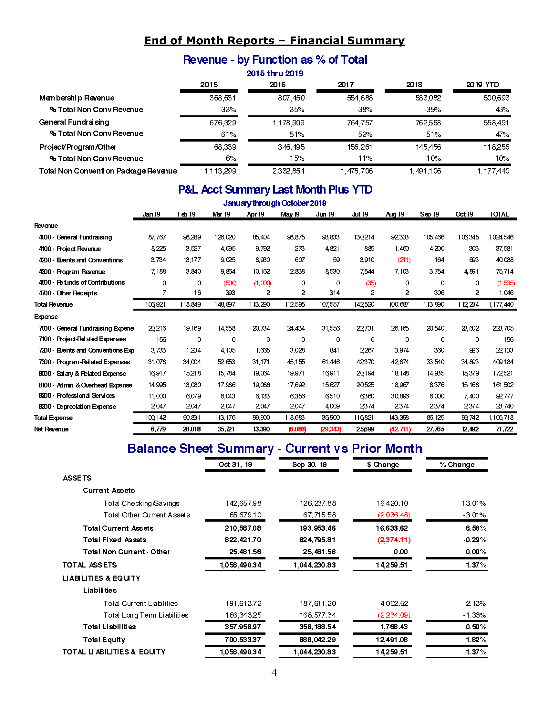

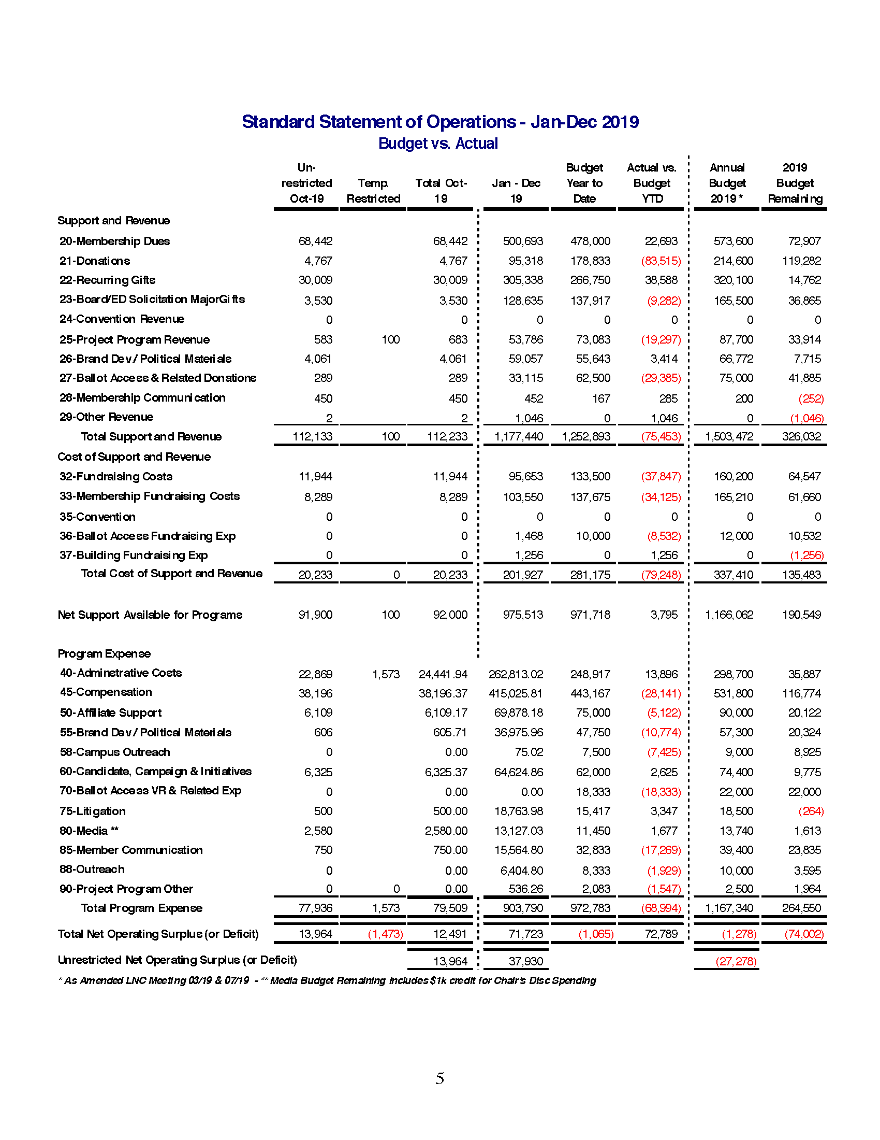

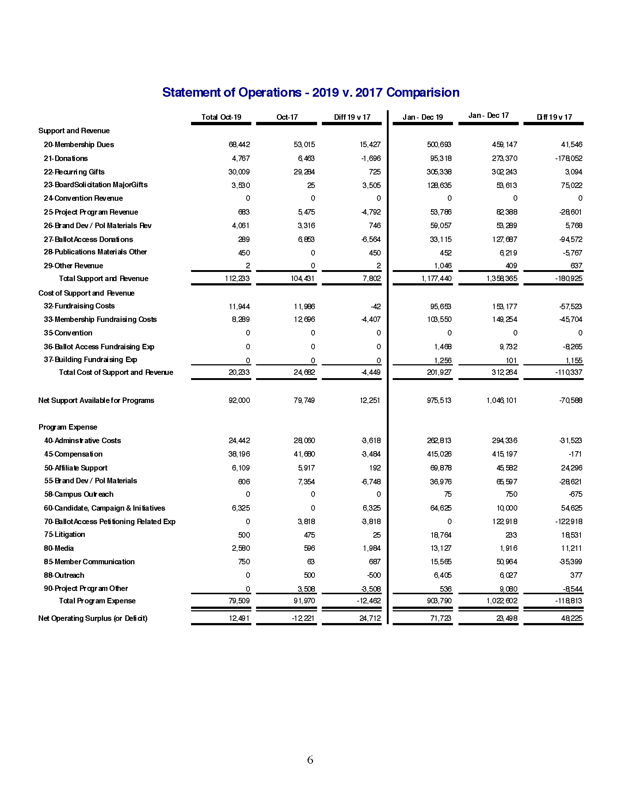

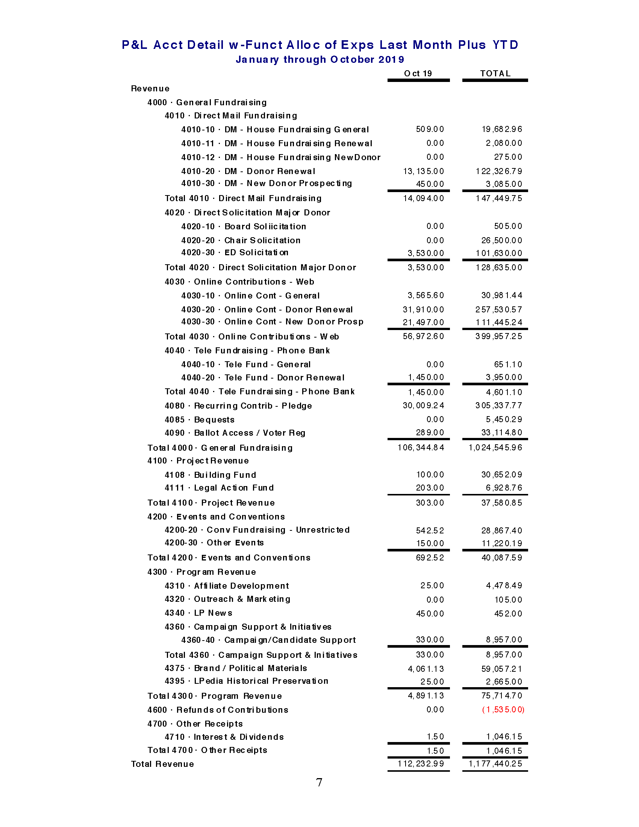

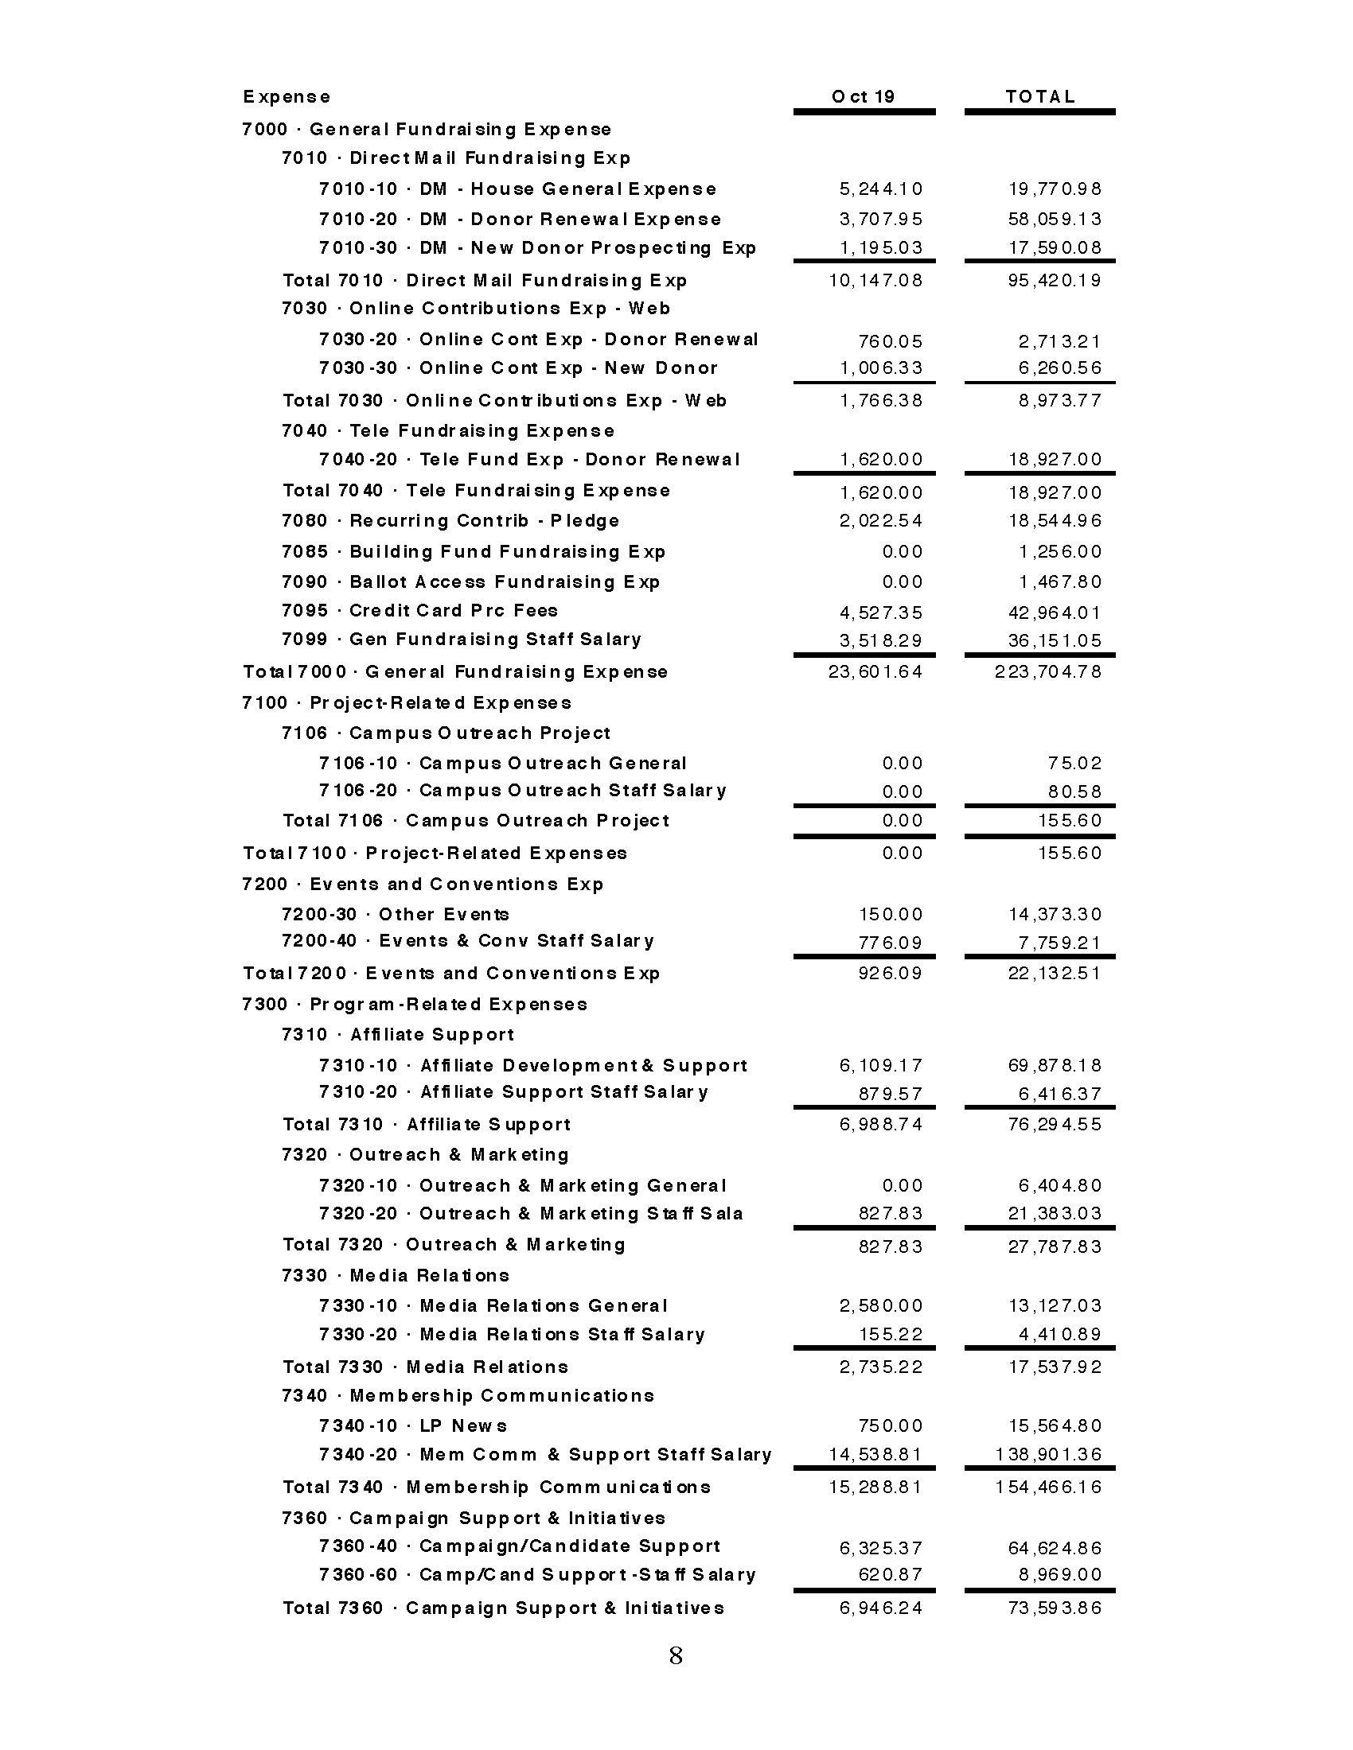

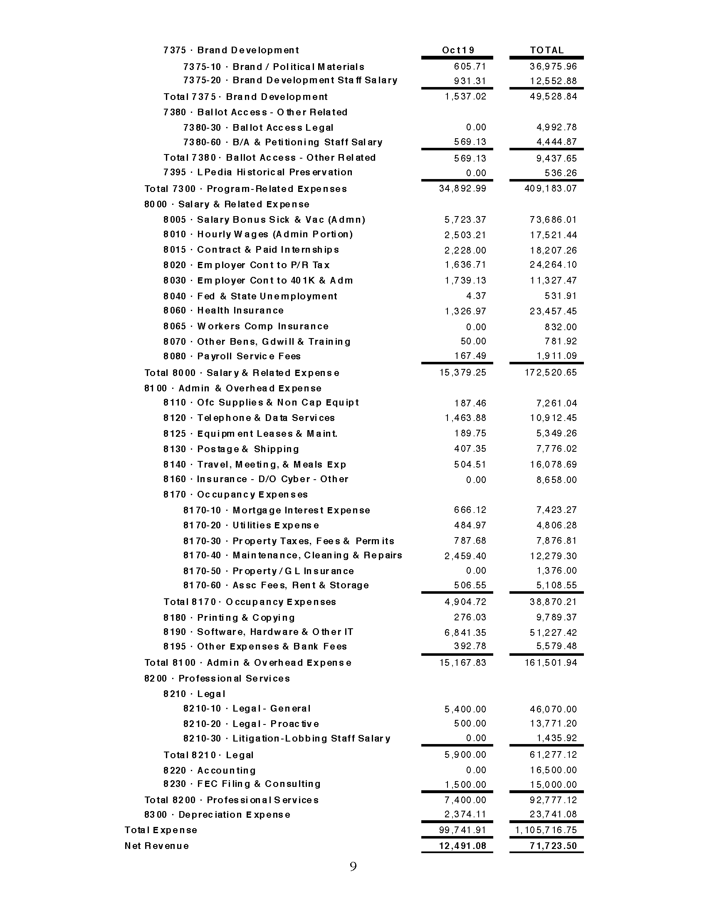

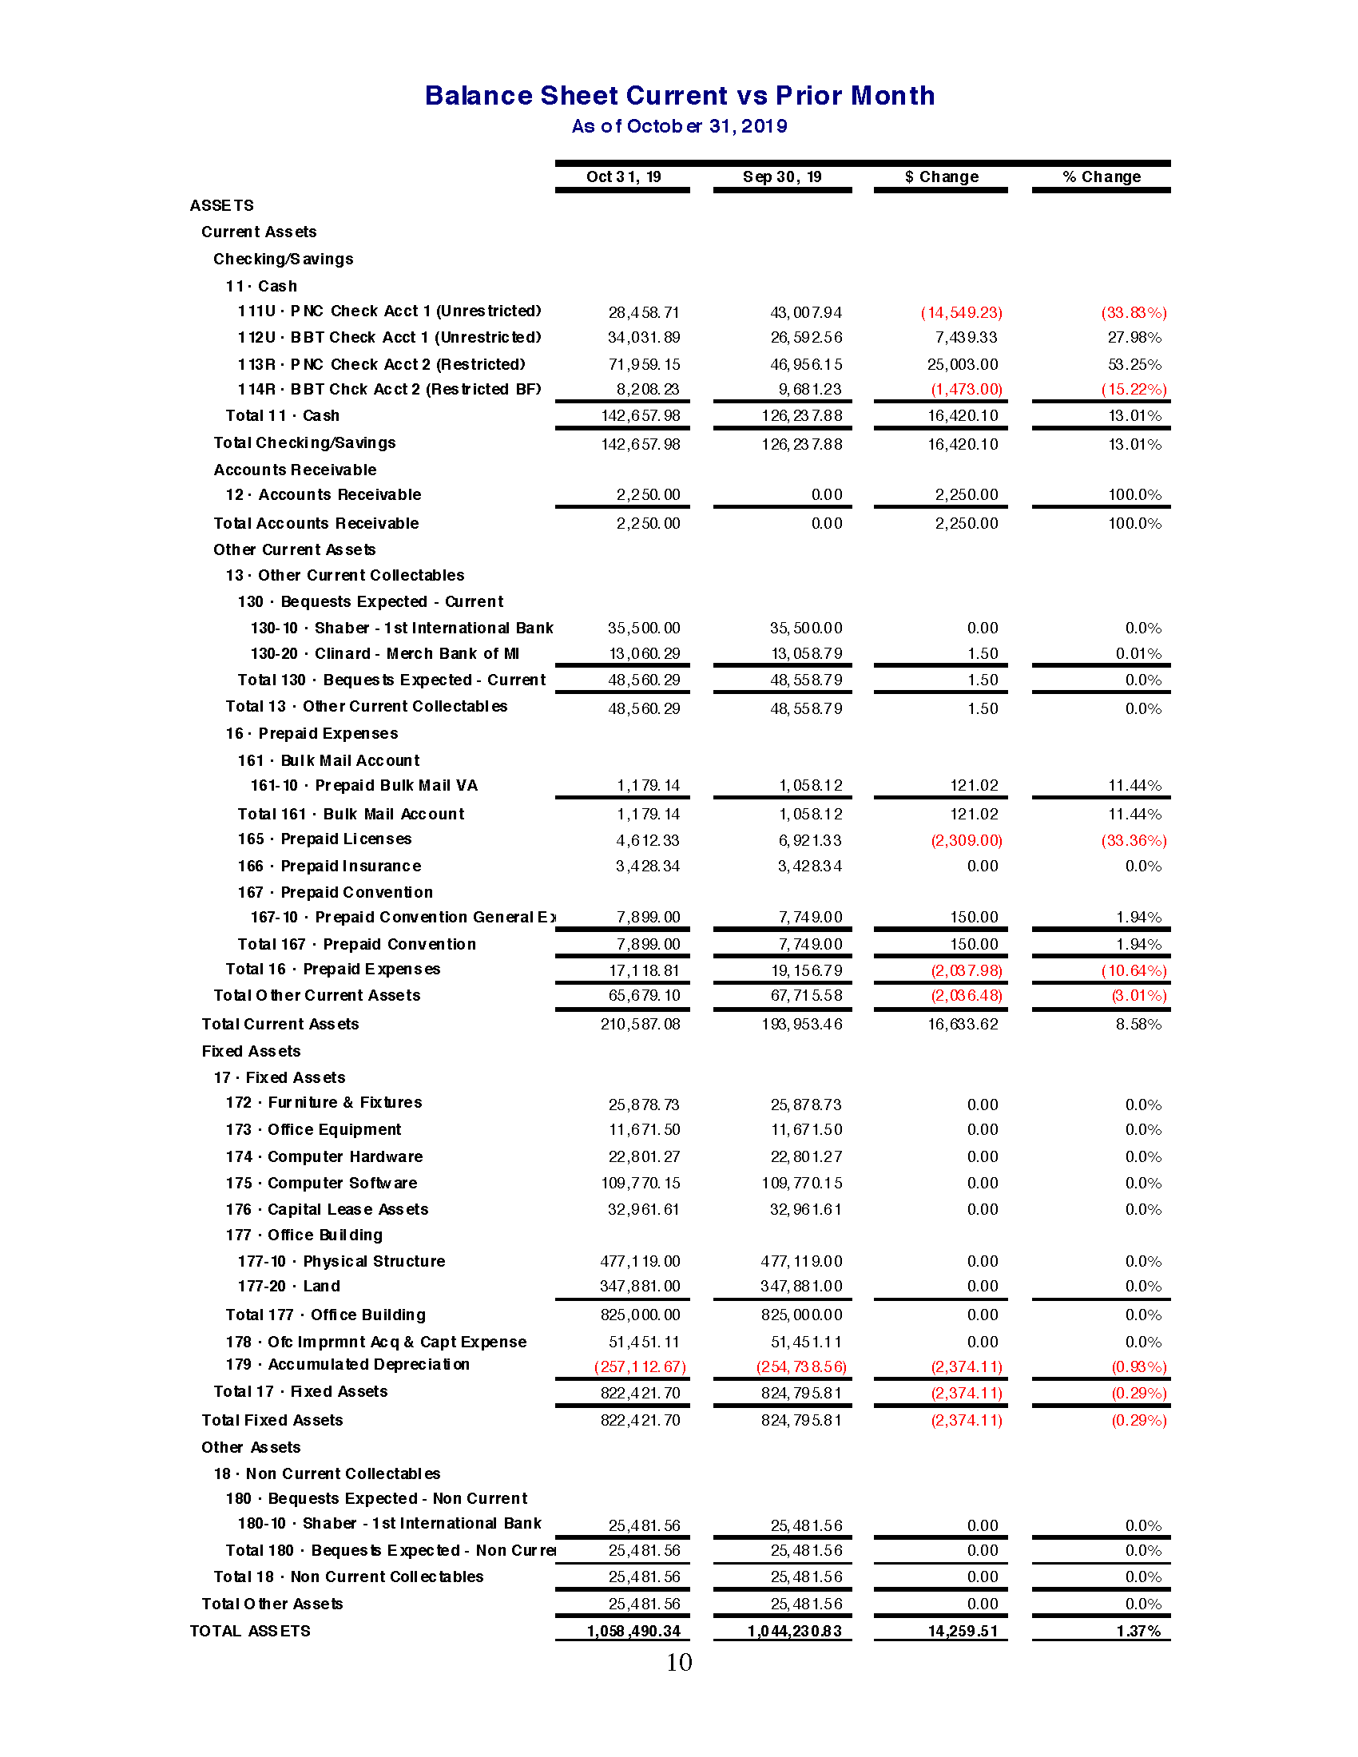

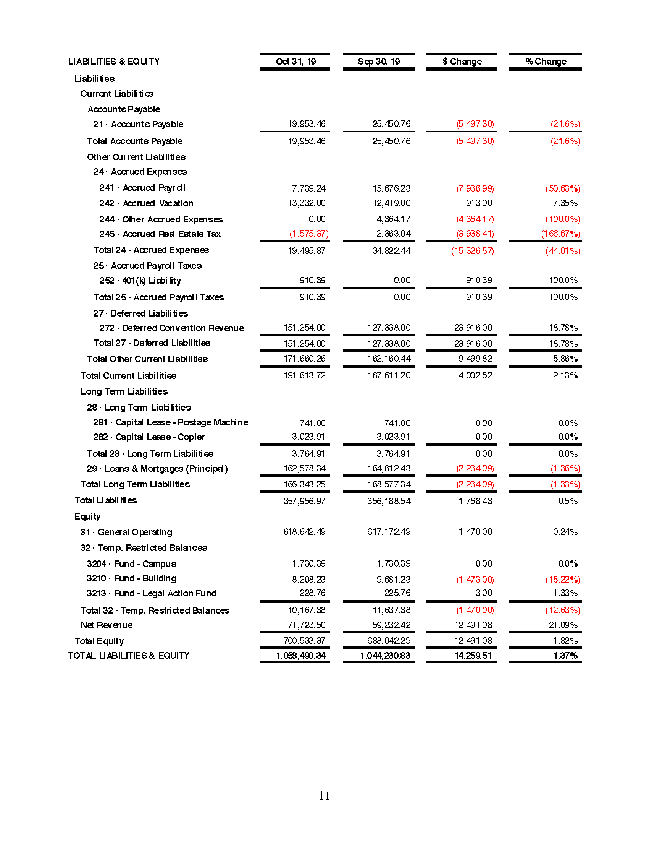

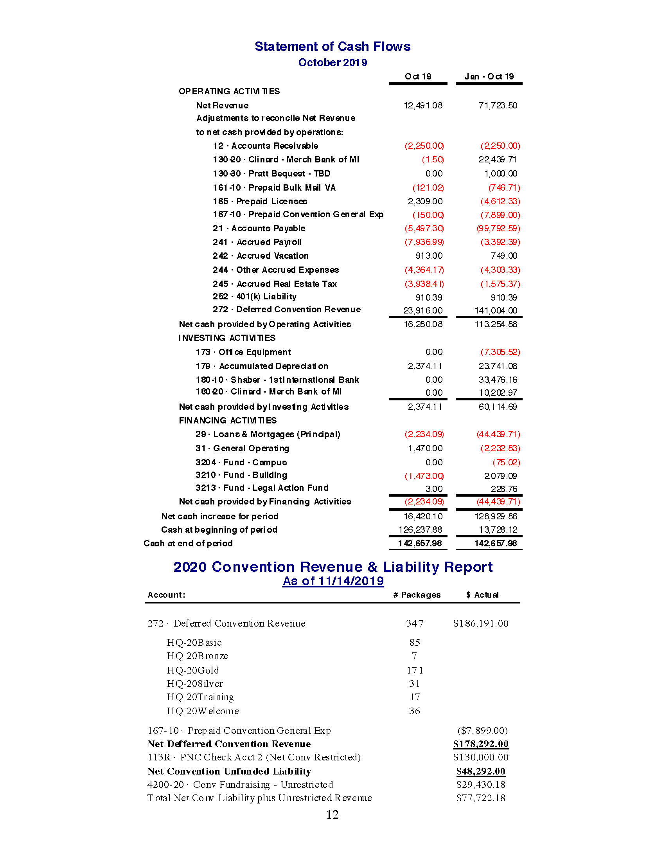

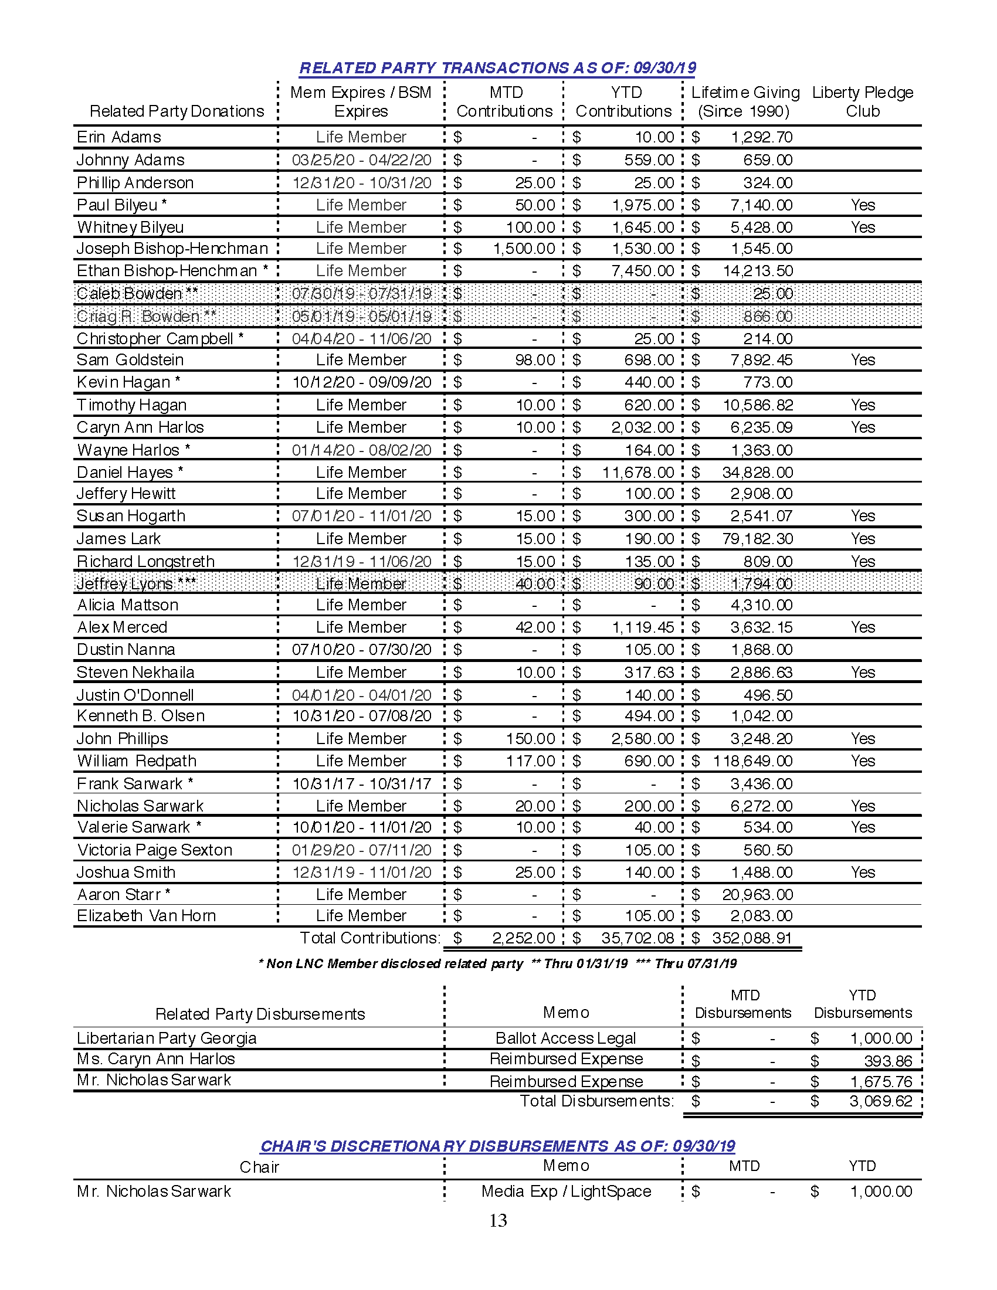

APPENDIX F – SECRETARY’S REPORT

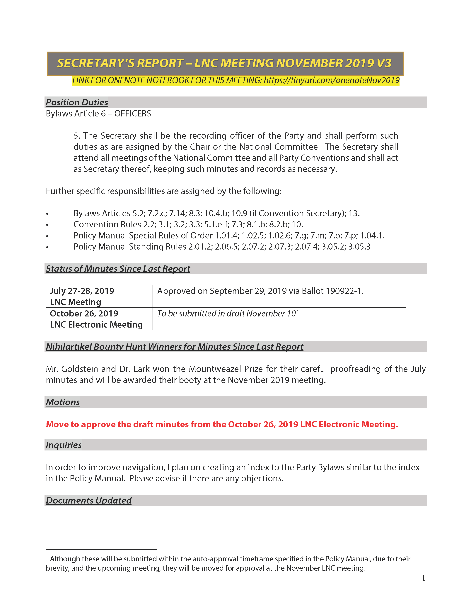

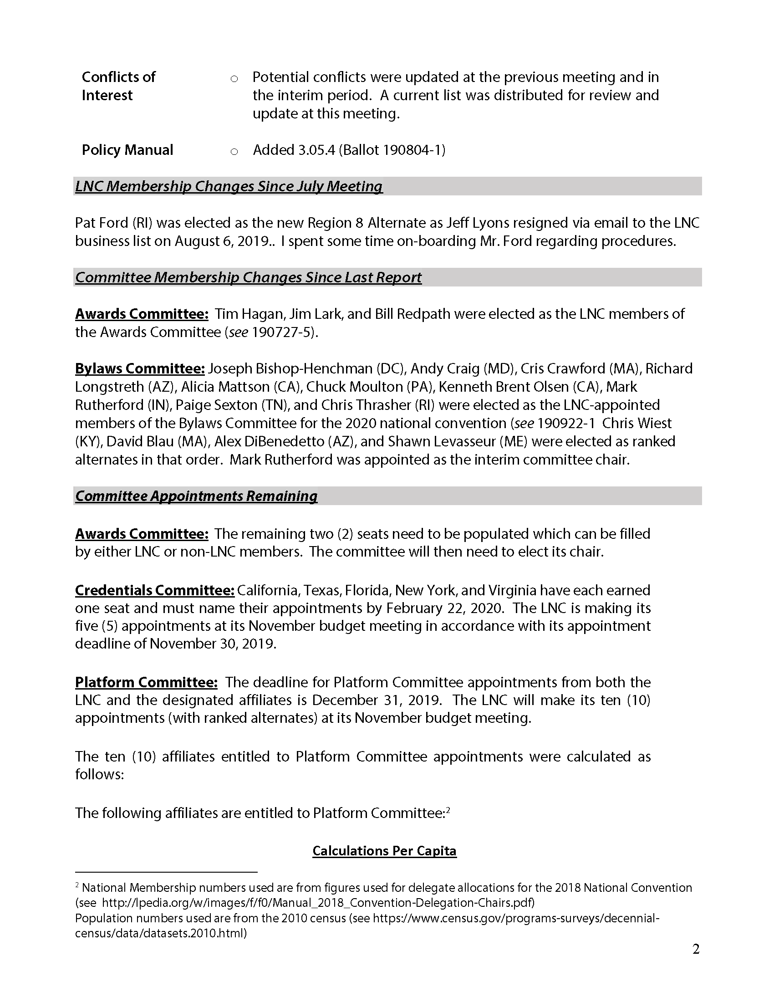

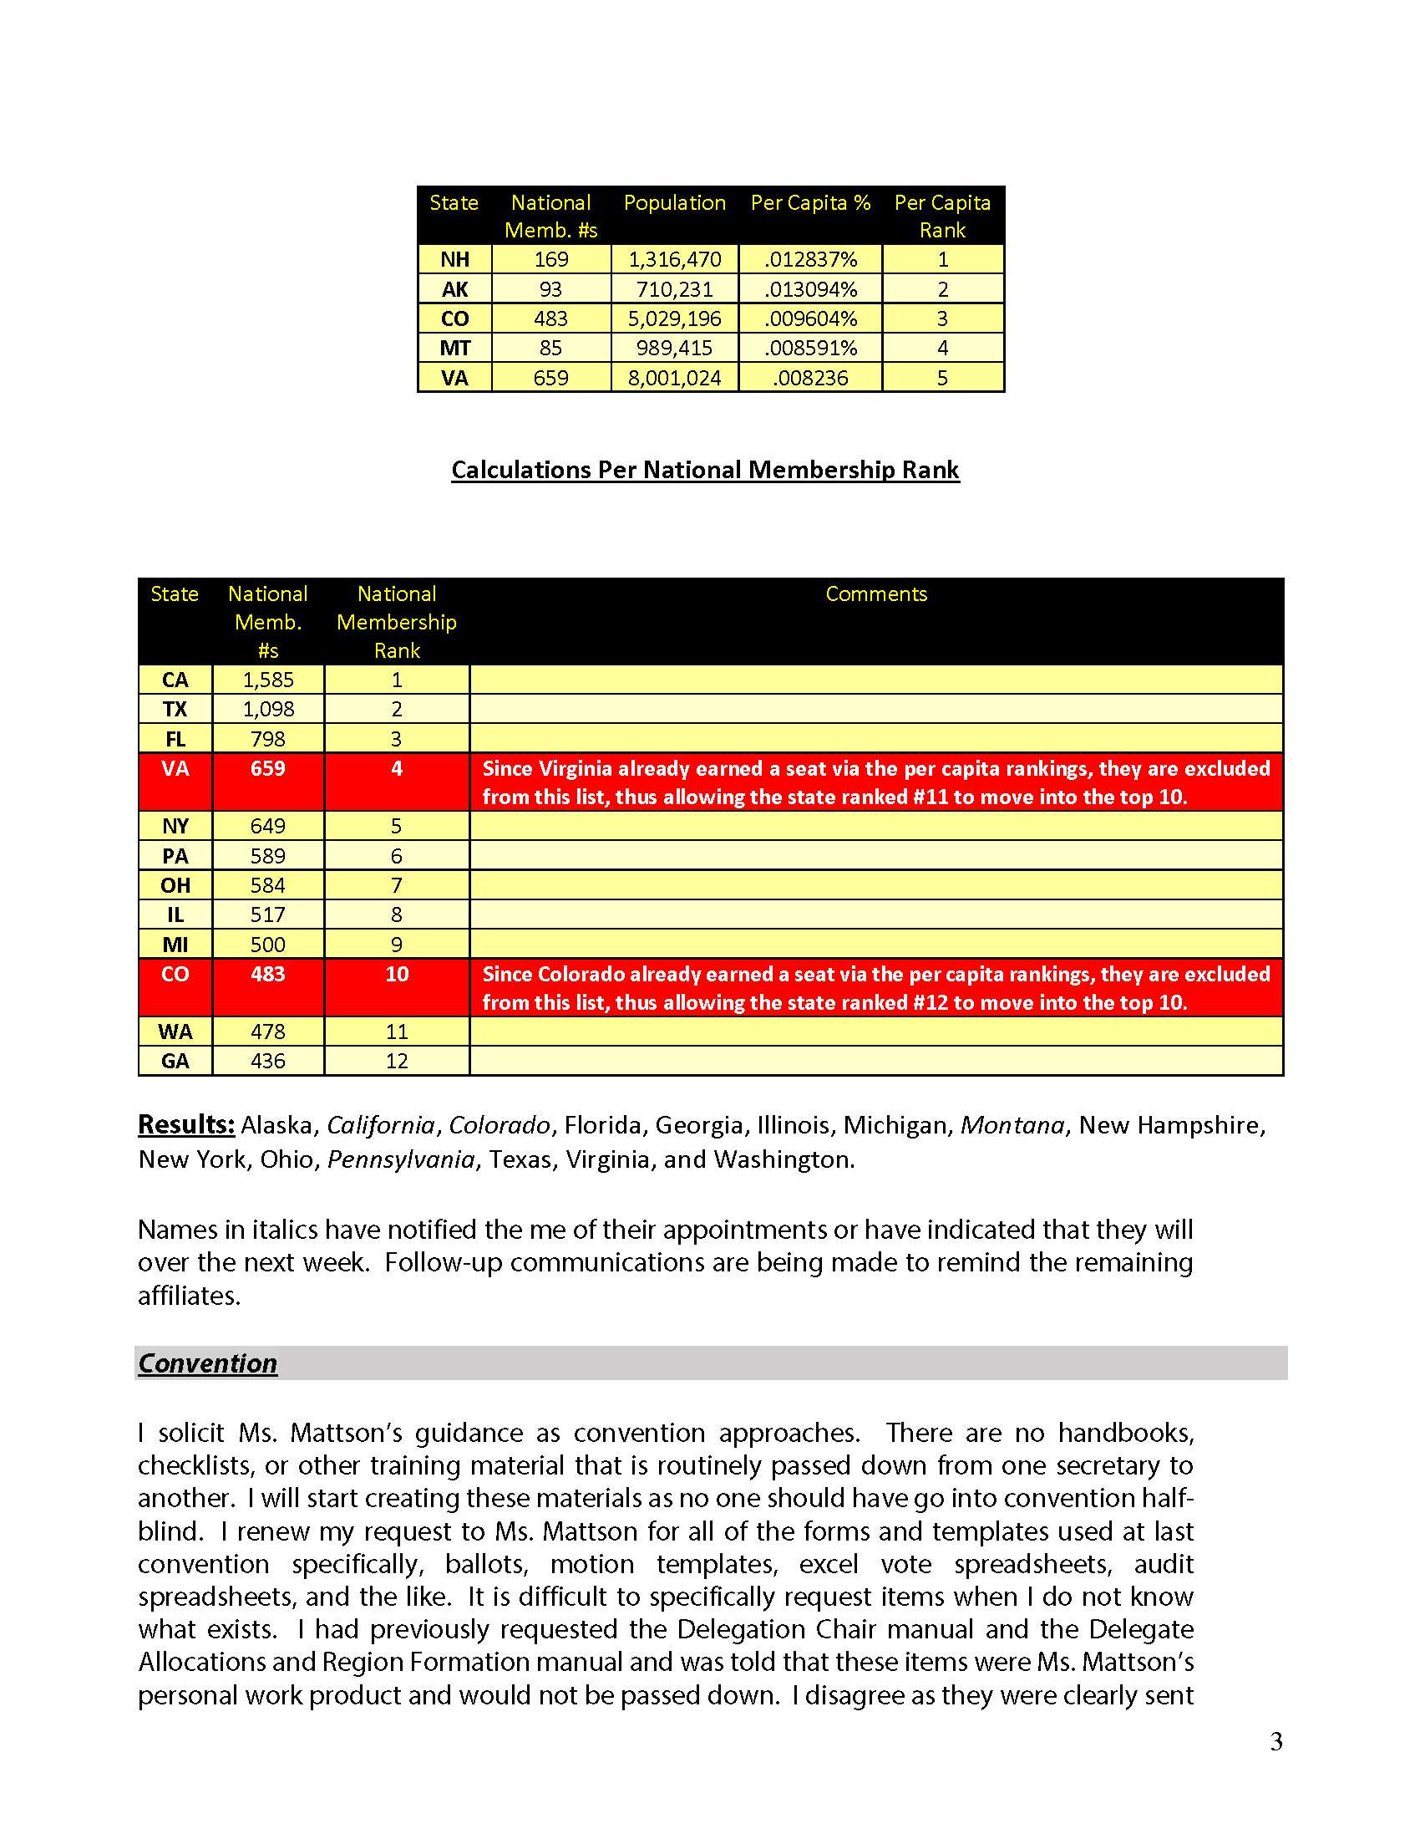

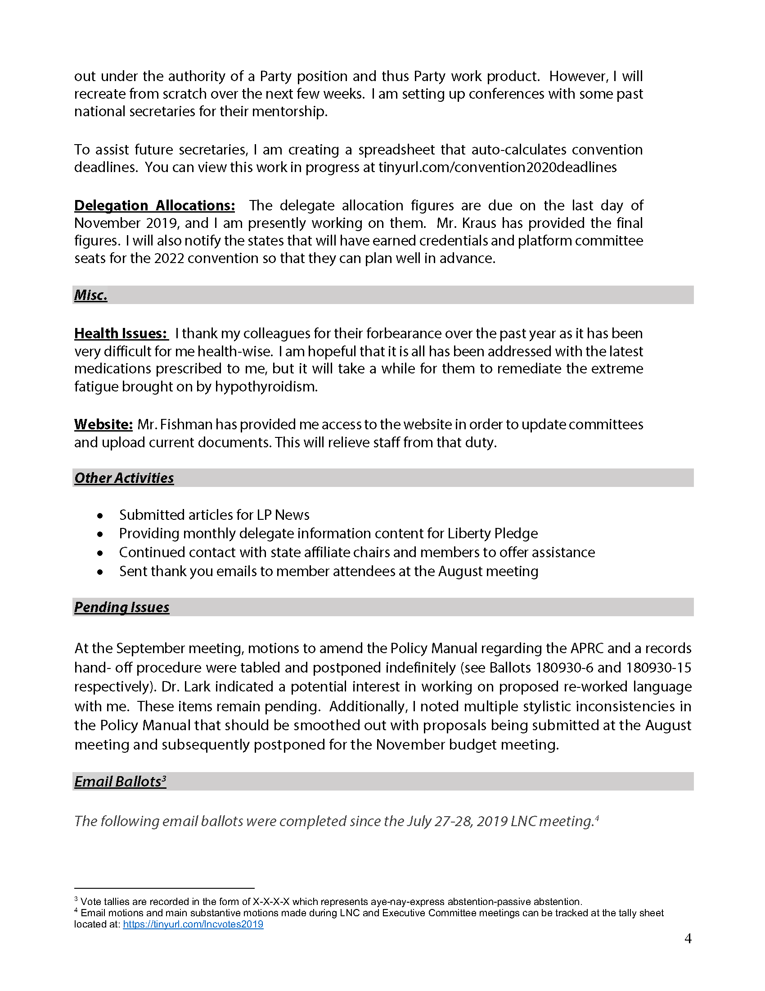

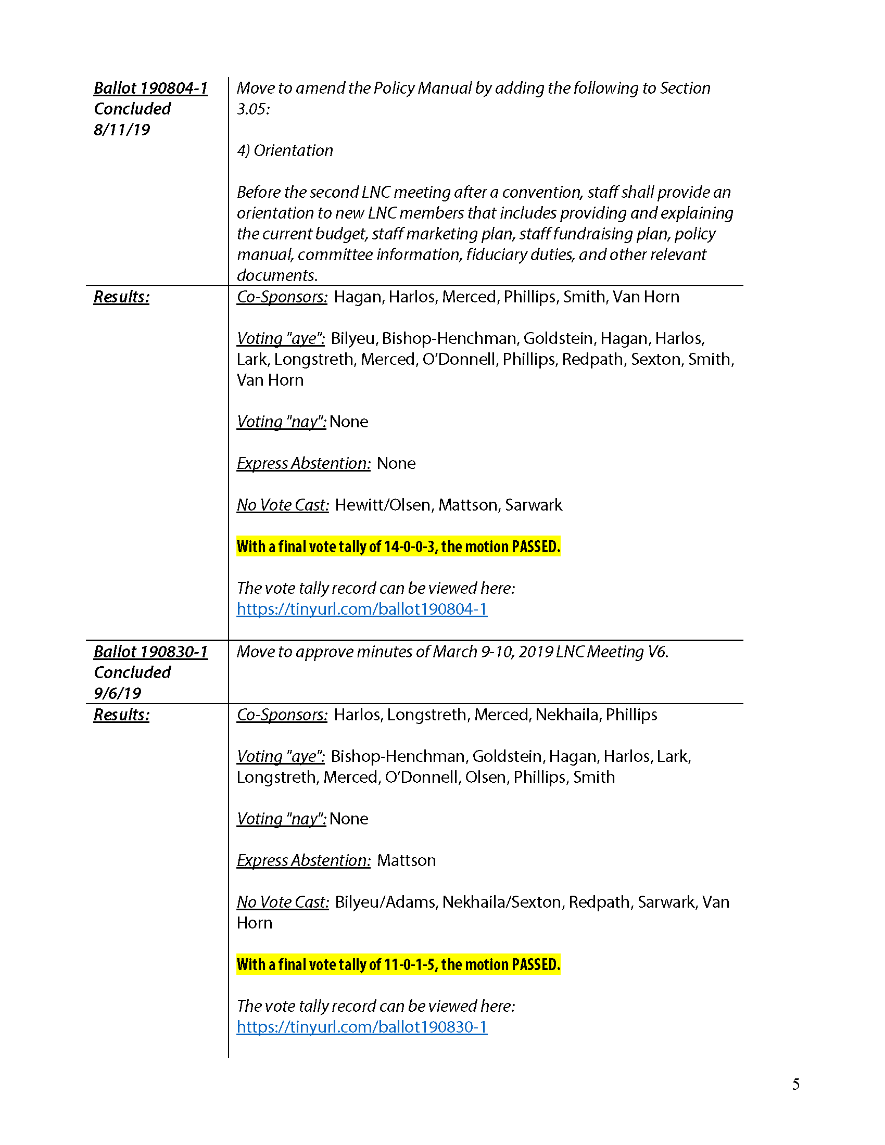

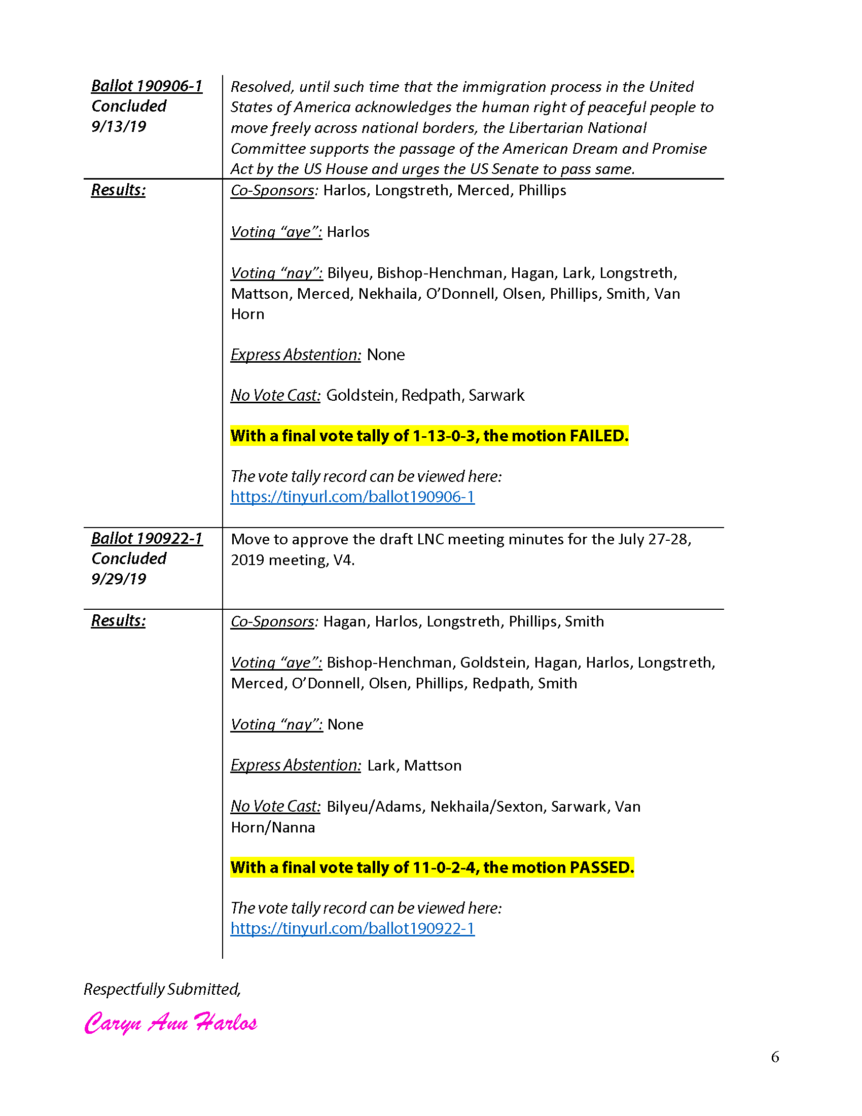

APPENDIX G – STAFF REPORTS

Executive Director’s Report Q3

Executive Summary

We have had an excellent quarter by all metrics.

- The party made significant gains in membership
- We had a steady increase in fundraising.
- We acquired a development team.
- We engaged a contractor for publication work.
- We engaged a contractor for social media, who has had significant success.
- We have two technology projects in alpha.
- We had superb election results.

First is a mention of Eric R. Dixon who was a critical part of our success over the last few years. Eric was a brilliant guy who was dedicated in his service to the Liberty movement. I wanted to mention one last time his hard work in the minutes, and how much his loss impacted LPHQ.


Daniel Fishman Executive Director

Technology:

Q2 goals:

Get off of IContact.
Bring online member portal
Bring online LPU (rename suggestions welcome)
Enable 2fa.
Bring Gsuite groups online for people who request it

^^ all goals accomplished Member portal and LPU are in alpha. We anticipate Beta by December and Launch in January.

N.B. We have moved away from IContact for sending email but I did not terminate the contract immediately in case we missed something. As it turns out we did — there was a form that added people ONLY to Icontact and nowhere else. Once realizing that I changed the add process and emailed all the people who had clicked on the “Stay Informed” link. This illustrates though why I have kept our IContact account (though significantly downgraded our capacity and cost).

The member portal is online, and I’d like to ask Andy Burns

Learnpress vs. Moodle. Both are being evaluated at my request by the IT Committee and whichever one they decide will be the one we go forward with. We anticipate a go live date for CONTENT CREATORS in December. Alec Merced has agreed to be the oversight leader of the project, including recruiting the initial course creators.

Do courses need to be approved by APRC? I would suggest the volume will be large. On the other hand, it clearly does need to be evaluated. I *believe* Moodle to be the best option as it is a dedicated LMS (Learning Management System). My goal is that by January we have 3 classes online: Candidate 101, Campaign Manager 101 and Treasurer 101.

The IT Committee is also, with my assistance, engaged in a technology audit of LPHQ.

We have signed 2 technology deals -- one with a news aggregator: Meltwater, and one with a Direct Mail list provider, Wiland technologies.

Membership:

This is taken directly from my Q2 report:

The decline in membership continues. We are taking several steps to address this.

We are viewing every day that we do not increase membership by a net of 1 as a failure, but because of the lag between when a membership is entered online and when it is entered into our database of record, Raiser’s Edge, we try to look at the statistics in the context of a weeks data.

We have had a marked success in increasing membership. We brought online our referral program which is truly picking up steam now, with several podcasters such as Dave Smith, Tom Woods and Marc Clair signing up. For me personally when I hear Tom Woods asking people to join the LP on his podcast, I think we are growing the party.

Membership continues to be my primary focus. I believe that membership will always be the MOST sustainable and consistent source of revenue we have, as well as being the most resistant to the whims of the Libertarian Drama cycle. Case in point, while we have seen fundraising vary dramatically from month to month, based on reaction to Libertarian candidate and personality news, membership remain constant.

To that end I am going to, in the next quarter, direct a focus towards increasing revenue from members, in particularly asking basic members ($25/annual) to renew as pledgers. Last report I mentioned my “A quarter a day keeps the government away” pitch, and I’m happy to explain it again in more detail.

The basic math is that we currently have 6658 basic members at $25/year resulting in $166,450 of revenue. Converting 25% of those members to $100/year when they renew (ideally as pledgers) will increase revenue by roughly $13,000 a month.

I also want us to start segmented renewal program, where instead of sending blanket renewal notices, we start asking members to renew in a letter targeted to them with their current level. This becomes much easier when the CRM comes on line, but it is still doable now using Raiser’s Edge.

I have been attending meetings of the Membership Committee for guidance and to coordinate all of our efforts.

We will be engaging in direct mail prospecting for new members and donors. We has a 2A piece written by Ms. Congdon that is going out this month to 10000 never members who have been identified as sympathetic to that issue.

Fundraising

We managed to reactivate one of our top 5 lifetime donors who had been inactive for 4 years. We are specifically trying to bring our top lifetime donor back into the fold

We also have had generous donors put up $60,000 as a match for a building fund drive. We are going to rollout a very targeted campaign to use that match to raise a total of
$120,000 to pay the mortgage down to under $50,000 (the current amount due is roughly $164,000), with the idea that we will pay the mortgage off entirely in 2020. Paying the mortgage off saves the LP ~$36,000 a year.

Financially we passed our aggregate revenue goals for the quarter, falling short in August but exceeding in September and October. I look forward to the inefficiency in fundraising being addressed by our new team. We hired Tara DeSisto and Bekah Congdon to form the core of the Development Team. Mindful of the LNC’s instructions in July to hire a three person team, I have a third prospect that I am interviewing to come in at the associate level.

Our monthly outlay for the Development department is now considerable and we will be asking for much more support from the LNC members in reaching fundraising goals.

As an example, the DoD has scheduled me for call time at around 8 hours a week, where she gives me researched targets to call, potential asks, and then sits with me while I call and coaches me up on my performance, makes notes about what future contact to scheduled, etc. I envision the DoD being able to target some people in certain geographic areas and using LNC members for certain calls. I also would greatly appreciate the LNC providing the DoD with potential supporters that they would be able to assist with.

Many of you have generously offered to do this in the past, and previously I doubted our capacity to do this in an organized and productive manner. I know think with the support of our development team we will be able to design a plan for those who are amenable.

Operations

We have gone over budget on maintenance of our digital properties. One way in which that happened is that I asked for maintenance on the CRM and the corresponding down time to not occur during business hours. As we start to use the CRM as a professional tool, we must run it professionally.

Ken Moelmann and Andy Burns have addressed some of the other overruns in their reports.

The building still needs repairs and the Air Conditioning is still broken -- but we don’t anticipate needing AC for 6 months.

The LP News publication was delayed by Eric Dixon’s death. I’m happy to go into the details This caused a significant delay in getting the most recent LP News out the door, but I anticipate that all members will have been delivered their copy by the time of the LNC meeting.

I hired Robert Clarke as a contractor to be the Social Media manager. While there were a few issues with some posts, we achieved truly dramatic reach with some posts, and anecdotally complaints about content decreased significantly.

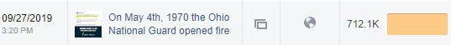

We bought a subscription to Meltwater (quick demo).

We have a contract with Wiland.

Elections

Most of you are aware of the huge success we had on election day, including 21 victories in Pennsylvania due to the strategy now being referred to as “The Moulton Maneuver” The numbers are still coming in, but we seemed to have moved the window in many places. The Campaign Strategists reports cover this in more detail.

I attended the Frontier Summit in Cheyenne and got to meet many of the candidates who we anticipate having a legitimate shot at victory and we hope to put significant resources behind. Mr. Pazell’s report will have more details behind this.

I also have a proposal from ECanvasser to provide a service at the national level to Libertarian candidates across the country. I will let Mr. Pazell speak to the efficiency of ECanvasser. I’ll reserve the details of the proposed contract to a private handout because of sensitivity issues.

I helped Stuart Flood, chair (Until November 2nd) of SCLP organize the SCLP debate, particularly emphasizing the qualities that I thought would make the debate a top flight production. I was able to assist in bringing Matt Welch to moderate. The physical aspects of the debate were 90% of where I would like us to be, but we had a major technology let down. I will continue to advise state parties that seek my input on how to put on a high end debate.

To that end Tom Arnold and John McCasky have put together a LLC that exists SOLELY to put on high quality LP Presidential debates. They will charge states to bring “debate in a box” to their state convention. They will have certain requirements about what venue they chose to shoot in and other aspects of the production. I have had a stated criteria that “professional debate” will include separate lecterns and microphones for each candidate, as well as a person to monitor the sound board, and at least 3 manned cameras. I make no requirements as to a live stream, because the technological barrier to a live stream with multiple cameras and sound mixing is very very high. And of course

Should the scenario seem good for us to create a very high quality production, I would like the LNC to greenlight me to spend in conjunction with a state party on a Presidential debate to shoulder some of the costs. The state would be paying the lion’s share. In return for our investment the LNC would get unlimited license to rebroadcast the debate on our platforms.

Next Quarter

Membership must remain the critical focus of LPHQ, as it is the basis for the support of the strategies set by the LNC. Converting our annual basic members to having a larger investment in the party is a critical strategy towards financial stability. As we (fingers crossed) start to turn the tide financially, LPHQ must bear down and focus LPHQ on the core issues.

We appear to have implemented a successful customer acquisition plan which we should now move to maintenance mode, and focus on improving customer satisfaction and retention. We currently have a membership retention rate of ~58%
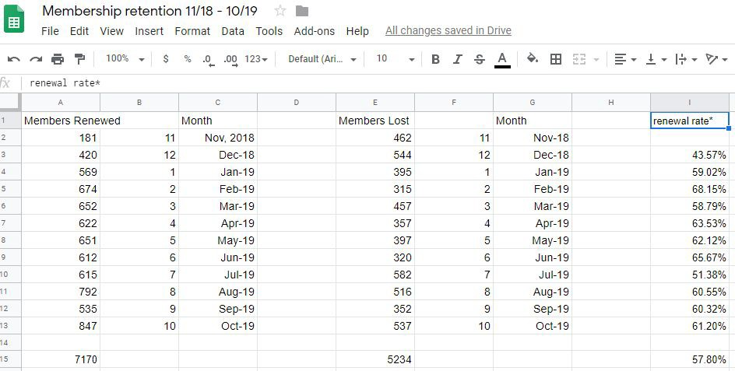

We need to continue to convert our outdated fundraising practices and move to donor financed projects.

We need to significantly update candidate support through the Ecanvasser project as well as putting effort into the Frontier Project.

We also need to start planning NOW the details of operations at the Convention, including a question of security.

Director of Operation's Report – Miami 11/16-17
by Robert Kraus

Financial

Our reserves are improved since last meeting & as of end of Oct we are just above $112k which is only the 2nd time since May-18 we’ve been above our reserve target (currently at $57,225). We also remain current on all payables (nothing past due).

Based on current trends: I am currently projecting we will end up just above $1.4M vs budget of $1.5M for 2019 total revenue - & will remain on track to be under budgeted expenses. Please note we continue to be below expenses in almost all categories but in particular fundraising costs.

Here is a summary of our revenue over since the last meeting:

P&L Acct Summary Last 3 Months
Aug 19 Sep 19 Oct 19 YTD

Revenue

4000 · Fundraising & Membership | 92,333 |  | 105,466 |  | 106, 345 |  | 1,024, 546
4100 · Project Revenue | 1,460 |  | 4,200 |  | 303 |  | 37, 581
4200 · Events and Conventions | (211) |  | 164 |  | 693 |  | 40, 088
4300 · Program Revenue | 7,103 |  | 3,754 |  | 4, 891 |  | 75, 714
4600 · Refunds of Contributions | 0 |  | 0 |  | 0 |  | (1, 535)
4700 · Other Receipts | 2 |  | 306 |  | 2 |  | 1, 046
Total Revenue | 100,687 |  | 113,890 |  | 112, 234 |  | 1,177, 440
Total Expense | 143,398 |  | 86,125 |  | 99, 741 |  | 1,105, 717
Net Revenue | (42,711) |  | 27,765 |  | 12, 493 |  | 71, 723

August, which normally is a very tough month, was a struggle to get over $100k & did present some challenges in terms of meeting our obligations but we were able to make up for that over these last 2 months where we pulled out decent revenue in the last few days of each. The membership surge at the end of last month also helped! That said, we still have some upcoming major expenses including our annual license for Raiser’s Edge & replacement of our HVAC. Thus, we would continue to caution the LNC when it comes to any new expensive projects that are not already planned.

Blackbaud – Data Dumps – Internal Customer Service

Data Dumps continue to be sent out regularly & via the CRM to several states that are working with Andy Burns.

Building Fund / Office

Mortgage balance = $162,578 as of end of Oct Extra payments made so far this year = $27,000 Curr in restricted fund $8,208 as of 10/31/19
HVAC: As reported at last meeting we were planning to replace one of 2 compressors on our HVAC system which we thought would give us another 2-3 years life. However when the contractor was replacing it they discovered the Freon leak was worse then anticipated & could not be fixed. In addition the other compressor also had a leak which would not be cost effective to fix. This will require us to replace the entire HVAC system at this time for a projected expense of $20,000-25,000 which will come out of building funds. We expect to raise the funds & replace the unit by early Spring.

In addition, as mentioned in the last meeting, we had our 5 year review of the sprinkler system & went forward with the repairs to that which came under budget at $1,500 (also paid for with building funds). We also successfully completed the switch from our very old Broadview VIOP (which ran on a shared T1 line) to a new Comcast VIOP system that runs on a high seed data line saving us about $40 a month.

FEC Filing

We continue to file accurate FEC reports and use Paula Edwards to complete the FEC Filing Process on a monthly basis and handle our amendments. The reconciliation and audit steps to this process continue to work to assure that these reports are correct prior to filing, and to insure that the disbursements and contributions match to our cash accounting records.

As a reminder, the FEC reports are done on a cash basis while our financial reports are done on an accrual basis as required by our bylaws which require adherence to GAAP. Therefore, our Statement of Operations will not always look the same as what is reported on the summary page of our FEC Filings.

Convention

LPHQ remains very much involved in planning for the 2020 Convention & site selection for 2022/24. We remain concerned about the lack of sleeping room availability at the JW Austin but have worked with the COC to find an acceptable overflow solution.

Also, please note as of 11/11 we have a total of $112,000.00 set aside in our restricted PNC account for the convention leaving a net liability (unfunded balance) of $58,611 for the convention. This # is improved from the amounts shown on the Oct Financial Report due to the transfer of an additional $42,000 on 11/8.

Feb LNC Meeting

LPHQ would strongly encourage you all to pick the next meeting location ASAP by the end of this weekend. Preferably Reno (if one of the venues are picked for 2022) or the Embassy Suites LAX if Reno is not picked.

Thank you!

Robert

Tara DeSisto
Director of Development

Hello Libertarian Leaders. I am very excited to get to know each of you and your personal reflections of the party as well as the regions of the country you are connected to. I know that this beautiful nation has hundreds of millions of interesting people with unique minds, different ideas, certain values, distinct upbringings and various tolerances. I appreciate the vantage point each of you has and I value any support you are offering in leveraging outreach in your respective regions.
As you have come to know, I am not a registered Libertarian. I am not sure the level of importance this is to each of you however, I invite you all to engage me as we meet in bringing me into your party. This effort on your part will be a critical part of the growth and success of my job and your Party as I identify as an Independent. I have voted for candidates from all party backgrounds based on the individuals agenda and values. You may be happy to know that I voted Ron Paul in 2012 valuing his desire to retreat back from the many wars we were and continue waging across the world. And although Republican’s have been attempting to claim me ever since, I have worked for candidates’ efforts and administrative agendas from various parties authentic in my support for each of them. I do not prescribe to any one ideology, but I connect very deeply with my values as a human being, a citizen and voter, which I am sure is true of you as well.
As any of you who can see, hear or smell, the political atmosphere is ripe for adjustments. Big adjustments! The Libertarian Party has an opportunity to capitalize on these adjustments by making major gains at the polls and ultimately legislation. With victories in ballot and debate access, important ideas are being heard and Libertarians are gradually becoming embedded into policy framework as they work within standing structures and alongside individuals with different and often competing agendas.
As predicted, corporations are becoming more moralistic in their decision-making processes shifting focus from shareholders to stakeholders. Society is attempting to do what it needs to in order to correct the shift from autonomy to authority. While I believe society as a whole seeks cooperation to thrive in many areas, that cooperation may not need to be legislated or collectively administered at the cost of all. These are philosophies where we can meet. There are not just one, but many highly legitimate Libertarian cases to be made and what I see for the party with that are many opportunities for victories. I am happy to be a practice run for when you are all engaging other independents on why they should elect their local Libertarian. These are the critical votes you will certainly need to turn campaigns into Office jobs and grow this party into a reckoning force for the electorate to the powers that be.
Ultimately the LNC is the governing body for the LP and will lead the organization in the best direction you all see appropriate and necessary. My mission is to help you meet your future as a party. In every opportunity we have to connect, I will look to work with you to help expand that progress and lay out my recommendations of best strategies to achieve those goals. I am honored that your Chairman and Executive Director have made the decision to bring me in to the operational infrastructure. Both are honorable Libertarians who have laid out a beautiful case for preserving Liberty while being inclusive and expansive for the sake of party growth.

Personally I have developed a very process focused strategy to fundraising that has been successful in my previous experiences. I look forward to working alongside Bekah Congdon to implement strategies in the Development department. I also look forward to working with other members of the team to establish best practices to increase professional appearance so that donors see the value of their investment. I hope that you see me not at a one-woman army for fundraising, but a support structure for each of you to help grow your organization to its fullest potential. With that, I hope that you will all become fundraisers with me. This is the only path to success for an organization that stretches from sea to shining sea. I will be building out our CRM and making sure that I am utilizing all of our human capital in networking out further.
My reports will become more detailed and metric once I have had a chance to deep dive into numbers. Should you ever need further clarification on anything, I invite you to ask. I am happy to be transparent and forward thinking. As I take in the landscape of what has already been built within, I will certainly be looking to connect with each of you. I hope that you will be candid with any concerns and open to opportunities to work together. From there, things can only get exciting.

Andy Burns
Affiliate Development Specialist
LNC Meeting Miami, November, 16-17 2019

Key Projects
- Continue to bring on more states to State CRM
- Provide support to the 20 states using CRM and provide maintenance service
- Helped put together our Iowa party leader regional training
- Finished discovery and started implementation of a Member Portal
- Worked with our development partners and in-house to bring the Simplified CiviCRM County dashboard to implementation
- Assisted in managing data capture for candidates self-reporting contact / election data and a candidate survey

Key Tasks
- Respond to affiliate questions
- Maintain lpstore.org and post products
- Assist with national IT Helpdesk
- Resolved Sparkpost email issue to allow states to keep their accounts

Effectively Managing State Data
Our State CRM database continues to bring on more states and broaden functionality and its data model. The performance has improved since moving to a more powerful, yet cost-neutral hosting plan. We have also instituted a weekly maintenance window to deploy improvements / functionality from our development environment.

We have added Pennsylvania to the system, added New Hampshire to the CRM side only and are nearing completion with California. A breakdown of the states statuses are d etailed h ere. The main point we see is that we are now having a wave of states opting into it. There are only a handful I have not heard express interest. At our current numbers, we have 20 running, with 3 in the process of migration and 9 waiting. This totals 32. It is quite realistic to think that we would have close to 40 states on if we had more resources to devote to on boarding. As we move toward 2020, it is essential we have organized operations where counties and state leaders are managing and improving our data sets and are proficient in doing so. If additional on-boarding resources are not added, we will need to pivot to strategically supporting states using it and away from migration around Spring 2020.

Lots of states are queued to join, not enough focused time to process

We cannot adequately handle the added interest with the same amount of resources and additional projects added to my workload. It is worth noting that there are states willing to give $1-2K to get onto the CRM if they get assurance of a migration date. However, this funding does not actually increase our resources to dedicate to them. It merely allows us to prioritize them as I have done on t his page, ordering states queue based on contributions to the LNC earmarked for the project. This is a problem that is outside of my control as our budget doesn't commensurate with the level of interest the project is getting.

Provide support to 20 states using CRM and to LNC IT

We systematically use our ticketing system to process requests from states. Including all affiliate support, we've closed 426 tickets and 123 for national IT Helpdesk.

As we prepare for substantially increasing our user base to county users, we have implemented d etailed logging for greater security and transparency on who changes what, when and the ability to roll back.

The CRM allows greater synergy between the national and state parties. We all can work from the same ‘command center’ and benefit from each others success. A new donor at national can be encouraged to get involved with a volunteer opportunity. The ‘strike while the iron is hot’ principle applies.

More information on the State CRM Project can be found at: l p.org/crm

Simplified CiviCRM County Dashboard
While there were some delays due to funding issues, we have reached the end of development. We have tested in staging and are implementing the week of 11/11. The roll-out will come in stages as we ease ourselves into the process of using the new functionality in production.

In short, this will give every county leader in the nation (their state must be on it) real-time access to Libertarians in their county. County volunteers will be able to quickly get on the phones and contact Libertarians assigned to their call queue by the county leader. It was our goal at the outset to get people on the phones and access in under 15 minutes.
And we’ve achieved that.

Here’s the breakdown:
For County Volunteers (~5 minutes):
- Logging in (30 seconds)
- Training: C ounty Volunteer using Call Next dashlet (4 min)

For County Leaders (~12 minutes):
- Logging in (30 seconds)
- W atch the welcome training video for county leaders (11 min)

No more confusion. No more creating ad-hoc processes and google docs where the data never ends up back into the account of record. No more out-of-sync data, or worse — lost data. No more frustrated county volunteers with insufficient toolsets to do the foundational work of a county affiliate. It’s time to really grow this party from the ground up!

This improvement is a game changer. Our vision has been relentlessly focused on the people we need the most - new county volunteers. New volunteers come in and need to be engaged and equipped for success. At present, we do not know precisely how many county affiliates we have and to what degree they are supporting campaigns and assisting in raising state and national membership. We've now created a way to track what c ounty affiliates are out there so that is being resolved.

National will also benefit from this new system, as county volunteers provide more updates to the data National uses to communicate with Libertarians around the country. We’ll reduce undeliverable mail. We’ll find new leads for national membership. And we can use the same system to reach Libertarians by email, streamlining operations.

The added functionality for county leaders is as follows:
- Access only their county data
- Restrict what data entities and fields they see
- A dashboard that shows at minimum:
  - A Call Next dashlet
  - See current and lapsed national members
  - See current and lapsed state members
  - Additional reports can be made available
  - Log phone calls with notes and log their engagement index
- Provide a simple interface for county users. The usability is straight-forward.

The LNC approved up to $50k for this project at the LNC meeting in New Orleans. We currently have been billed $50,231.25 of which $50,000 will have been paid. Several donors have expressed interest in paying the overage for the good of the project.

There is $1,050 of work done to date that has not been billed and is not approved.

With that said, we have one main task to do which is to establish a resident relationship between existing contacts and their county to make those contacts accessible to county users. It is estimated that it will take approximately 40 hours or $1,080 in staff time to complete. Alternately, we could hire our developer vendor, Tadpole, to perform this work, at which they estimate 8 hours or $1,200. It is recommended we hire this out to Tadpole for efficiency sake.

Therefore, we are asking for $2,250 to complete this project.

Build a county affiliate landing page
I've created a lead page to gather signups for new county affiliates. This will encompass a startup guide and we’ll ensure they are connected to their state point person. This integrates with the member portal to encourage our members to take additional action. It will go live with the member portal.

Member Portal
I've been tasked with specifying, developing and implementing a member portal for national party members. This work started with an initial discovery in Q3. We now have a working member portal in development; we have sent the Membership Committee access and have asked for feedback.

Key benefits to members

- Control your Information
- Check your membership status and renew
o Renewing can still be done as an anonymous visitor to site
- Update your preferences
- Tell us what matters to you
- Find volunteer opportunities
- Get prioritized support from LPHQ

We will be able to conduct surveys to track the most important issues and concerns from members.

The volunteer opportunities will not only give actionable ways to get involved but log the volunteer occurrence, type of volunteering activity (petitioning, doorknocking, tabling, etc). States will be able to enter in volunteer opportunities and they will also show at national site.

I encourage that this should tie into the ticket system (Get Support form) so we can have a more efficient and orderly work flow to process member requests.

The process for turning on the member portal will entail changing how data moves around. The goal: stop moving around data manually so much.

The portal will process national memberships as a requirement to make it 'work' correctly. This change will remove the need to manually import on a bi-monthly or monthly basis. It is essential that when we migrate the national membership data we redirect all existing membership pages to it so member records are automatically updated.

In addition, lp.org contains too many forms that become unsustainable to manage. These should be migrated to CiviCRM to minimize imports. From this, we can create automated daily reports to send data back to RE (Inquiries, candidate inquiries, memberships, contacts changed).

The net benefit is we now have national data fully automating into the CRM to give states real- time access to new information, eliminated exports / imports into CRM from RE which saves staff time, avoids disjointed and conflicting data, and adds on a member portal.

Regional Training
I assisted in organizing and presenting at our first r egional training in Iowa. This was organized by Cara Schulz. Her report will cover this in detail.

Top Challenges
- Too many projects at once, delayed ongoing projects of bringing on states / implementing Simplified County Dashboard Development
- States should get data real time, no reason not to. Stop spending time syncing data.
- Not enough resources to bring on states quickly

Apollo Pazell Staff Report

*Much of my report is provided in a document not designed to be shared.

2019 Review:

Goals from last report:

- Identifying municipal candidates for 2019 with unique, electable opportunities to assist with operations and strategies.

While I spent much of the last three months working toward 2020 recruitment and strategy goals, I continued to advise municipal candidates up until election night. Many of the candidates who I worked with ended up with wins and others in runoffs, including alumni from the Libertarian Frontier Project.

- Recruitment and training of 2020 candidates for state legislative and municipal races.

I have recruited 10 quality candidates for state legislative office already, with the goal of recruiting five more and the Frontier States rounding out five additional candidates that I will be advising. The candidates are already on-boarded and are participating in morning conference calls, designing their brand and messaging, and keeping in constant contact on an independent slack channel.

- Working with previous target candidates to institutionalize their knowledge and to replicate success where we can.

In September of 2019, I hosted the first annual Libertarian Frontier Summit. This event was a resounding success and was attended by several state chairs, elected officials, members of the LNC, candidates and prospective candidates, and donors. There will be a second summit in the spring to kick off the 2020 campaign season.

Accomplished at the Frontier Summit:

- Fundraising goals for all frontier states
- Recruitment goals for frontier states
- Elected officials support groundwork
- Intense candidate training

- Developing strategies to more effectively utilize our assets.

For a year I have been in talks with Ecanvasser for a contract that would centralize campaign data management and field software. After many months of discussions, we were able to come to an initial proposal that will be presented to the LNC. Ecanvaser would centrally manage campaign data as states opted into participation. This would allow data to be collected centrally at national, and be refined and cultivated for micro-targeting strategies to be used by candidates and the various participating states.

Through multiple discussions with Ecanvasser and Dan Fishman, we have devised the possibility of a limited beta rollout to test the usefulness and functionality of such an endeavor. Campaign software is one area where the party is seriously deficient. In its current format, the CRM is not a tool that can be efficiently utilized for fieldwork, and data captured by various candidates is not transitioning to future candidates in that same area.

- Producing a pilot program for a strategy summit and candidate training that monetizes our successes.

See the Frontier Summit.

The frontier summit broke even, and with an adjustment to cost should be able to make a profit. The event was two days long, had two conference rooms and one banquet room reserved, three meals a day were catered, and speakers filled the agenda.

Additional accomplishments:

- I hired a canvasser for the month of October to assist in cultivating our data through an issue survey canvass. In just one month, we knocked 10,000 people with only one hired canvasser. The information gathered provides us with a snapshot of the district and also gives us a sense of accuracy in our voter file.
- The last week of October, Christine Stenquist, brain tumor survivor and cannabis activist went on a tour of Wyoming and Montana to discuss medical marijuana and adult use. We met with 9 lawmakers and dozens of patients. The Libertarian Parties of both states will now be partners in the legalization efforts in those states and have negotiated a data-sharing agreement with the partnered organization.
- Christine Stenquist, a member of the Utah Party for three years, has agreed to enter into contract negotiations to be a commissioned based fundraiser/activist that will give the Libertarian Party an opportunity to lead on drug policy reform issues. Details to be worked out.

2020 Goals:

We are less than a year away from the 2020 election! I have provided each member of the LNC with a confidential copy of the 2020 campaign overview and budget. This details the strategy of the Frontier Project and the targeted race strategy for 2020.

We will be targeting 10-20 races in strategically significant districts with the highest targeted races being state senate. We will be working with various state chairs in demographically similar or opportunity ripe states to replicate the strategy without stretching me and the resources of the party too thin.

For any LNC members who would like to be involved, please feel free to let me know.

Recommendation for Political Department structure:

I have discussed with Dan my concern that we seem to lack a single, cohesive strategy with shared goals in the political department. There are too many irons in the fire and there is little to no communication on those projects. I would like to see a cultural shift in the political department at national to be more interconnected and driven toward shared goals. I believe that this would require some restructuring that would be beneficial to focus our objectives on progressively improving strategies and allowing staff to distribute the weight of their workload in a way that advances the party permanently.

I would be happy to work with leadership to refine and restructure in a way that maximizes efficiency and sets clear, attainable goals.

Bekah Congdon
Development Associate

Fellow Libertarians,

My name is Bekah Congdon, I am 29-years-old, currently living in San Antonio, Texas, and I am the new Development Associate. I have been working for the Libertarian Party for one month, and each day I have become more and more convinced that I am where I am supposed to be.

I know many of you from my years of volunteering within the Libertarian Party at the county and state level; others of you I have admired from afar and am very excited to work more closely with in the future. For any who are still unfamiliar with me, I have been part of the fight for Liberty in some capacity since 2013. As a child I was raised with very Conservative beliefs, and as a teen I became very interested in the political world. I became a defender of who I believed to be the good guys, and preached Republican talking points boldly, mostly to those who didn’t care or were already on the team. However, I broke out of that echo chamber and moved to Chicago when I was 21. Much soul searching and many friendly disagreement later had me questioning the world as I saw it, and eventually set me on way to embracing the Libertarian message.

Like anyone, my journey from statism to freedom was not immediate, and I will always be grateful to the Libertarians who took me in upon my return to Texas, and helped me to slowly refine my worldview and understand the policies that started out feeling foreign to me. Our platform and principles are now so treasured to me, and I have become a champion for them as the Chair of the Libertarian Party of Bexar County, a district representative in the Texas SLEC, and a volunteer in several departments and committees. The majority of my own time over the past 5 years has been willingly spent block walking, canvassing, working outreach booths, hosting meetings and events, and coordinating Libertarian campaigns. I have personal goals and hopes for the future that don’t center around politics - however I see them as virtually unattainable in the ever increasing authoritarian system we are subjected to, and for that reason I give all the fight that I have within me for this cause, to see real Liberty achieved in my lifetime, for me and for everyone.

I am grateful for the opportunity to continue fighting for Liberty, now at the national level, and I look forward to all that we will accomplish together.

Candidate Recruitment Specialist, Cara Schulz, November 2019 Report

2019 Election results
The 2019 Election was very successful in recruiting candidates, number of Libertarians elected to office, and shows a positive trend. We do not have all the numbers in yet (1 race is too close to call, 1 race is headed to a run off, and up to 30 other race outcomes won’t be known until the end of November.)

Recruitment Goal: 200 candidates on ballots
Recruitment Actual: 273 candidates on ballots
Election Goal: 70
Election Actual: 69 (this number is expected to increase by the end of the year)

When Libertarians ran for office in 2019, they had a 25% chance of winning their election.
An additional 6% could have won election with a small increase in fundraising, volunteer recruitment, and/or door knocking.

To put these numbers in historical perspective:
In 2015 we had 27 candidates win election
In 2017 we had 53 candidates win election
In 2019 we had, so far, 69 candidates won election

Survey Results
We sent out a survey 1 week before the November 2019 election. It had a 15% return rate, which is an acceptable sample size. However, it has a higher percentage of winners (43% vs 25%) than the general pool. This exact same survey will be given out each year 1 week before the election to track campaign behaviors commonly thought to be positive to check for increases or decreases. Numbers will not always add up to 100%.

Primary Goal of Campaign
87% Win Election
6% Educate Voters on Issues
6% Offer LP Choice on Ballot

Out of those who said their goal was to win the election:
50% won
6% could have won/were very competitive
21% had a Campaign Manager
21% had a written Campaign Plan
57% had an accurate win number calculated

7% knocked on more doors than votes needed
86% had at least 1 volunteer, with a high of 10 volunteers
50% had a fundraising goal
42% of those who set a fundraising goal, hit their goal

Of special note: Looking at a partisan candidate who didn’t win, but was very close: They needed 700 votes to win, knocked 600 doors resulting in 501 votes out of 1234 total votes. Typical for a smaller race they didn’t have a campaign manager, no written campaign plan, and no fundraising goal (although they did raise $800). This was a smart, ambitious candidate who sought out training and personal assistance from me and put it into action with good techniques. They simply didn’t knock enough doors. This is typical of many of our close races.

Training

Alabama, Pennsylvania, Minnesota, Iowa, Wisconsin, Oregon, and Maine paid for me to travel to their state train their candidates. The training ranged from 2 hours to a full day, with most in the 4 to 6 hour range. Training is set up in 1 hour modules and is not generic campaigning information - it is specific to how Libertarians need to adjust for our unique realities.

"I wanted to let you know how well received Cara Schulz's presentation at the Libertarian Party of Iowa was by our convention attendees. Her presentation was so well liked she received a standing ovation at the end. The national party was presented in a positive way and I felt our members and potential candidates got an honest look at what it’s like to run for office and what we need to do as candidates and campaign staff. Additionally, during the convention I heard several comments about how much the LNC is doing to support us and I have never heard that in the past.” Jake Porter, Iowa

Continued hosting monthly teleconference training for candidates. Most months we brought in a campaign expert for the call. Calls last 20 minutes of presentation and 10 minutes of Q & A with attendees. Attendance ranged from 8 to 26 attendees.

“Half of everything I learned about running for office came from your calls. Thank you, I really appreciate it.” Ohio candidate

New: Regional State Affiliate Leaders Training.

We used Region 6 as the first test in an all day State Affiliate leaders training. The training was open to all state affiliate leaders and key volunteers. The goal is to help state leaders be more effective in their positions and to have peers meet face to face to network, form relationships, and exchange ideas. Training key officers in each state affiliate could reduce churn and increase effectiveness. Face to face relationship/support network building with peers could reduce burnout and feelings of isolation and being overwhelmed.

Training was conducted by myself, Andy Burns (LP Affiliate Support), and Kevin Gaughan (LPPA Executive Director). Topics included a Chair roundtable, Political Director training, Effective Board Basics, Executive Director and Membership, Fundraising, Volunteer recruitment and retention, and CRM training.

Feedback, in the form of surveys and email feedback, was overwhelmingly positive and constructive.
How likely are you to recommend this to a friend: 4.75 out of 5
Was there enough time set aside to network with peers? 4.6
How satisfied were you with the event? 4.6
The negative most often mentioned was that the day went so fast and they wish it was longer.

Based off feedback from attendees, suggested changes I would make are:
- Prior to event, email out to attendees who is registered with contact information. We can add an opt in on the registration form so attendees agree to allow their info to be sent.
- Prior to event, email attendees with clearer expectations for what will happen and what is to be covered so they can better prepare questions and make sure their needs are met.
- Have a 1 hour networking before the presentations, with a snack. Not just networking during the breaks (10 minutes at each hour) and during dinner and after.
- Tailor the presentation content to include the areas mentioned (such as making sure specific sub topics are covered)
- Does the training day need to be longer or should we leave them wanting just a touch more? Should we add a 4th presenter?
- Print costs can be reduced by creating a shared region file for people (and me) to upload documents into. Those documents can be referenced during the meeting and attendees can click a hyperlink in the training agenda to access them.

Question: Should the Regional Training be done in odd years, while we host the training at the National Convention during even years? As most LP staff attends the National Convention, we could have each of them lead 1 or 2 workshops.

The Numbers: Budget $1900 Final $1300 This covered travel, food, lodging, and venue. A budget of $2000 per region should be enough to cover this training in odd years.
Attendance 27 people (goal was 20)
8 donated
4 new LP National Members
6 of 8 states in attendance

“I attended the ‘proof of concept’ pilot Party Leader Training event in Des Moines yesterday hosted by Cara Schulz, Andy Burns, and Kevin Gaughen (LPPA ED). As I said in my survey, the thing I liked the most about this event was the wealth of information provided. It was valuable not only for leader training but is affiliate support as it should be. My only suggestion is that the next regional event include training for secretary and treasurer. Those two positions are also critical to the success of LP organizations.

Cara and Kevin set excellent presentation technique examples. They both have outstanding big picture and leadership skills. Cara is a Libertarian rock star today and Kevin is well on his way to a Libertarian rock star role. Andy, as always, was great on CRM database, affiliate support, and fund-raising. His unbridled enthusiasm, complemented by his hard work and dedication, contributed to his competent presentations.

I hope this well-attended and well-received event is a forerunner of more LP national regional leadership and affiliate support training events to come. The money was wisely invested and frugally spent. I don’t know how much money was raised but I hope my modest donation based on my current ‘retirement’ income fully expressed my excitement about the success of this event and portends for the future.

Dan, this event was a home run!” David Pratt Demarest

Candidate Workbook and Candidate only area of website: The candidate workbook is updated yearly and sent out to every prospective candidate to download. Updating for 2020 will be how to create a campaign timeline. For smaller campaigns this can take the place of a written campaign plan and is easier and less intimidating for candidates to do on their own. The candidate only area of the website has been slow to update with new articles due to time constraints. However, there are over 30 articles uploaded. Some of the topics covered include messaging, fundraising, events, fieldwork. This is the area to consolidate documents, articles, how to guide, etc that candidates need so we don't lose institutional knowledge or have information scattered in several different places.

Campaign Newsletter: Opt in, once a month newsletter, with campaigning tips and information, which goes out to 927 prospective/declared candidates and their campaign teams. Up from 667 in 2018. Old campaigns are removed once the election happens.

Morale

After the 2018 election, I noticed a general down feeling after the election despite some incredible wins. Libertarian Party members may have only been focused on one or two high profile races and if those candidates didn’t win, that is all they noticed. Likewise with volunteers. Candidates expressed they felt alone and abandoned after the election. One candidate said it felt like they had a contagious disease no one wanted to catch. Another told me how much it hurt to put their heart and soul into the election and, while they didn't win they gained significant positive media coverage, yet didn’t get a single thank you. (Candidates were sent thank you cards, but it was longer than a month after the election) Some volunteers, donors, and candidates burned out.

To correct this, I changed my candidate intake process, added a segment on goals into my candidate training, created a candidate after care program, and implemented live coverage of the election so people could hear about the wins as they happened.

Candidate Intake: In 2019, when I spoke with candidate, I asked additional questions. Is your goal to win the election or run for a specific seat? This got candidates to realistically assess what was most important for them and what office matches that goal. I also asked them, other than winning the seat, what are your other goals for your campaign? Coming up with these secondary goals not only helps them focus on behaviors which win elections, it also helps them define *how else* a win can be defined.

Live Election Night Coverage: To spread awareness and celebrate election wins, I worked with Tyler Harris to have 4 hours of live election night coverage. Tyler and I were on the entire time and had a different host joining us each hour. Hosts included Chairman Sarwark, Executive Director Dan Fishman, Candidate Support Manager Bob Johnston, and Chief of Staff for Jeff Hewitt Boomer Shannon. Candidates were sent directions ahead of time on how to join us on camera for the live coverage if they won their election and we had several winners join us live so we could congratulate them.

State Chairs and Political Directors sent me updates on winning candidates and we were able to announce them as they came in. The coverage was hosted through Zoom and streamed live on FaceBook. We had between 100 and 140 viewers throughout the entire 4 hours. While there are things we would change for the 2020 live coverage (a constant scroll of winner’s names, better audio, better lighting, more interviews lined up) the feedback has been overwhelmingly positive. Several people said they would host election parties in 2020 if we have this live coverage since “we would finally have election coverage we could have on our TV that is shows how OUR candidates are doing.” People were also able to immediately talk about the wins and share in the excitement.

Candidate Aftercare: To show our candidates appreciation, check on them, and lessen burn out I wanted each candidate to receive a call within 24 hours thanking them and for them to receive a handwritten thank you card within 7 days. To accomplish the call within 24 hours volunteers from LP National staff, the LNC, and the Candidate Support Committee assisted. (Thank you to Dan Fishman, Bob Johnston, Nick Sarwark, Alex Merced, Richard Longstreth, Sam Goldstein, Brent Olsen, Jim Turney, and Tim Hagen for assisting me with those calls). Feedback from candidates has been immediate and extremely positive. “I can’t believe I got a call from X! X talked to me for over 20 minutes, I went from super sad to feeling great about what I accomplished. I’m going to run again and this time, I’ll win!”

During 2019:
192 calls made within 48 hours of election. 183 cards sent out.
Note: some candidates and state affiliates prefer not to give LP National contact information.

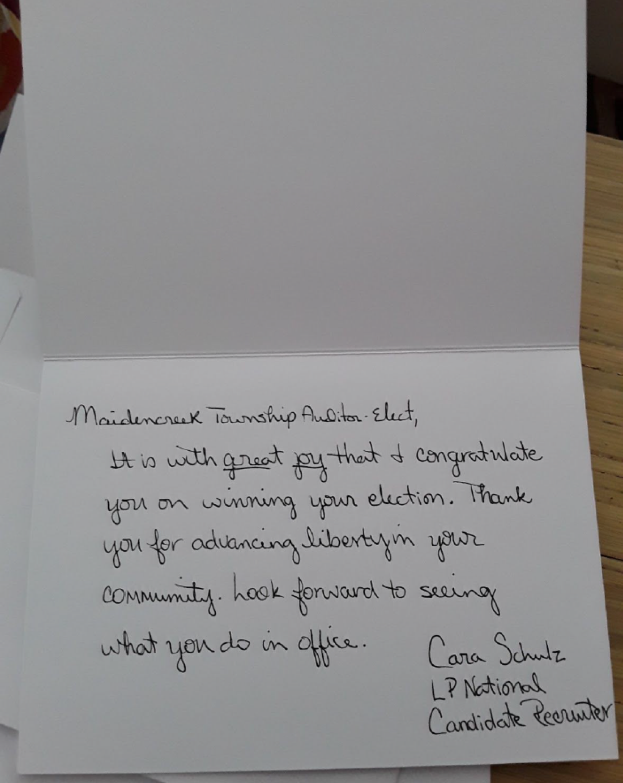

Challenges
Time: For the 2019 election year my hours were reduced to up to 20 hours per week due to budget constraints. Most weeks I continued to work 40 hours per week, while billing for 20. In the 2020 election cycle I will not be able to maintain this work schedule as I need to take on side contracts to make up the monetary difference to bring me up to 40 hours paid. For 2020, if my hours for the LP National remain at 20 per week, my work load will need to be reduced and reprioritized. If my hours change to 40 per week, I will not accept other contract work.

Partners: We are still facing extreme churn in State Affiliates and lack of designated Political Directors. Burn out, lack of communication, lack of training is hampering many State Affiliates. My suggestion is to implement in person State Affiliate Training for each position, by region in odd number years in the Spring and have this as a line item added to the budget. In even number years, this training can be held at the National Convention. Instead of 1 of me, or Jess, or Andy, or Dan (for example) we need 51 of them.

Not able to implement/ shelved due to budget cuts or time constraints

Won 1, Win 1
- Project for all past and currently elected Libertarians.
- Our elected Libertarians are our best resource for increasing the number of elected Libertarians.
- Implementation by one on one phone calls with each of our elected officials in month of January 2019
- Data needed (contact information, dates of office, offices open for run and dates)

Elected officials often hear about seats that the incumbent will not run for reelection before the general public. Races which do not feature an incumbent are easier to win (as incumbents are reelected at a 90% or higher rate). They also know what seats are often appointed due to lack of candidates. They know which Commissions will have openings and how to get selected for them (such as City Planning Commission or Parks Commission). Additionally, they have developed relationships with influential people in their area, have established donor networks, and volunteers. They also know how to win a campaign in their area.

If each of our elected Libertarians committed to finding one local level race (during a year when they are not up for reelection) to target, helped recruit a candidate, and then ACTIVELY mentored the campaign, we could conservatively increase the number of elected Libertarians by 24% every 2 years. We could also start building voting blocks on local governments. Residents could experience the benefits as Libertarians played an increasingly prominent role in city and county government.

Actively mentoring the candidate means more than offering the occasional advice. It means helping the candidate with their campaign plan, introducing them to community leaders, connecting them to donors and volunteers, and knocking doors and making phone calls.

The benefit to the elected Libertarians is they would no longer be so isolated in their seat. They wouldn't a solo vote, but would be able to implement Libertarian solutions to the challenges their residents face.

Campaign in a box

In winter of 2018, we were less than 7 design hours away from being able to offer local candidates a free (hosted) website with donation and volunteer processing, campaign lit design, and a yard sign design. There were three basic designs to choose from and candidates simply filled out a webform to populate the design templates. There was a minimal amount of staff time to look over and make small changes. The websites had been tested during the 2018 campaign year and were solidly functional and attractive.
The websites, and the campaign in the a box, were placed on hold during budget cuts. LP National may now be exploring other options for candidates, some of which are contracted services with a 3rd party vendor.

Monthly Political Director Calls. This was put on hold due to time constraints and the difficulty in keeping current contact information with frequently changing Political Directors. Will work on setting this up for 2020 as a priority.

Slack channel: there is a slack channel for candidates and campaign teams, but it needs staff time to spark conversation. As of now, it is a dead channel without much use.

Changes
Prospective candidate intake change. All prospective candidates who are not yet members of National will be forwarded to Jess Mears to encourage membership. Tyler Harris will then get their information so they can take part in a New Member Hangout (video conference call) and learn more about the LP.

Gideon Oakes
Publications Editor / Media Specialist Q3 2019 Report

Summary
I had the privilege of joining LPHQ in early September as a replacement for the late Eric Dixon. As my skill set closely mirrored Eric’s, I was given editorship of the LP News, the Liberty Pledge and other visual communications platforms as well as the opportunity to become the party’s in-house graphic designer. As I approach two months with the party, I am proud of the accomplishments I’ve been able to achieve, and the learning curves I’ve been able to straighten out.

Per my contract, my job description is, “Facilitate the Libertarian Party’s media operations, as directed by LPHQ.”
Specific duties include:
- Tools and Technology: Employ and leverage new and existing technology platforms to help the party with media matters. This includes their web presence, physical publications, graphic design, online donation acceptance, email services, voter ID, etc.
- Marketing: Help the party with marketing and support materials by providing professionally designed materials for campaigns, and assist all members of LPHQ with material creation as requested.
- Archiving and Information Architecture: All work done by the contractor *must* be available in the cloud. The Contractor will diligently ensure that all work done is stored in the LP’s google drive structure, and make sure that all work is named and organized in a method to facilitate others accessing it.
- Proofreading and Content Generation: As needed.
- Feedback: Explore and investigate strategies to help state and national parties work more efficiently.

Time Tracking
For reporting purposes, I have broken my work down into five categories: Publications Layout & Editing, Graphic & Web Design, Press Release / Content Development, Meetings & Phone Calls, and Administrative.
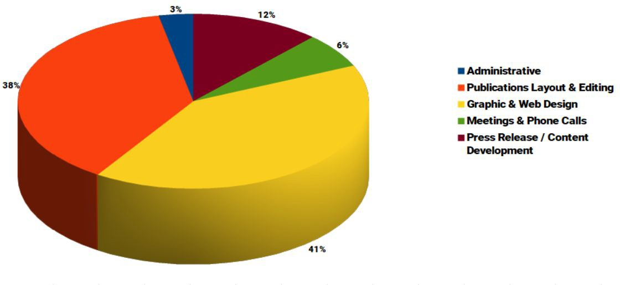

(Please note that Administrative work is likely underreported and absorbed into other categories as it would be time-prohibitive and inefficient to switch my timer every time I need to read an email or answer a message.)

Publications Layout & Editing
As my job title indicates, publication editing is a large function of my position. I have spent a good deal of time on our two main print publications, as well as editing copy for emails and blog posts when possible.

- LP News: Unfortunately, any work Eric had performed on the third issue of the LP News was on his personal laptop and not accessible to staff after his unexpected passing. (This liability has been addressed by Dan for future instances.) As a result, I had to start work on the layout from nothing but the last issue’s template file. I finished my layout about a month after my start date, and that issue should hit mailboxes by the time this report is delivered. The fourth issue is in pre-production planning, but there is also discussion of moving straight on to the Q1 2020 pre-convention issue since the third issue came out so late due to uncontrollable circumstances. Watch for design updates in the new year.

Despite my deeply ingrained love of newsprint, I believe it would ultimately be beneficial to move the LP News to an interactive digital platform such as Issuu.com. Not only would it eliminate a significant cost center in printing, it would also enhance reader experience through interactivity, increase impulse-based CTAs (including donations) and significantly reduce lag time in the production process. (It currently takes approximately one month from finished design to printed product delivery.)

- Liberty Pledge: One of my objectives has been to make Liberty Pledge more visually interesting. As it is a monthly newsletter printed in black and white, my options are a bit limited in that regard, but I took great pleasure in reading APRC feedback from an LNC member who called my last design, “Very eye-catching!” My colleague, Jess Mears, has been exceptionally timely in collecting content for the Liberty Pledge. As a Membership project, I have and continue to defer to her frequently regarding deadlines and editorial judgment. Together, we have published two issues, and the third is headed to the printer this week.

Graphic & Web Design
I have spent a significant amount of the last two months working on several graphic and web design projects:

- Vape.vote was the first issues-based site on which I worked. The site was created in response to the president’s recommendation for a federal ban on flavored vaping products. More than 12 million adults use vaping products, and the site has become a rallying point for vapers to share their stories and receive news headlines and legislative action alerts. As of this report, more than 450 individuals have signed up for action alerts.

- LP.org/antiwar, LP.org/impeachment and LP.org/redflag were more issues-based landing pages we developed to tie-in fundraising efforts with current issues.

- WeDeserveBetter.LP.org is currently under development and will be focused on data harvesting and fundraising, reaching out to voters tired of the political theatre in D.C. This site is significant as its backend will serve as somewhat of a framework, ultimately being duplicated with other "flavors" to replace and/or enhance some of our current issues-based sites like 23Trillion.org, AmericaAtPeace.com and Vape.vote, as well as future ones. Currently, these issues sites are merely data harvesters. Once updated, they will be data harvesters AND (hopefully) revenue streams — all the while eliminating a fairly hefty annual cost from our previous landing page host.

- I have had the pleasure of creating and editing numerous graphics for internal departments such as membership emails, LPStore.org products, literature/collateral and campaign-related events.

- Finally, Dan has tasked me with a redesign of the LP.org front page for 2020. The project does not yet have a full scope or timeline, but I would like it to coincide with any new design element changes in the LP News.

Press Release & Content Development
In addition to content for the above-mentioned web projects, I have written several press releases, blog posts and articles. We will be partnering with a couple of volunteer content authors in the near future, which will reduce budget overhead while magnifying our reach. One fun item to note: While our social media presence is not within the usual scope of my position, I did have the privilege of designing a meme about Beto O’Rourke which subsequently became the party’s widest-reaching post, ultimately finding its way to more than 712,000 people.

Meetings & Phone Calls / Administrative
I have done my best to be at every daily standup meeting, and I had a great record until I took off a couple weeks for paternity leave. During that time, my attendance record was unfortunately imperfect, but I have been assured I’m forgiven in this instance. I’m also working to become better at time-blocking, specifically when it comes to answering emails and non-urgent instant messages. It is very easy to get sidetracked when a new project or message comes in. I’m not terrible in that regard by any means, but there is always room for improvement.

Goals for Q4 2019
- Continue to bring cohesive branding to all LP designs
- Work on ways to reduce lag in publication production process
- Freshen up looks of LP News and Liberty Pledge
- Work on time-blocking skills
- Continue my migration into a full-time capacity, and out of other non-LP responsibilities

###

Ken Moellman
“Staff” Report
For Miami LNC Meeting on 11/16/2019

Hi. I’m Ken. As the member of “Staff” who is a volunteer, I do as much as I can, when I can.
Services Consolidation
We performed a big migration a few months back. We consolidated disparate resources into one central server, allowing us to spend the same amount of money but significantly upgrade the State CRM server. The LPmail service, which hosts email LP.org and multiple state parties, now rides as a “piggy back” on the main CRM server.

We also cloned the production server to create a Staging server. This allows all changes to be tested prior to being put into production. This is a very good practice which we sought to implement soon after Dan Fishman came on-board, and has been enabled by the consolidation of services on the new server.

The CRM is much faster after the migration.

We moved the ticket server, which some LP Staff and a few state affiliates use, to the consolidated server as well. The ticket system software was upgraded immediately after migration to the latest available version.

We implemented backups. Backups run to my dev lab for the time being. They are sent and stored encrypted. If the new server failed critically, we would be back online in approximately 24 hours or less.

I am still working on getting the lab environment completely up and running. The hardware is in place, the internet connectivity is in place. However, VPN access is not yet configured, and an automated process to scrub live data has not yet been developed. The lab was enabled, in part, by a donation from a generous donor. Also on the to-do list is possibly adding a generator to the lab environment, in case of power failure, if the lab is to be used as the “disaster recovery site”, which has been discussed but not decided.

Assisting staff and states

I help Andy when I can. I can’t always help, and due to having a full-time job I often can only help at night, outside of normal working hours for Andy. (Though Andy and I still do a lot of work at odd hours, but we each also have spouses, too.)

I have assisted with multiple maintenance windows. Generally this is taking an online backup of the system prior to patches and upgrades. I also patch and upgrade the Operating System. Andy handles CiviCRM and Wordpress updates.

As the IT Director for LP Kentucky, I also get the “state leader” experience to help suggest improvements for the State CRM project.

I have been trying to learn more of the “front end” of CiviCRM as well, both as a state leader and system administrator. The latter is still very much Andy’s realm, but to any extent I can help Andy keep building out the front-end, I’m willing to do it - time permitting.

I helped move Jess Mears’ massive Inbox to the new LPHQ.org email domain. This took approximately a weekend to complete. (Friday mid-day through Monday morning)

I also help states with Email implementations, issues, etc.

I set up a server for the IT Committee to implement Moodle. Alex Merced set the server up, but something went wrong and filled up all of the allocated disk space on that virtual server; it was corrupted beyond repair. I re-implemented that server, installed Moodle, and made sure that the server was locked down. It is up and ready for testing, but the IT Committee is also investigating other technologies.

Growth and Expansion

I am extremely excited about the roll-out of the County User portion of the State CRM. I am sure I will be helping Andy with parts of this roll-out and improvements. Andy and I squashed some of the last few bugs ourselves, making us familiar with the code and preparing it for production.

I have not been involved with the Membership Dashboard project, due to time constraints, but I’m excited to see that happen and I hope that I can be of assistance with that project in the future, if necessary.

I’m going to try to improve the onboarding process, so that we can bring more states online. We’re backed up, due to demand. The process of brining in a state’s data is pretty brutal, so anywhere where we can improve this process will save a lot of time and energy.

We have room to grow! If there’s a really cool IT project that we want to try out, it can probably fit, at least as a test, in our current infrastructure. This should be the case until we get more states into the CRM. It appears as though we have enough room to bring all 50 states plus DC into the system, if they all decide to participate. Participation is optional, of ourse.

Challenges

My primary challenge is having the time to do the job. I do wish I could help more, and I expect that in Spring 2020 I will have more time to help Andy and other staff with IT needs, as I work to hand-off some of my other commitments to other portions of the party.

- Daily - Receive mail and other deliveries: open and distribute, and process bouncebacks to obtain new addresses (use AlumniFinder or send email)
- Daily - Enter into Raiser’s Edge mailed-in donations (checks and charge authorizations), make data corrections, process merchandise fulfillment, deposit checks in bank account, and pursue charge authorization failures with donors (phone and/or emails)
- Thrice weekly - Enter into Raiser’s Edge the online donations, purchases, and memberships (new and renews)
- Thrice weekly - Merchandise fulfillment of orders from LPStore and promotions
- Weekly - Order member cards from vendor, then print, stuff, and frank letters for new and renews
- Weekly - Print, stuff, and frank acknowledgments (thank-you letters and postcards)
- Monthly - In-house generated pledge checks entered into Raiser’s Edge and deposit in bank account
- Monthly (approx) - Print, stuff, and frank mailings in response to inquiries
- Monthly (approx) - Layout, print, stuff, and frank In-house mailings
- Regularly - Report low supply levels (branded office, general office, merchandise, cleaning)
- Regularly - Restock inventory
- Annually - Prepare pledger member cards mailing
- Bi-Annually - Perform required assistance for National Convention (acknowledgments, shipping supplies, etc.)
- Assign above tasks to Assistant as needed Mat Thexton, External Affairs


Membership Department Report November 2019
Submitted By: Jess Mears

Considering this LNC meeting will focus on the budget, I would like to present a brief membership report depicting the importance of the LNC’s membership program for the organization’s operational revenue. With the departure of Lauren Daugherty as the Development Director, I set an autonomous goal for membership revenue in the amount of
$80,000 each month. The revenue streams related to membership include pledge revenue, online, and mailed memberships.

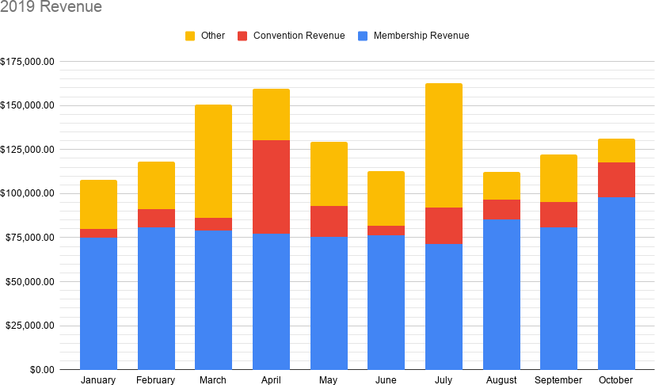

The other category includes revenue from: ballot access, LPstore.org, Chair solicitation, Executive Director solicitation, house fundraising appeals, historic preservation, prospecting, web non-membership donations, LP News sponsorships, building donations, and legal offense donations.

It is my intention to convey the importance of the LNC’s membership revenue via this stacked column chart.

Setting a revenue goal for membership revenues allowed me to establish a program to achieve this goal, and I am proud to share that this goal has been achieved each month since established in August.

To increase revenue and membership numbers, I have recommended in past reports that the LNC implement one-click donation processing, improve donation forms, and invest in email segmentation. In the past report, I highlighted email deliverability (our emails are getting sent to spam folders) as a severe issue impacting membership growth. This issue has not been resolved. The elimination of IContact (email service provider) from the stable of services at the staff's disposal has further hindered email deliverability.

Tyler Harris External Relations Associate
Prepared November 2019

Effective August 2019, my role transitioned from Member Services to the newly created role of External Relations. While some of my responsibilities and day-to-day tasks remain similar to those outlined in prior staff reports, this change reflects a shift in emphasis and expanded autonomy in areas relating to direct interaction with constituents and members. My area of responsibility has also expanded to include the operation of LPStore.

Membership Communication and Interaction
An important component of our long-term membership success is creating good experiences, demonstrating value, and ensuring that interactions are helpful and positive. It’s through these efforts, which can be described in simplified form as “good customer service” that we ultimately encourage constituents to become members, lapsing members to renew, and renewing members to upgrade to a higher level of member support. To that end, my key responsibilities include:

  - Monitoring and responding to member emails sent to info@lp.org (the main email address of the Libertarian Party, which is both listed on LP.org and set as the reply path for most of our outgoing email solicitations). This inbox can, at times, receive over 100 emails in a day, and common tasks include assisting with membership-related questions, answering queries about the platform and issue positions of the party, responding to member feedback on recent outgoing communications, and helping to connect constituents with their local/state affiliate parties.
  - Answering the “General Questions” communications originating from the LP.org webform, as well as the corresponding phone tree option via 1-800-ELECT-US
  - Receiving and processing member change of address, change of email, and manual email unsubscribe requests submitted either via email or via our various webforms on LP.org
  - Placing thank-you calls to new Liberty Pledge members
  - Organizing, promoting, and conducting weekly Member Welcome Hangouts

Member Welcome Hangouts
Beginning in June, I began hosting a regular weekly Google Hangout targeted towards new members and existing members looking to become more involved with the party. The events include a short (10-15 min) presentation focusing on the online resources available to our members and how to connect with their state and local affiliates regarding events and opportunities for outreach in their area. The remainder of the hour-long session is devoted to answering member questions and discussing in more detail topics of interest to those in attendance.

The goal is to help bridge the gap for members new to the national party who have not yet made a connection with their local parties and may not know where to begin. They also offer an additional opportunity to express our gratitude to new members, to encourage more active involvement in the LP, and to be available to answer member questions and/or assist with issues our members may be experiencing.

This opportunity to interact with our new members face-to-face on a direct and personal level is often the highlight of my week. Attendance is typically only 2-3 members, but the smaller setting has more often than not fostered active participation and a more comfortable, conversational atmosphere. Participant feedback, both solicited and unsolicited, has been quite positive. As of this writing, Member Welcome Hangouts have had 67 participants out of a total of 168 who have expressed an interest via their RSVP.

LPStore & Purchasing
I also oversee the day-to-day operation of LPStore, with the ultimate oversight and approval of the Executive Director. Regular tasks relating to the operation of LPStore include:

- Directing the development, pricing, and marketing of new and existing LPStore items
- Tracking and maintaining accurate inventory counts for LPStore, manually decrementing mail-order, in-person, and membership promotion items, and conducting inventory
hand-counts as needed
- Periodically obtaining competitive quotes on commonly ordered items to ensure we continue to benefit from the best available pricing
- Establishing and maintaining vendor relationships, and managing ordering and reordering of LPStore merchandise as well as packaging and mailing supplies
- Assisting Operations Director Robert Kraus with the organization and filing of vendor invoices and other related records

The Future of LPStore
The Pareto Principle generalizes that in most organizations and endeavours twenty percent of the effort generates eighty percent of the results, while eighty percent of the effort is put into creating the remaining twenty percent of results. In its current form, LPStore represents a significant expenditure of effort (in the form of staff time, postage, the cost of maintaining substantial and illiquid on-hand inventory, time spent seeking out new products and developing new designs), while accounting for only a small share of our results (in terms of revenue to sustain the party’s ongoing operations).

As such, under the direction of the Executive Director, I have begun exploring options to outsource fulfillment of LPStore’s branded apparel and promotional items, with a goal towards eliminating or greatly reducing the in-house effort required to provide these items by May of 2020. Our existing vendor for many of these items is in the process of developing a system that may align well with both our needs and our timeline. That said, we will also explore other available options before making a recommendation. It is my goal that any option moving forward, at a minimum, meet the following criteria: ease of use for our members and constituents, the ability to support a variety of products and designs at least comparable to our current offering, our complete control over product design and messaging, reasonably rapid delivery timeframes and attentive customer service, information sharing on orders so as to facilitate the continued addition of customers to our constituent database, flexibility on setting item prices, and revenue sharing.

Items that remain core to the operation of any political party, such as literature, signs, buttons, and stickers would continue to be stocked and fulfilled in-house.

Issue/Interest Segmentation and Targeting
Several months ago, with the assistance of Operations Director Robert Kraus, we implemented into our database a system for noting our constituents interests in, and aversions to, specific issues. Since then, data entry into these fields has been occuring on a gradual, ad hoc basis as communication is received from constituents expressing opinions on particular issues. At the time of this writing, I am in the midst of undertaking a more systematic effort to review prior mail appeals to determine which have centered around our position on a specific issue, so that we can capture the support of that issue from those who have supported the given appeal. My intention is to cover all issue-based appeals from 2005 to present.

This will have two important benefits. Firstly, it will allow us to make better use of targeting issue-based messages to constituents who have already indicated to us their receptiveness. Secondly, it will give us the opportunity to develop and test batch updating this database field across a larger number of constituents — a necessary process if we are to use this in the future in conjunction with member surveys or other large-scale projects.

Member Services
In addition to the areas of responsibility outlined above, I remain the primary backup for Mat Thexton and assist as needed with various core Member Services tasks, including (but not limited to):

- The timely, efficient, and accurate fulfilment of LPStore orders
- Preparing and mailing membership cards for new and renewing members, inquiry packets, and those fundraising appeals generated in house.
- Sorting and processing incoming mail
- Stocking new inventory when it arrives
- Inputting and updating member information into our database, and cross-checking existing information for accuracy
- Maintaining the general state of readiness and organization in our HQ Operations Center

Election Night Live Stream Coverage
Finally, I would be remiss not to mention my role in the recent election night live stream. Cara Schulz deserves full credit as the impetus behind this event. Because of my experience with regular web conferences (like the weekly Member Welcome Hangouts), Cara asked for my assistance as co-host early in the planning stages. Together, we extensively tested the existing technology at our disposal and developed a process flow and division of labor to make the event work.

In addition to being on air for the full 4-hour run, I was also responsible for establishing and maintaining both the feed and the backup recording of the event, for determining which incoming camera to spotlight and switch manually between fullscreen and multi-box images for the feed, for monitoring and communicating to Cara when guests were connected and ready to be introduced, and for promoting guests onto the panel and returning them to regular attendee status at the appropriate times.

Due to the collaborative efforts of all involved, the election night coverage received very positive feedback, and at the time of my writing this report has been viewed nearly 16,000 times.

APPENDIX H – SPECIAL COUNSEL’S REPORT

MEMORANDUM

TO: Libertarian National Committee

FROM: Oliver Hall

DATE: November 14, 2019

SUBJECT: Special Counsel’s Report

Introduction

This report summarizes my work as Special Counsel to the Libertarian National Committee since I last submitted a report on July 26, 2019. The report is a privileged attorney-client communication, but only relates facts, and not legal advice. As such, it may be appropriate for sharing with a wider audience, including members of the Libertarian Party, at your discretion.

General

As Special Counsel to the LNC, I have reviewed documents and correspondence, responded to questions, and provided legal advice and services on a variety of matters as needed or requested. In particular, I researched and resolved queries involving: construction of Policy Manual as applied to independent contractor contracts; publication of online content; compensation to deceased employee; state party affiliate’s acceptance of bequest; and proposed litigation against FEC.

I also provided the following services:

- Coordinated disbursement of escrow funds for state party affiliate;
- Reviewed FEC decision on debate sponsor complaint and provided counsel;
- Provided counsel to state party affiliate preparing response to FEC complaint.

Finally, I drafted or reviewed and approved multiple contracts, including those executed with the following: 2020 National Convention hotel and addendum; 2022 National Convention hotel; External Relations Associate; Development Director; Development Associate; and fundraising contractor.

Litigation

Arizona Libertarian Party v. Reagan, No. 2:16-cv-01019 (D. Ariz. April 12, 2016), No. 17-16491 (9th Cir. July 21, 2017): This case challenges Arizona’s newly enacted law that drastically increased signature requirements for Libertarian Party candidates seeking access to AZLP’s primary ballot. It requests declaratory and injunctive relief. The Plaintiffs sought preliminary relief in time for the 2016 election, which was denied. Thereafter, the parties conducted discovery and filed cross-motions for summary judgment. On July 10, 2017, the District Court granted summary judgment to the state. The Plaintiffs appealed to the 9th Circuit. Briefing on the appeal was completed in April 2018 and oral argument was held on March 12 in San Francisco. The 9th Circuit affirmed on May 31, 2019. Plaintiffs’ petition for certiorari is due December 8, 2019. (I represent the Plaintiffs outside the scope of my representation of the LNC.)

Cowen v. Raffensperger, No. 1:17-cv-04660 (N.D. Ga. Nov. 21, 2017), No. 19-14065 (11th Cir. 2019): This case case challenges the Georgia law requiring that candidates for U.S. House submit nomination petitions with signatures equal in number to 5 percent of the registered voters in the last election. No candidate has ever complied with that requirement since the law was enacted in 1943. Plaintiffs are individual voters and the Libertarian Party of Georgia. The District Court granted summary judgment to Defendants and Plaintiffs appealed. Plaintiff-Appellants filed their opening brief in the 11th Circuit on November 13, 2019. Plaintiffs’ counsel is Brian Sells: (404) 480-4212; bryan@bryansellslaw.com.

Level the Playing Field v. Federal Election Committee, No. 1-15-cv-01397: This case challenges the FEC’s failure to act upon, and constructive denial of, an administrative complaint against the Commission on Presidential Debates. On February 1, 2017, the Court granted Plaintiffs’ motion for summary judgment and denied Defendant’s motion. The Court remanded the case to the FEC with instructions to reconsider the evidence and allegations and issue a new opinion within 60 days. The Court also ordered the FEC to reconsider Plaintiffs’ petition for rulemaking and enter a new decision within 60 days. In March 2017, the FEC issued a new decision that upheld its prior position. The case is now back before the District Court, and the Plaintiffs have filed a supplemental complaint. The parties filed cross-motions for summary judgment. On April 21, 2019, the District Court denied the plaintiffs’ motion for summary judgment and granted the FEC’s motion. The plaintiffs have appealed. Plaintiff-Appellants filed their opening brief in the D.C. Circuit on September 26, 2019. Plaintiffs’ counsel is Alexandra Shapiro, Shapiro Arato LLP: ashapiro@shapiroarato.com; 212-257-4881.

Libertarian National Committee v. Federal Election Committee, No. 16-cv-0121: This case challenges the FEC’s treatment of a bequest from Joseph Shaber, deceased, to the LNC, which imposes an annual limit on the amount of the bequest that may be distributed to the LNC. The FEC filed a motion to dismiss, which the Court denied on January 3, 2017. The parties have taken discovery. In September 2017, Plaintiff filed a motion requesting that the District Court certify certain questions of law to the D.C. Circuit for decision. In October 2017, the FEC filed a new motion to dismiss. On June 29, 2018, the District Court granted Plaintiff’s motion and denied the FEC’s motion. The District Court certified the questions of law to the D.C. Circuit. Briefing of the appeal was completed in October 2018. The D.C. Circuit ruled for the FEC on the merits in May 2019. Plaintiffs filed a petition for certiorari with the Supreme Court on August 19, 2019. The case has been distributed for the Court’s November 22, 2019 conference. Plaintiffs’ counsel is Alan Gura, Gura & Possessky: alan@gurapossessky.com; 703.835.9085.

Libertarian Party of Maine v. Dunlap, No. 1:19-cv-00509 (D. Me. 2019): This case challenges several provisions of Maine law governing the establishment of new political parties. LPME initially complied with these provisions by enrolling 5,000 members prior to the 2016 general election. It was therefore ballot-qualified for the 2016 and 2018 general elections. To remain ballot-qualified, however, it was required to double its enrollment to 10,000 members, and to ensure they all voted in the 2018 general election. At the same time, it was required to nominate by primary election, but Maine’s primary election ballot access requirements are impossible or near-impossible for LPME candidates to meet. Consequently, LPME could not run any candidates in the 2018 general election, and it failed to ensure that 10,000 LPME members voted in that election. The party was thus disqualified and its 6,168 members unenrolled. LPME is seeking a declaration that these provisions are unconstitutional and injunctive relief as needed to become ballot-qualified again. Plaintiffs’ complaint was filed November 1, 2019. (I represent the Plaintiffs outside the scope of my representation of the LNC.)

Libertarian Party of Minnesota v. Choi, No. 1:19-cv-02312 (D. Minn. 2019): This case challenges a statute requiring that signers of a minor party candidate’s nomination petition swear that they will not vote in the primary election. Violation of the statute is a felony, perjury, punishable by five years in jail and $10,000 in fines. Signers of major party nomination petitions do not swear to the same or any similar oath. Plaintiffs filed their complaint on August 21, 2019. Plaintiffs’ counsel is Erick G. Kaardal, Mohrman, Kaardal & Erickson, P.A.; 150 South Fifth Street, Suite 3100, Minneapolis, MN 55402; (612) 341-1074; kaardal@mklaw.com.

Conclusion

I look forward to discussing this report with the LNC during its next meeting. Should you have questions or need further information prior to that time, please contact me at 202-280-0898 or oliverbhall@gmail.com.

MEMORANDUM

TO: Libertarian National Committee

FROM: Oliver Hall

DATE: November 15, 2019

SUBJECT: Addendum to Special Counsel’s Report Dated November 14, 2019

Introduction

This Addendum to the November 14, 2019 Special Counsel’s Report is submitted for the purpose of providing members with notice that the Libertarian National Committee has received a request that it file a brief as amicus curiae in support of the petitioner’s petition for certiorari in United States v. Salgado, No. 18-10312 (11th Cir. July 8, 2019). The request comes from petitioner’s counsel, Dan Alban of the Institute for Justice. The Heritage Foundation is helping to coordinate the effort. The Heritage Foundation memo setting forth the request is reproduced below. Thereafter follow six proposed topics for potential amicus briefs that Dan Alban provided. Additionally, the 11th Circuit decision from which the petition arises is attached hereto.

The petition for certiorari has not been filed yet. It is due on November 19, 2019. Assuming the petition is filed on that date, the deadline for filing amicus briefs will be December 19, 2019.

Heritage Foundation Memorandum

TO: Legal Strategy Network

FROM: The Heritage Foundation

DATE: October 25, 2019

RE: Cert. Stage Amicus Request & Call – United States v. Salgado (Civil Asset Forfeiture Attorney Fees)

This case involves a civil asset forfeiture proceeding where the prevailing property owner was denied attorneys’ fees under the Civil Asset Forfeiture Reform Act (CAFRA) because the case was dismissed without prejudice.

CAFRA provides that the government must pay attorneys’ fees “in any civil proceeding to forfeit property under any provision of Federal law in which the claimant substantially prevails.” The purpose of this provision, as indicated by the language of the bill that passed this into law, is for claimants to “make themselves whole after wrongful government seizure” and to provide a disincentive for the government to file frivolous forfeiture lawsuits.

In 2015, Miladis Salgado’s home was raided based on a confidential informant’s false tip that her then-husband was a drug dealer. In addition to seizing approximately $200,000 in cash and checks from her then-husband’s garment importing business, the police found a separate bag in Miladis’ closet containing $15,000. Miladis had been saving this money to spend on her children, including for her teenage daughter’s quinceañera.

The federal government ultimately attempted to forfeit both Miladis’ and her now-ex-husband’s money. During that forfeiture case, the police admitted in depositions that they had no evidence supporting any of their claims. With summary judgment in favor of Miladis and her ex-husband finally on the horizon two years after the seizure, it became clear that the government would not only need to return the money but would also be on the hook for Miladis’ and her ex-husband’s attorneys’ fees. Realizing that it was about to lose the forfeiture lawsuit, the government leapt at the fact that a default judgment had been entered in a separate lawsuit involving her ex-husband’s business (a contract dispute with a supplier) and asked the judge to dismiss the case without prejudice so that the money could be used to pay the default judgment. Miladis’ money was not implicated in the contract dispute lawsuit.

Miladis’ (and her ex-husband’s) forfeiture attorney objected to the dismissal without prejudice and argued that the dismissal should be with prejudice. Nonetheless, the court granted the government’s requires to dismiss without prejudice. While doing so, the court ordered that any attempt by the government to refile the forfeiture action would result in an automatic award of costs.

Pursuant to the court’s order, Miladis’ money was returned to her, so she sought an award of attorneys’ fees. Under any reasonable understanding of the term “substantially prevailing” party, she would qualify. After all, she obtained the full refund of her money, and she even obtained a court order barring the government from trying to seize her money again. Unfortunately, the court decided to follow the approach taken by most, but not all, circuits. The court ruled that the fact of dismissal without prejudice meant that Miladis could not obtain an award of attorneys’ fees, and the Eleventh Circuit affirmed.

Miladis will petition the Supreme Court for review. The tentative questions presented are (1) Whether a claimant in a civil forfeiture lawsuit who successfully obtains the full return of the money seized from her, as well as a court order preventing any future forfeiture lawsuit against her money, is a “substantially prevailing” party and therefore entitled to an award of attorneys’ fees and costs, even though the dismissal was entered without prejudice; and (2) Whether it was an abuse of discretion for the district court to dismiss the civil forfeiture lawsuit without prejudice two years after the claimant’s money was seized and when it was clear that the civil forfeiture lawsuit would never be refiled.

This case may be of interest to the Supreme Court for several reasons. The Eleventh Circuit’s ruling is in tension the Supreme Court’s recent opinion in CRST Van Expedited v. EEOC (2016), where it held that a favorable ruling on the merits is not required to be a “prevailing party” in a non-forfeiture context. Moreover, there is a circuit-level disagreement over how much judicial relief is necessary for a claimant to qualify as a “substantially prevailing” party, and the unfortunate conflation of the “substantially prevailing” and “prevailing” standards is contrary to the statute’s plain text. Finally, the second question presented is also aided by a circuit split, albeit not a particularly deep one. Most circuits have relied on the broad discretion given to trial courts on this issue to affirm decisions to dismiss without prejudice in this situation. However, in its unpublished opinion in United States v. Ito (9th Cir. 2012), the Ninth Circuit disagreed, finding the district court’s dismissal without prejudice under similar circumstances to those at issue here to be an abuse of discretion.

-End-

Proposed Topics for Potential Amicus Briefs

- How the legislative history shows the original purpose of CAFRA’s fees provision was to make victims whole, but that’s rarely happening in the current system

- The original public meaning of “substantially prevail” from other statutes and case law

- That when your money is seized, yo​ur primary goal is to obtain the return of your money and that alone should be considered “substantially prevailing”

- The practical problem of the disparity in negotiating power when police seize someone’s money and then offer to split the money 50/50 as a settlement

- The practical difficulty/impossibility of getting attorney’s fees in CAFRA cases under these standards and how that affects indigent claimants

- The incentives created when judges allow law enforcement to evade financial responsibility for the harms they have caused as long as they move to voluntarily dismiss the lawsuit without prejudice – ideally signed by public choice or other economists/academics

Conclusion

I look forward to discussing this Addendum with the LNC during its next meeting. Should you have questions or need further information prior to that time, please contact me at 202-280-0898 or oliverbhall@gmail.com.

APPENDIX I – AFFILIATE SUPPORT COMMITTEE REPORT

Affiliate Support Committee Report

- The affiliate support committee LP Everywhere 1000 dollar give away contest went well. Submissions were sent in from around the country, and now the voting process will start after the weekend.
- John Phillip’s put together a spreadsheet for all the submissions.
- Pat Ford is working on putting together a complete list of libertarian forward media to build a coalition of podcasters to get affiliate reps and candidates on.
- Committee is still working on putting together institutional continuity packet for affiliate building.
- Chair had talk with Daniel Fishman ED about giving password to the ASC for lpaction.org so that this committee can start building more modules to help candidates and affiliates of all levels.

APPENDIX J – AWARDS COMMITTEE REPORT

2020 AWARDS COMMITTEE REPORT

Submitted to: Libertarian National Committee, Nov. 8, 2019

Submitted by: James W. Lark, III
Region 5 Representative, Libertarian National Committee
Member, 2020 Awards Committee

The members of the 2020 Awards Committee are Tim Hagan, Jim Lark, and Bill Redpath; these members were elected by the LNC during the July 2019 meeting in Austin, Texas. Two additional people must be selected to serve. If the custom for the previous four committees is observed, the two additional people will not be LNC members.

Once the Committee is fully constituted, I shall suggest that the Committee prepare articles soliciting nominations for the 2020 awards. These articles should appear on LP.org and in at least one issue of LP News. In addition, the Committee should prepare a solicitation for nominations to be distributed at least once to the LP e-mail list.

I recommend that the nomination period end by April 1, 2020; I believe the period should end no later than April 15, 2020. This should provide the Committee sufficient time to accomplish the following tasks:

* To determine the inductees for the Hall of Liberty and the recipients of the several awards (Thomas Jefferson, Samuel Adams, Thomas Paine, Patrick Henry, and Benjamin Franklin)
* To order and receive the awards to be presented to the inductees and recipients
* To organize the award presentations to take place during the national convention.

Information about the Awards Committee, the awards, and previous inductees and recipients is available in the appendix.

APPENDIX
From the LNC Policy Manual:
Section 2.02 (Committee Scope and Responsibilities)
5) Awards Committee
For the convention awards described below, the Awards Committee shall set the budget, manage the nomination process, select the award winners by committee vote, secure the awards, and present the awards at the convention.
The award descriptions are:
Thomas Jefferson Leadership Award with recognition of outstanding leadership, high character, and dedication to the principles and goals of the Party.
Patrick Henry Candidate Award with recognition of a very effective campaign for public office at the state or federal level, while communicating Libertarian ideas, principles, and values.
Benjamin Franklin Candidate Award with recognition of a very effective campaign for public office at the local level, while communicating Libertarian ideas, principles, and values.
Thomas Paine Communication Award with recognition of outstanding communication of Libertarian ideas, principles, and values through written, published, or spoken communication.
Samuel Adams Activism Award with recognition of effective activism by building Party membership, organizing community outreach, or communicating Libertarian principles.
The Hall of Liberty induction is to honor lifetime or significant achievement that has made a lasting impact on the Libertarian Party and/or libertarian movement.
With a majority vote the committee may select recipients of the Thomas Jefferson, Samuel Adams, Benjamin Franklin, Thomas Paine, and Patrick Henry awards. While the committee has discretion as to the frequency of such convention awards, it is hoped that at least one recipient will be found worthy for each award at each regular convention.
With a unanimous vote the committee may select recipients of the Hall of Liberty award, with up to 3 inductees per convention. While the committee has discretion as to the frequency of this convention award, it is hoped that at least one recipient will be found worthy for each presidential nominating convention.
Recipients of Libertarian Party Awards:
Benjamin Franklin Award:
2018: Jeff Hewitt
Patrick Henry Award:
2012: Lex Green, Travis Irvine
2014: Rupert Boneham, Robert Sarvis
2016: Will Hammer
2018: Mark Miller
Samuel Adams Award:
1996: Don Ernsberger
1998: Steve Dasbach
2000: Richard Rider
2002: Bruce Baechler
2004: Jim Lark
2006: Michael Badnarik
2008: Bill Hall
2010: Michael Johnston, Kevin Knedler
2012: Clyde Garland
2014: Hardy Macia
2016: Wendy Adams
2018: Joe Johnson, Alicia Mattson
Thomas Paine Award:
1996: Jacob Hornberger
1998: Harry Browne
2000: Michael Cloud
2002: Richard Pearl
2004: Mary Ruwart
2006: John Stossel
2008: Mike Ferguson, Eric Schansberg
2010: Rex Bell
2012: Jim Lark
2014: Sharon Harris
2016: Jason Scheurer
2018: Carla Howell
Thomas Jefferson Award:
1996: David Nolan
1998: David Bergland
2000: Ed Clark
2002: John Perry
2004: Ron Crickenberger
2006: Harry Browne
2008: Ruth Bennett, Jim Lark
2010: Bill Redpath
2012: Sharon Harris
2014: Pat Dixon
2016: BetteRose Ryan
2018: Julie Fox
Hall of Liberty:
2012: Ed Clark, John Hospers, Roger MacBride, Tonie Nathan, David Nolan
2014: Harry Browne, Richard Winger
2016: Ron Paul, Bill Redpath
2018: Ruth Bennett, David Bergland, Ron Crickenberger, Jim Lark, and John Perry

APPENDIX K – BALLOT ACCESS COMMITTEE REPORT

LIBERTARIAN PARTY BALLOT ACCESS COMMITTEE REPORT
Libertarian National Committee meeting
Miami, Florida
November 16-17, 2019

Dear Colleagues:

The following memo addresses ongoing petition drives and petitioning opportunities for the LNC in 2019 and 2020.

The Ballot Access Committee (“BAC”) currently consists of Dustin Nanna, John Phillips, Richard Winger, Christopher Thrasher and me. The BAC has had two telephone conference calls subsequent to the July 2019 LNC meeting, the last one being on Thur, Nov 7.

I may have an oral update at this LNC meeting.

We currently have presidential ticket (but not necessarily for all offices) ballot access for 2020 in the following 35 states: AZ, AR, CA, CO, CT, DE, DC, FL, GA, HI, ID, IN, KS, KY, LA, MA, MI, MS, MO, MT, NE, NV, NM, NY, NC, OH, OK, OR, SC, SD, TX, UT, VT (assuming town meetings occur on a timely basis), WV & WY.

AL: A party petition would require 51,416 net sigs. Ballot access reform looks difficult to accomplish; the Alabama House Speaker said ballot access reform would happen “over his dead body.” 5,000 net sigs for an Independent Presidential petition in 2020 that will very likely require LNC help.

Paul Frankel plans to form a group in AL to lobby for better ballot access laws. It would not be an LP group, per se, but Libertarians will certainly be involved.

Litigation is ongoing re: extremely high cost to non-qualified parties to get voter lists, while it is given free to qualified parties.

While I have not yet spoken with anyone in the LPAL about this petition drive, I estimate a $15,000 contribution from the LNC will be necessary.

AK: For this report, AK was dropped as having presidential ticket ballot access, because the State of Alaska asserts that the LP does not have limited political party status (contrary to statutory law), even though due to the Johnson/Weld ticket received over 3% of the vote in AK in 2016.

The LPAK and I are worked to secure an attorney to file a lawsuit regarding this matter.

The LPAK might have to undertake an Independent petition to place the LP’s presidential ticket on the ballot, and the LPAK might need LNC financial assistance for that 3,000 net signature petition drive.

The LPAK needs more voter registrations to regain full party status. As of July 5, 2019, the LPAK had 7,182 registered voters, while it needed 8,495 to regain party status (1,313 more regs needed).

AR: A hearty congratulations and THANK YOU to the LPAR for gathering over 18,667 gross signatures for 10,000 net signatures needed to regain ballot status in AR in 2019. No LNC funds were expended for this petition drive.

On July 12, attorneys for the state of Arkansas asked the Eighth Circuit to reverse the July 3 decision of a U.S. District Court in Libertarian Party v Thurston. The U.S. District Court had enjoined the 2019 law that increased the number of signatures for a newly-qualifying party from 10,000 signatures to 26,746 signatures. Oral argument before the 8th Circuit US Court of Appeals will occur on Wed, Dec 11, 2019.

IL: No statewide candidate received 5% of the vote in 2018, so the LPIL will need to do a 25,000 net sig petition drive between March 24 and June 22, 2020. Given the validation procedures in place in IL, no more than 40,000 gross sigs should get the job done.

I (Bill Redpath) moved to IL in October 2019, and I have been appointed by the LPIL to be the coordinator for its 2020 statewide petition drive that can place the LP presidential ticket and a US Senate candidate on the ballot in Illinois (both can be placed on the same petition).

I am striving to maximize the number of volunteer signatures. I am asking LPIL members to make a commitment of “Personally Responsible” signatures (meaning that that person will gather or pay for, regardless of price, a certain number of signatures). My “Personally Responsible” commitment is 1,000 gross signatures for this drive.

LNC financial help will definitely be needed. I hope to keep the needed LNC contribution to $62,500, which would be much less than what was spent in previous IL petition drives, although more may ultimately be needed.

Ballot access improvement bills in the IL legislature made little progress this year. I intend to work on that as much as I can after my move to IL.

IA: 1,500 net sigs for President in 2020. The LPIA should be able to do this themselves. We lost party status due to not getting 2% for Governor.

The LPIA is litigating a March petition deadline for all offices other than President. West Virginia University law professor Bob Bastress, who had done great work for the LP for many years, is handling the case, with the assistance of local counsel.

ME: The LPME has filed litigation regarding the Maine law that puts parties on the ballot with 5,000 voter registrations, but then requires parties to have 10,000 voter registrations (including only those who vote in the last election). Oliver Hall is representing the LPME in this litigation, which has been filed. If that does not succeed, the LPME can do a 4,000 net sig petition drive starting Memorial Day 2020 until late July 2020. I estimate LNC needed financial help of $10,000.

MD: We lost party status in MD because the LP Governor candidate did not get 1% of the vote. 10,000 net sigs needed to gain party status again. Projected LNC financial help is $25,000. The volunteer portion of this petition drive is underway. Bob Johnston, LPMD Chair, estimates that 500 gross sigs have been gathered to date. The paid portion of this petition drive has not started because of the inability, to date, to find paid petitioners willing and able to work for a price affordable to the LPMD, although that should start sometime soon.

I had hoped to complete this petition drive in 2019, but now it is my goal to complete this petition drive before the start of the Illinois petition drive on March 24, 2020.

The LPMD has sued MD over that sig requirement, because the LPMD has over 22,000 voter registrations and will argue that alone proves we have sufficient support and a 10,000 net sig petition is redundant. We lost that case in US District Court. While there is an appeal pending in the US Court of Appeals, we probably cannot wait for that to play out.

MN: 2,000 net sigs starting Memorial Day 2020 (due to no substitution), with a six week window for a Presidential petition. LPMN should be able to do this themselves.

A statewide party petition would require over 100,000 net sigs. This law has existed since 1913, but is so difficult that it has never been used for statewide candidates.

The LPMN filed a lawsuit against MN’s difficult ballot access laws. I have no new information beyond that.

NH: 1,500 net sigs in each of NH’s two US House districts (3,000 net total). No substitution, so start date will be Memorial Day 2020. Deadline in August 2020. The LPNH needed LNC help to do this in 2016. Estimated LNC needed contribution: $7,500.

A party petition in NH would be 14,556 net sigs and could not start until 1/1/2020.

NJ: 800 net sigs in 2020. The LPNJ needs to and should be able to do this petition themselves.
ND: The LPND lost ballot access after the November 2018 election, but funded its own party petition drive to regain party status. A party petition requires 7,000 valid sigs, but only about 7,500 gross sigs would have to be gathered due to no voter registration in ND. The sigs from that drive have been turned in, and the LPND is awaiting notification that it is certified for the 2020 ballot. The LPND has been told by ND that it can supplement with more sigs, if the petition is found to have fewer than 7,000 valid sigs.

PA: 5,000 net sigs. Start Feb 2020. Deadline: 8/1/2020. Hopefully, the LPPA will be able to do this themselves, but my estimated LNC financial contribution is $10,000.

RI: 1,000 net sigs in 2020 to get the Presidential ticket on the ballot listed as Libertarian. A party petition would be 18,975 net sigs. The LPRI has not been able to do the 1,000 net sig petition on their own in the recent past. Hopefully, that will change, but my estimated LNC financial contribution is $2,500.

TN: 275 net sigs after Memorial Day 2020. Deadline in August 2020. LPTN should be able to do this themselves. Party petition is now 55,965 net sigs. Party petition has been used only once since 1968. Lobbying will be encouraged. Possible litigation as TN is in 6th Circuit with Michigan, and there was a ruling that 30,000 net sigs for statewide Independent candidates in MI was too many to require, as it had only been used twice in the last 30 years.

VA: 5,000 net sigs and at least 200 net sigs in each of the 11 US House districts. Start: 1/2/2020. Deadline: Noon on the Friday that is 74 days before Election Day 2020. The LPVA has for the last several presidential petition drives been able to get on the ballot without LNC help. That streak may come to an end in 2020. It is highly questionable that the LPVA will be able to do this themselves in 2020. Estimated LNC financial contribution: $10,000.

WA: 1,000 net sigs in 2020. The LPWA has done this themselves and should be able to do so again.

WI: 2,000 net sigs. Start: Memorial Day 2020 (due to no candidate substitution). Deadline: Not before 8/1/2020 (I don’t have the exact date). The LPWI should be able to do this themselves.

I will allow our General Counsel to update the LNC on ongoing litigation.

Start dates for these petition drives: Already started (MD), Jan. 2 (VA), sometime in Feb. (PA), March 24 (IL), Memorial Day (after the pres ticket is set) (AK, AL, IA, ME, MN, NH, NJ, RI, TN, WA, WI).

Summary of estimated needed LNC financial contributions in 2019 & 2020: AL-$15,000; IL- $62,500; ME-$10,000; MD-$25,000; NH-$7,500; PA-$10,000; RI-$2,500; VA-$10,000. Sum=$142,500.

I do want to note that the above listed dollar amounts are somewhat aspirational in nature, and, because of the possibility of an AK petition drive, and the possibility that signatures will be more expensive than in the past, I have asked for a $250,000 budget for Ballot Access in 2020. Please note that LNC Ballot Access expenditures for 2019 have been $0 to date.

Thank you.

Bill Redpath
Chair
Ballot Access Committee

APPENDIX L – CAMPUS ORGANIZING REPORT

CAMPUS ORGANIZING REPORT

Submitted to: Libertarian National Committee, Nov. 8, 2019

Submitted by: James W. Lark, III
Region 5 Representative, Libertarian National Committee

This report will provide information concerning efforts to build and support Libertarian campus organizations. I shall provide an updated report at the LNC meeting in Miami should additional information become available.

1) I continue to respond to inquiries from people who want information about the LP campus outreach effort. I am usually able to respond within 24 hours.

I have contacted members of the Youth Engagement Committee to ensure that the Committee is aware of my desire to assist their efforts, especially regarding outreach to high school and college students.

2) I remain available to work with the Advocates for Self-Government to assist student organizations. Unfortunately, I am not aware of specific efforts by the Advocates at this moment to assist such organizations.

3) I continue to work with various state and local LP organizations to assist their campus outreach efforts. In particular, I work with state campus outreach coordinators to assist their programs to build campus organizations and assist campus activists. For example, I delivered a lecture on regulation and risk at Florida State University on Sept. 20; the lecture was organized by the FSU College Libertarians. (As an aside, I was delighted that Doug Klippel, former chair of the Libertarian Party of Florida and former member of the Advocates for Self-Government Board of Directors, was able to attend my FSU lecture.)

4) I continue to work closely with Students For Liberty to build libertarian groups at high schools and colleges. (I am a member of the Board of Advisors of SFL.) As part of this effort, SFL board members and I have found ways for the LP to use the services available from SFL. We must take care in the ways we work together to avoid jeopardizing SFL’s 501c(3) status.

I regret to report that the SFL conference at Harvard University at which I was scheduled to speak was canceled. In addition, the LibertyCon Brasil 2019 conference in Sao Paulo (sponsored by Students For Liberty Brasil) at which I was to deliver an address was rescheduled. I was not able to participate due to the change of date.

However, I was able to visit Sao Paulo from Oct. 17 until Oct. 22, where I met with representatives of several libertarian organizations, elected members of the Legislative Assembly of Sao Paulo, and faculty members at the Universidade Presbiteriana Mackenzie (Mackenzie Presbyterian University). I anticipate returning to Brazil next year to assist in building libertarian campus organizations in several parts of the country.

5) I continue to work with Young Americans for Liberty on various projects. For example, on Oct. 30, I delivered a lecture to the Young Americans for Liberty organization at James Madison University (Harrisonburg, Virginia) on the topic of the prospects for the liberty movement.

6) I serve as a member of the Foundation for Economic Education Faculty Network. I do not know the status of the proposed workshops that I would deliver on risk analysis and understanding public policy data.

APPENDIX M – CONVENTION OVERSIGHT COMMITTEE REPORT
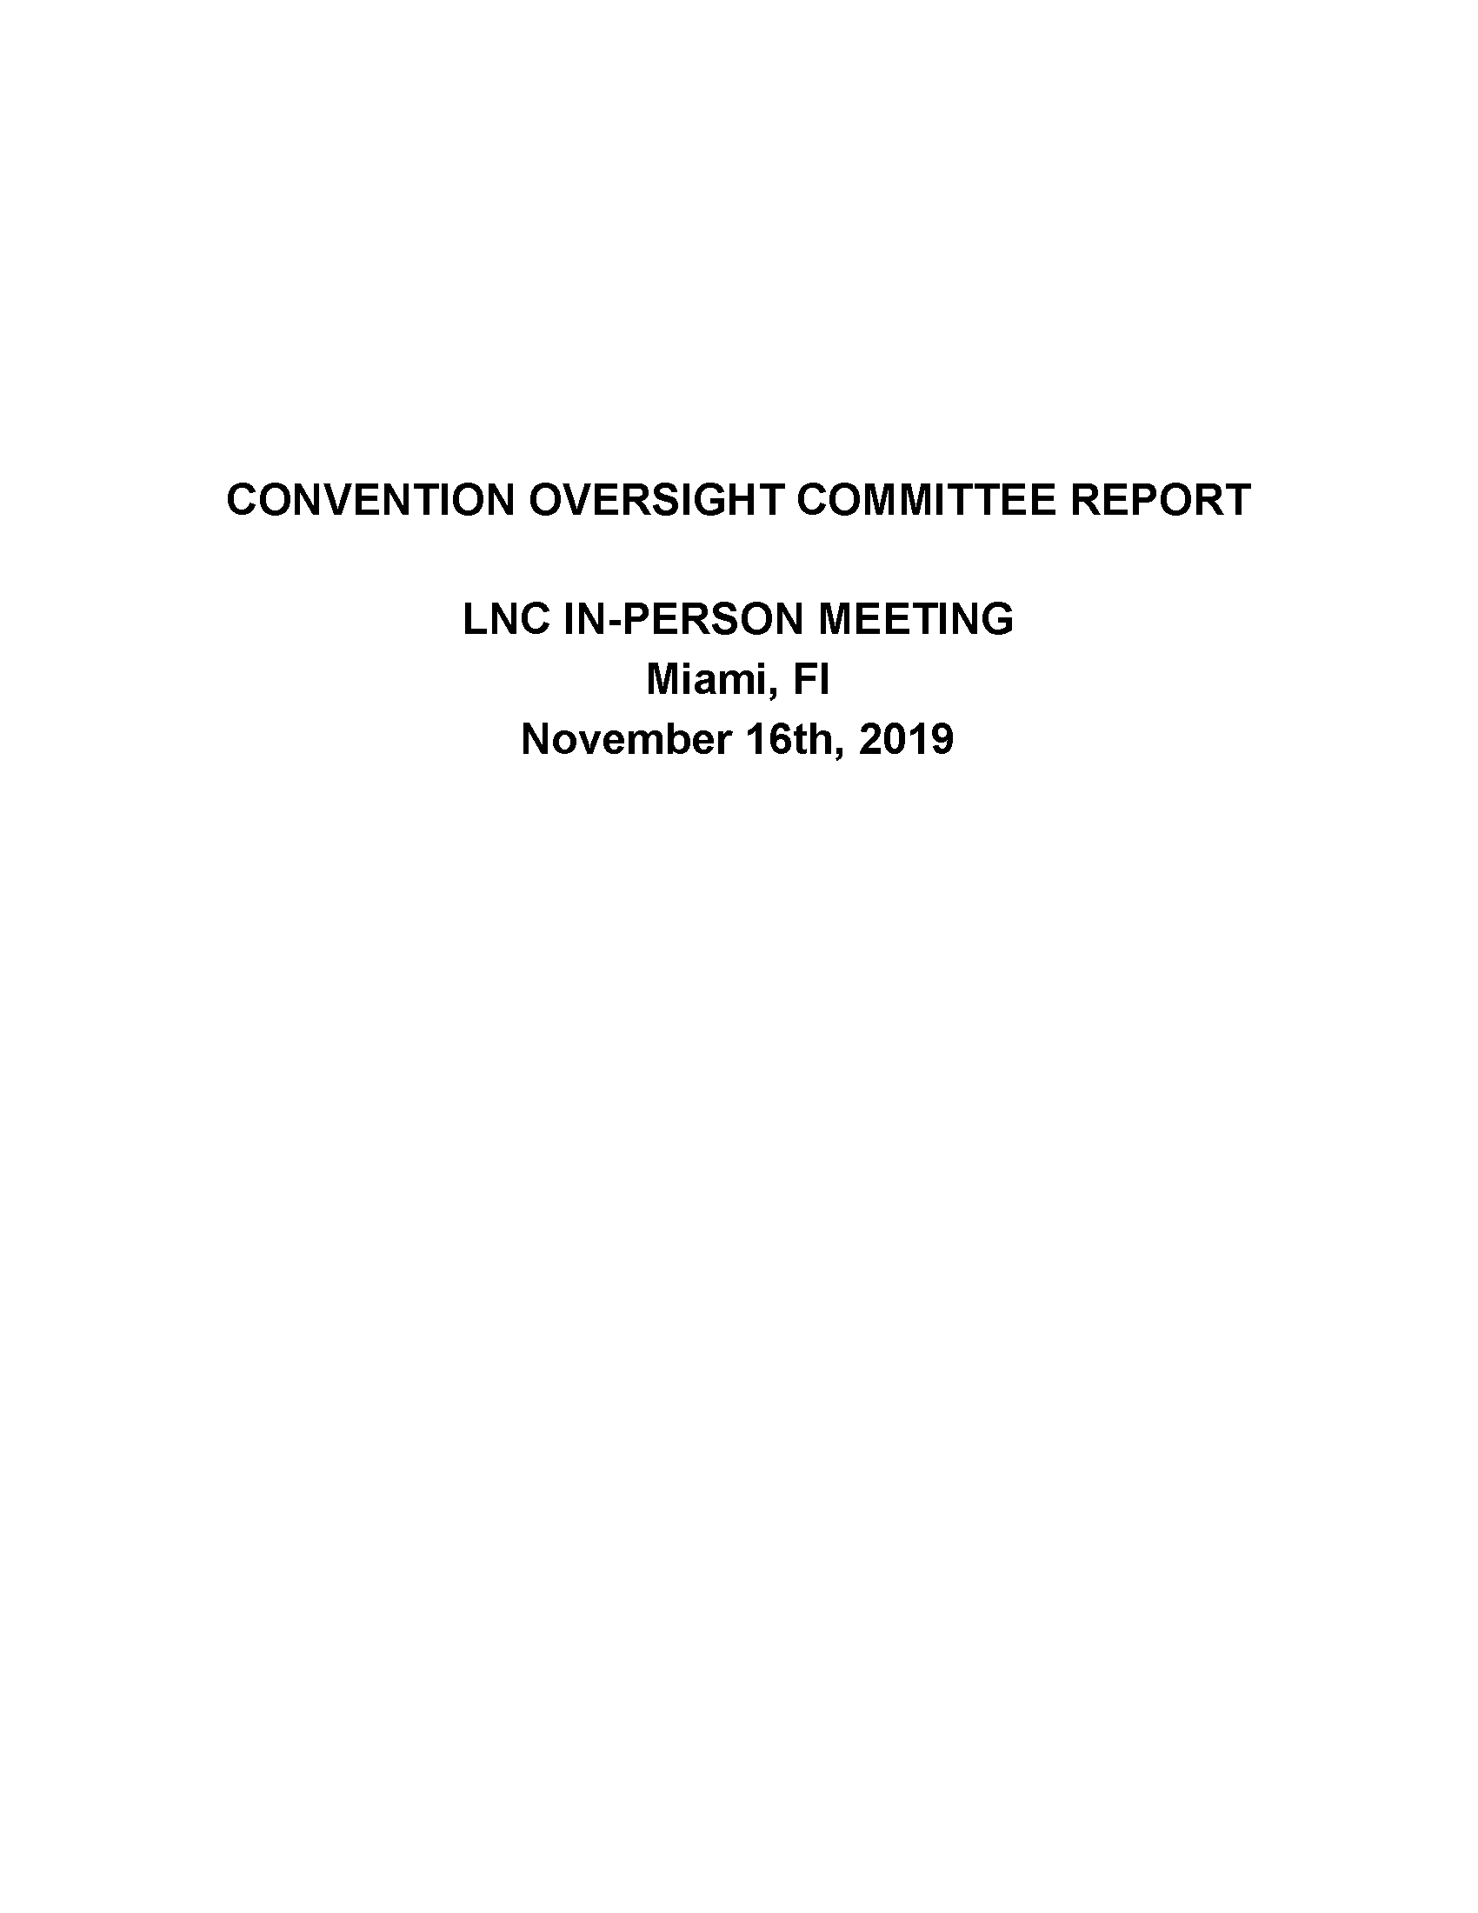

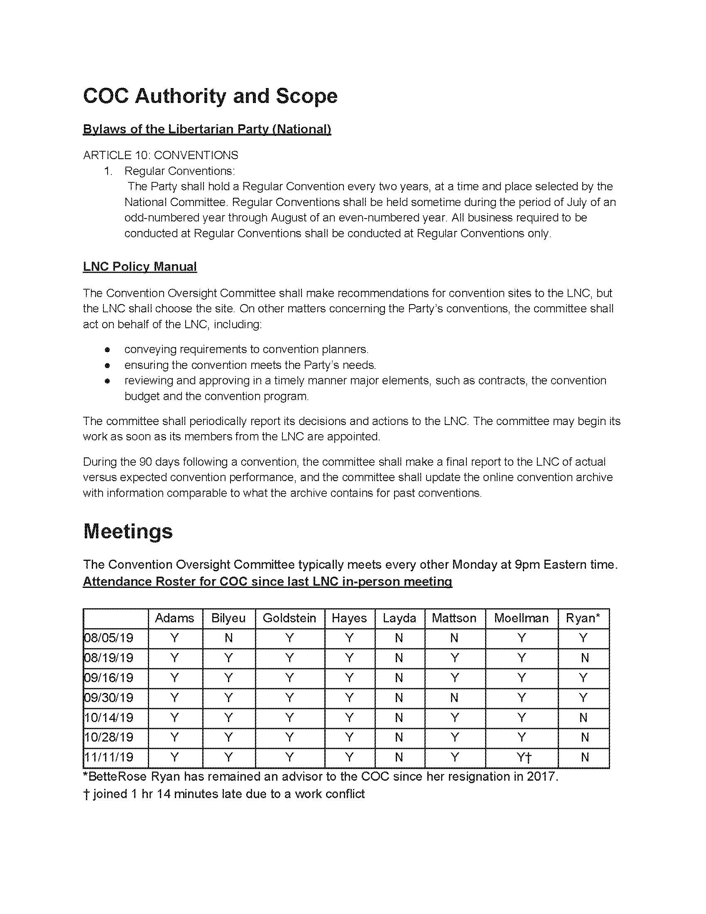

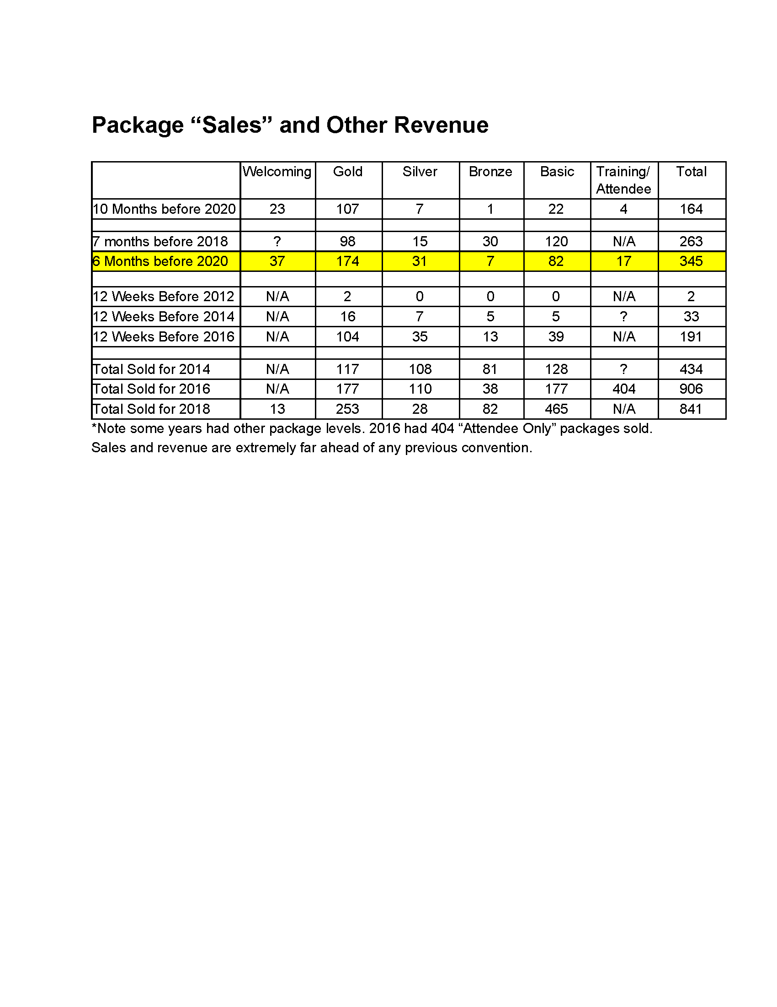

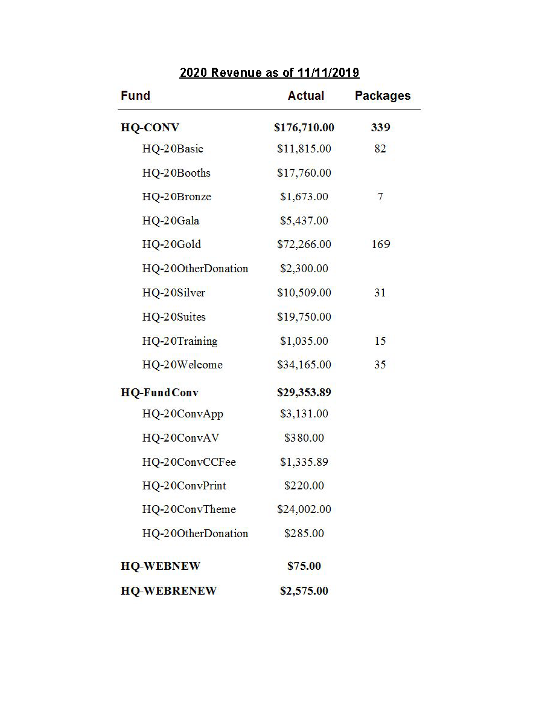

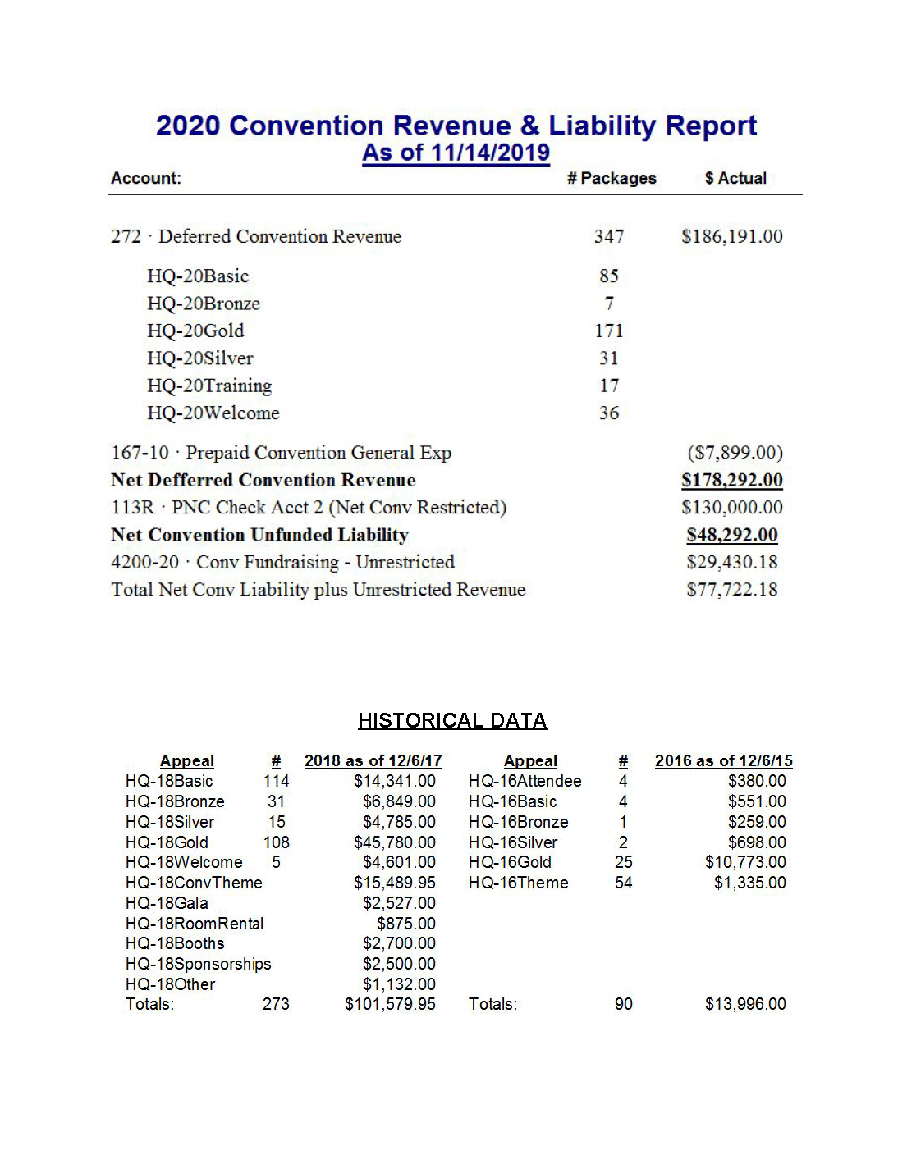

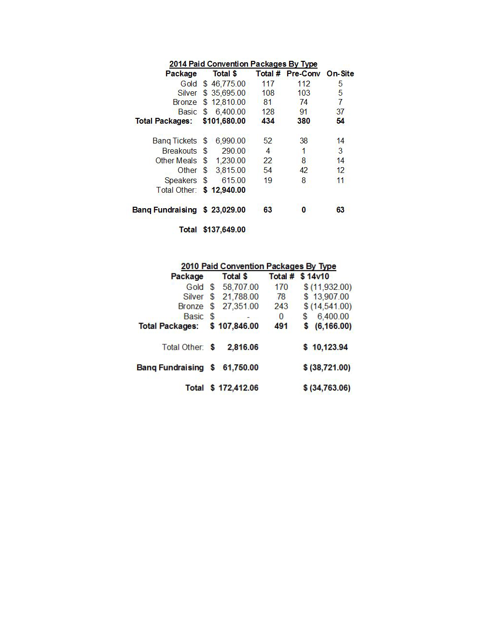



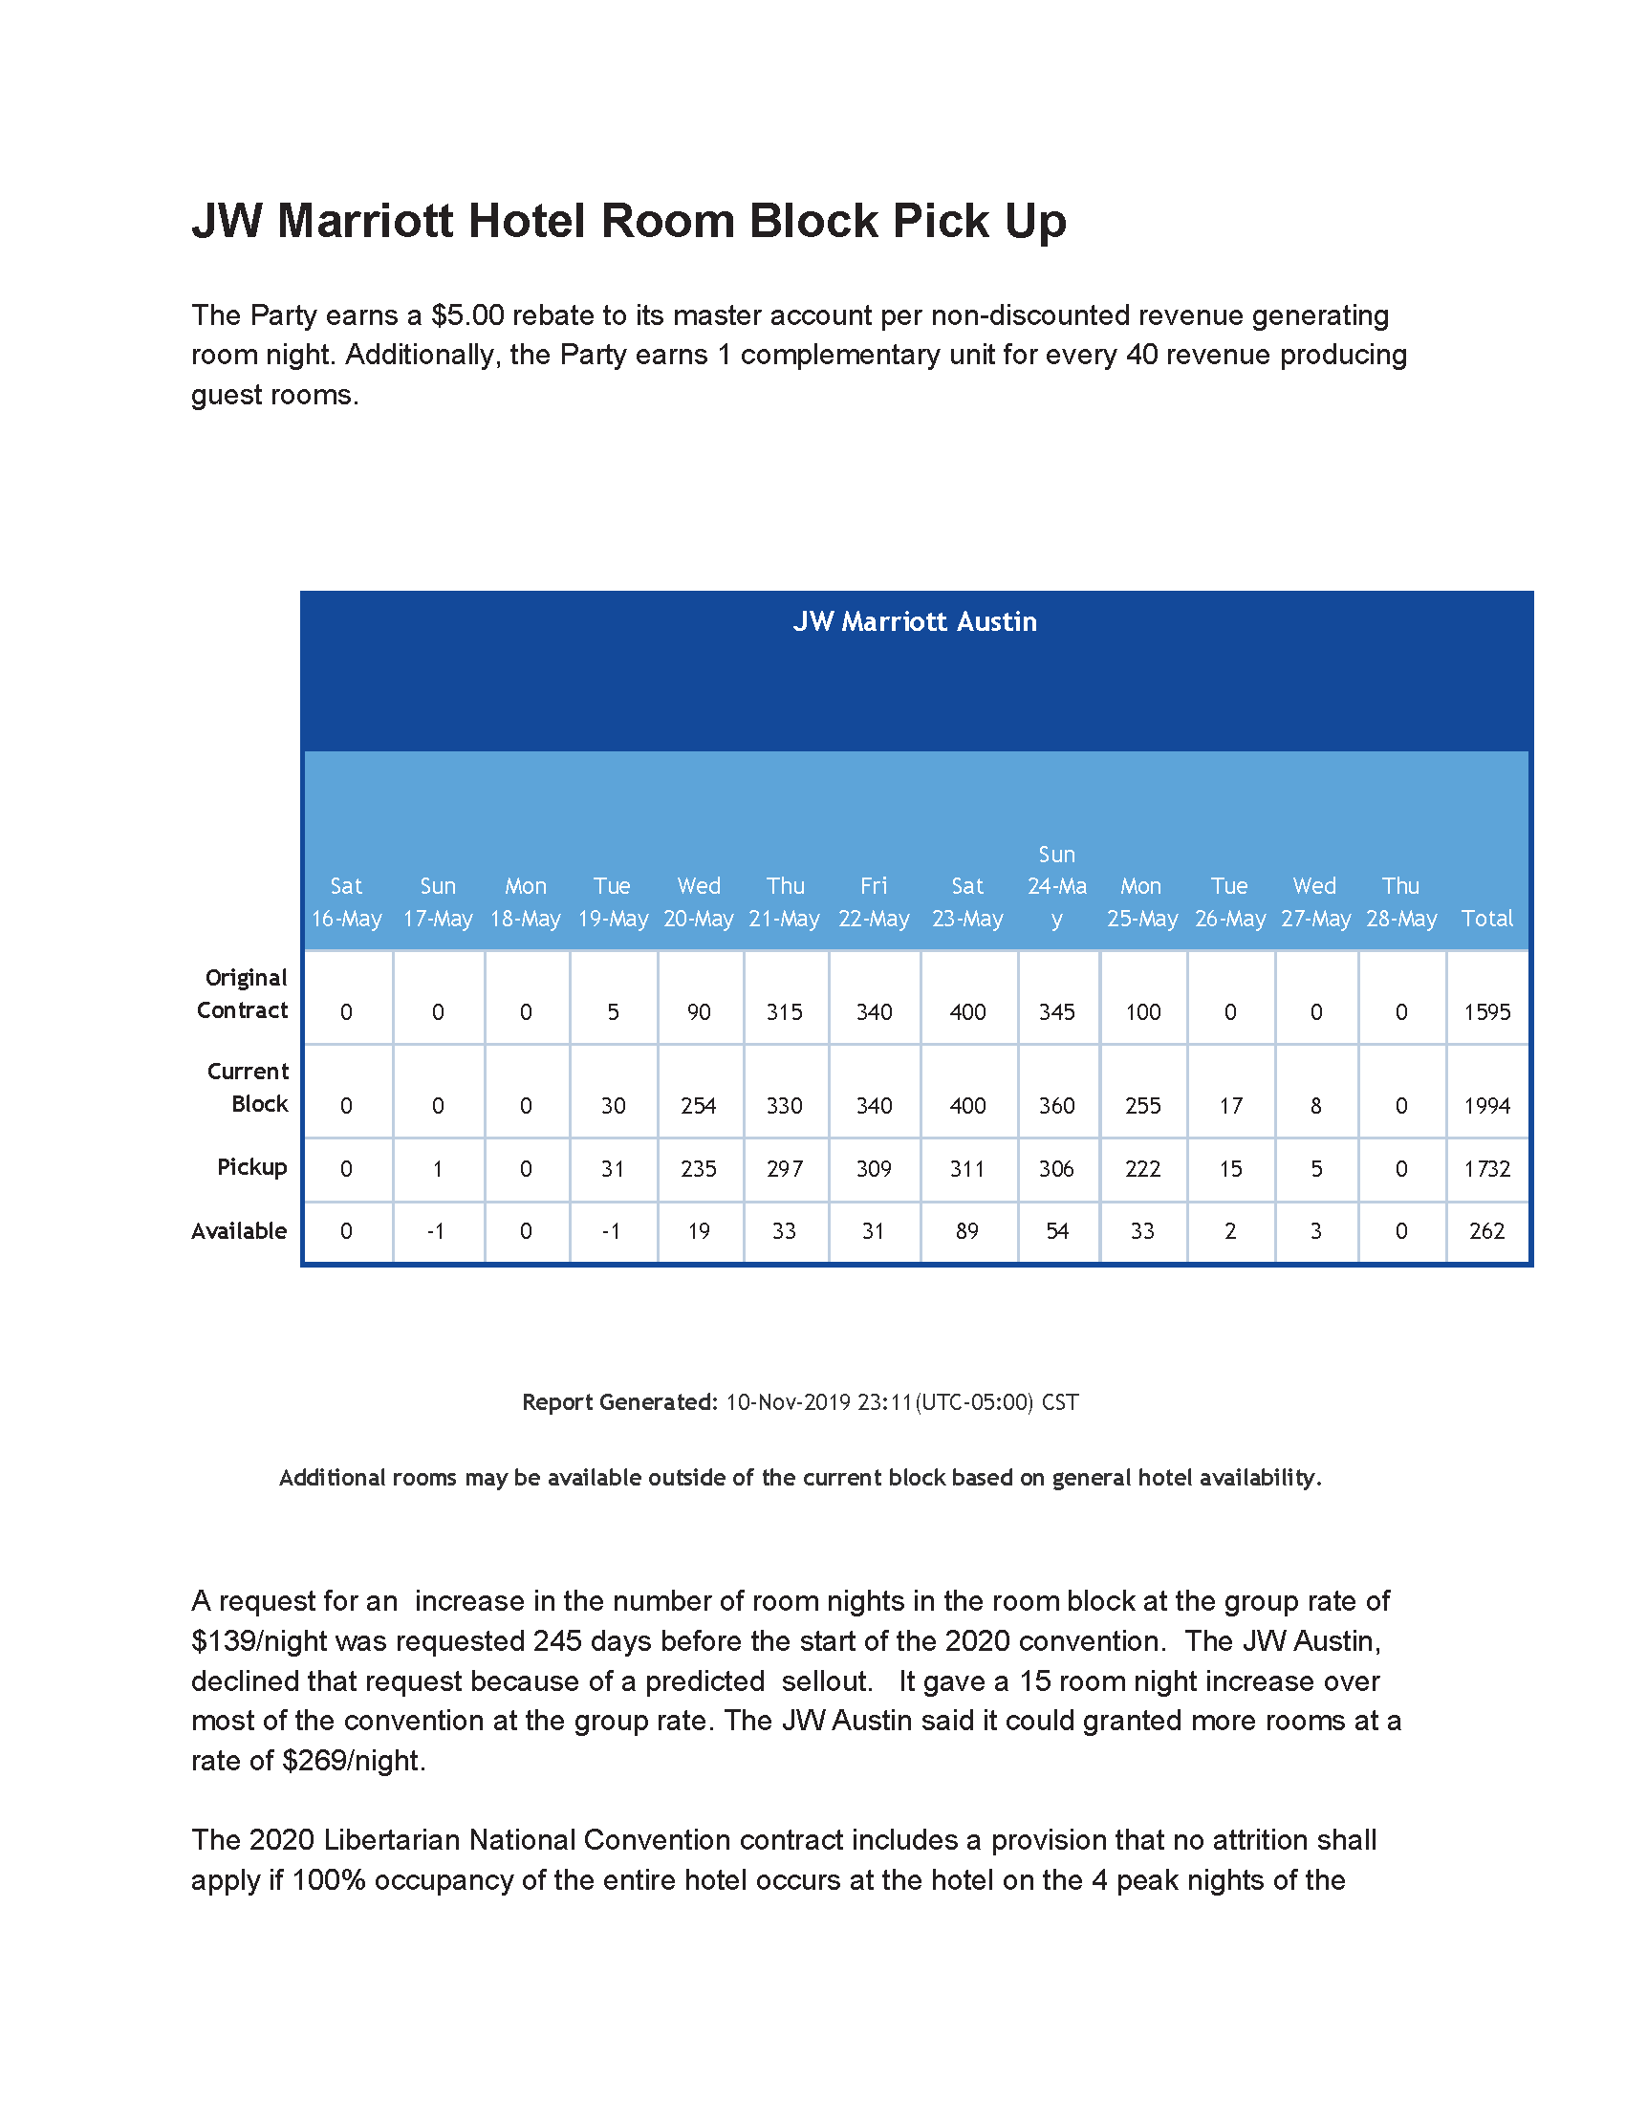

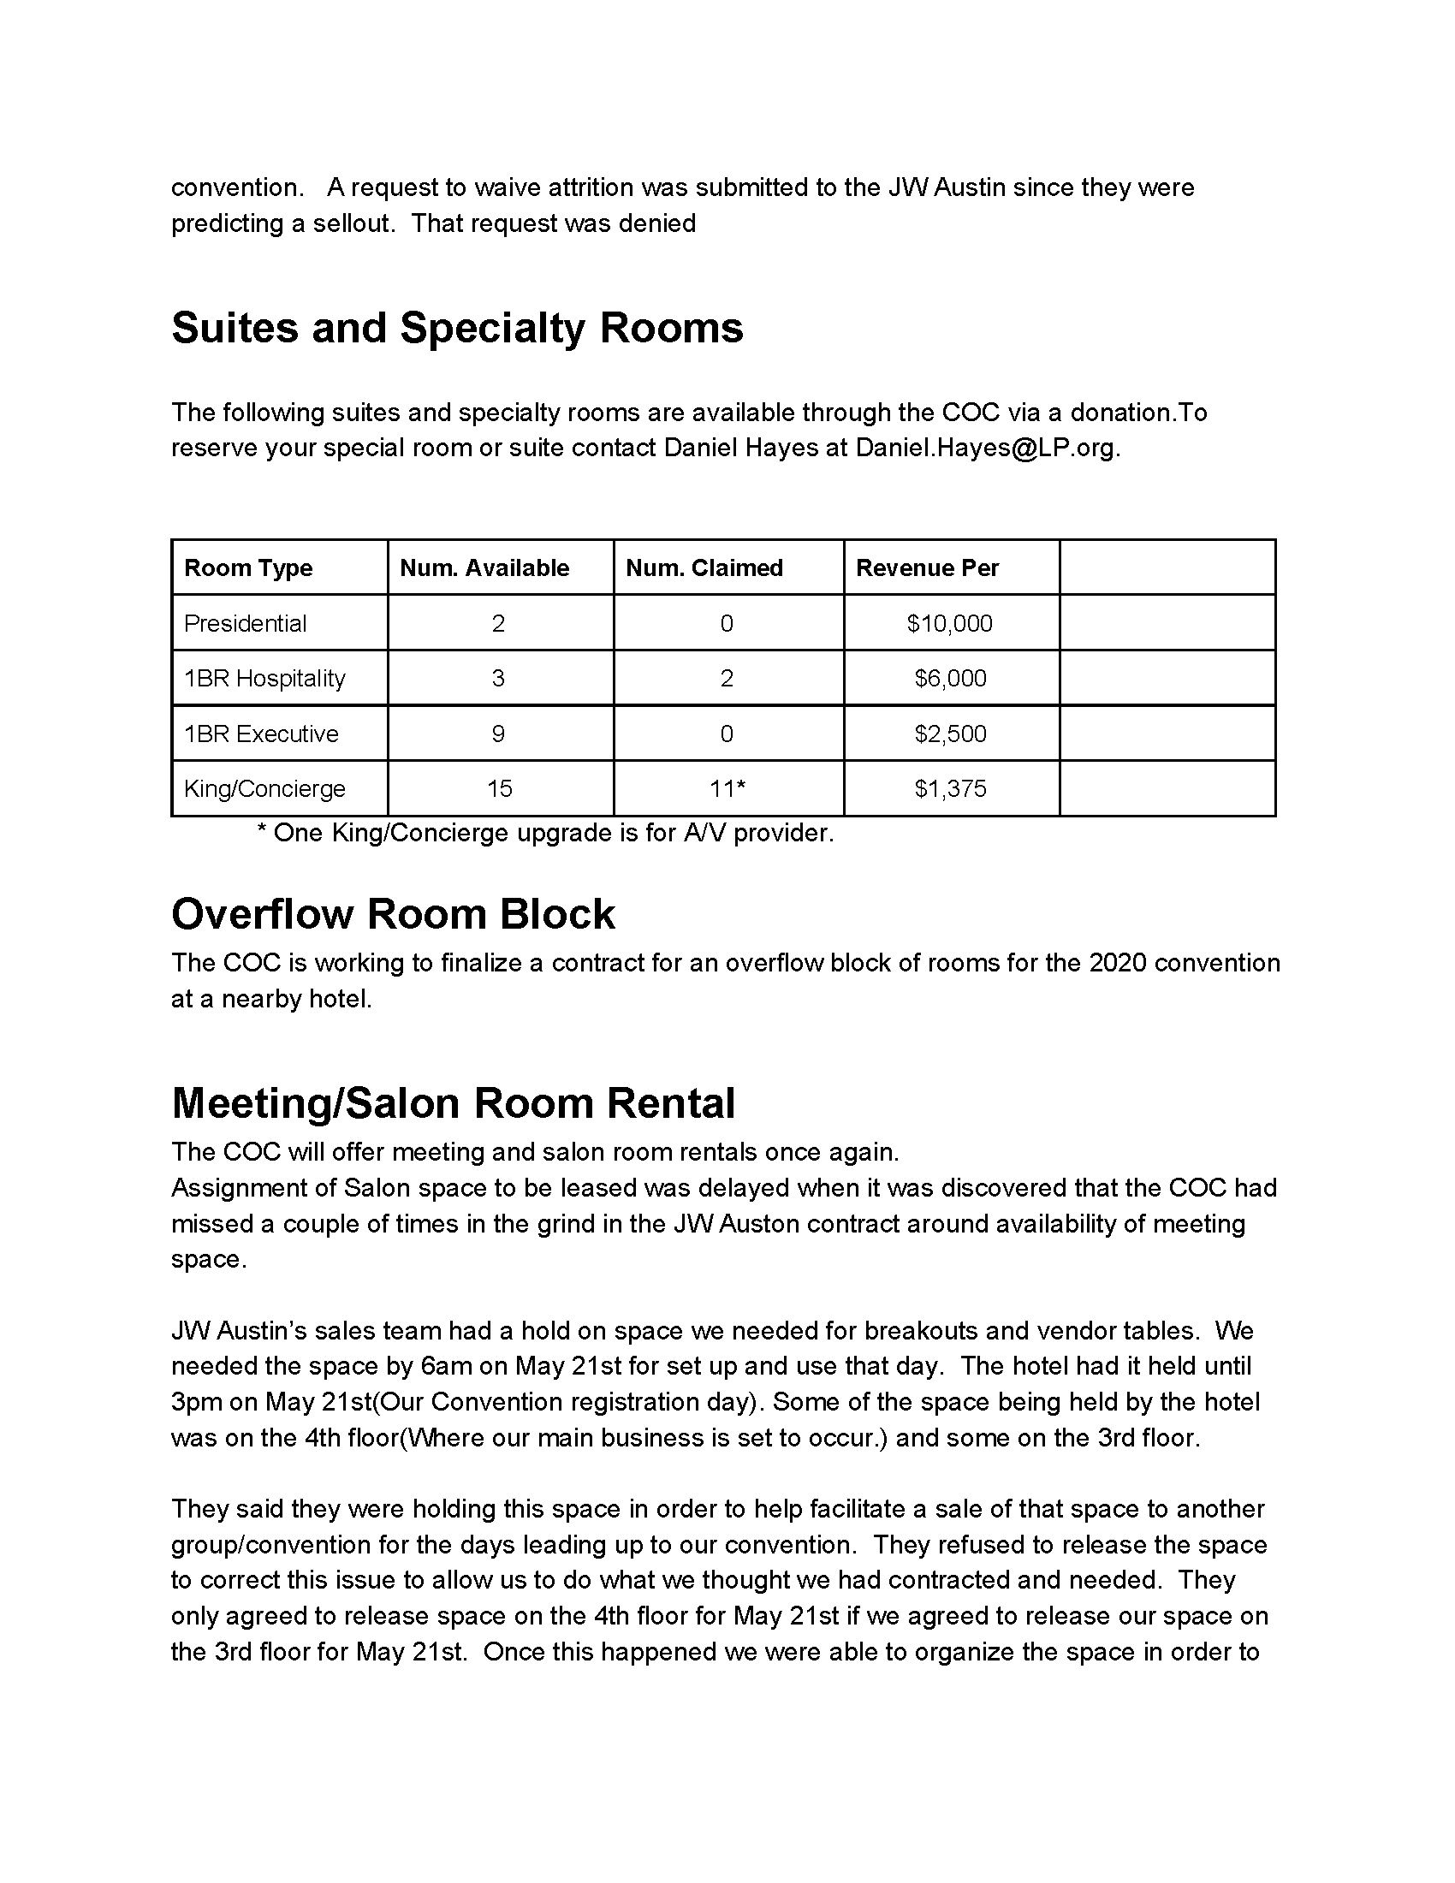

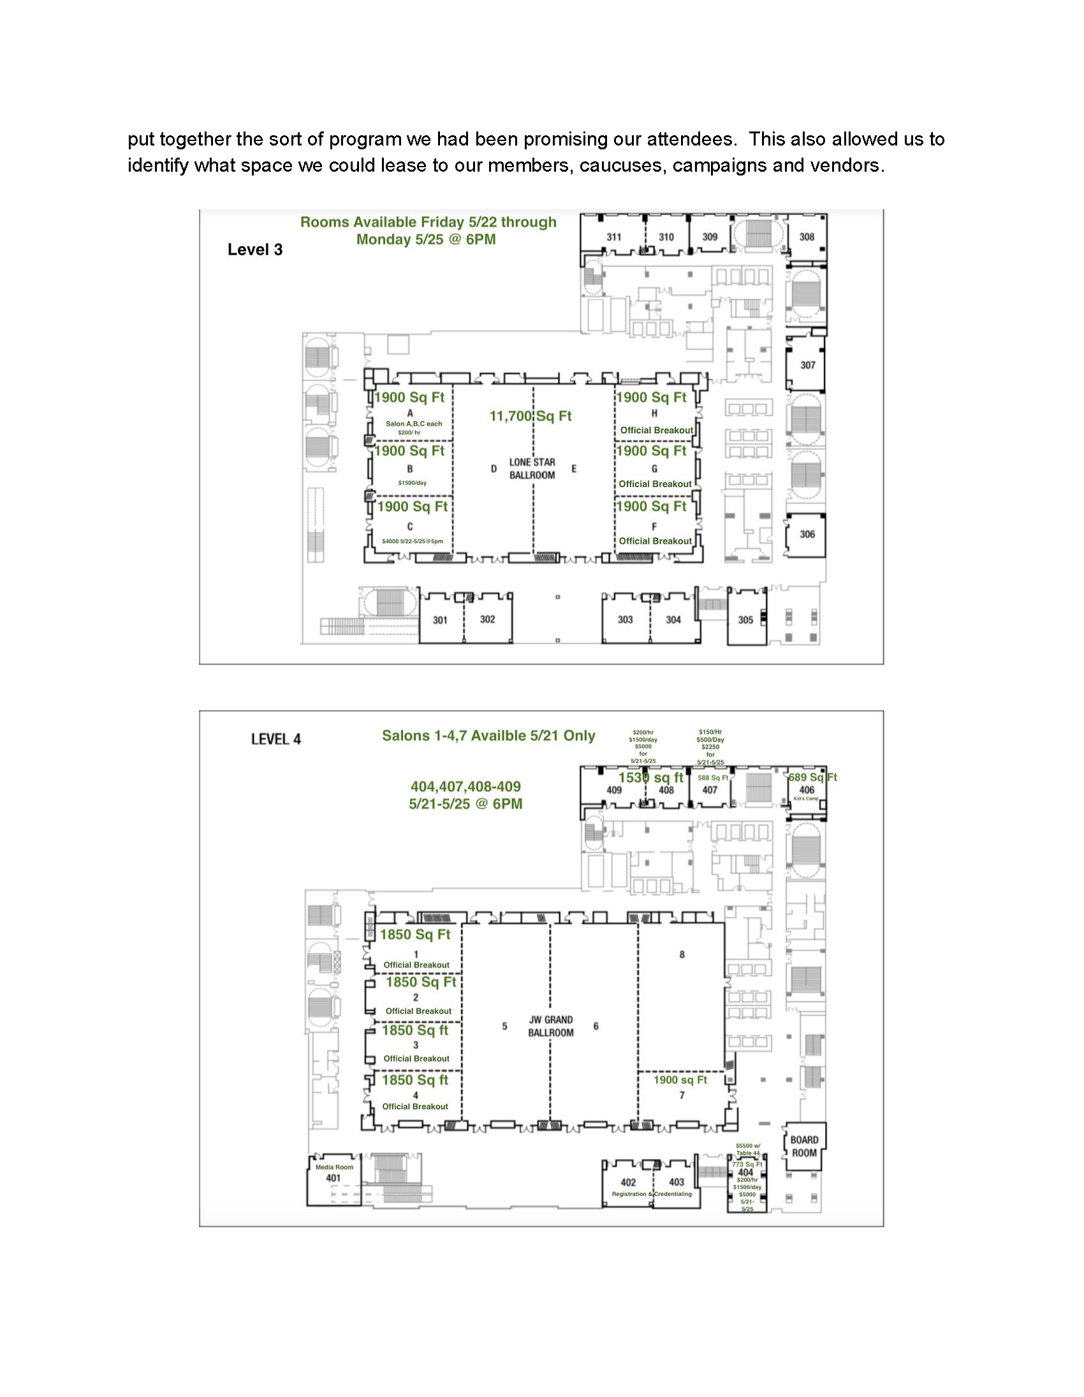

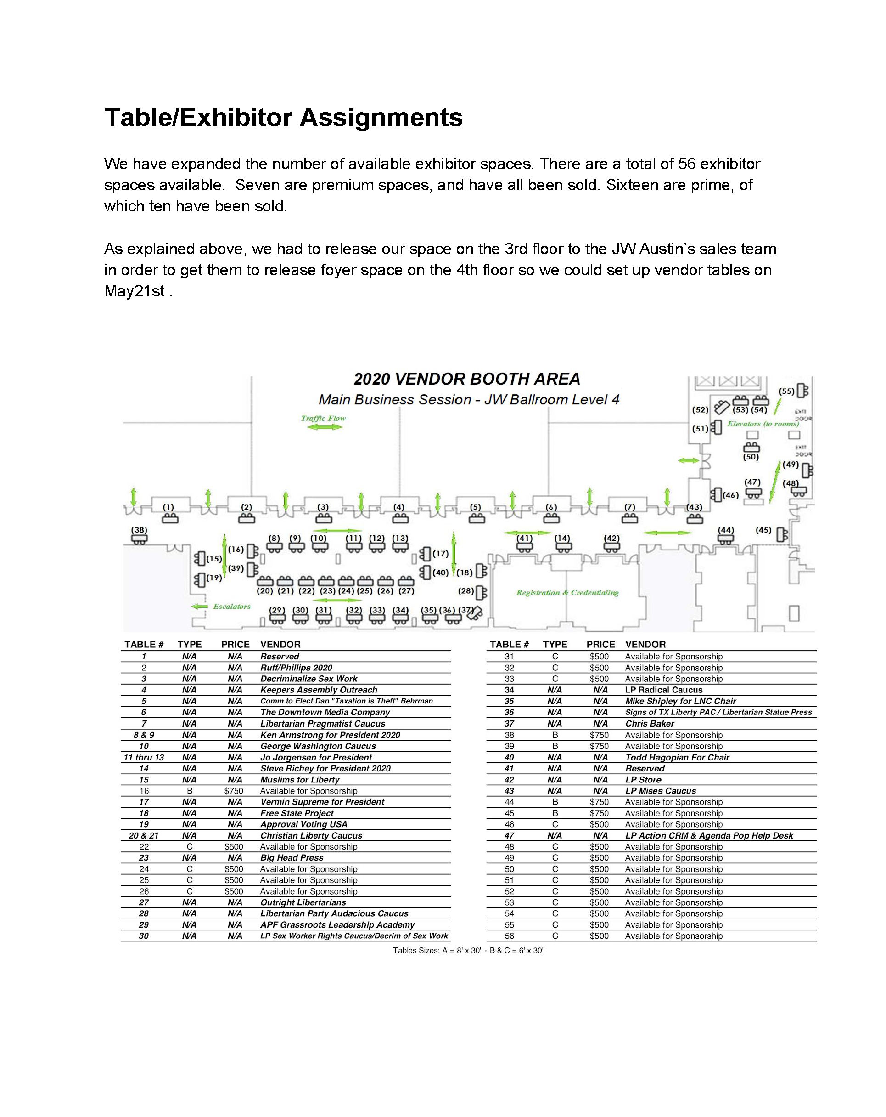

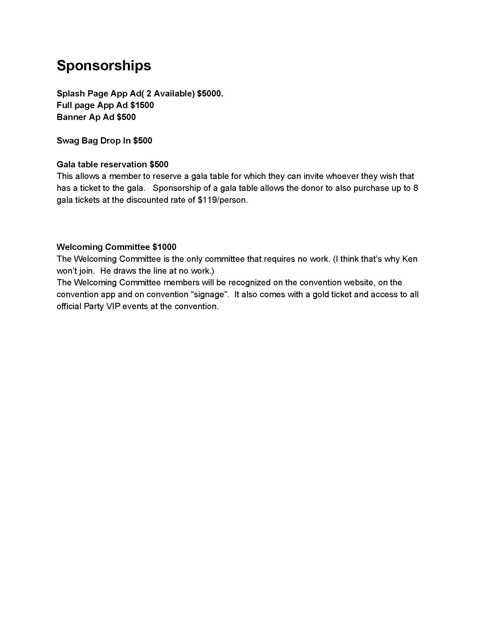

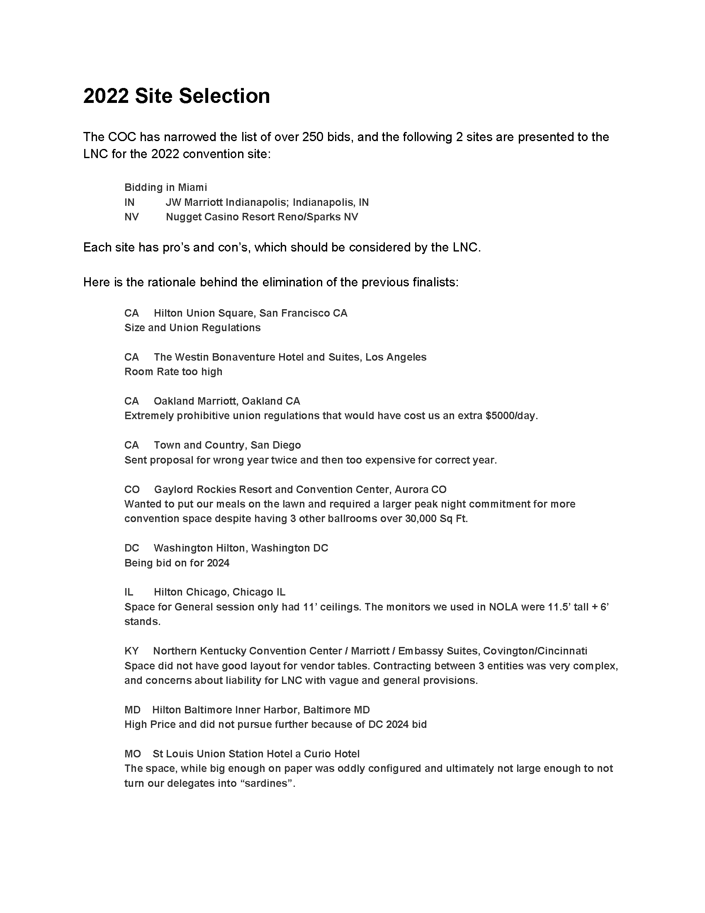

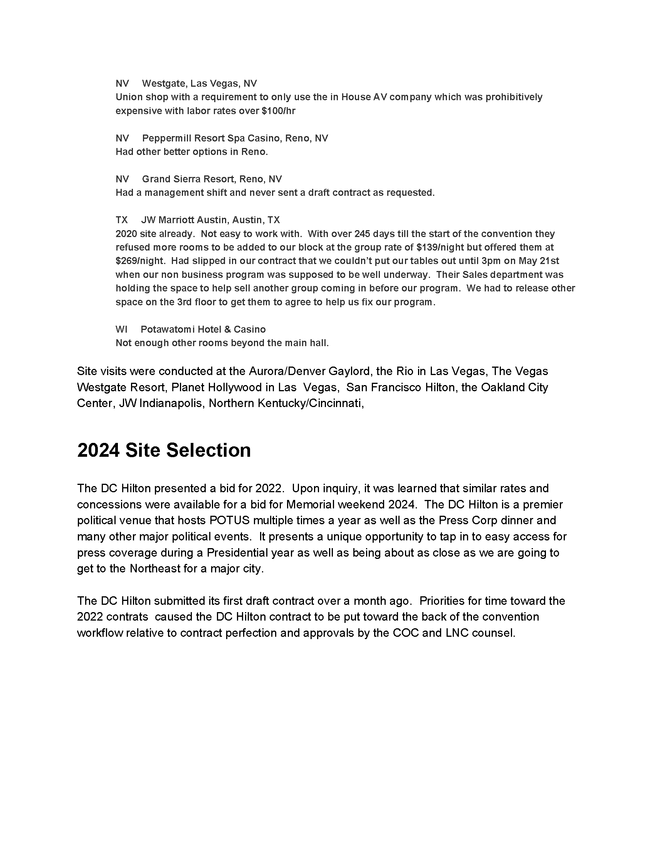

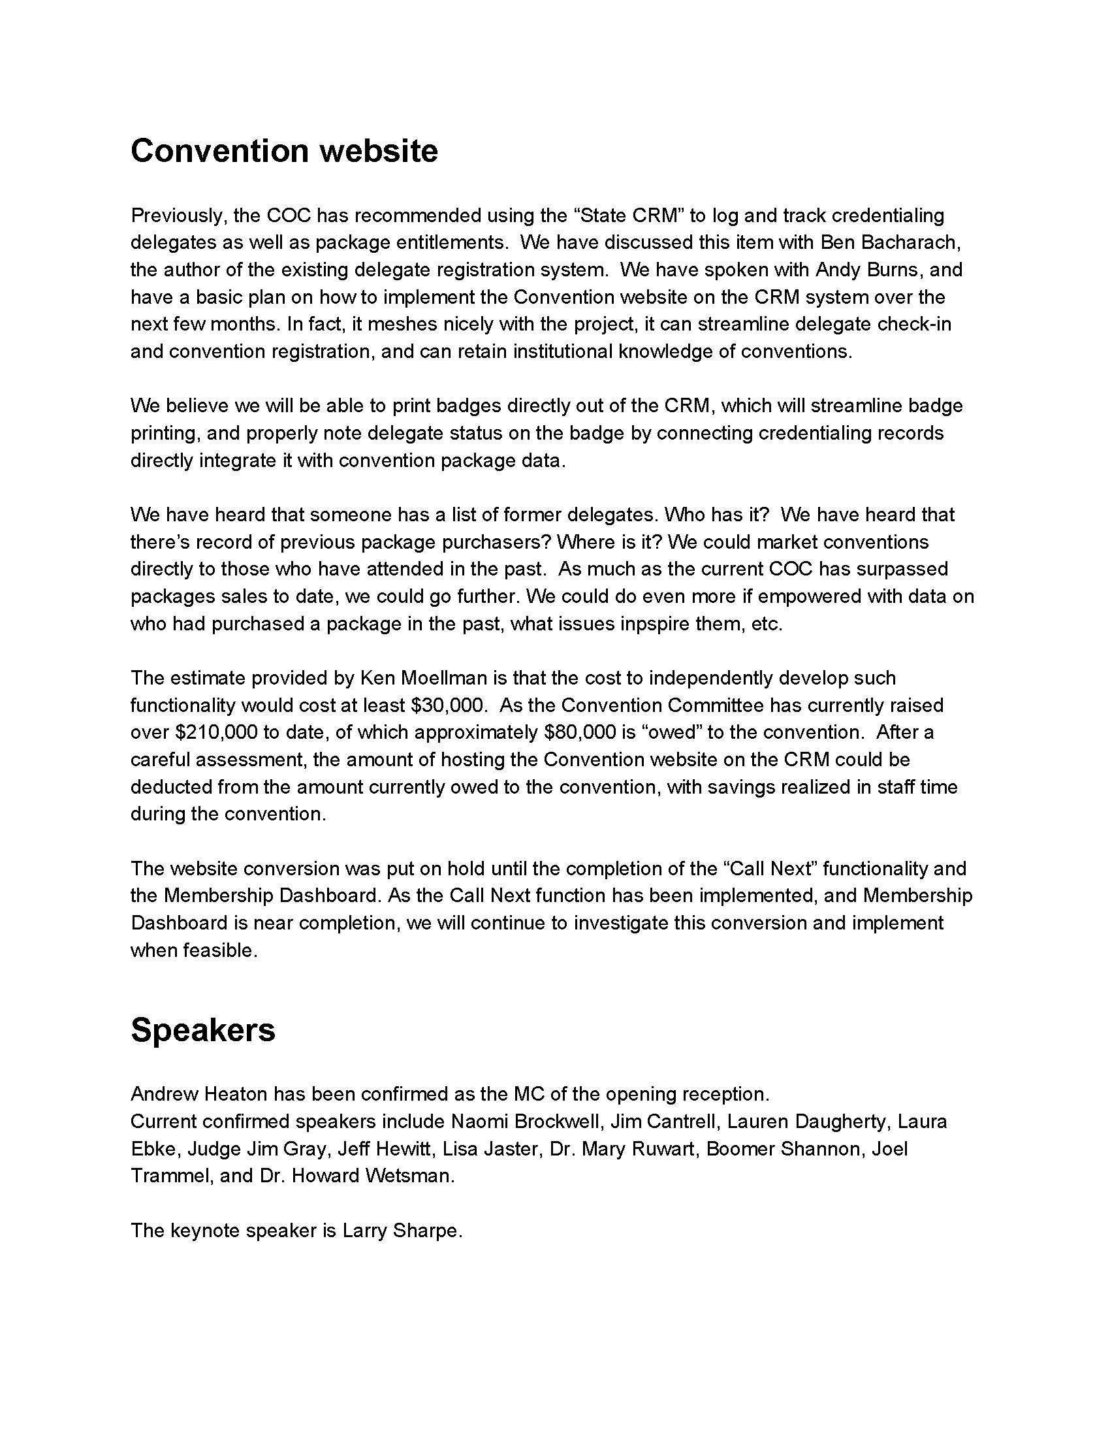

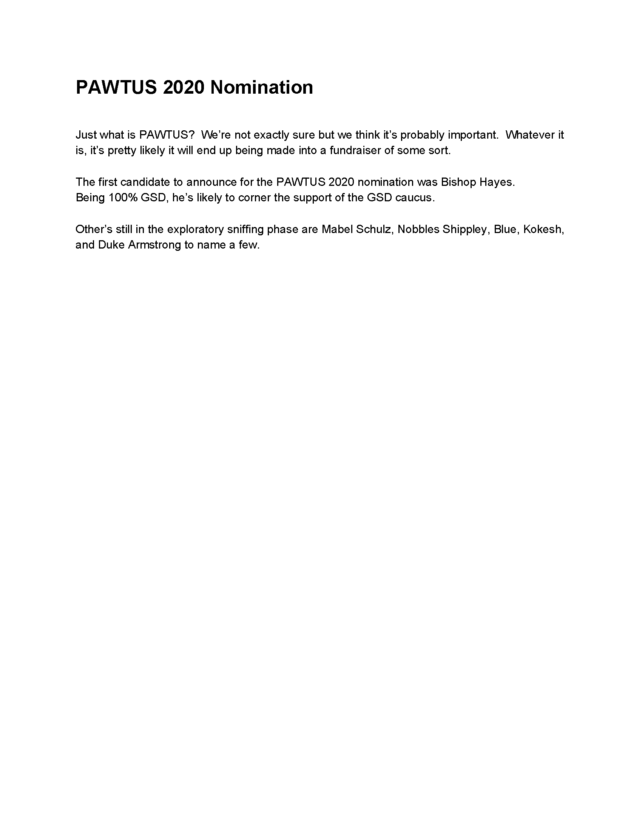

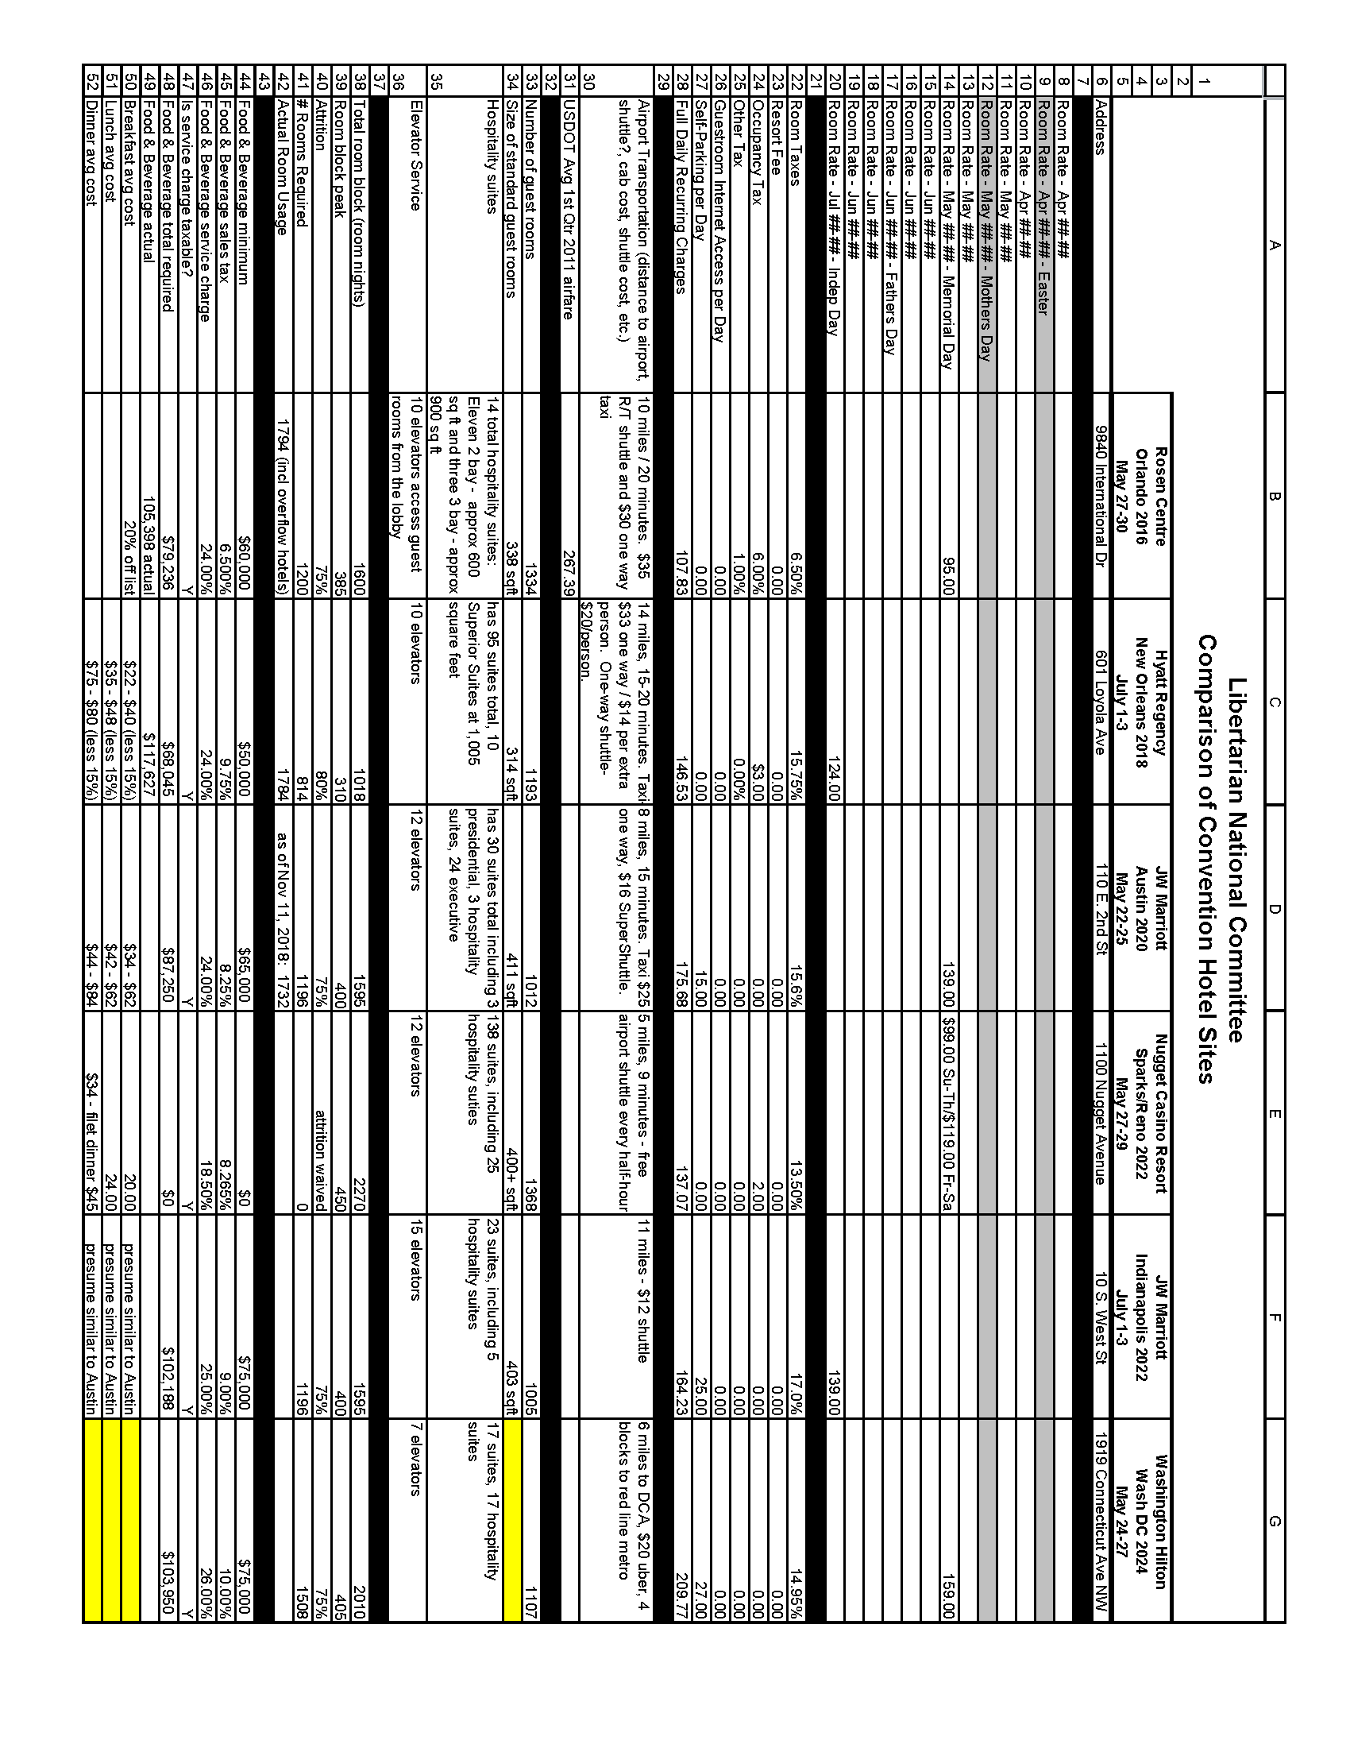

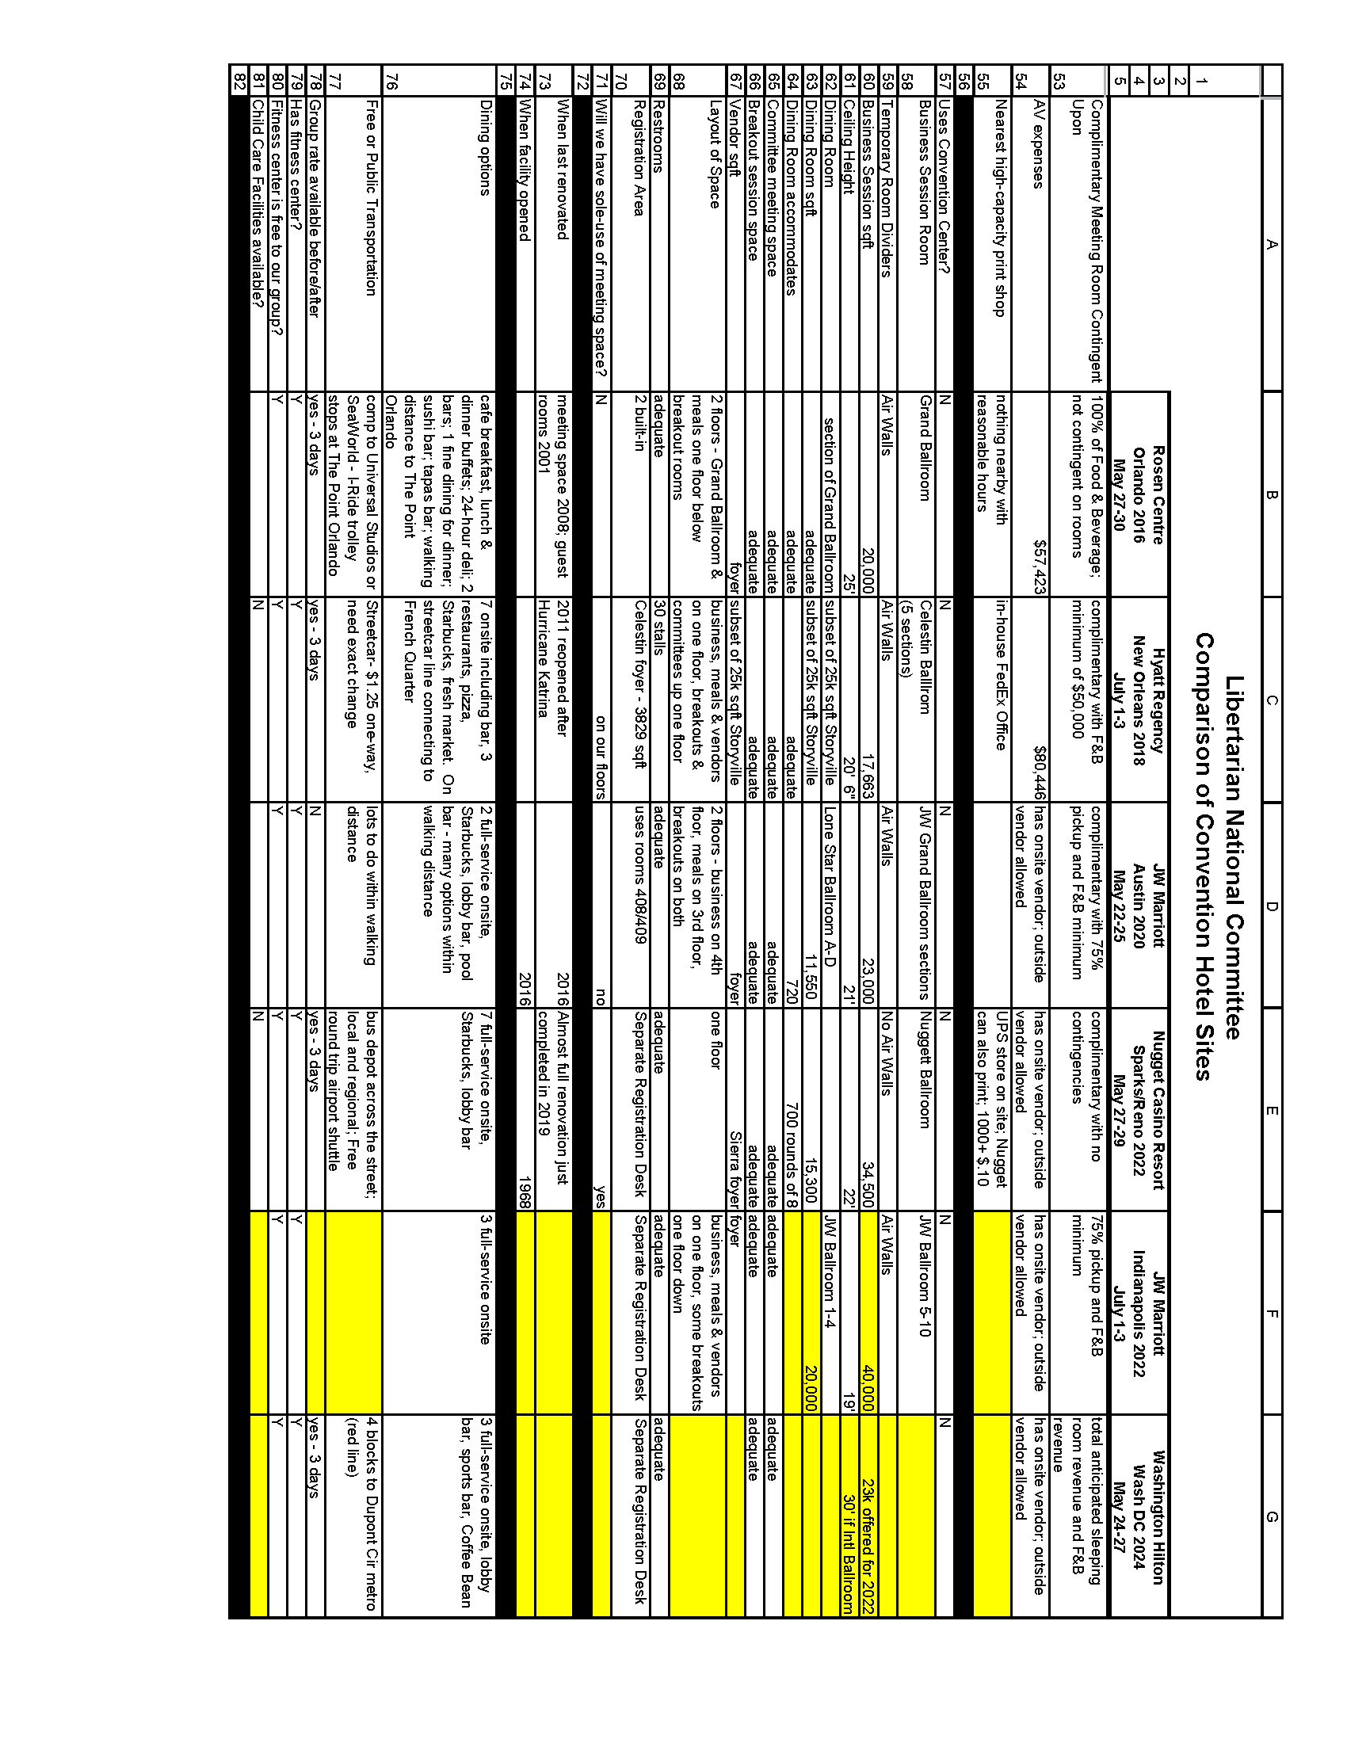
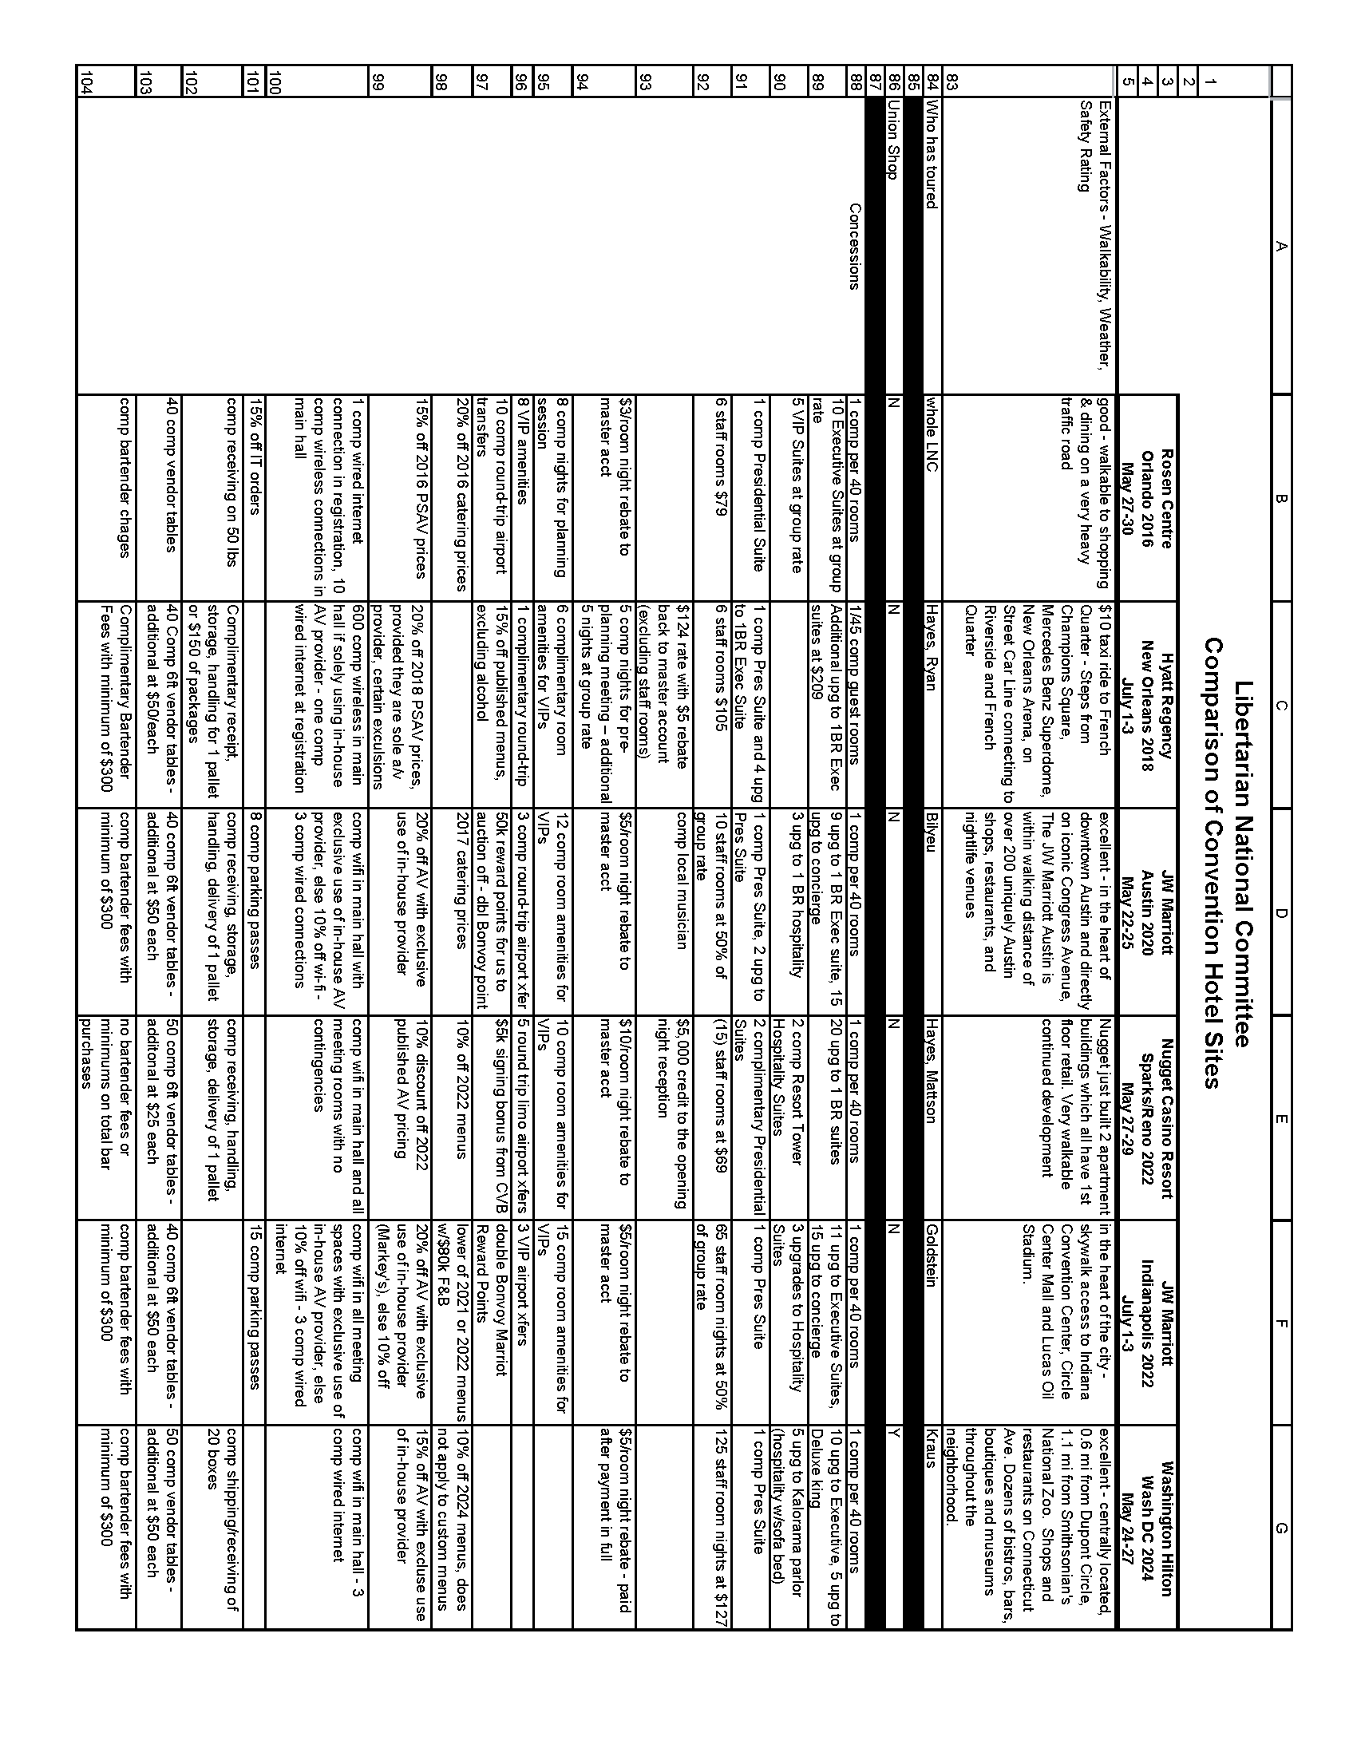

APPENDIX N – EMPLOYMENT POLICY AND COMPENSATION COMMITTEE REPORT

EMPLOYMENT POLICY AND COMPENSATION COMMITTEE REPORT
Submitted to: Libertarian National Committee, Nov. 8, 2019
Submitted by: James W. Lark, III
Region 5 Representative, Libertarian National Committee
Chair, Employment Policy and Compensation Committee
The members of the Employment Policy and Compensation Committee (EPCC) are Joe Bishop- Henchman, Jim Lark, and Bill Redpath. They were elected during the LNC meeting on Sept. 29- 30, 2018. Dr. Lark was selected by the EPCC to chair the committee on Nov. 9, 2018.
1) As noted in the previous EPCC report, an “exit interview” with Lauren Daugherty, former Director of Development, was conducted on July 16, 2019. The EPCC has prepared a report based upon this interview.
Since this report contains information regarding evaluation of employee performance, the EPCC believes this material should be regarded as confidential, and that the report should be delivered during an executive session.
2) On Oct. 20, 2019, Executive Director Daniel Fishman sent an e-mail message to the EPCC in which he provided a copy of the signed contract he had negotiated with Tara DeSixto. Ms. DeSixto was hired as a contractor to serve as Director of Development for the Libertarian Party. The message also contained a copy of Ms. DeSisto’s resume. LNC chair Nick Sarwark was copied on the e-mail.
Neither I nor the other EPCC members expressed objection to the terms of the contract. However, there is consensus among the EPCC that the contract should have been approved by the EPCC or approved by the LNC prior to its being signed by an authorized representative of the LNC (either Mr. Fishman or Mr. Sarwark).
Specifically, Section 2.02, subsection 8, paragraph 3 of the LNC Policy Manual reads as follows:
Following General Counsel’s review of a director-level employment contract, the EPCC shall review the proposed contract and any related advice from General Counsel. No such contract may be signed by the Chair without having first obtained either EPCC approval of the contract at least 10 days prior, or an affirmative vote from a majority of the fixed membership 40 of the LNC.
(Footnote 40 reads as follows: The term “fixed membership” is defined in the footnote on RONR p. 403.)
Please note that one may reasonably question whether this requirement concerning EPCC approval or LNC approval applies to contractors as well as employees. It is the consensus of the EPCC that any contractual arrangement regarding a director-level position should be submitted for approval by the EPCC or the LNC, regardless of whether the person hired is a contractor or an employee.
The EPCC recommends that if the LNC shares the aforementioned consensus regarding the approval process, the LNC should amend the language of the Policy Manual to remove the potential for misinterpretation.

APPENDIX O – HISTORICAL PRESERVATION COMMITTEE REPORT

HISTORICAL PRESERVATION COMMITTEE REPORT
LNC MEETING NOVEMBER 16-17, 2019

COMMITTEE OVERVIEW
Policy Manual Section 2.02 SCOPE AND RESPONSIBILITIES

Historical Preservation Committee

The HPC shall be responsible for directing the preservation and publication of Party historical documents and the administration of LPedia.org. A report of its decisions and activities shall be delivered at each LNC meeting.

The scope of the initial organizing work will last well into several years (the estimate is at least additional five years depending on member involvement), and LPedia will need to be maintained for the time of its existence.

Committee Members
- Caryn Ann Harlos (Chair)
- Joe Dehn (Secretary)
- Ed Fochler
- James Gholston
- Andrew Kolstee

Status of search for potential additions to committee:
The search for additional committee members has thus far been unsuccessful in discovering additional qualified applicants. The committee next term may wish to address this or decide to keep the committee at its current size.

Reports, Meetings, and Communications
The Committee is committed to transparency and conducts open meetings on the first and third Wednesday of each month via Zoom. The monthly agenda is posted and updated here: http://lpedia.org/LPedia:LPHPC_Agenda. Committee discussion is also conducted via email with a read-only subscription option available to all Party members by sending a message to lphpc-request@lists.dehnbase.net with “subscribe” in the subject line. The minutes and other records from its proceedings are preserved on LPedia (links noted below for member review):

Minutes Prepared since the last report:
- July 17, 2019 https://lpedia.org/w/images/a/a6/Minutes_2019-07-17_HPC.pdf
- August 7, 2019 https://lpedia.org/w/images/9/95/Minutes_2019-08-07_HPC.pdf
- August 21, 2019 https://lpedia.org/w/images/d/d9/Minutes_2019-08-21_HPC.pdf
- JOE TO UPLOAD REST

Prior Committee Reports this Term:
- September 29, 2018 http://lpedia.org/w/images/e/e8/Report_2018-09-29_HPC.pdf
- March 9, 2019 http:// http://lpedia.org/w/images/4/48/Report_2017-04-15_LPHPC.pdf
- July 29, 2019 https://lpedia.org/w/images/6/64/Report_2019-07-28_LPHPC.pdf
Motions Considered

- WAITING FOR MINUTES

Regular Dedicated Non-Committee Volunteers
There are multiple regular volunteers that tend to specialize either in their state or in broader subject matters such as election statistics. The committee is in search of another Colorado on-site volunteer and will be exploring internships once again. Ms. Harlos has been encouraging the state affiliates to take ownership of their pages and update them regularly.
STATUS OF DOCUMENT PRESERVATION

Storage Unit
Initial plans have been made to expand the shelving at the unit in order to maximize the storage space, but we are not at that point. Details on the method behind the organizational process as well as a tour of the site are available upon request.

Digitization

Documents and Papers:
All of the issues of LPNews are now up and digitized and another large batch is being prepared comprising fund-raising letters, tri-folds, and misc. national publications such as Libertarian Volunteer.

Audio/Video/Electronic Data Materials:
We received previously unknown boxes and boxes of Clark video material that will be digitized in the future, with some of the items being in the rarer formats for which there is only one current vendor who does that work. We need volunteers to work on other media categories such as audio and VHS. Additionally, all of the past meetings on UStream need to be downloaded asap as the Party wishes to cancel that account.

YouTube Channel:
This has worked out very well and the option of mirroring to Bit.tube will be implemented in the future for protection and redundancy. Bit.tube has just undergone a massive restructuring, so this project is waiting to make sure all the kinks have been worked out.

Miscellaneous
Ms. Harlos obtained high-quality sheet-fed and large-format flatbed scanners to use (used items retired from an office environment), Mr. Fochler acquired a CZUR scanner, and Mr. Dehn has also obtained an overhead book scanner. These were not charged to the committee but are personal purchases that will be made available for the committee’s use.

HISTORICAL COLLECTIONS AND PROJECTS

State Party Preservation Efforts

State Party Coordinated Preservation Efforts/Committees:
- California
  - A historical committee, chaired by Joe Dehn, is working on collecting and preserving material relating to the state and local LP organizations.
- Colorado
  - The affiliate is using LPedia as its public records archive and regularly uploads records.
- Illinois
  - Their complete archive has been donated to the special collections library at the University of Illinois and added to the LPedia external archive list.
- New York
  - A historical committee is being led by Andrew Kolstee to organize their substantial records.

Individual Preservation Efforts or Donations of Items
Individuals regularly contact the committee regarding their personal collections. The committee is very focused about what kinds of material it will accept, and offers advice concerning items it generally does not accept. In cases where it appears that important items will be thrown away if the committee does not intervene, we try to find a home for them in an academic archive if possible. The priority remains the national party records, and the committee encourages and trains state parties to use LPedia as their permanent archive and to organize local volunteers to do the digitization work.

Nolan Archive
These materials are presently stored in the Utah home of Dr. Buchman who has expressed interest in writing a biography of David with the encouragement of his widow, Elizabeth. Elizabeth signed a written copyright waiver for these materials to be published with or without attribution to LPedia and for commercial or non-commercial use. Ms. Harlos will be consulting with Dr. Buchman to find out his current intentions and perhaps transfer those records to Colorado.

Craigslist
Ms. Harlos proposed that the committee put advertisements on Craigslist in major cities soliciting donations of older historical material and had researched a vendor that could manage this for us. It appears that the vendor may have scammed us, and Ms. Harlos committed to making a personal donation to recoup the cost if her efforts to pursue a refund from the vendor is unsuccessful.

Yahoo Lists
The committee is researching potential solutions to bulk download these lists for preservation but so far is encountering difficulties. New options are being explored at the November meetings. Yahoo has notified its users that these groups will be deleted on December 14, 2020.

Miscellaneous

Doug Hoiles (CA) sent the committee a previously unpublished manuscript of Karl Bray that he had from when he was working with on potentially self-publishing in the year of Karl’s death. Doug did not want this manuscript to be lost and wanted it to be preserved in our physical archives at a minimum. The title of work is “Taxes are Revolting: Why Aren’t You?.”

STATUS OF LPEDIA

General Statistics
- 3,532 Articles
- 22 Active Editors
- 4,222 Document/Image Uploads

Daily unique visitors remain about 100-125 with bumps when particular pieces are featured on Facebook or Ms. Harlos appears at various speaking engagements. The committee is presently working hard to provide a framework for having usable and helpful data as the crucial 2020 election season approaches.

Featured Articles
At least once a month (preferably twice) detailed and image-rich articles are featured on the front page to freshen up content and highlight various affiliates, events, people, and documents. Nearly any article can qualify if they meet the standards of high-quality content. Types of content are alternated in order to not emphasize one interest over any other and provide variety. The following are the 2019 featured articles thus far:

- Chuck Moulton
- Libertarian Party US Presidential Election Results
- Alex Merced
- Libertarian Party of California Voter Registration
- David Bergland
- Mike Seebeck

Massive Category Clean-Up
During the Wild West years of LPedia, the category tree decided to embrace anarchism and had resisted Ms. Harlos’ top-down insistence on a logical organization but her determined authoritarianism has prevailed, and the resource is rapidly becoming more useable rather than having arcane categories for any possible combination of desired tags such as “Pink-haired Libertarians in Colorado with a Beagle.” The initial structure has been laid out using OmniOutliner with the master file available for download. The process is coming close to completion with the exclusion of the “images” and “publication files” categories. The current top-level category tree is structured as follows:

- Collections
- Definitions
- Events
- Images
- Issues
- Lists
- LPedia
- Organizations
- People
- Places
- Publications
- Records

Templates
This is another area that had been in rough and disorganized shape and has been methodically organized by Mr. Kolstee. The present goal is the deletion of all obsolete templates, the creation of a current template index, and preparation of usage documentation for each template.

Technical Issues
Mr. Fochler noted that current wiki best practices involve using /wiki/ as the subdirectory for main wiki content. The committee is working with the host provider (mywikis) in order to make a smooth transition to this format without losing our page ranks.

Data Back-Ups
Regular back-ups are done professionally and consistently. All of the uploaded documents are also kept offline on hard drives and regularly copied to drives stored at a safety deposit box. Any member who provides Ms. Harlos with hard drives may have a copy of all of these records. The committee would like to see them widely distributed so that there is never a single source/point of failure.

General Upgrades/Improvements
The following items were added:
- “Getting Started as Contributor” added to sidebar
- An informational box was created for insertion on documents which change over times (such as platforms and bylaws) to indicate that the subject version was not the most current version.

STATE CONVENTIONS
Conventions booths featuring historical items were featured at the Alabama, California, Colorado, and New York conventions.

2020 NATIONAL CONVENTION
The committee has begun its initial planning to table at the 2020 national convention.
ACCOUNTING FOR CALENDAR YEAR 2019
Total Expenses Booked: $536.00
Total Revenue: $2,665.00
Total Budget: $2,500.00
Funds Committed: $2,000.00

The committee is now fully funded for the year and has been advised by Mr. Kraus that it can raise and spend up to 10% over budget without requiring a budget amendment. These figures will be re-evaluated before the December meeting. The historical project has fundraised its own budget since its creation.

Respectfully Submitted,
Caryn Ann Harlos, Committee Chair

APPENDIX P – INFORMATION TECHNOLOGY (IT) COMMITTEE REPORT
IT Committee Report
By Alex Merced
07/27/19 - 11/16/19

- Motion to be made at LNC meeting regarding renaming the IT committee the “Information Services Committee”, this proposal was voted on unanimously by the IT Committee
- The committee is assisting with creating an education platform for the LP. The Committee has initially made an install of the Moodle Learning Management System, which had some technical issue which was fixed by Ken Moellman. Some members raised the discussion of whether Moodle should be the LMS of choice which is an ongoing discussion.
- Discussion of creating materials to better inform State Chairs of the breadth of technology services provided by National.
- Discussions on improvements to the CRM, assisting with the membership portal and other projects are ongoing.

APPENDIX Q – INTERNATIONAL REPRESENTATIVE REPORT

INTERNATIONAL REPRESENTATIVE REPORT

Submitted to: Libertarian National Committee, Nov. 8, 2019

Submitted by: James W. Lark, III
Region 5 Representative, Libertarian National Committee
International Representative, Libertarian National Committee

This report will provide information concerning my efforts as International Representative since the LNC meeting in Austin last July to assist the work of libertarian political parties and activists throughout the world.

1) I met with many libertarians during my visit to Sao Paulo, Brazil on Oct. 17-22. Specifically, I met with Paulo Ghedini, a member of the Board of Directors of Students For Liberty Brasil on Oct. 17 to discuss ways to build more effective Libertarian student groups throughout the country.

On Oct. 18, I met with Helio Beltrao, president of the Instituto Mises Brasil, along with several IMB staff members. We discussed various ways to promote libertarian ideas among students and in the popular press.

On Oct. 19, I served as chef for a dinner party at the home of Leandro Narlock in Sao Paulo. Mr. Narlock is a well-known journalist and writer in Brazil. In particular, he is the author of a popular book titled Guia Politicamente Incorreto da História do Brasil (“Politically Incorrect History of Brazil”), along with two sequels. The party was attended by several libertarian scholars and think-tank members. (The dinner was arranged by Thaiz Batista, chief operating officer of Instituto Mises Brasil.)

On Oct. 20, I met with Vinicius Albano, a campus coordinator for Students For Liberty Brasil. We discussed many of the “nuts and bolts” issues of building campus organizations. In addition, we discussed issues that SFL Brasil will face as it moves forward.

On Oct. 21, I met with Ricardo Mellao, Daniel Jose, Ricardo Stella, and Andre Bonini at the Legislative Assembly of Sao Paulo. Mr. Mellao and Mr. Jose are members of Partido Novo, a libertarian party in Brazil that has enjoyed electoral success recently. They are deputies in the Legislative Assembly (rather like House of Representatives members in a state legislature). If I understand correctly, Mr. Stella and Mr. Bonini serve as chief of staff and legal counsel, respectively, for Mr. Mellao.

We exchanged a great deal of information about the efforts of our respective parties to promote libertarian policies. As is typically the case when I meet libertarian legislators from other countries, our Brazilian colleagues were surprised at the difficulty the U.S. LP has in placing candidates of the ballot.

Following my meeting with Mr. Mellao, et alia, I met with Vladimir Maciel, Mariana Abreu, and Allan Antonio of the Centro Mackenzie de Liberdade Economica (Mackenzie Center for Economic Liberty). Dr. Maciel is the director of the Center and a professor in the Department of Economics at the Universidade Presbiteriana Mackenzie (Mackenzie Presbyterian University) in Sao Paulo. Dr. Abreu is a fellow of the Center and professor in the Department of Economics. Mr. Antonio is a senior analyst at the Center.

We discussed various economics topics that are the subject of ongoing research at the Center, as well as means to promote libertarian economic policies in a hostile intellectual environment. I have been invited to give an address next year at an economics/public policy conference in Sao Paulo.

2) While I was in Brazil, I received a forwarded message from Paul Frankel, long-time LP stalwart and former LNC alternate representative. The message was forwarded to both me (as the LNC’s representative to the IALP) and Geoff Neale (IALP chair).

The forwarded message was from Karol Parkita. The message requested that IALP remove the Wolnosc party (a Polish party) from the alliance. Mr. Frankel indicated that he supported Mr. Parkita’s request.

Mr. Neale responded to Mr. Frankel; Mr. Parkita, Andrew Withers (IALP representative) and I also received Mr. Neale’s message. Mr. Parkita responded to Mr. Neale’s message. I have enclosed Mr. Parkita’s response to Mr. Neale’s message in an appendix to this report. Please note that Mr. Parkita’s response contains all of the messages regarding this matter, including his original message that was forwarded to me.

Please let me know if you want me to take action in this matter. I believe Mr. Neale’s suggestion for action by Mr. Parkita and his associates is appropriate. Unless I receive additional information about the matter, I am inclined to proceed along the lines Mr. Neale suggested.

3) I have accepted an invitation to address the upcoming Liberty International conference in Medellin, Colombia next year. I shall endeavor to make arrangements to visit other countries during my trip.

APPENDIX

From Karol Parkita to Geoff Neale, Jim Lark, Paul Frankel, and Andrew Withers (IALP)
Tuesday, Oct. 22, 2019, 12:30 p.m. EDT

Hello everyone,

What if we had support from Russian Libertarian Party?

Its not a purity test. They explicitly violate the IALP regulations many times what we have shown in our request. Every day brings more evidance.

Karol

wt., 22 paź 2019 o 17:38 <gneale@ialp.com> napisał(a):
>
> Hi Paul,
>
> It's been too long since we talked. I hope all is well with you.
>
> My response to this message, by necessity, needs to be somewhat lengthy.
>
> The IALP is an alliance of political parties. Each member party has a representative that can cast a single vote. As Chairman, I do not have a vote, since I'm not the representative of a member party. As such, only the representatives of each member party has standing to take the requested action, and I suggest that what needs to be done if further action is desired is to contact one or more representatives of member parties. The representatives are the only course of action.
>
> Removal would require a majority vote of the members.
>
> The other point I would like to raise is that we do not have any kind of "purity test". From our Charter: "Membership in the IALP will be open to any established political party, or provisional party seeking recognized status, that engages in real political activities, and is essentially libertarian, and does not promote or endorse any diminishment of individual liberties." At our founding we discussed about whether or not to have some basic standards, such as acceptance of the NAP. We decided against it, for a simple reason. We are an alliance of POLITICAL parties, not a philosophical group. Fledgling libertarian parties will each find themselves with different hurdles in their respective countries. A simple example is that in the UK it is a crime to call for the abolition of the monarchy, yet no philosophical libertarian would be accepting of monarchies. It is up to the members to decide if any new or existing party meets the minimal requirements.
>
> However, from looking at the list of those who endorsed the attached letter, I'd think there is sufficient support to found an actual political party in Poland that is "essentially libertarian". Do that, then apply for IALP membership, and once approved, not only can this new party call for the removal of Wolnosc, but it can vote to do so.
>
> Geoffrey Neale
> Chairman, International Alliance of Libertarian Parties
> gneale@ialp.com
> US(512)554-1523
>
> -----Original Message-----
> From: paul.frankel@lpalabama.org <paul.frankel@lpalabama.org>
> Sent: Monday, October 21, 2019 5:19 PM
> To: Karol Parkita <karol.parkita@gmail.com>; liber8or@austin.rr.com;
> James.Lark@lp.org; jwl3s@virginia.edu
> Subject: Re: request to IALP from polish libertarians
>
> Forwarding to USA representatives. I support this request.
>
> Paul Frankel, Secretary, Libertarian Party of Alabama
>
>
>
> On 2019-10-21 14:56, Karol Parkita wrote:
> > Hi,
> > I enclose our request to IALP to remove Wolność Party from IALP. Our
> > new party will be classically liberal. We have decided to introduce
> > free market and free society in Poland in a smaller steps than
> > Polish Libertarian Party - without any succes. We expect to be
> > registered in Poland in one or two months.
> >
> > Regards
> >
> > Karol Parkita
>
>
> --
> This email has been checked for viruses by Avast antivirus software.
> https://www.avast.com/antivirus
>

APPENDIX R – MEMBERSHIP SUPPORT COMMITTEE REPORT

Membership Support Committee
LNC report
November 2019
By Omar Recuero(FL)
The Membership Support Committee is a sub committee of the Libertarian National Committee(LNC). The committee consists of (9) members of the Libertarian Party(LP). The current members of the committee are as follows:
Omar Recuero (Chair)
Alex Merced (Vice Chair)
Steve Dasbach (Secretary)
Paul Bilyeu
Jeff Lyons*
Valerie Sarwark
Jennifer Moore
Jennifer Flower
Kevin Moore
On Sept 30, 2019 the committee formerly met to ramp things up, previously we held ongoing online discussion. A Chair, Vice Chair and Secretary were elected and we began to outline goals and discuss various topics involving membership, what LNC initiatives are in place and the relationship of membership from state affiliates to the LNC.
The committee has met several times since Sept 30th on a bi weekly basis and Dan Fischman is a regular on the calls providing the committee with the information it needs in order to begin assisting LNC staff. The minutes of all meetings can be made available to any LNC member by request.
Along with the stated purpose of the committee which is as follows:
“The Membership Support Committee will seek to find ways to support LP staff in matters of membership growth and retention.”
Other goals outlined, but not formerly finalized by the committee are to better understand membership growth and decline in order to retain members, give suggestions to LNC on best practices, collect feedback from members on what they like/dislike and how the LP can improve.
Currently the committee is assisting Mr Fishman with (2) new programs the LNC intends launch, the first being the “Membership portal”. This is a way for members to better manage their information with the party, as well as a way the party can more individually connect with members. The second initiative is “Membership renewal program” in which Mr Fishman has asked committee members to assist in reaching out to members who have dropped off. Both of these programs are in beta testing stages before being launched.
Jess Mears has also reached out to the committee to assist her in a new project for individuals who will become monthly plegers.
There are still things to accomplish and learn in regards to membership in order to deliver a more comprehensive report to the LNC, members and delegates, which the committee will continue to work on.
The meetings of the Membership Support Committee are video conference calls that are open to attend and participate by any and all LP members. Going forward we wish for notice of our meetings to published in more public places such as the LP website, in order to incentivize more participation.
Contact
Omar Recuero (Chair)
oforliberty@comcat.net
Alex Merced (Vicechair)
alex.merced@lp.org

APPENDIX S – REGION 1 REPORT

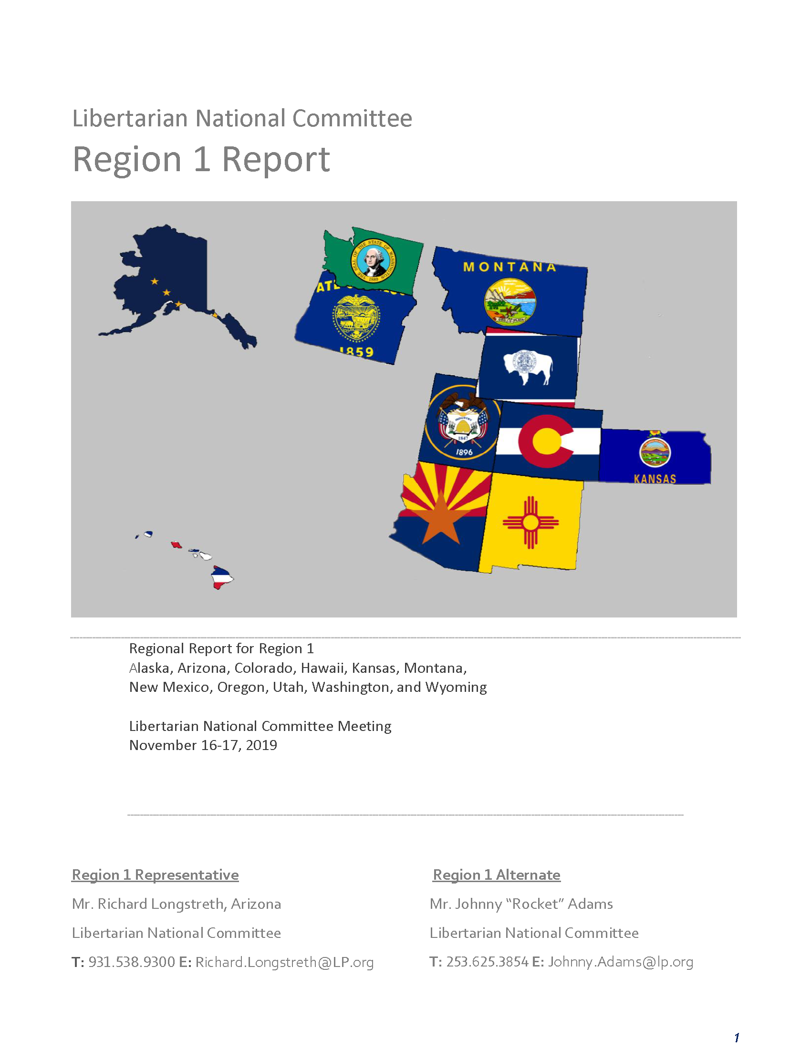

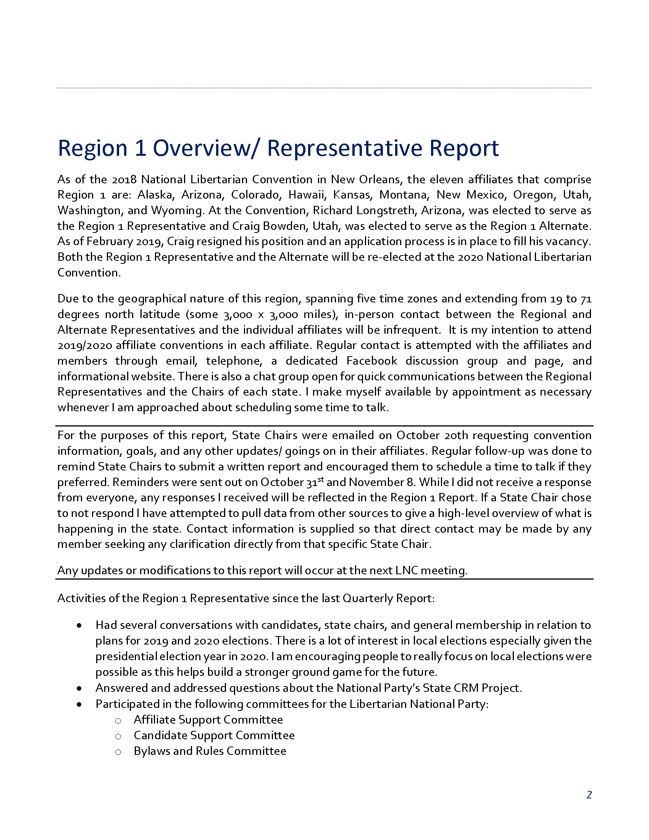

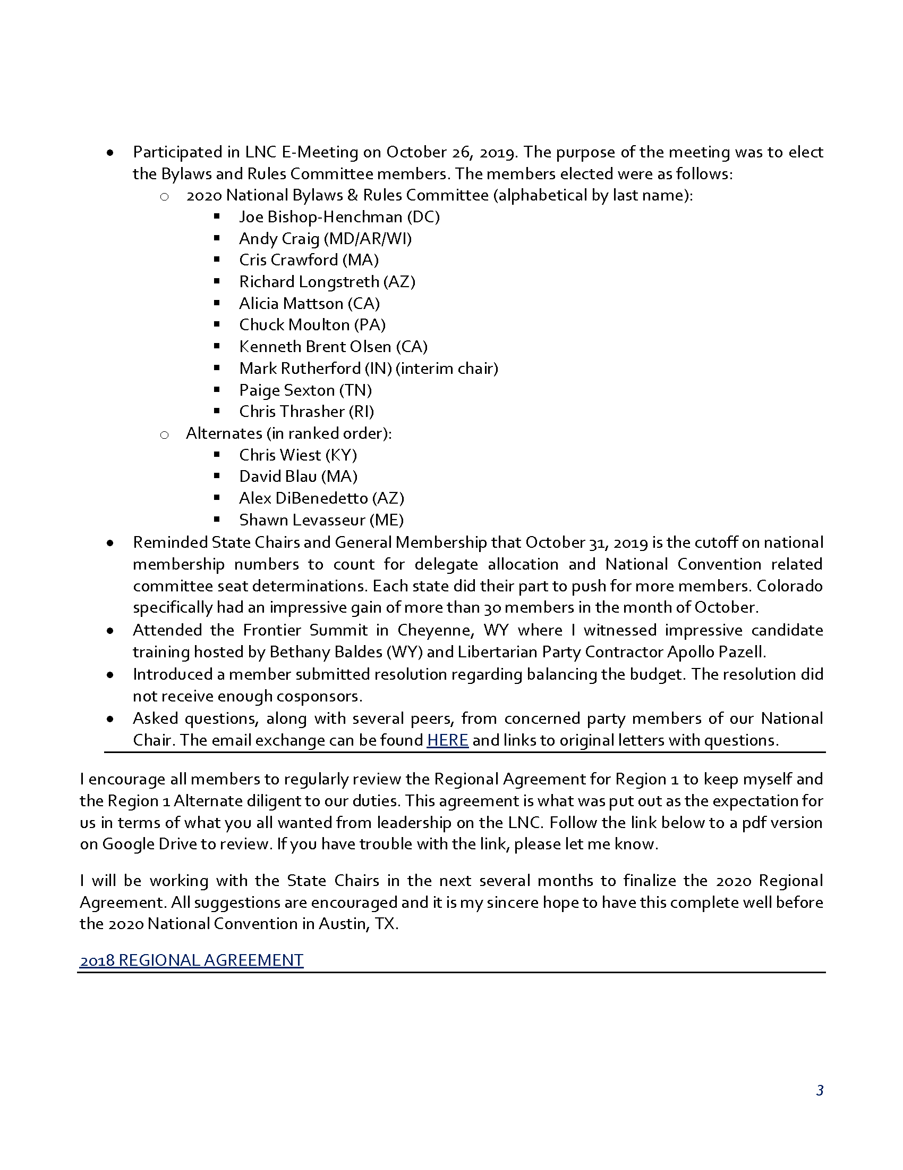

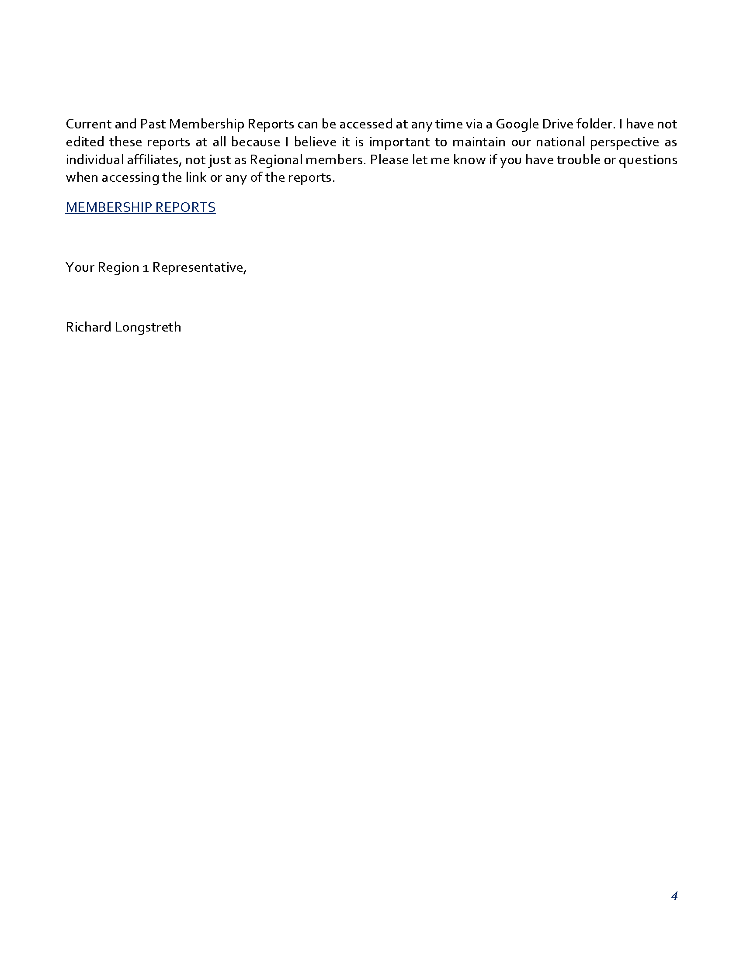



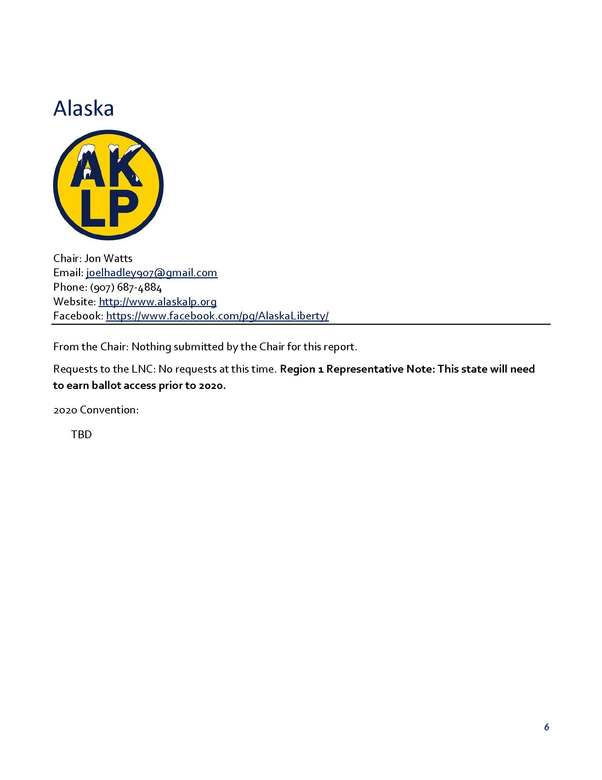

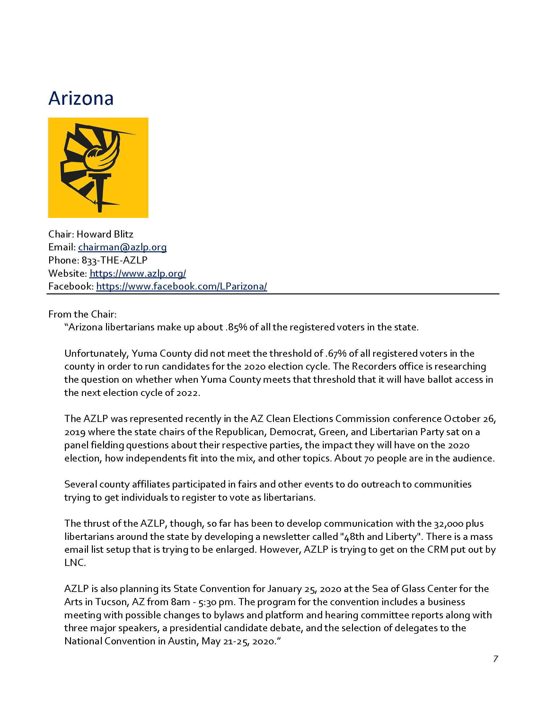

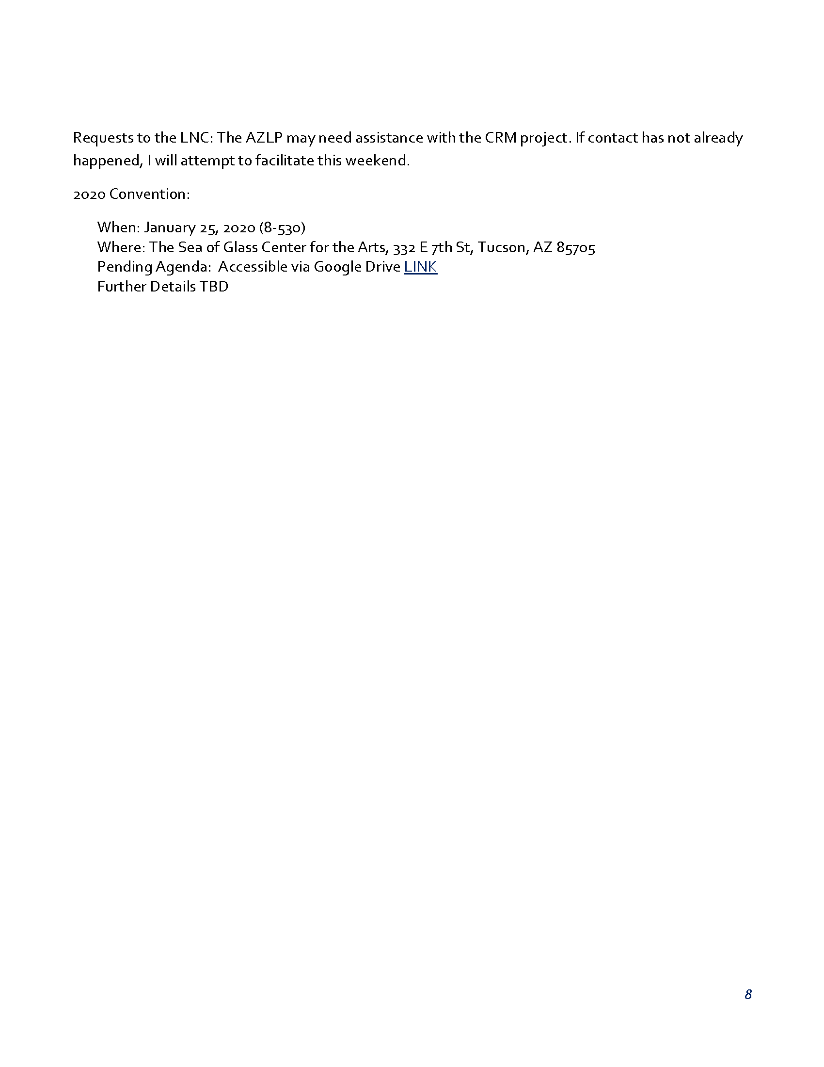

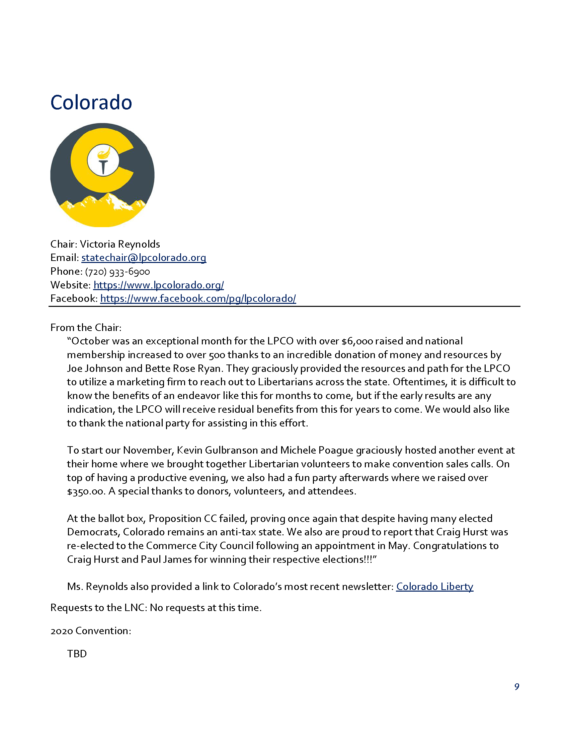

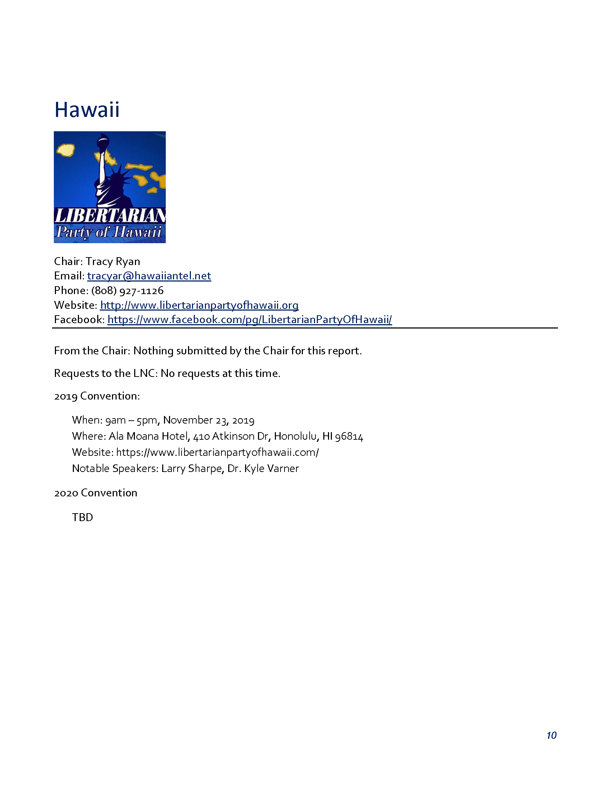

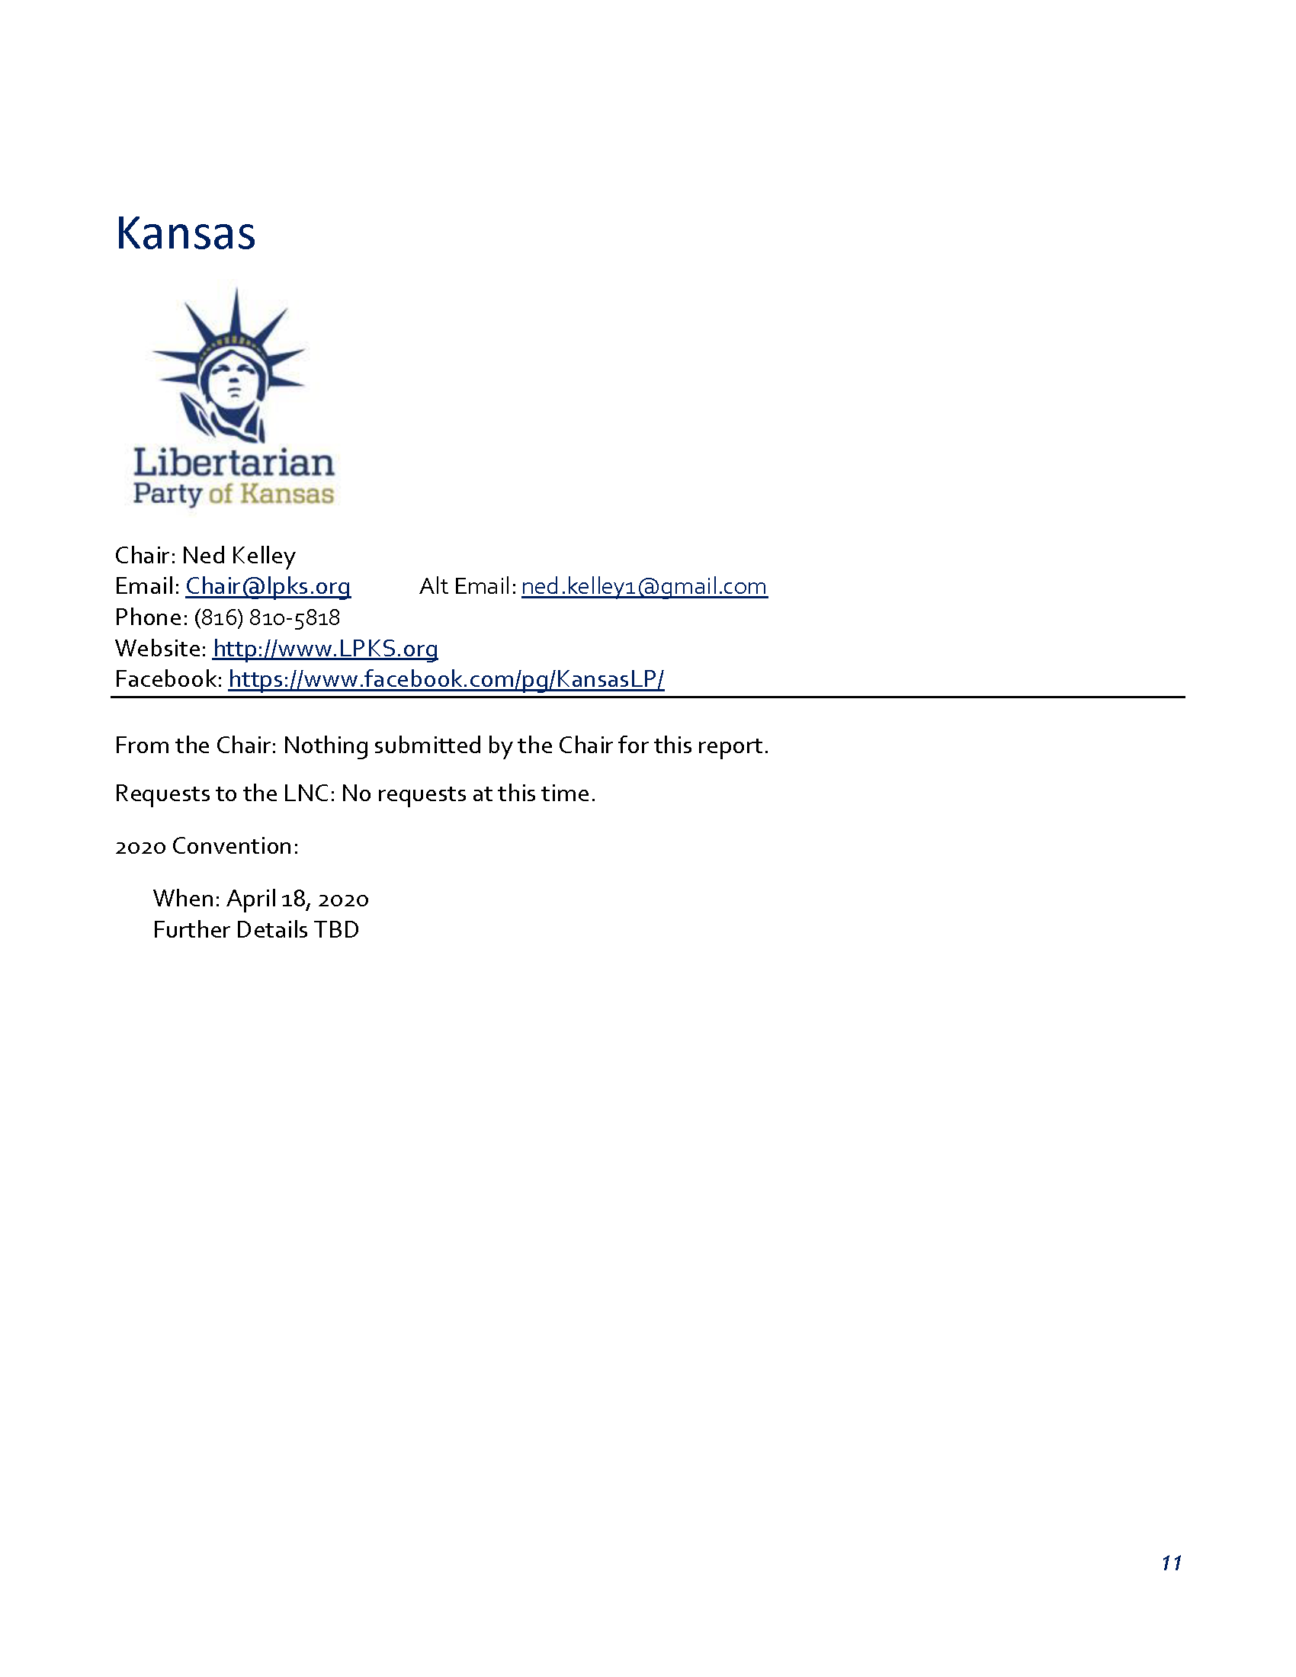

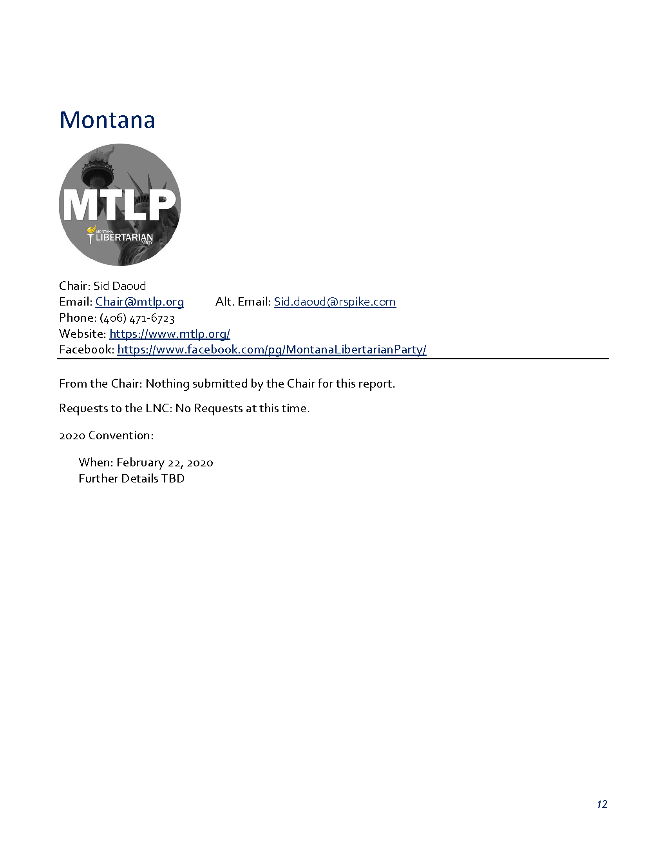

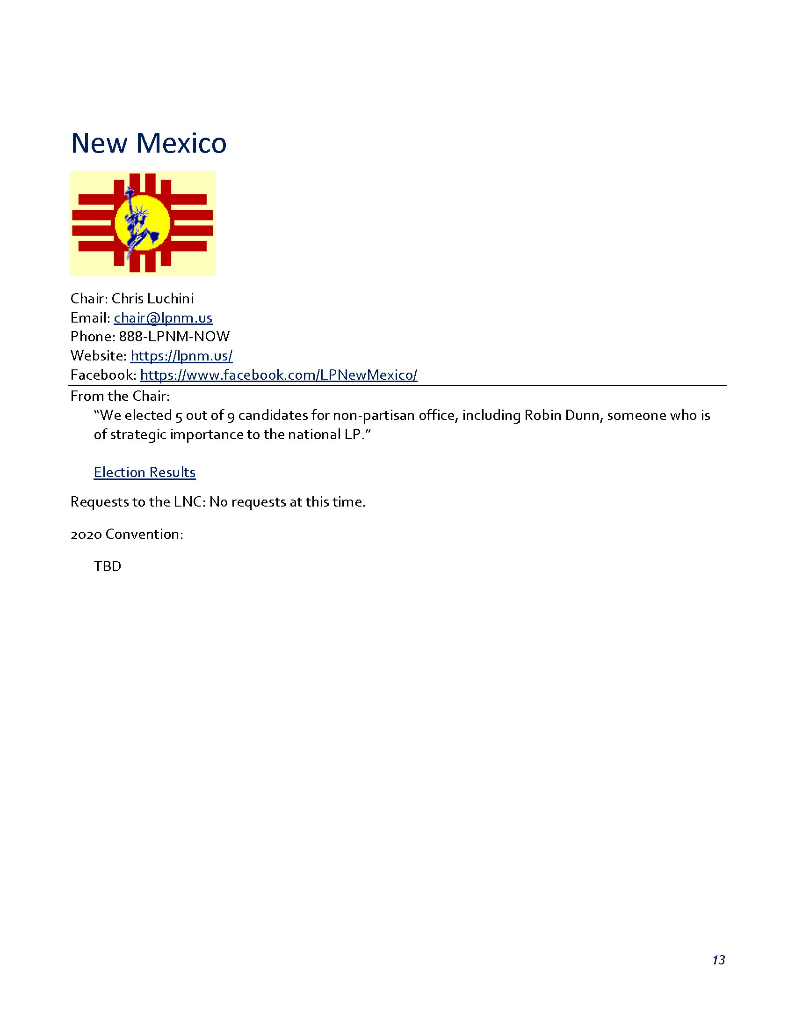

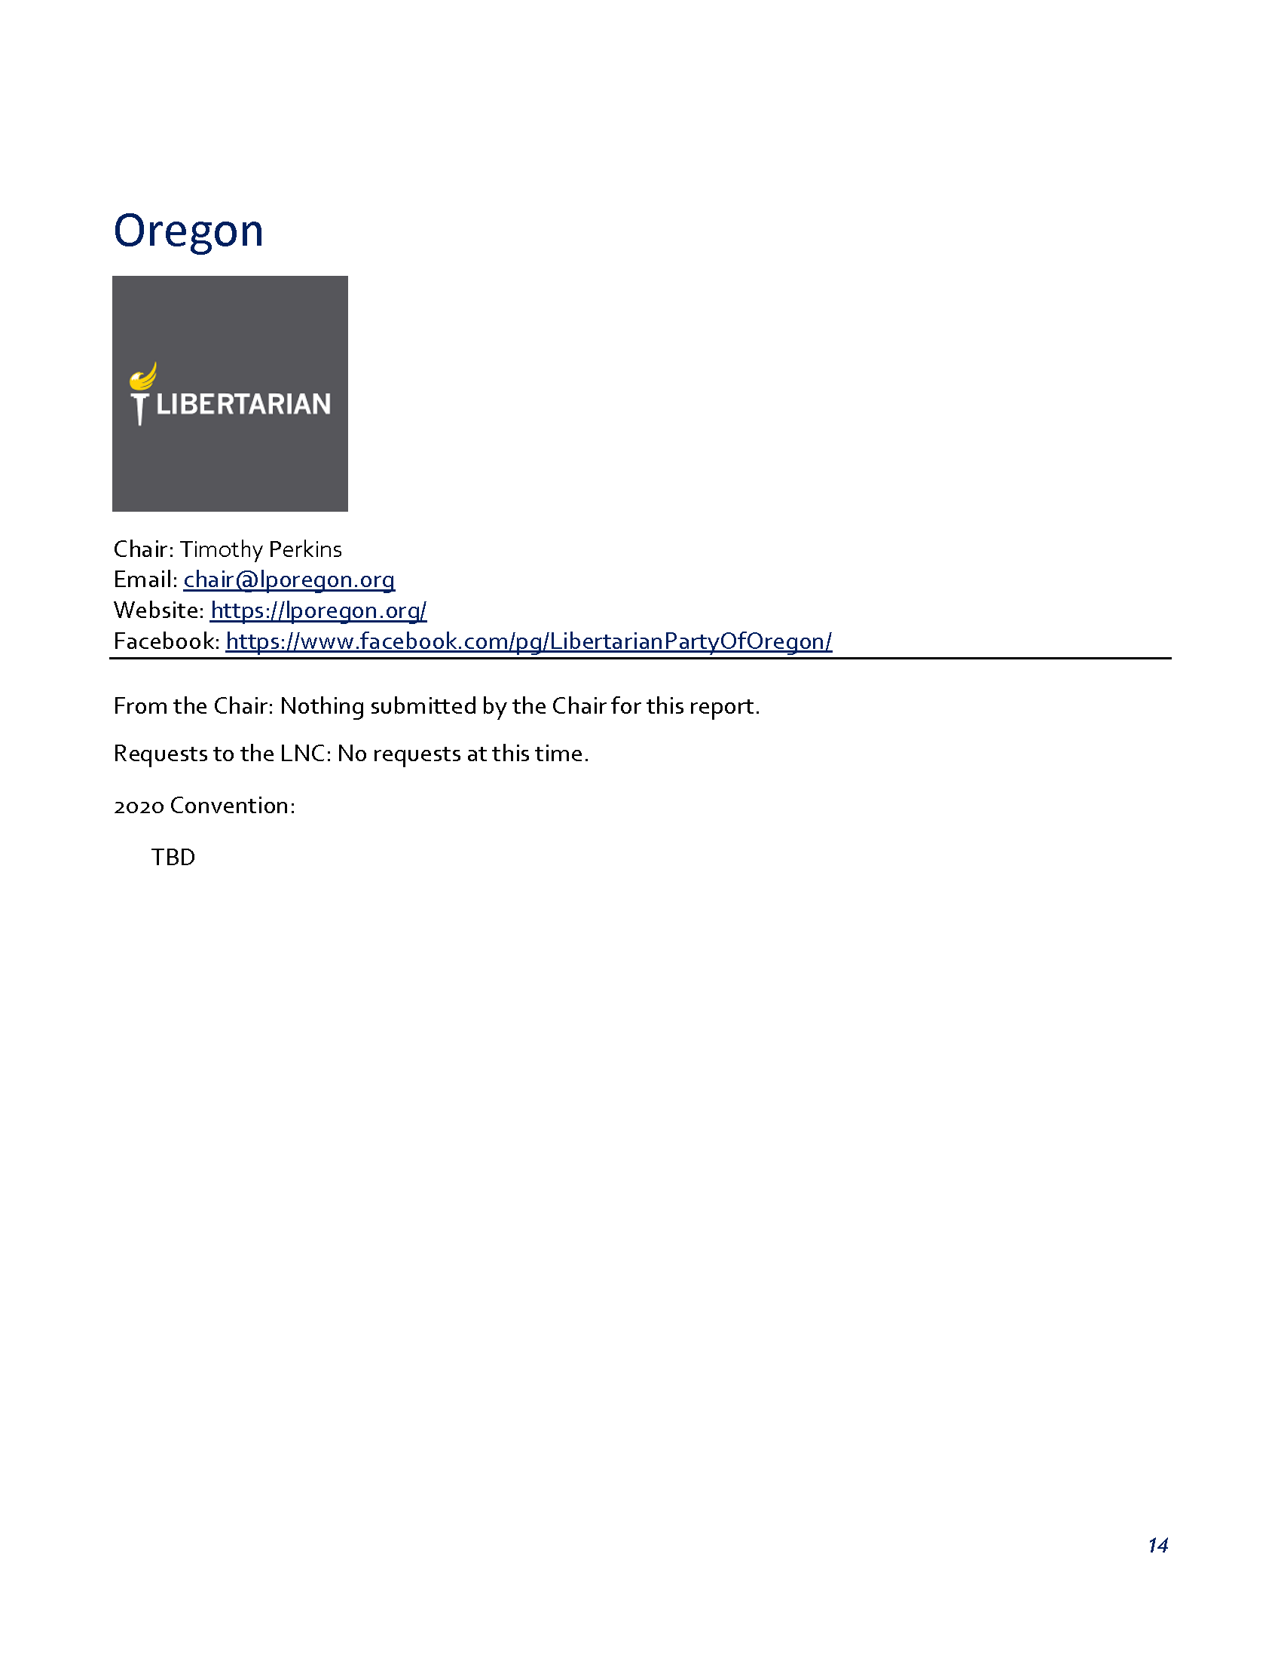

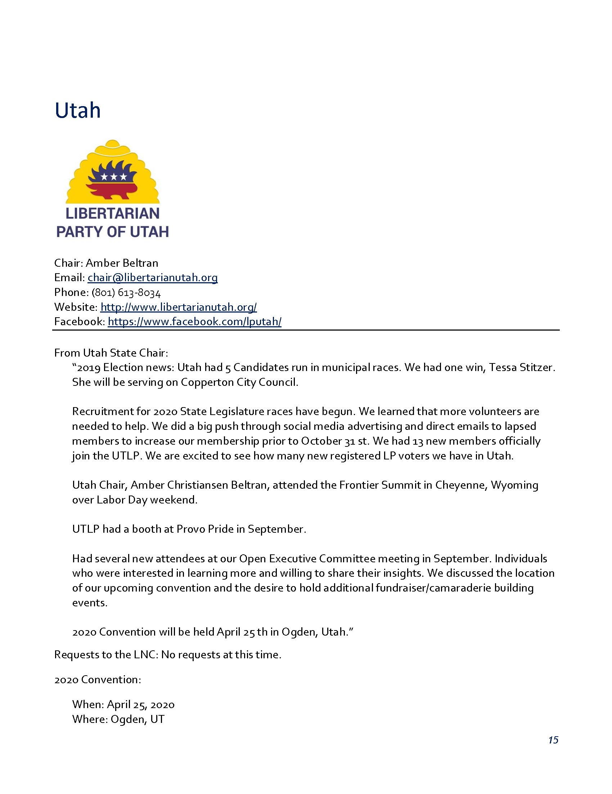

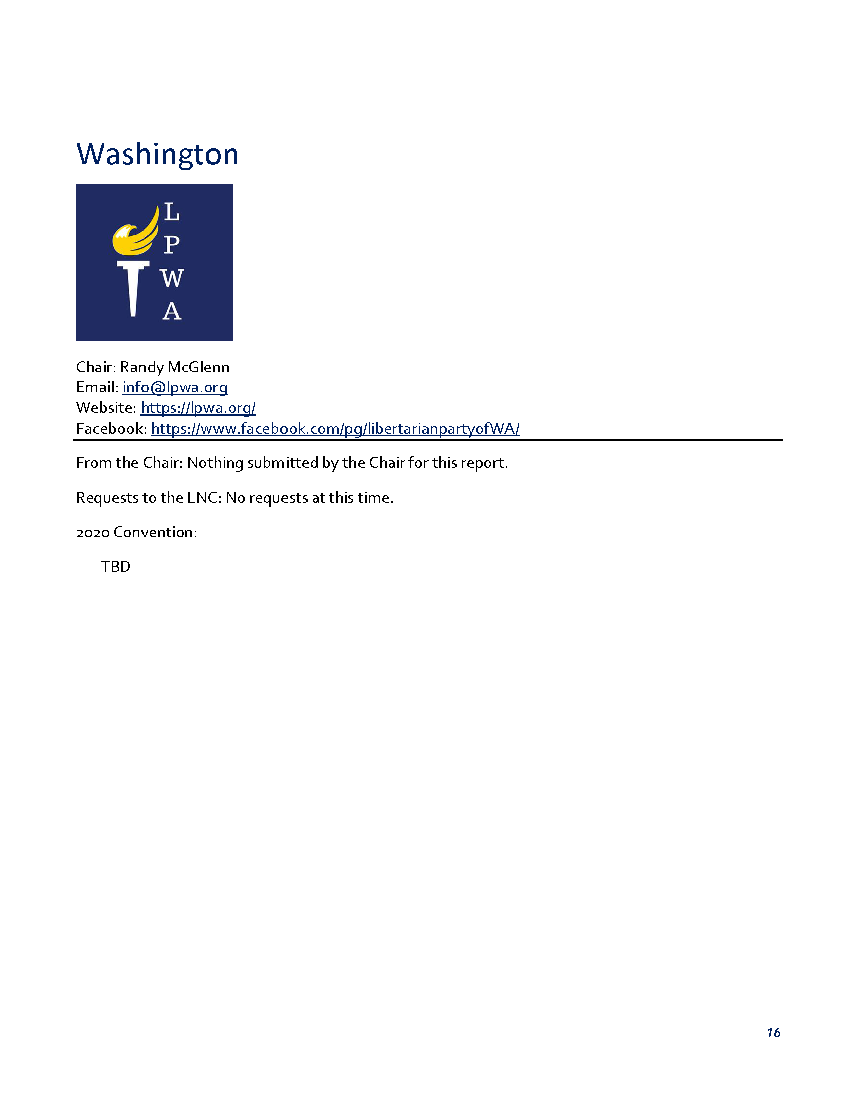

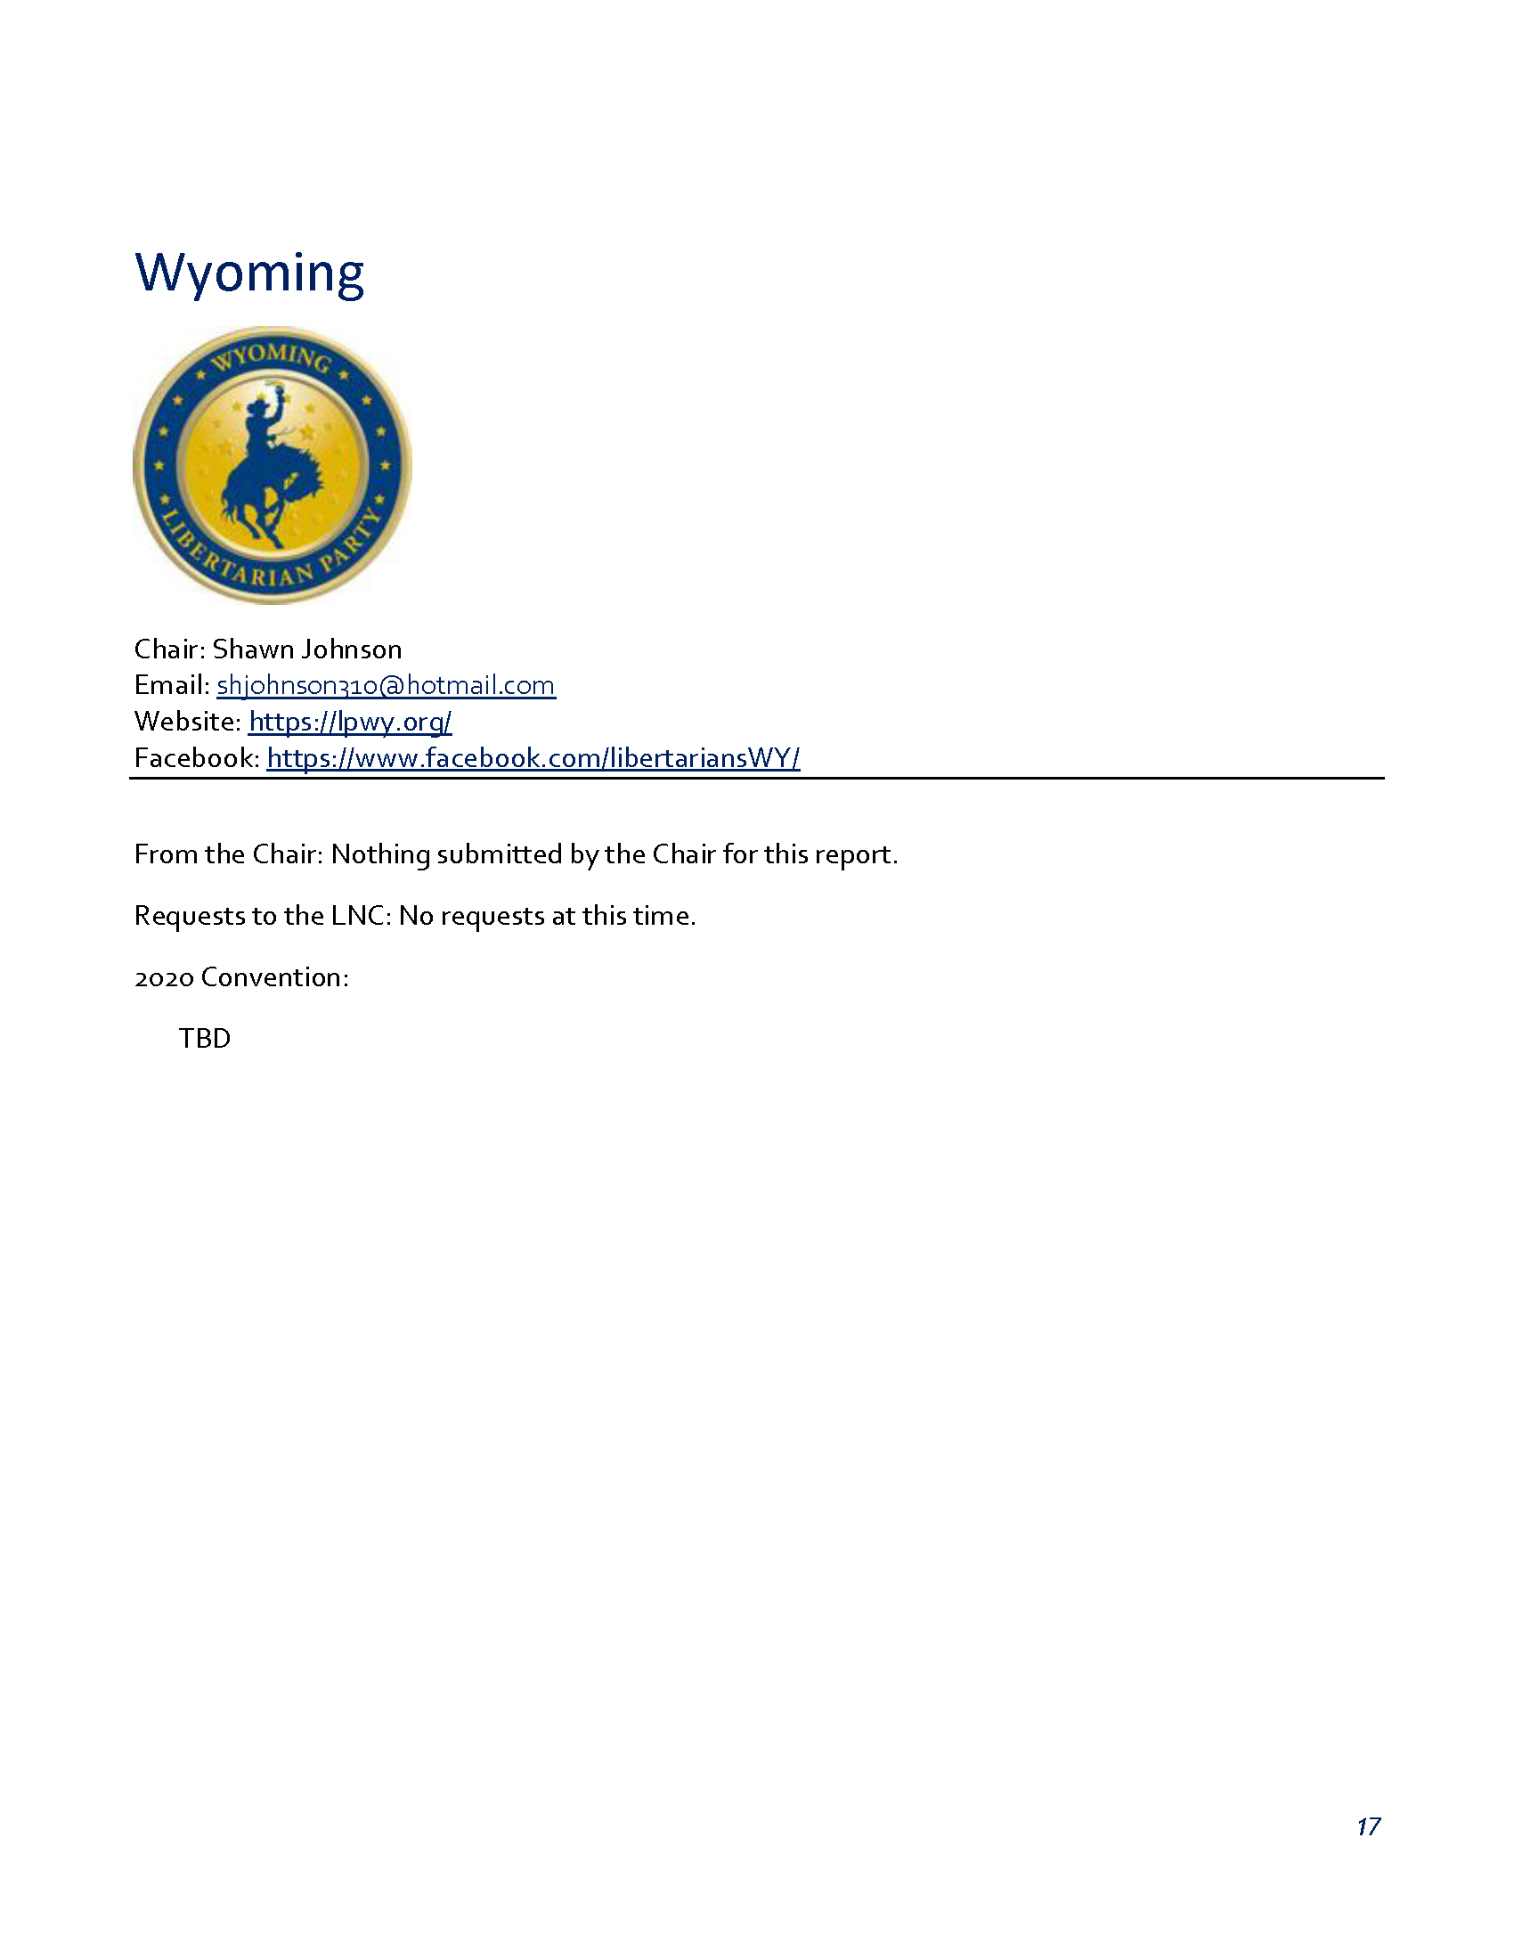

APPENDIX T – REGION 2 REPORT
Tennessee
- LP Tennessee State Convention is January 11^{th,} currently focused on the planning process.

Georgia
- Lost ballot access case in District Court and have filed an appeal with the 11th Circuit. Currently fundraising for that effort, only need roughly $600 more.
- State Convention is January 18th & 19th, all LNC members are invited. Convention will be showcasing activists for their keynote speakers. Presidential debate on the 19th.
- State Party is focused on ballot access and work with their criminal justice partnership to expand expungement opportunities for nonviolent criminal records.

Florida
- State Convention is February 21st-23rd in Orlando, FL.
- Organizing phone banking to affiliate unaffiliated regions.
- 2020 Plan is to continue on the basis of Operation First Step, identifying and targeting low hanging fruit campaigns with a high chance of a win.
- Continues to work on a tandem Civi CRM/eCanvasser systems setup
- Working on Moodle for hosting positional guides and other training material
- Begun an internship volunteer program for committee positions for University students

APPENDIX U – REGION 3 REPORT

APPENDIX V – REGION 4 REPORT

We had one win on election day for a neighborhood council. Cal LP is
getting involved with the recall of Governor Newsome. Southern
California Leadership Summit was successful, we had three presidential
candidates in attendance. Aaron Starr and Alicia Matteson collected 65K
signatures to place 5 ballot measures in the Oxnard election.
Libertarian Party is a recognized party so our candidates will be on the
primary ballot. Several viable candidates are beginning runs for 2020.
Jeff Hewitt Region 4 representative and Napkin Scribe

APPENDIX W – REGION 5 REPORT

REGION 5 REPORT

Submitted to: Libertarian National Committee, Nov. 8, 2019

Submitted by: James W. Lark, III
Region 5 Representative, Libertarian National Committee

This report will provide information concerning activities of the Libertarian Party state affiliates in Region 5 that have occurred since the previous LNC meeting. I shall provide an updated report at the meeting in Miami should additional information become available.

I am pleased to report that I have been able to represent the LP in various ways since the previous LNC meeting. For example, I continue to serve at least once a month as a guest on a two-hour political talk show that airs on weekdays on WINA radio (1070 AM/98.9 FM in Charlottesville, Virginia).

Delaware

Sean Goward (sean.goward@yahoo.com), chair of the Libertarian Party of Delaware, informed me that the 2020 LPD convention is tentatively scheduled for March 14.

District of Columbia

Joe Bishop-Henchman (jdhenchman@gmail.com), chair of the Libertarian Party of the District of Columbia, provided the following report:

DCLP focused on finishing a number of important housekeeping items this summer, including reopening a bank account, re-registering with the DC Office of Campaign Finance (in addition to the federal FEC), launching a new website (www.dclibertarians.org), and new email addresses. Our voter registration efforts are paying off, growing to 1,723. This is 16% growth YTD, compared to 1% decline for the Democrats, 2% decline for the Greens, and 3% decline for the Republicans.
Our team has also begun planning for 2020. Since the DC primary is in June after the national convention, we intend to host a weekend-long primary/convention/caucus at a date TBA to hear from candidates and select delegates. We are currently scoping venues and consulting calendars. Any questions, please contact me at joe@dclibertarians.org.

Maryland

Bob Johnston (bob.johnston@lp.org), chair of the Libertarian Party of Maryland, provided the following report:

The Maryland Libertarian Party filed a lawsuit in US District court on March 23 of this year, stating that the Maryland LP had no need to collect 10,000 signatures from registered voters in the state, since the party already has over 22,000 registered voters. The court dismissed the suit on July 11.

The Maryland LP filed an appeal to the US Court of Appeals on September 25. There has been no word yet from the court on the appeal.

The Maryland LP is currently undertaking a volunteer effort to collect signatures. To be on the ballot for the 2020 general election, the party must submit at least 10,000 valid signatures from registered voters in the state by next August 3.

The annual picnic was held on Saturday, 10 August at the home of Dave and Renee Sten in North East, MD. LNC Regional representative Jim Lark was in attendance.

Bob Johnston
(443) 310-5373
Bob.Johnston@lp.org

North Carolina

Susan Hogarth (hogarth@gmail.com), chair of the Libertarian Party of North Carolina, provided the following report:

Outreach/Tabling:

We tabled at Prepper Camp (a survivalist expo) for a weekend and made some great contacts.
Tabled at a few university events
We tabled at 4 or 5 Pride events, with good reception at each.
Tabled at Dixie Classic and State Fairs
All tabling events featured the Advocates’ WSPQ, which continues to be a great outreach tool.

Political:

Developing legislative agenda and liaison program to work with other issue groups

Candidates:

2019
We have several LPNC candidates running in nonpartisan races. At least one write-in candidate.
2020
One declared Senate candidate, several GA and local candidates declared; actively recruiting for December filings.

Affiliates:
Bringing several counties online or back online and starting up five campus organizations

Organizational:
Developing fundraising team
Completing structural reorganization work
Planning for 2020 state Convention is well underway with >20 registrants as of Nov 1.

Susan Hogarth
919-906-2106

Pennsylvania

Steve Scheetz (steve@stevescheetz.com), chair of the Libertarian Party of Pennsylvania, indicated that he intends to provide a report after he and his colleagues have more time to process the election results.

South Carolina

Sean Thornton (sean.r.thornton@protonmail.com) is the newly-elected chair of the South Carolina Libertarian Party. He provided the following report:

We held our biennial convention on November 2 and elected new officers, all of whom were unanimous or near-unanimous:
Chair - Sean R. Thornton
Vice Chair - Steven Biggs
Second Vice Chair - Matt Hicks
Treasurer - Jeff Dimit
Secretary - Victor Kocher

We also adopted, over moderate opposition, a resolution supporting the Convention of States project.

Following the convention, we held a presidential debate, which went very well--it was attended by about 100 people, all of whom seemed to enjoy the event, and 70 of whom participated in a straw poll to select the winner of the debate. Kim Ruff carried about 50% of the votes among members and non-members alike. There was an after party with the candidates enjoyed by over 30 guests, and a small auction raised over $500 toward ballot access for other states (SC has permanent ballot access).

There was a last-minute problem with the audio feed at the debate that prevented us from doing a live stream of the debate as we had planned, which was quite disappointing but beyond our control and did not detract from the experience for those in attendance. However, it has come to my attention that Justin O'Donnell and Dustin Nanna have publicly made several disparaging remarks about us over this issue, and everyone in my state party is quite upset about this. They are welcome to whatever incorrect opinions they want to have in private, but it is highly inappropriate for sitting members of the LNC to publicly insult any state party, and I would like this brought up at the meeting.

Sean R. Thornton
Chair SCLP

Virginia

Bo Brown (bocbrown@yahoo.com) is the chair of the Libertarian Party of Virginia. I did not receive a report from him.

West Virginia

Dave Valente (davidtvalente@gmail.com), chair of the Libertarian Party of West Virginia, provided the following report:

Libertarian Party of West Virginia | - Q3 Report Status
11/4/19
July | - LPWV State Registration totals cross 7,000 for the first time.  - Completed videos on how people can get involved in the LPWV and disseminated to Facebook & Twitter.  - Held Executive Board meeting online and finalized pricing for the State Convention.  - Mike Lockard & Will Hyman announced runs for WV House of Delegates, Rex Starkey announced for Harrison County Commission.
August: | - Erika Kolenich for Governor had first public event in Clarksburg  - Erika Kolenich had radio interview on WRNR Martinsburg & TV10 and appeared in Martinsburg.  - I appeared on WRNR Martinsburg & TV10 on the Friday Political panel & discussed Red Flag Laws.  - Registration numbers show 1% growth for month. The only party to grow every month this year.
September | - Cat Webster entered the race for WV Senate District 15  - Changed the 3 letter ballot designation for LPWV from LIB to LBN  - Working with the WV SOS office to honor the 19th Amendment on it’s 100th anniversary in 2020.  - Once again voter registration totals increase 1%, highest among all parties and Independent registrations.
October | - Kolenich for Governor & LPWV had outreach event at the Charleston Car Show & Doo Wop  - Kolenich for Governor & LPWV had outreach event at Bridge Day at the New River Gorge Bridge in Fayetteville, WV.  - Increased our national party membership by 20 over the final month to count for convention delegates, we stand at 71 members, roughly 1% of our registered voters.  - 2016 Gubernatorial candidate David Moran will run for US Congress in the 1st District.
Next Quarter plans | - Focus on the State Convention begins in earnest. In November we will work on getting websites, mailings and branding set up  - Focus will also begin on developing a point of contact for the LP in all 55 counties by the end of the year.  - Candidate recruitment may see a candidate for US Senate emerge and other candidates for WV State legislature emerge.

APPENDIX X – REGION 6 REPORT
Region 6 Report for the Second Meeting of 2019.
Iowa:
LPIA gearing up for 2020 caucus, will include straw poll for presidentially race. Will have virtual caucus option which Dems and Republicans will not have. Feb convention headlines by Chafee. Ruff, Armstrong and Abramson as guests. SCC elections at this convention. LPIA ballot access filed in federal court. Working on additional candidates. Likely to do a forum at convention in addition to speeches
Minnesota:
1. We had one candidate (our very own LPMN Chairman Chris Holbrook!) run for office in Minnesota in 2019. He got 13% as an outlier in his race for Saint Paul City Council, which has been a one party town for many years. The other two candidates were both DFL virtue-signalling progressives who combined for 87% in rank choice voting, which is historically typical in our capitol city. The biggest local issue this year has been a trash company sponsored service level mandate ordinance that went into effect a year ago. It was unfortunately upheld by voters 2-1 due to a Mayoral tax hike threat alongside a well funded marketing effort by MN DFL and unions stewards, in this year's so-called non-partisan elections.
2. The LPMN lawsuit against the State of Minnesota is currently being amended by our attorney to include an expansion of the ballot access petitioning window, which is currently a paltry 14 days. MN state minor party endorsed candidates must be announced and filed 10 weeks prior to the major party state primary in August, which is obviously the date the major parties decide and announce who their endorsed candidates will be. That is an unfair competitive advantage. This amendment is in addition to the original lawsuit challenge against the MN petition signor's oath that bans major party primary voters from signing minor party petitions under penalty threat of felony perjury.
Note: this is separate process from the Minnesota Presidential filing and primary system. For the first time in 2020 Minnesota will be switching over to a Presidential Primary instead of a Caucus for major parties; and will join 13 other states in voting on 'Super Tuesday', March 3, 2020. Minor party Presidential candidates in MN will continue to follow the previously established ballot access petitioning deadline in filing 10 weeks prior to the November 6, 2020 general election.
3. The LPMN membership drive in tandem with the LNC push last month garnered 6 new dues-paying members, bring the LPMN roll to approx. 325 and the LP roll of Minnesotans to 225. Our members will gather on March 28, 2020 in Maple Grove (again) for our annual LPMN State Convention; where we will vote on our leadership, candidates, and also our delegates to the May 23, 2020 LP National Convention (in Texas). Before 2020 we will be holding our year end annual Legacy club donor dinner on December 13, 2019. Furthermore, prior to this update one of our Legacy members sponsored a prime LPMN table at the Citizens for Health Care Freedom dinner in Mpls in September that focused on electronic health records privacy. We also had a group attend the Region 6 LP affiliate leadership cross training event which they found beneficial

N. Dakota
S. Dakota
The LPSD happenings. We finally elected a new Membership Director last month, Nikki Fosheim. That was the only position we were unable to fill on our Executive Committee at Convention in June. We are hoping to start using and implementing the CiviCRM program soon. We helped with a couple petition drives recently that wrapped up Nov. 4th to put Medical Marijuanna and another for Recreation/Medical/Hemp on the ballot next November. We are waiting on the State to validate signatures now to find out they made it. (They should). And we are about to start our 3rd Annual Holiday Food Drive where we collect donations for Feeding South Dakota
Illinois:
Illinois also working on state convention 2020. March 13-14. 8 verbal confirmations from POTUS candidates to participate in our debate. We have a new director of social media on my team and he is kicking butt and taking names! Helping to make LPIL a stong presence online. In addition Mr Redpath is finally a state resident and we are happy to have him.

Wisconsin:
Nebraska:
Missouri:
Missouri: working on 2020 state convention to be held in St Louis Feb 22. Cecil A. Ince, vice chair of the Missouri Libertarian Party was appointed to the Special Education Advisory Panel of the Missouri Department of Elementary and Secondary Education Presidental candidates need to contact Greg Talepk to br on the Missouri Primary ballot in march no later than nov 25

APPENDIX Y – REGION 7 REPORT
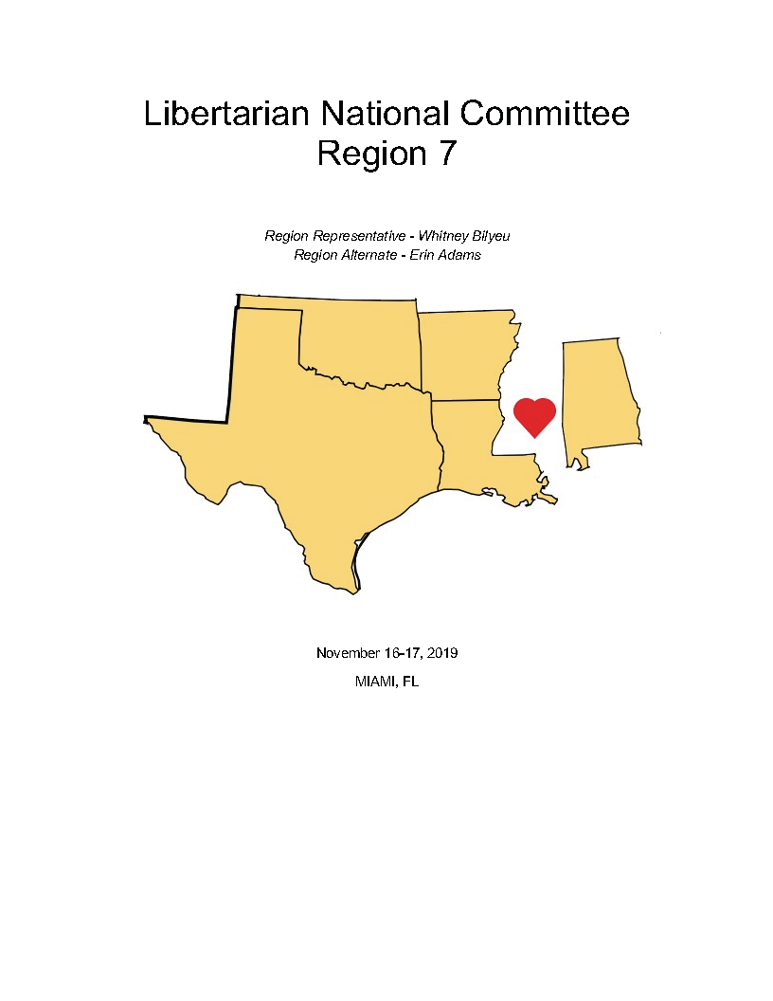

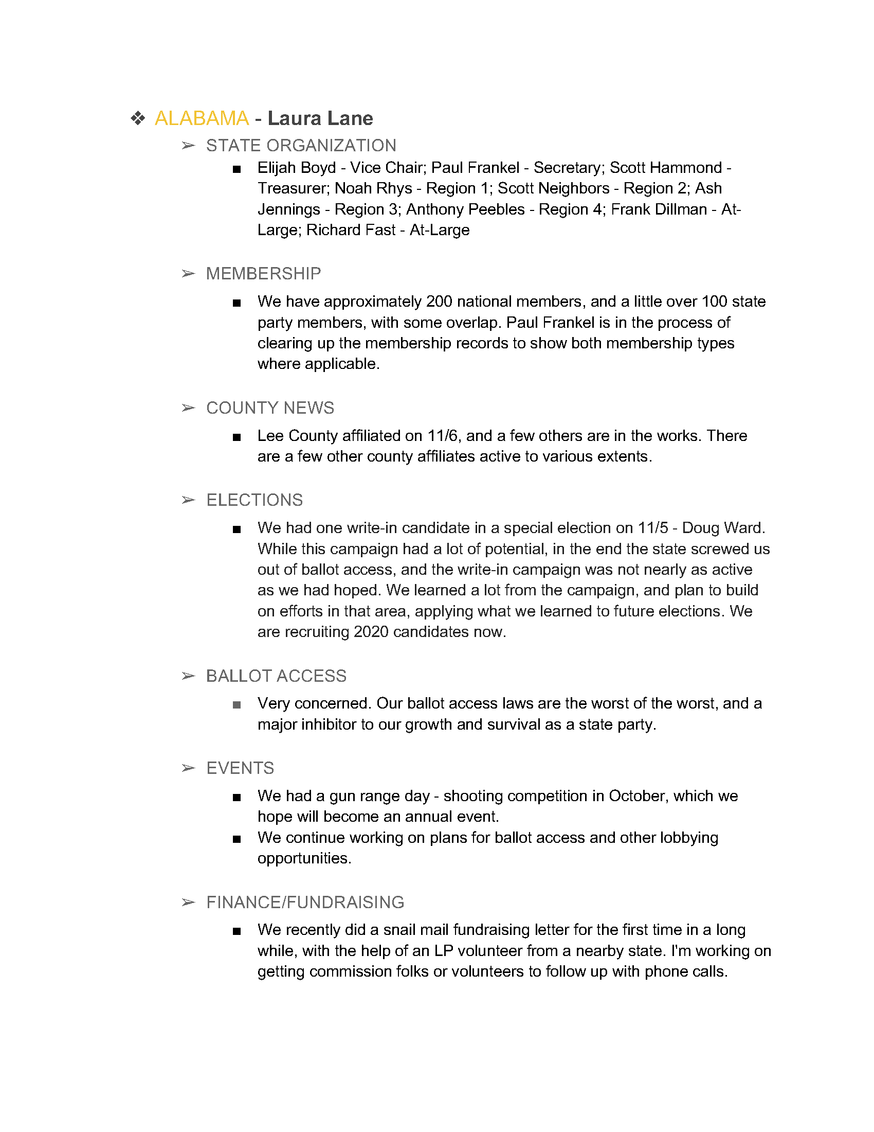

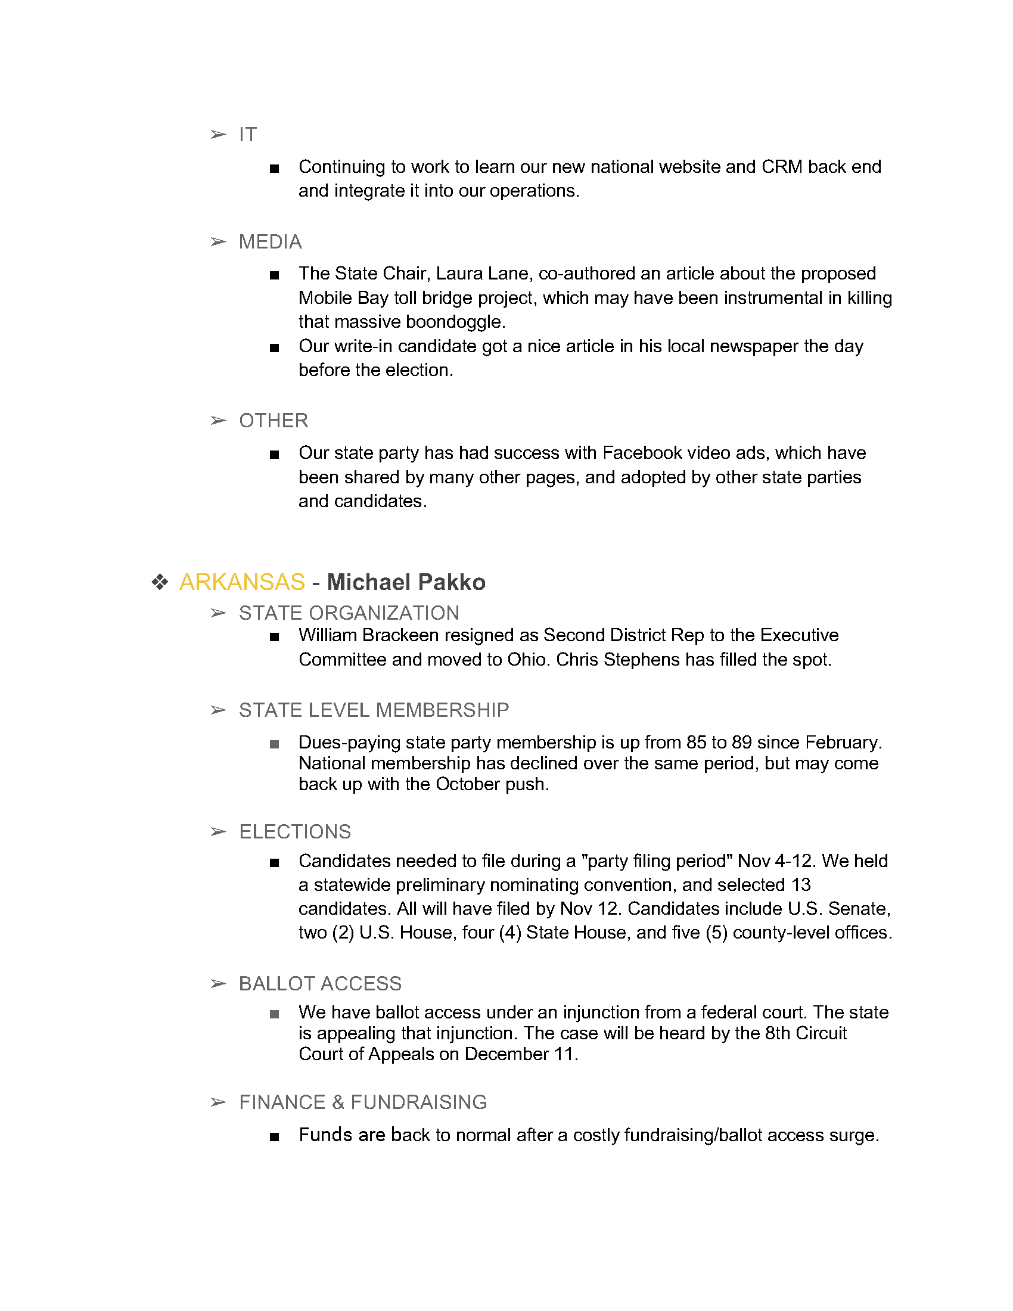

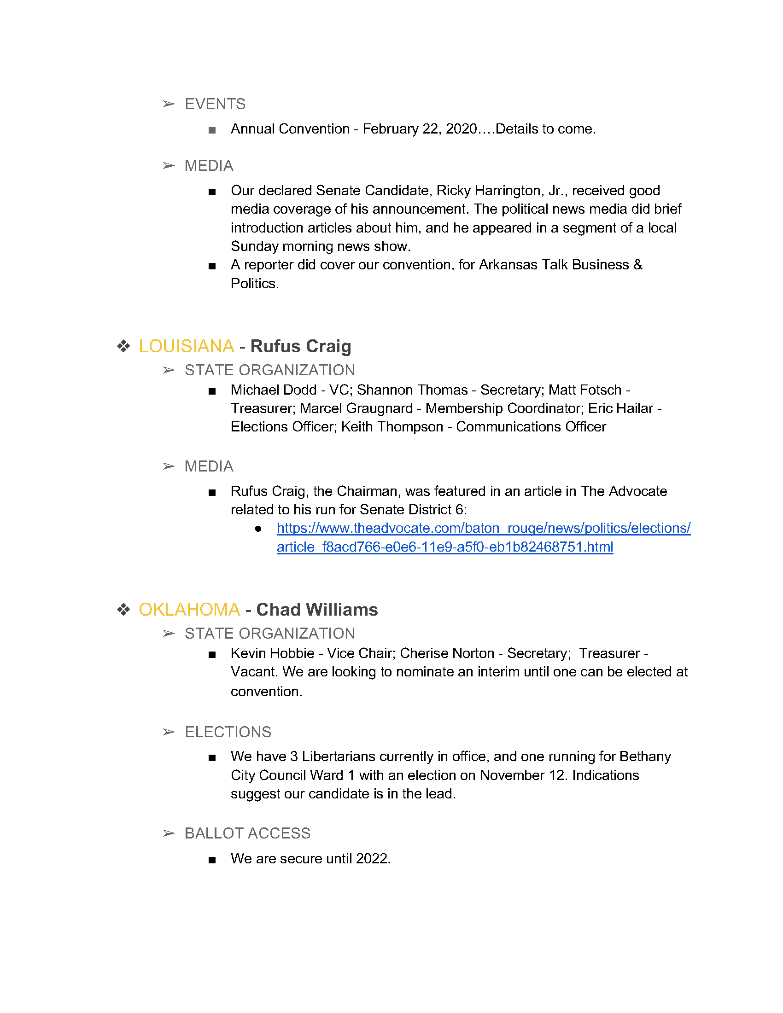

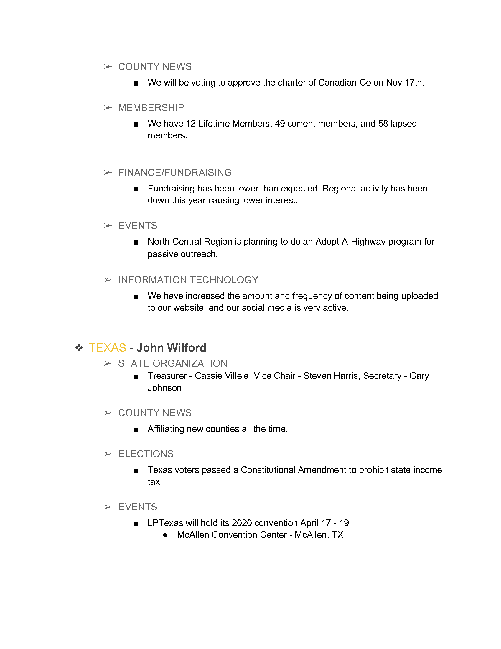

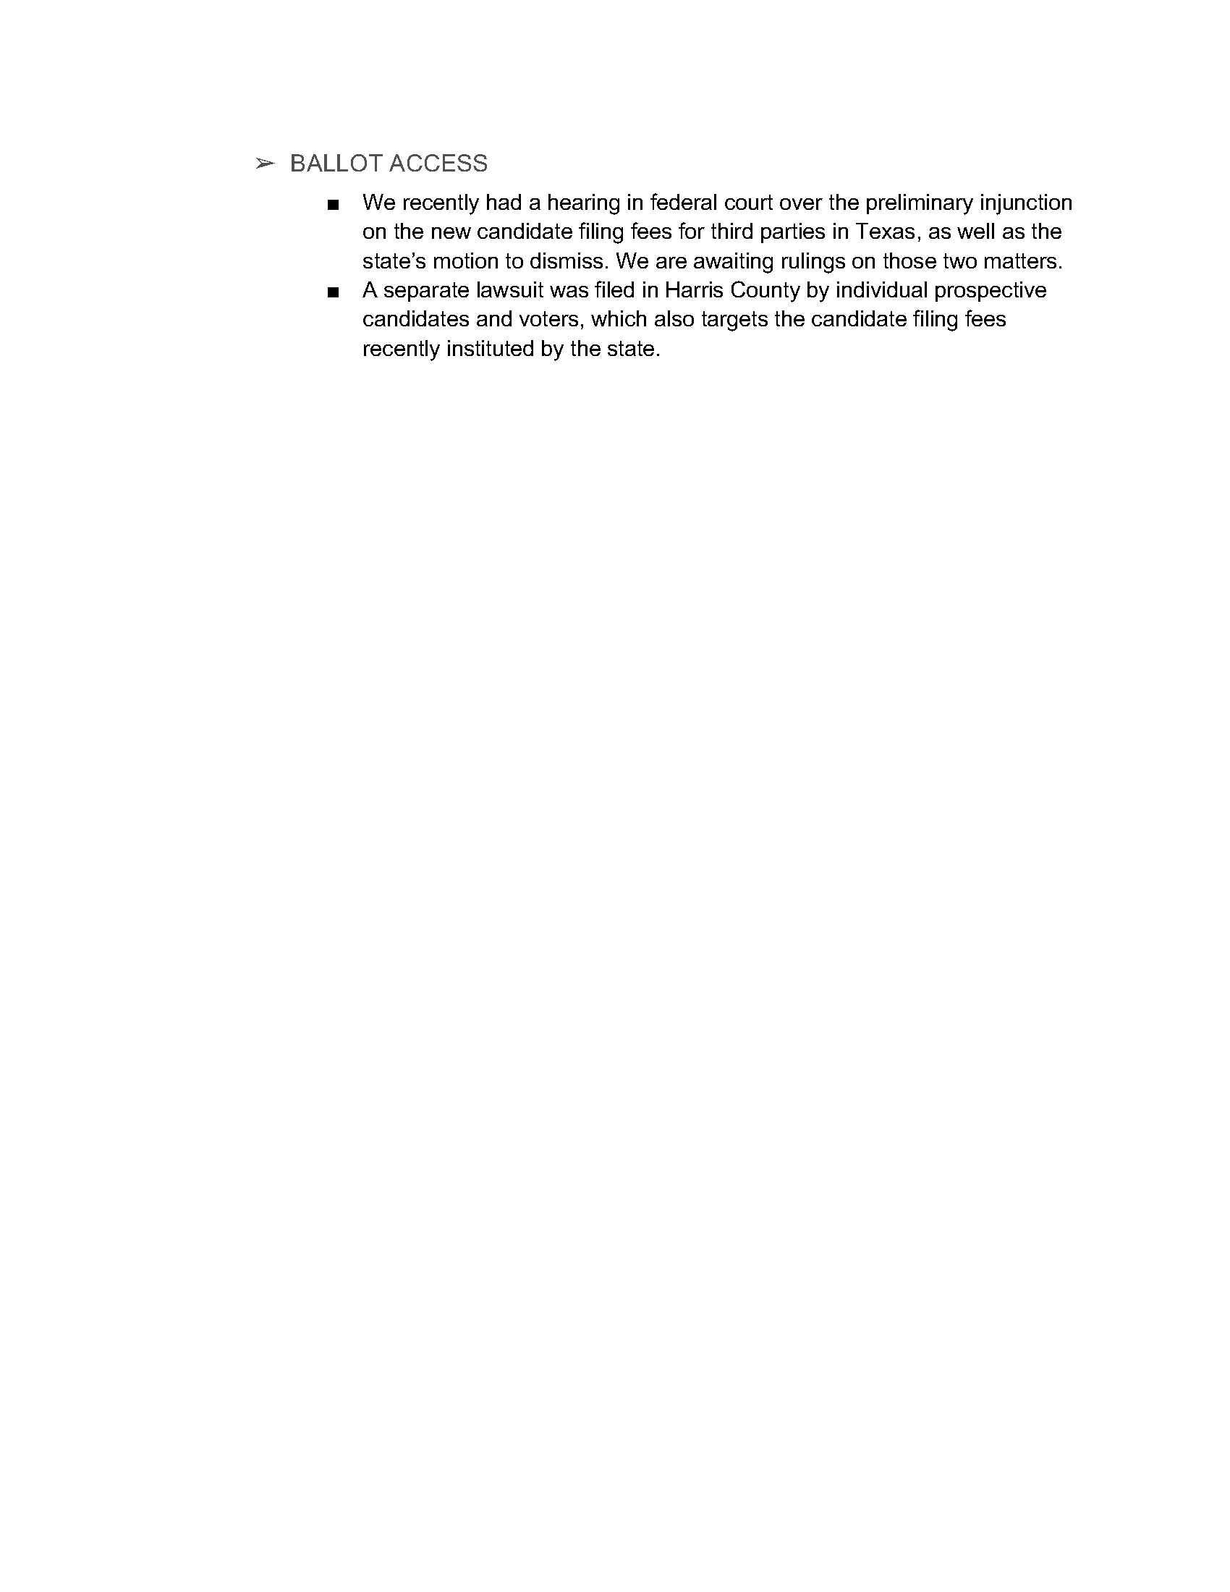

APPENDIX Z – REGION 8 REPORT


Region 8 Report
Submitted on 11.11.2019 by Regional Representative Justin O'Donnell

Regional Representative: Justin O’Donnell
Regional Alternate: Pat Ford

Notable events from Affiliates are reported below.

New Hampshire: LPNH is continuing it’s fundraising drive to get ready for the 2020 Ballot Access Drive in support of the LNC Presidential Nominee, as well as currently accepting registrations from Presidential Candidates to participate in the Self Funded LPNH Presidential Preference Primary to take place in February 2020, the Deadline for Presidential Candidates to file is November 15th.

Maine: The Libertarian Party of Maine recently filed a lawsuit against the Secretary of State regarding the disenrollment of Libertarian voters and decrecentialing of the LPME as a Recognized Political party in the State of Maine. Details of this lawsuit will be deferred to the LNC Counsel’s report.

New York: The Libertarian Party of New York held a special convention of their legacy organization, “The Free Libertarian Party” where the delegates voted to dissolve the existing organization, and transfer its name, assets, and affiliation with the LNC to the newly created and newly recognized “Libertarian Party of New York” to be in full compliance with the Election Laws in the State of New York.
Libertarian Party of New York Candidates saw a number of local wins and great showings in recent elections, including a projected win for District Attorney in a 3 way Race.

Vermont: LPVT is preparing for it’s biennial reorganization under state law, that will confirm minor party status, and assure presidential ballot access in 2020.

Massachusetts: LPMA had 3 candidates successfully petition to appear on the state primary ballot for State Committee in the first state sanctioned election since achieving major party status in 2016. The Candidates who successfully qualified for the ballot are Don Graham, Crs Crawford, and Peter Everett. LPMA also must submit a list of candidates to the Secretary of State by the end of the year, for who will be included in the Libertarian Party’s Presidential Primary. The Republican and Democratic parties hold caucuses to determine eligibility of candidates for their primary ballot, but there is no statutory obligation for a party to decide eligibility in a certain manner, and the State Committee of LAMA, will be tasked with deciding what LP Candidates appear on the Presidential Primary ballot.

APPENDIX AA – OCTOBER MEMBERSHIP REPORT

APPENDIX BB – TABLE OF PROPOSED POLICY MANUAL STYLE CHANGES
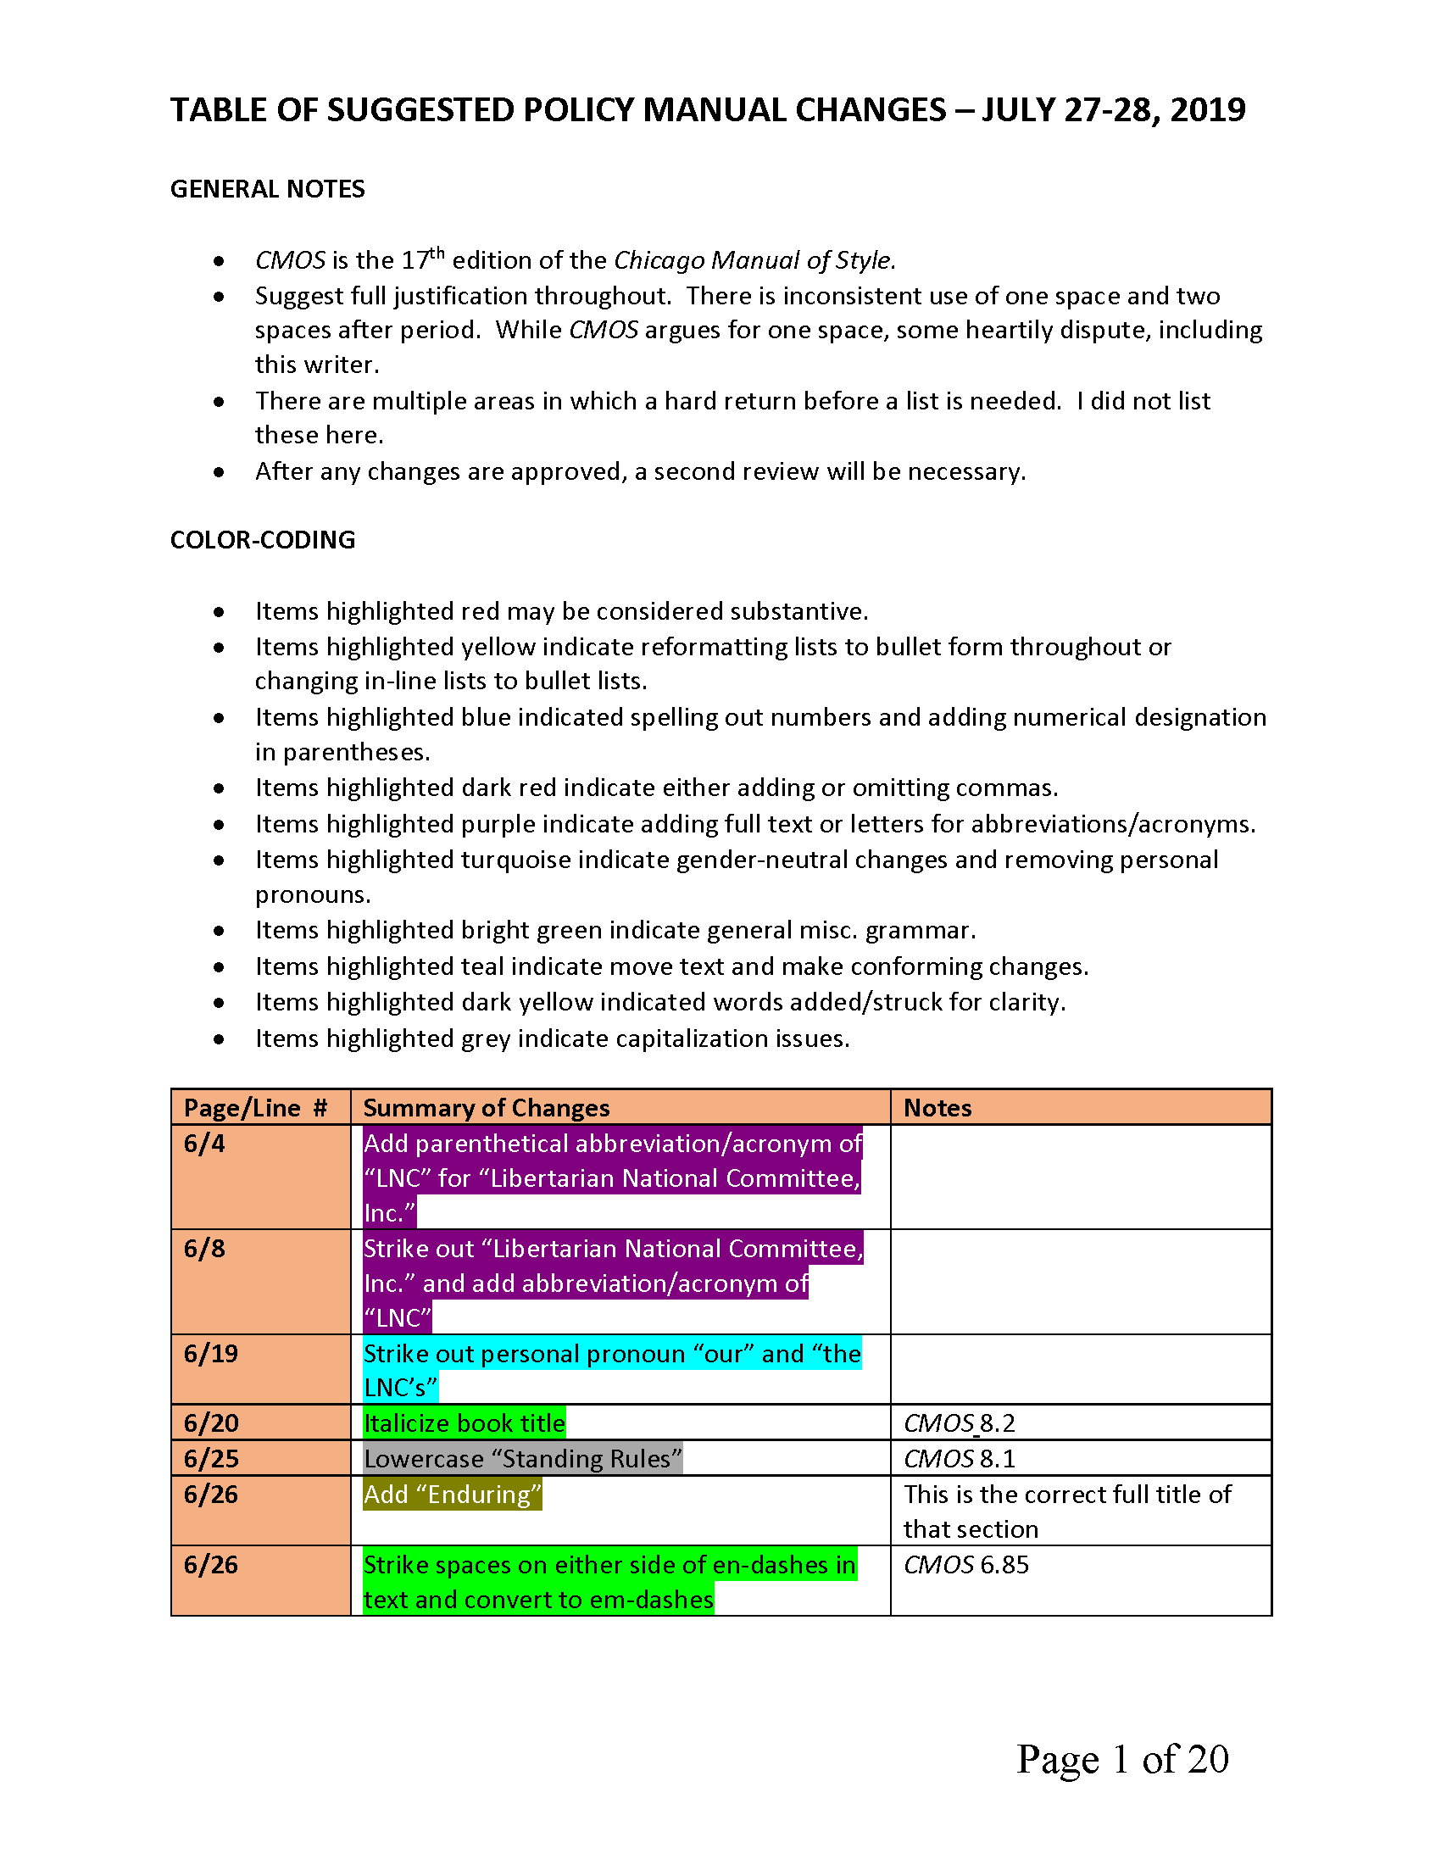

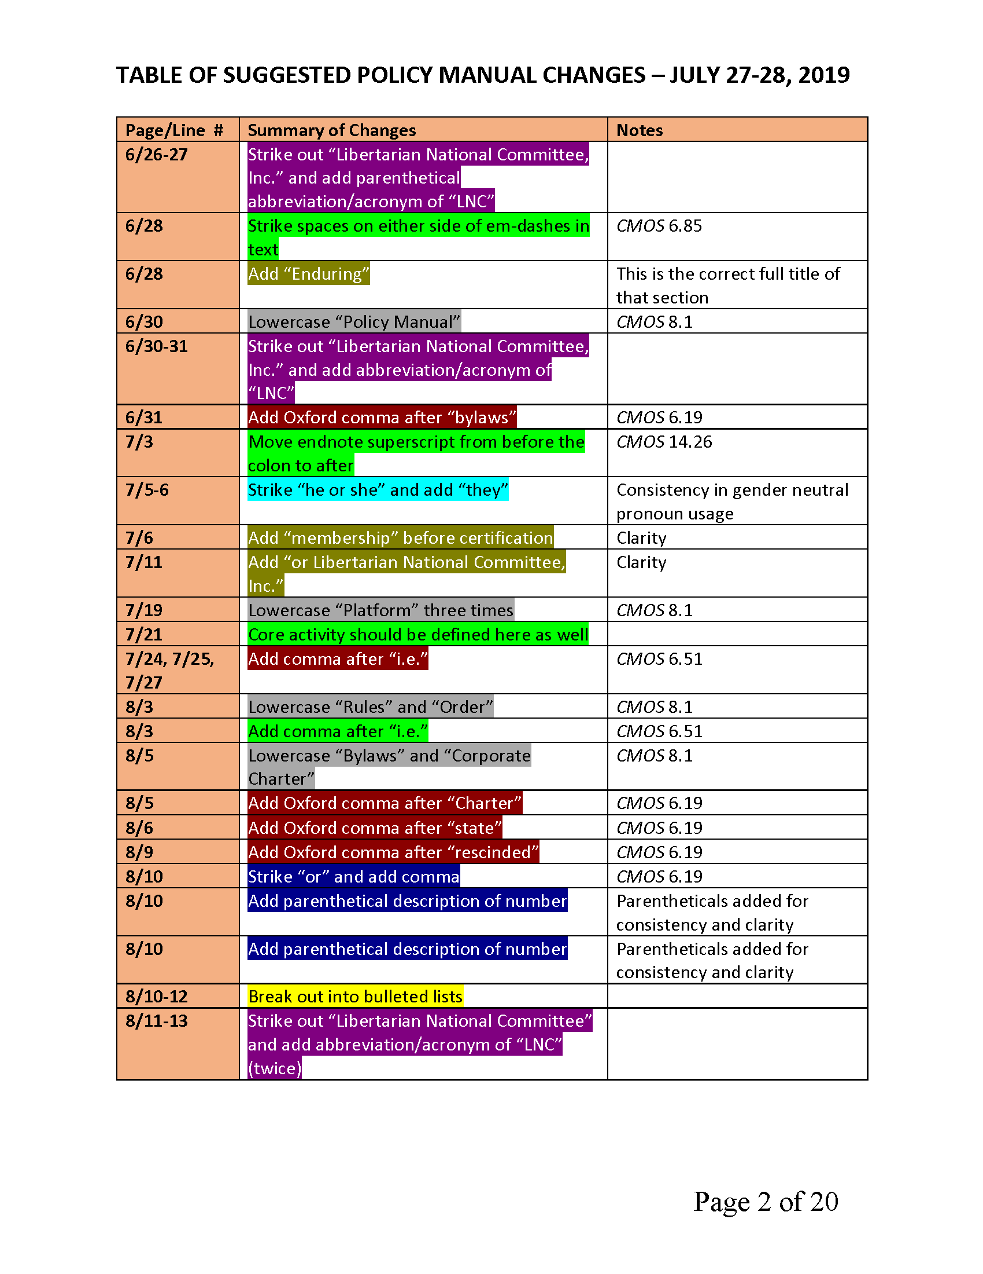

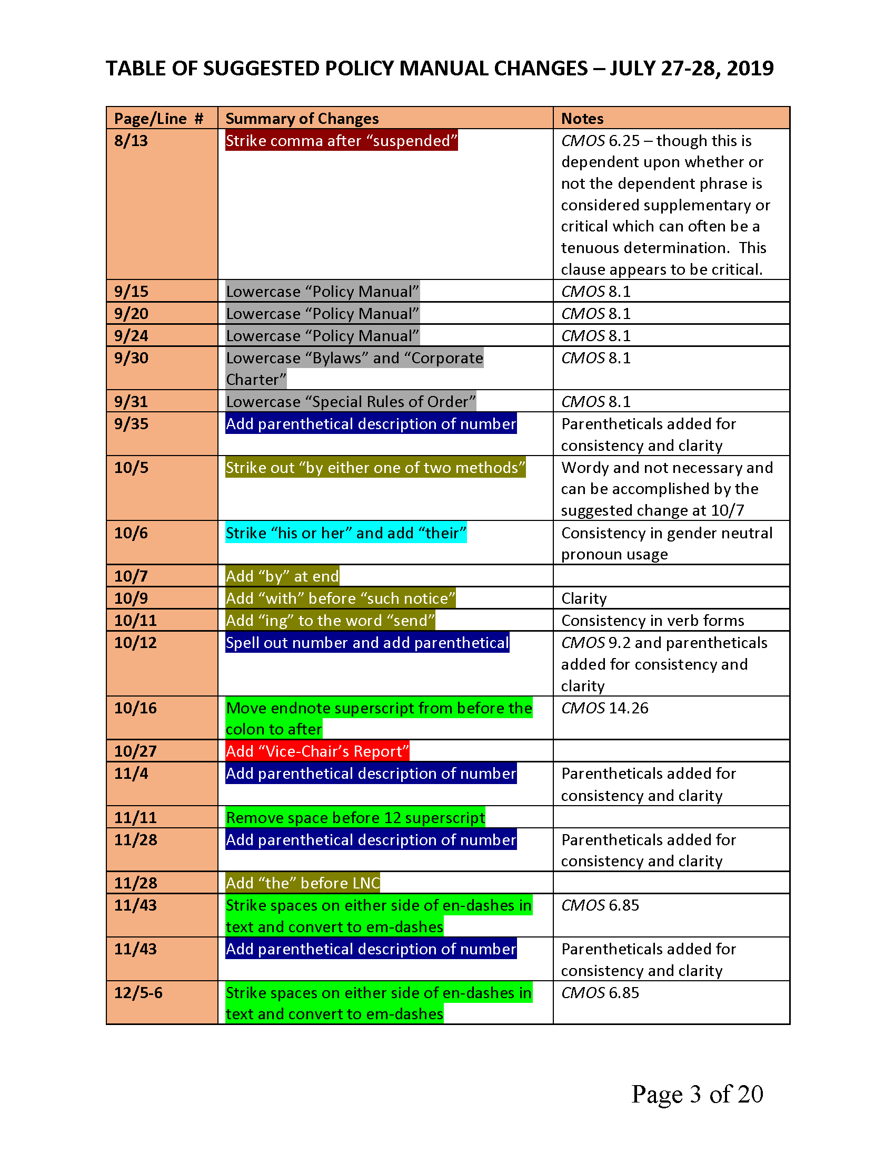

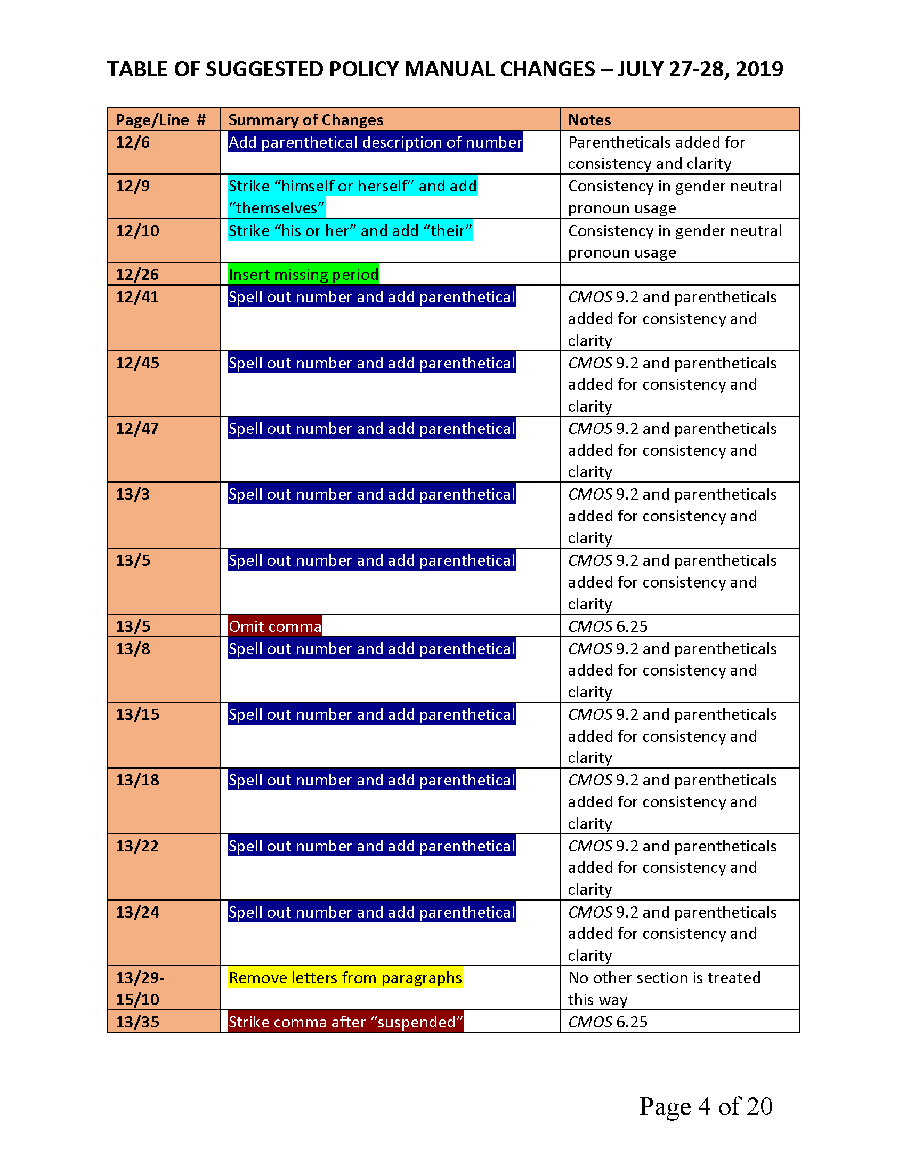

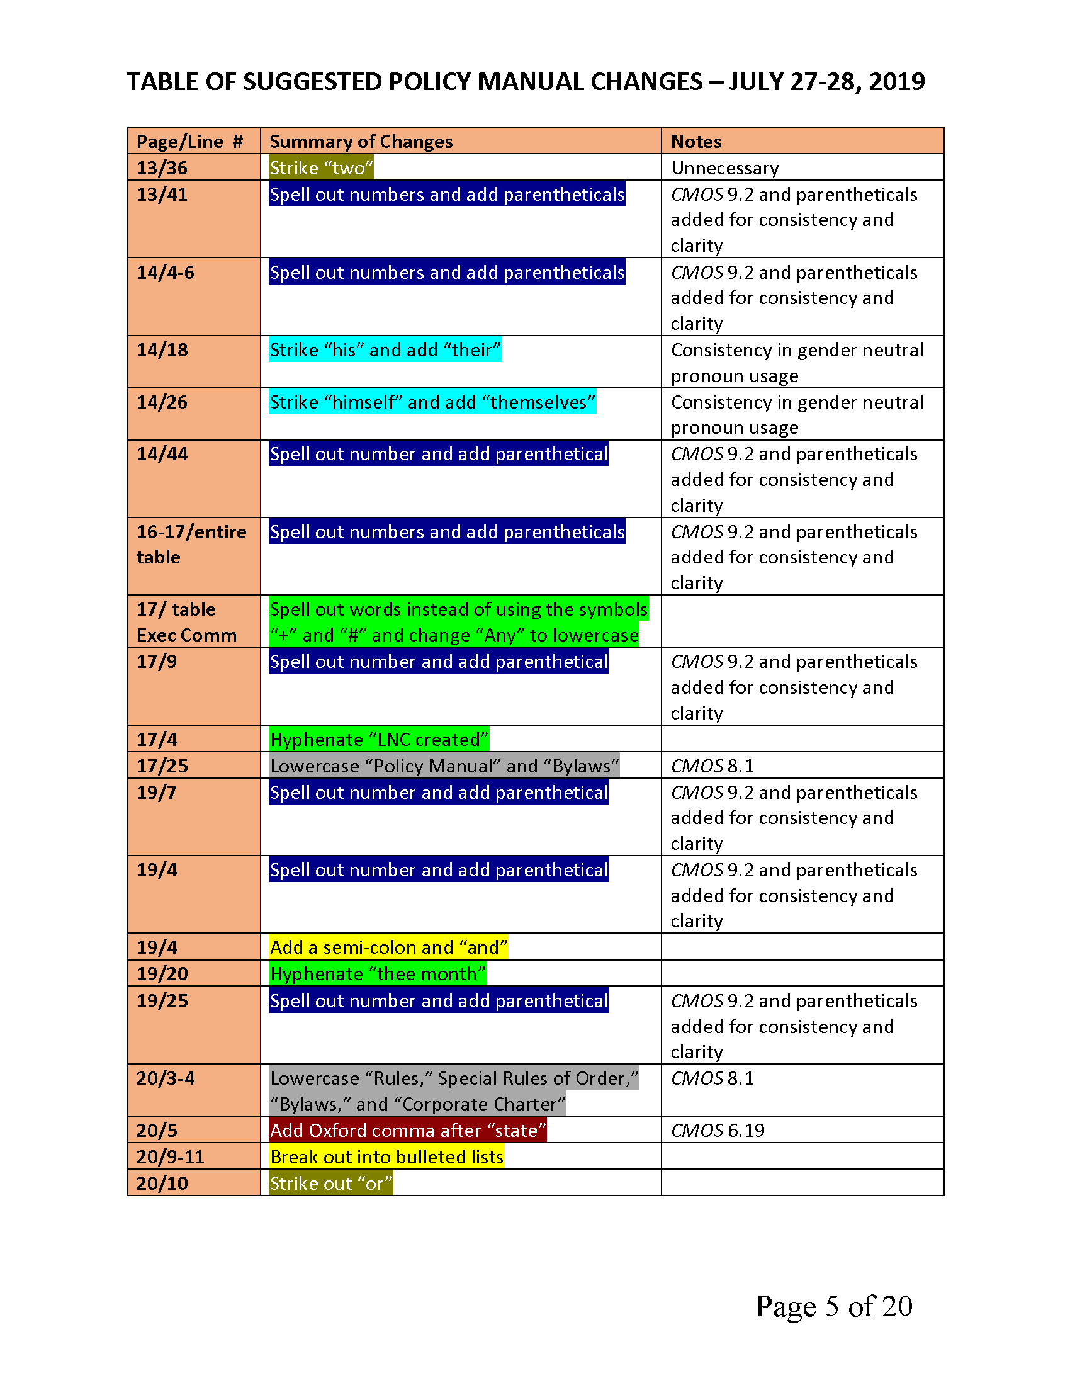

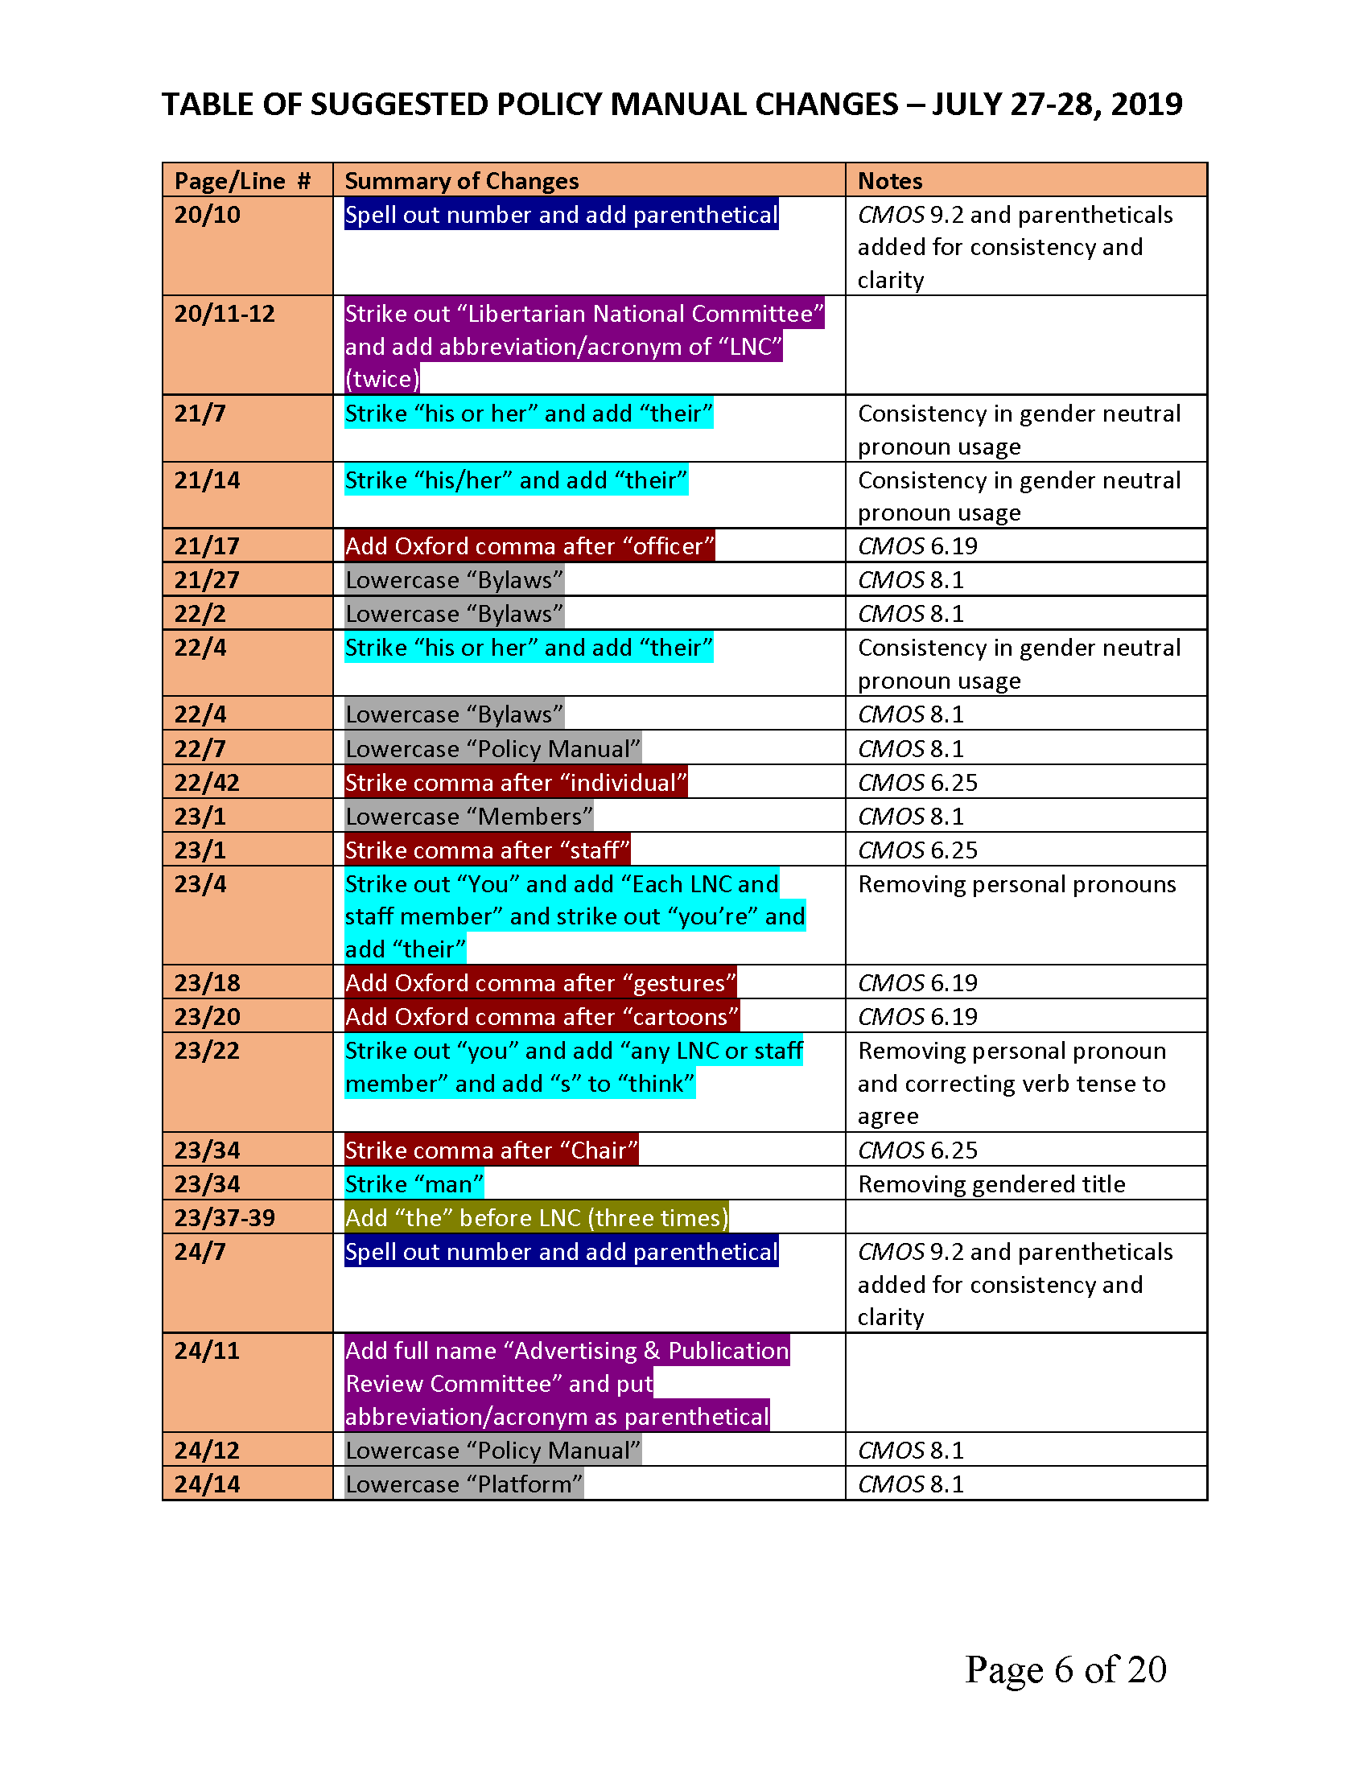

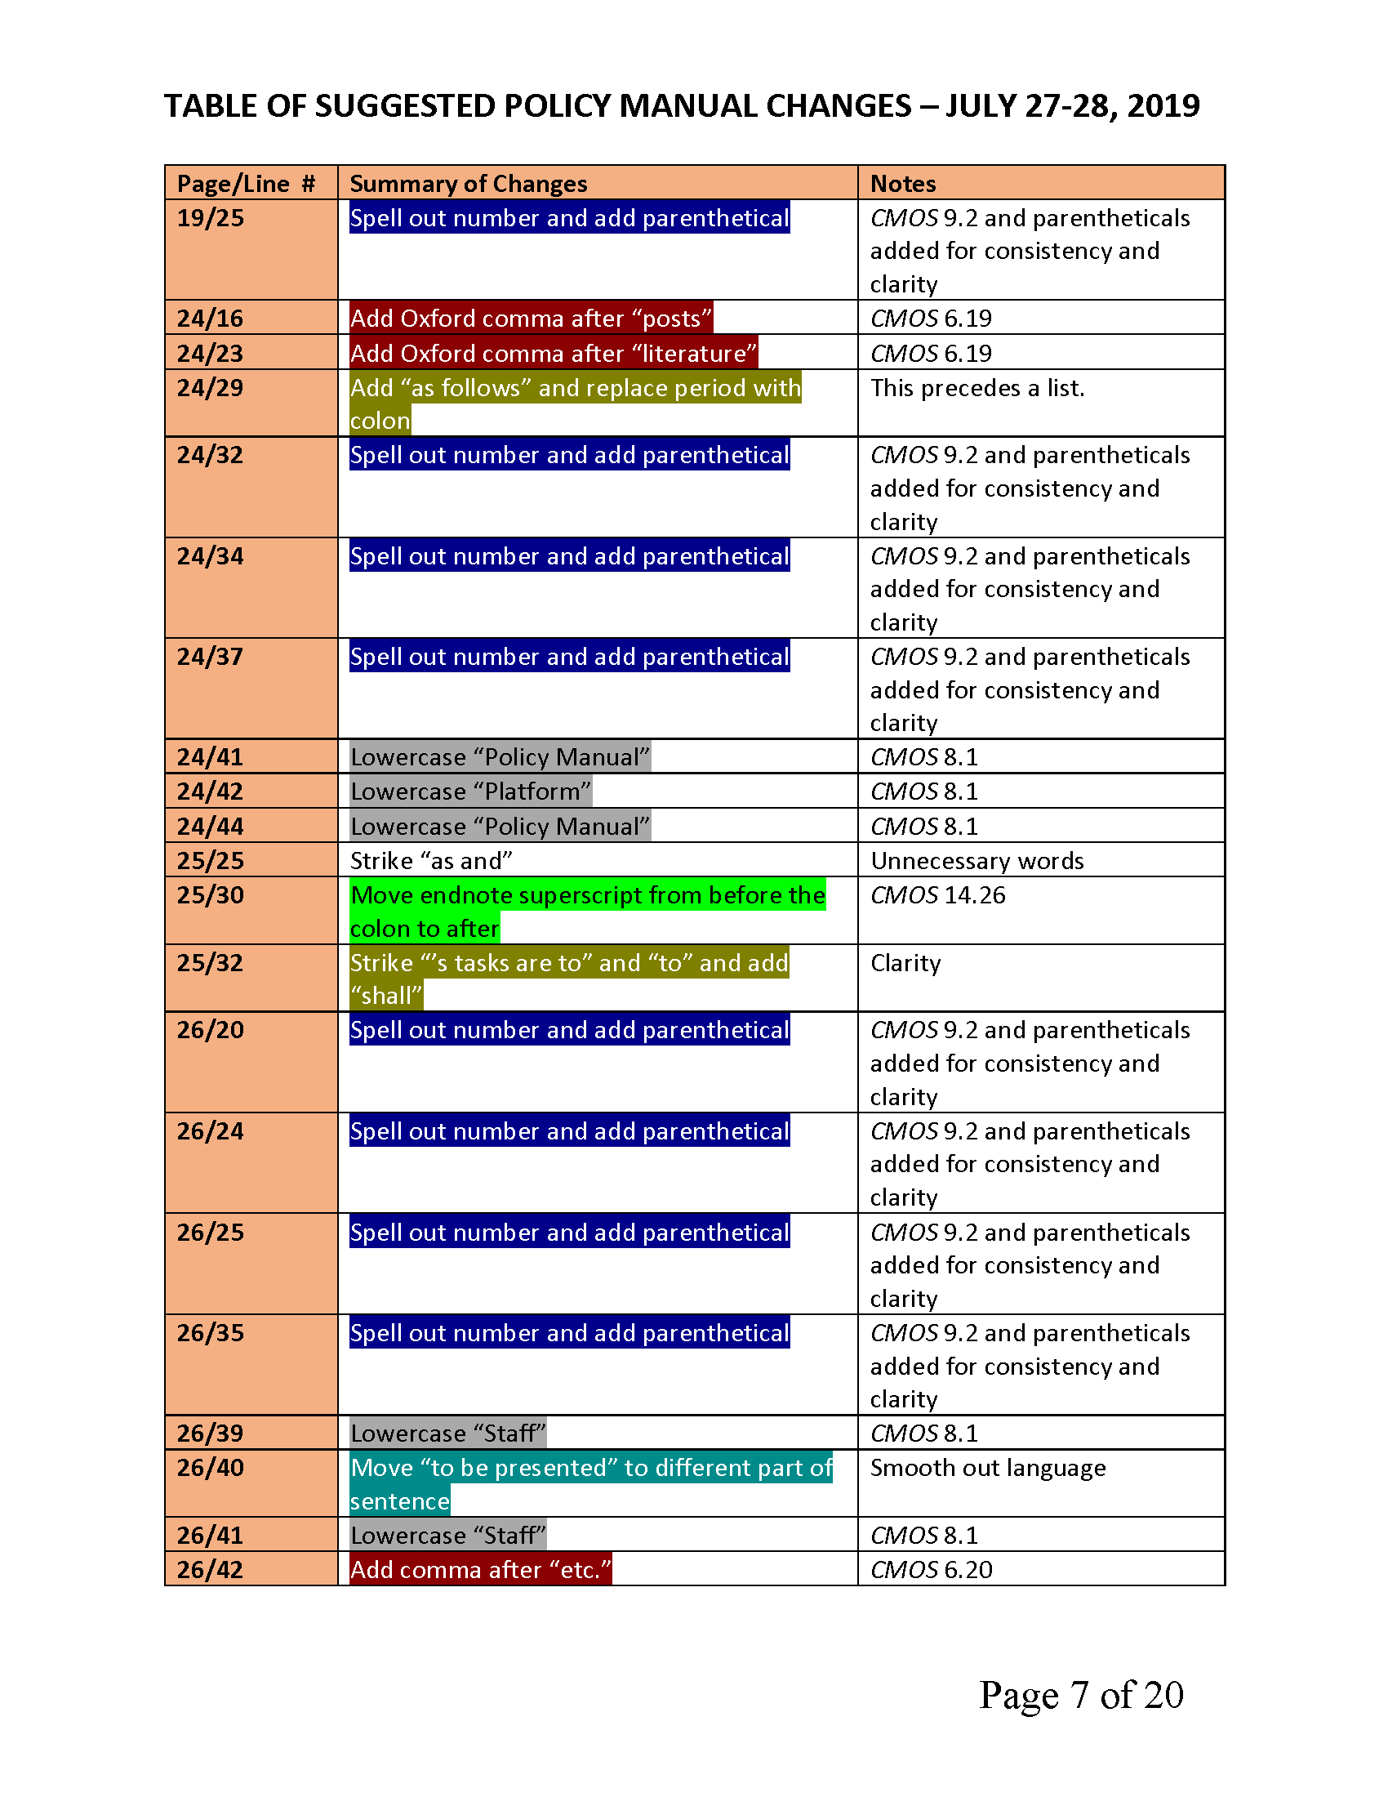

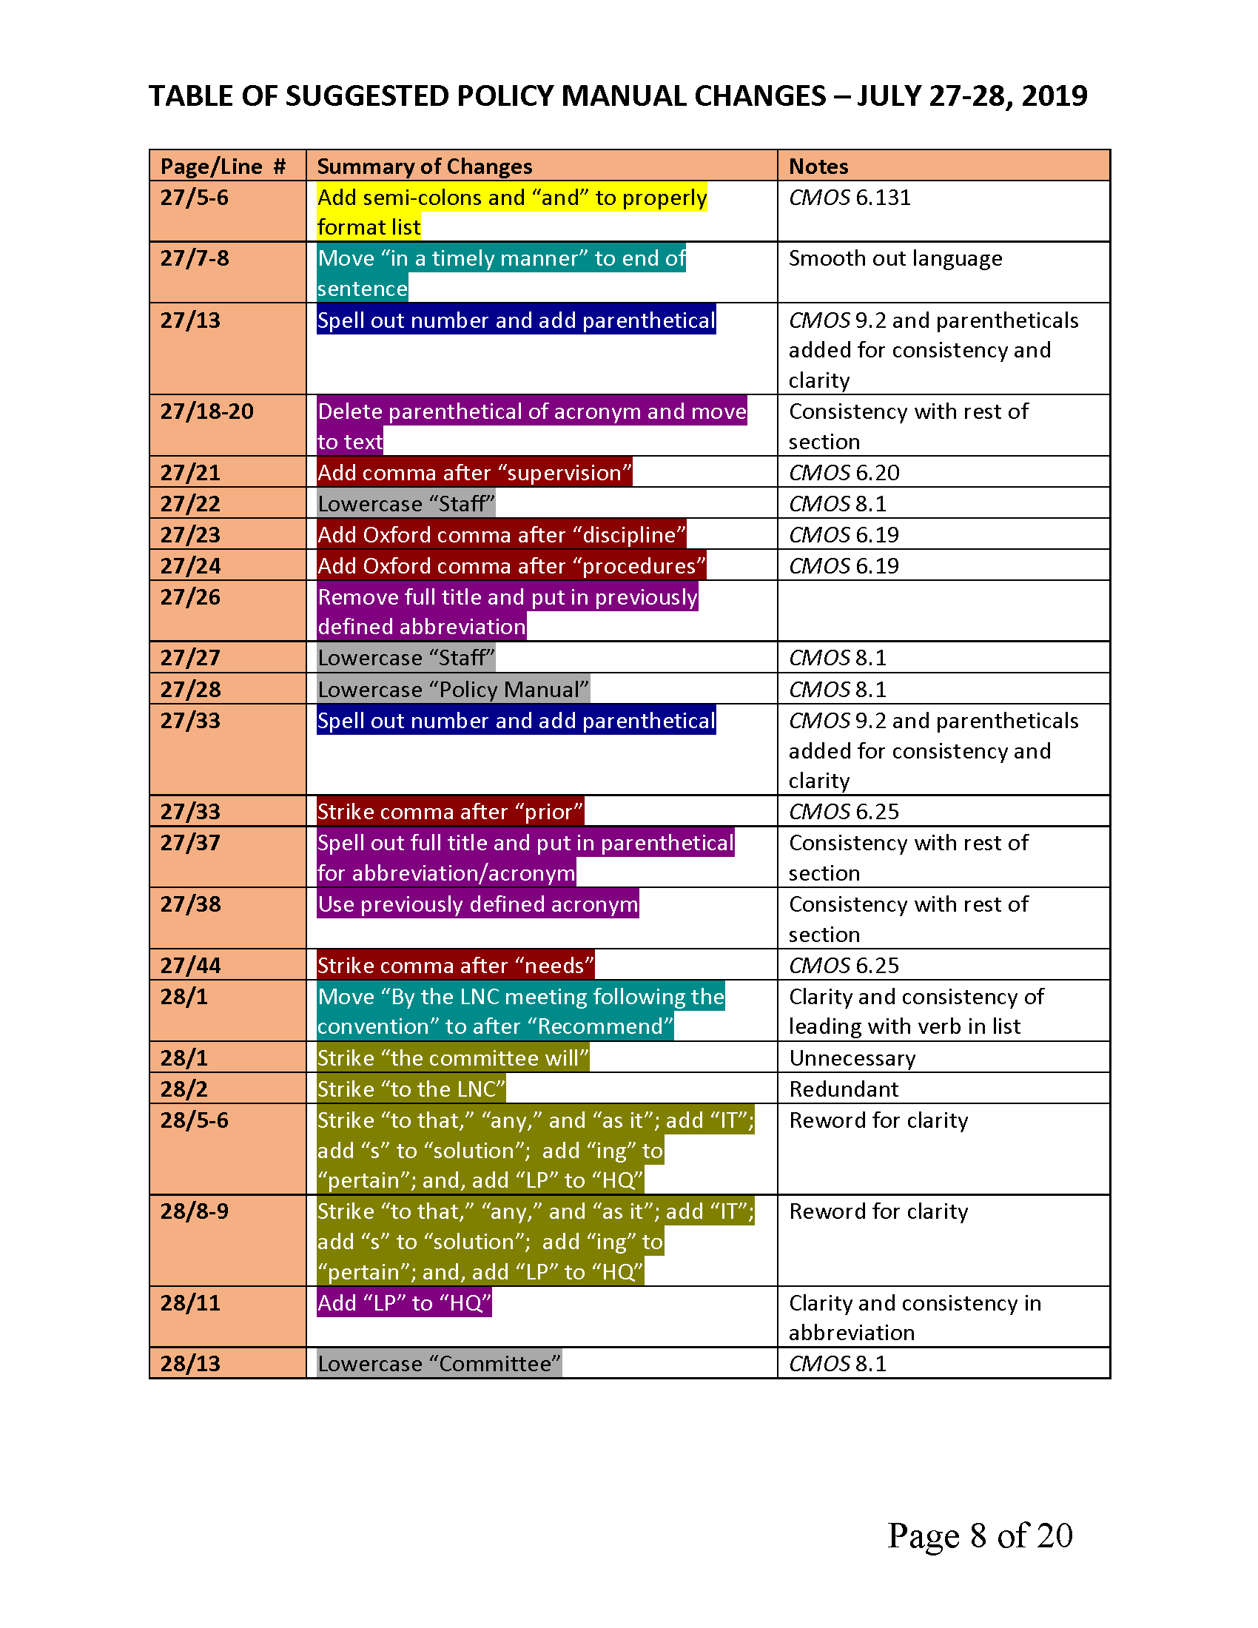

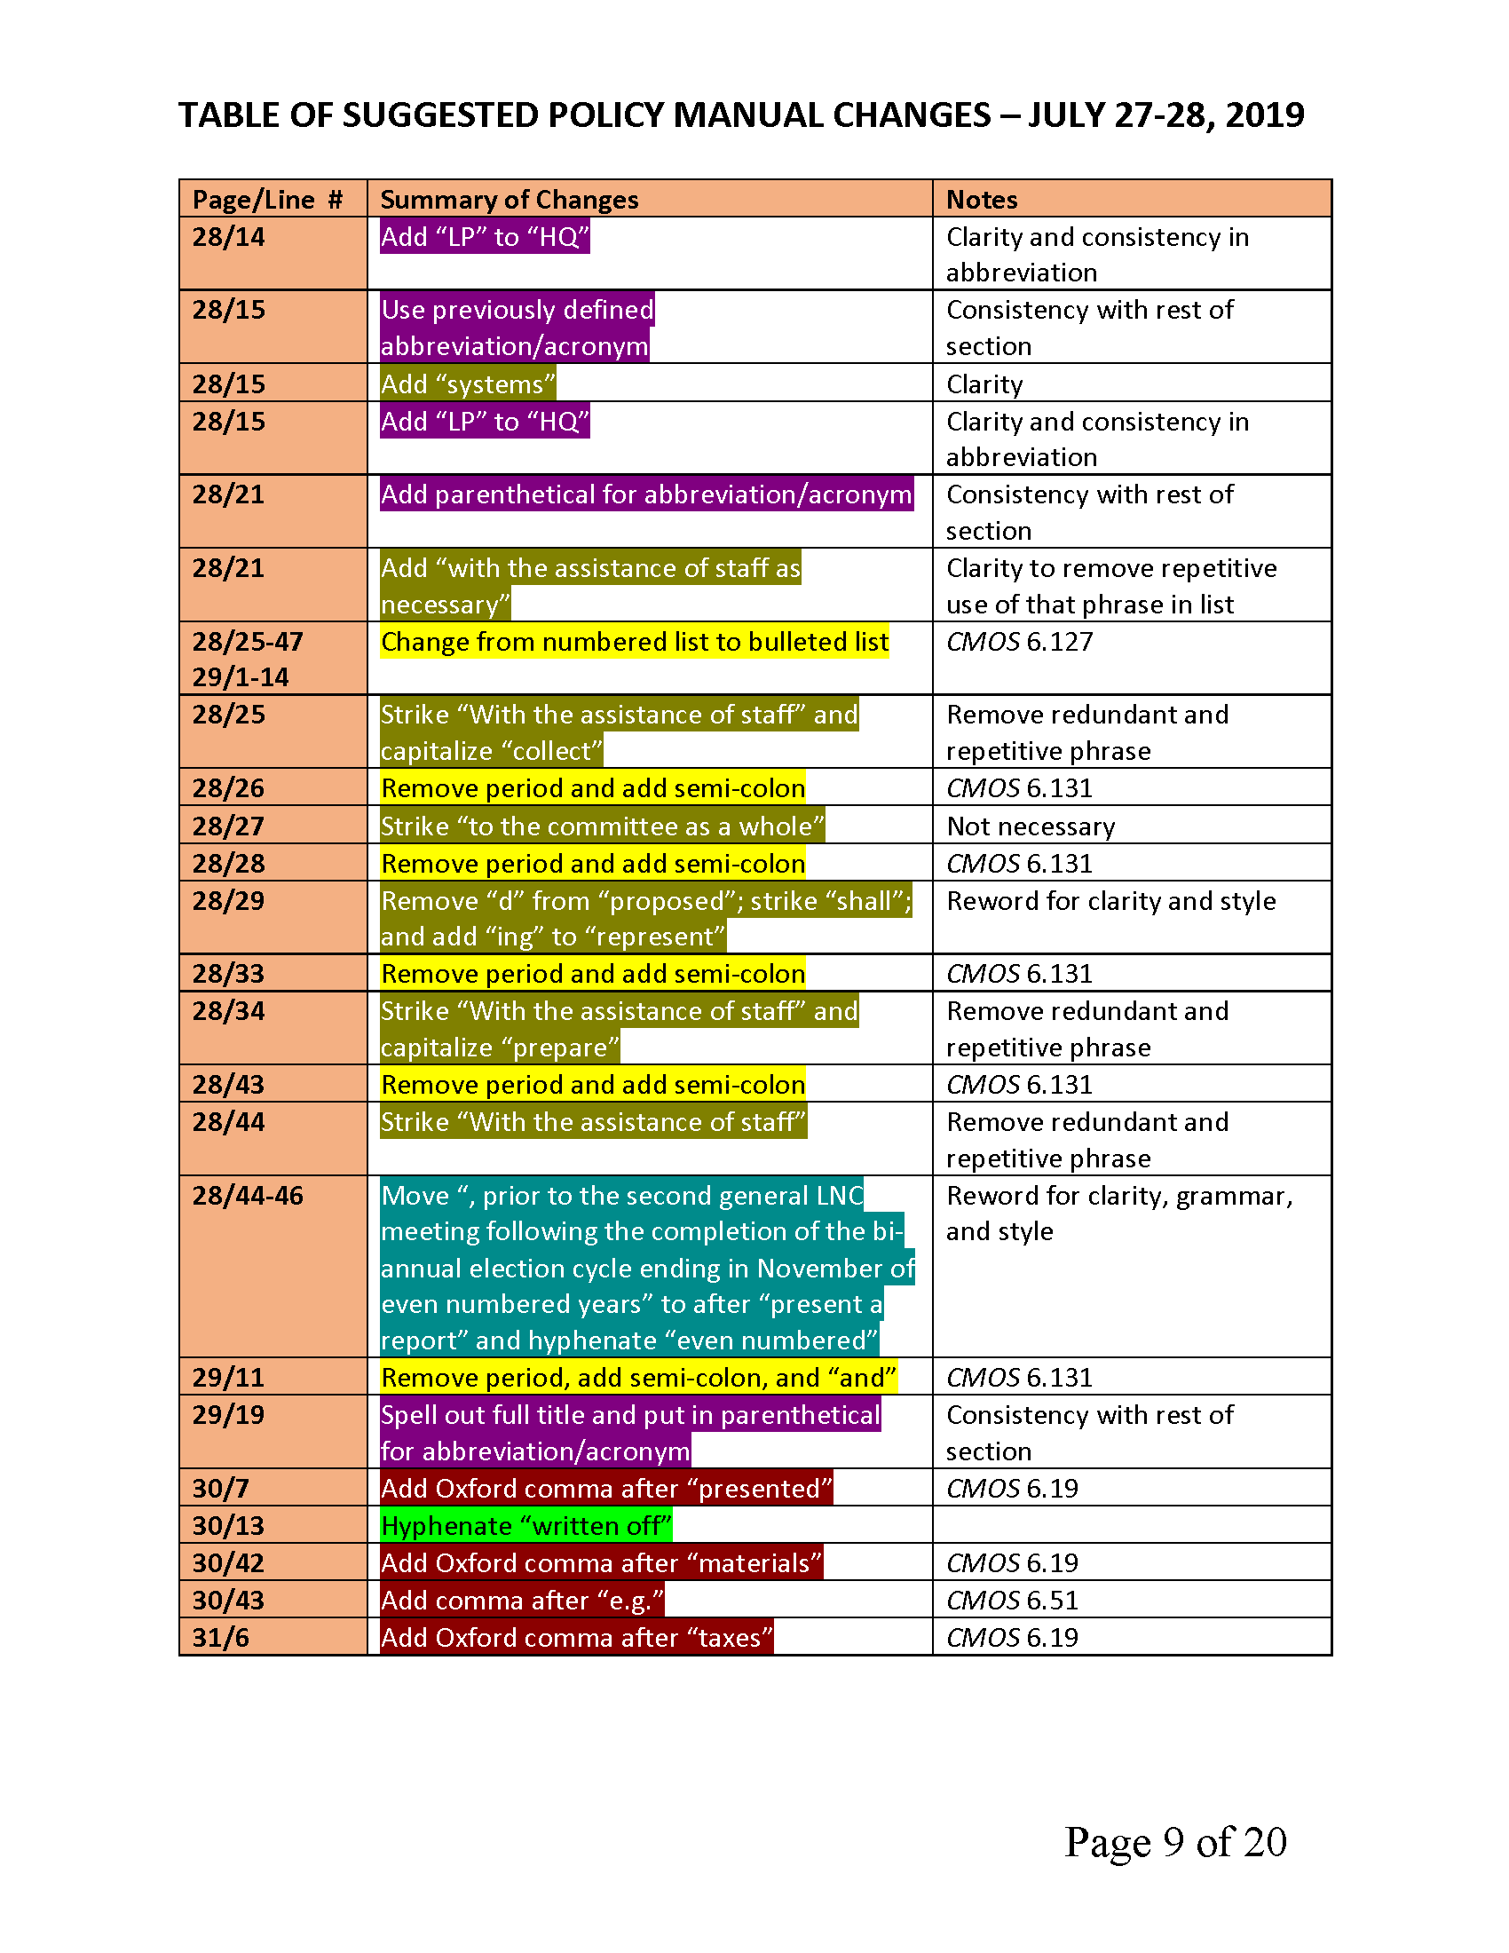

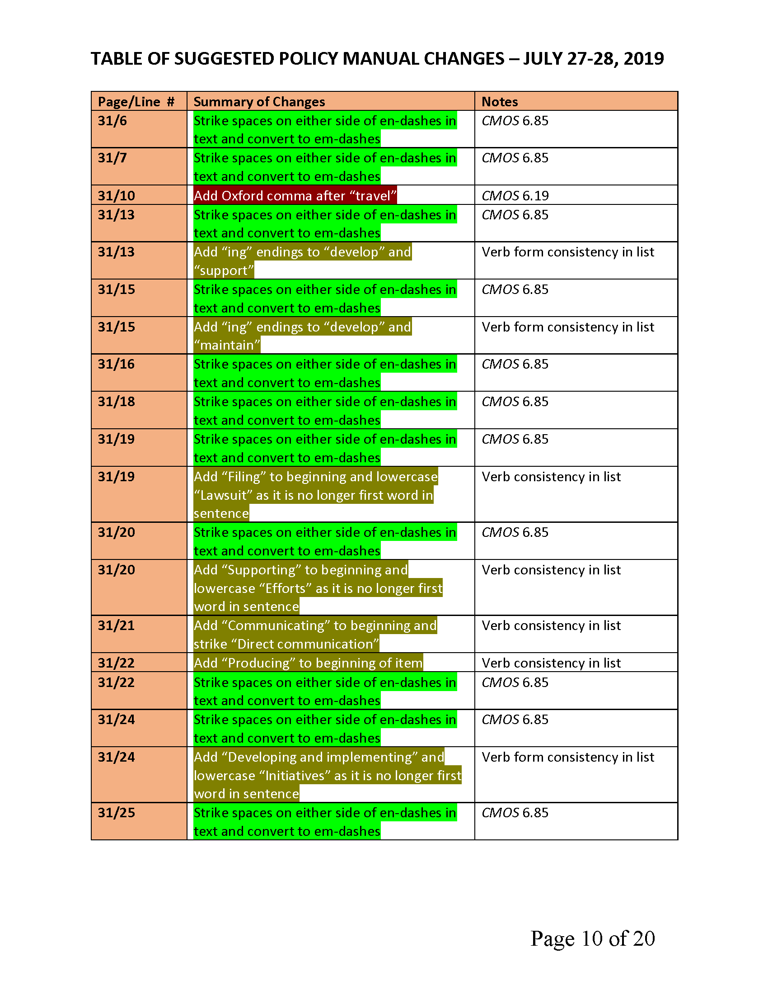

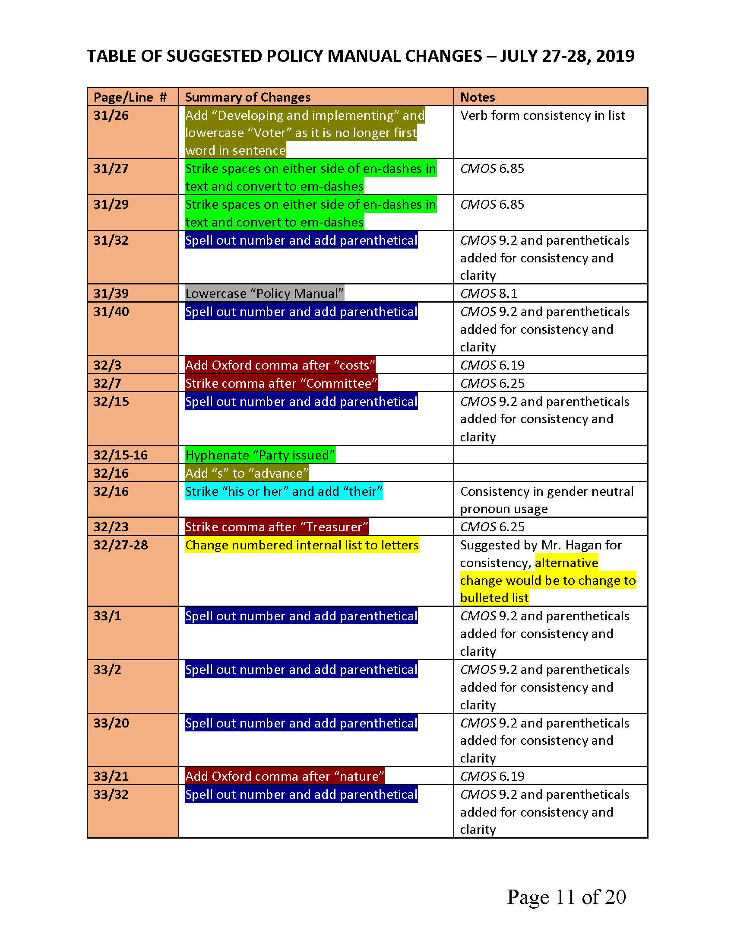

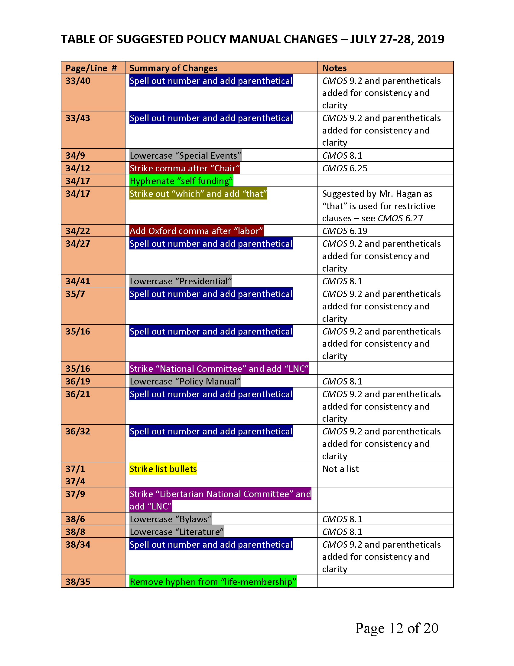

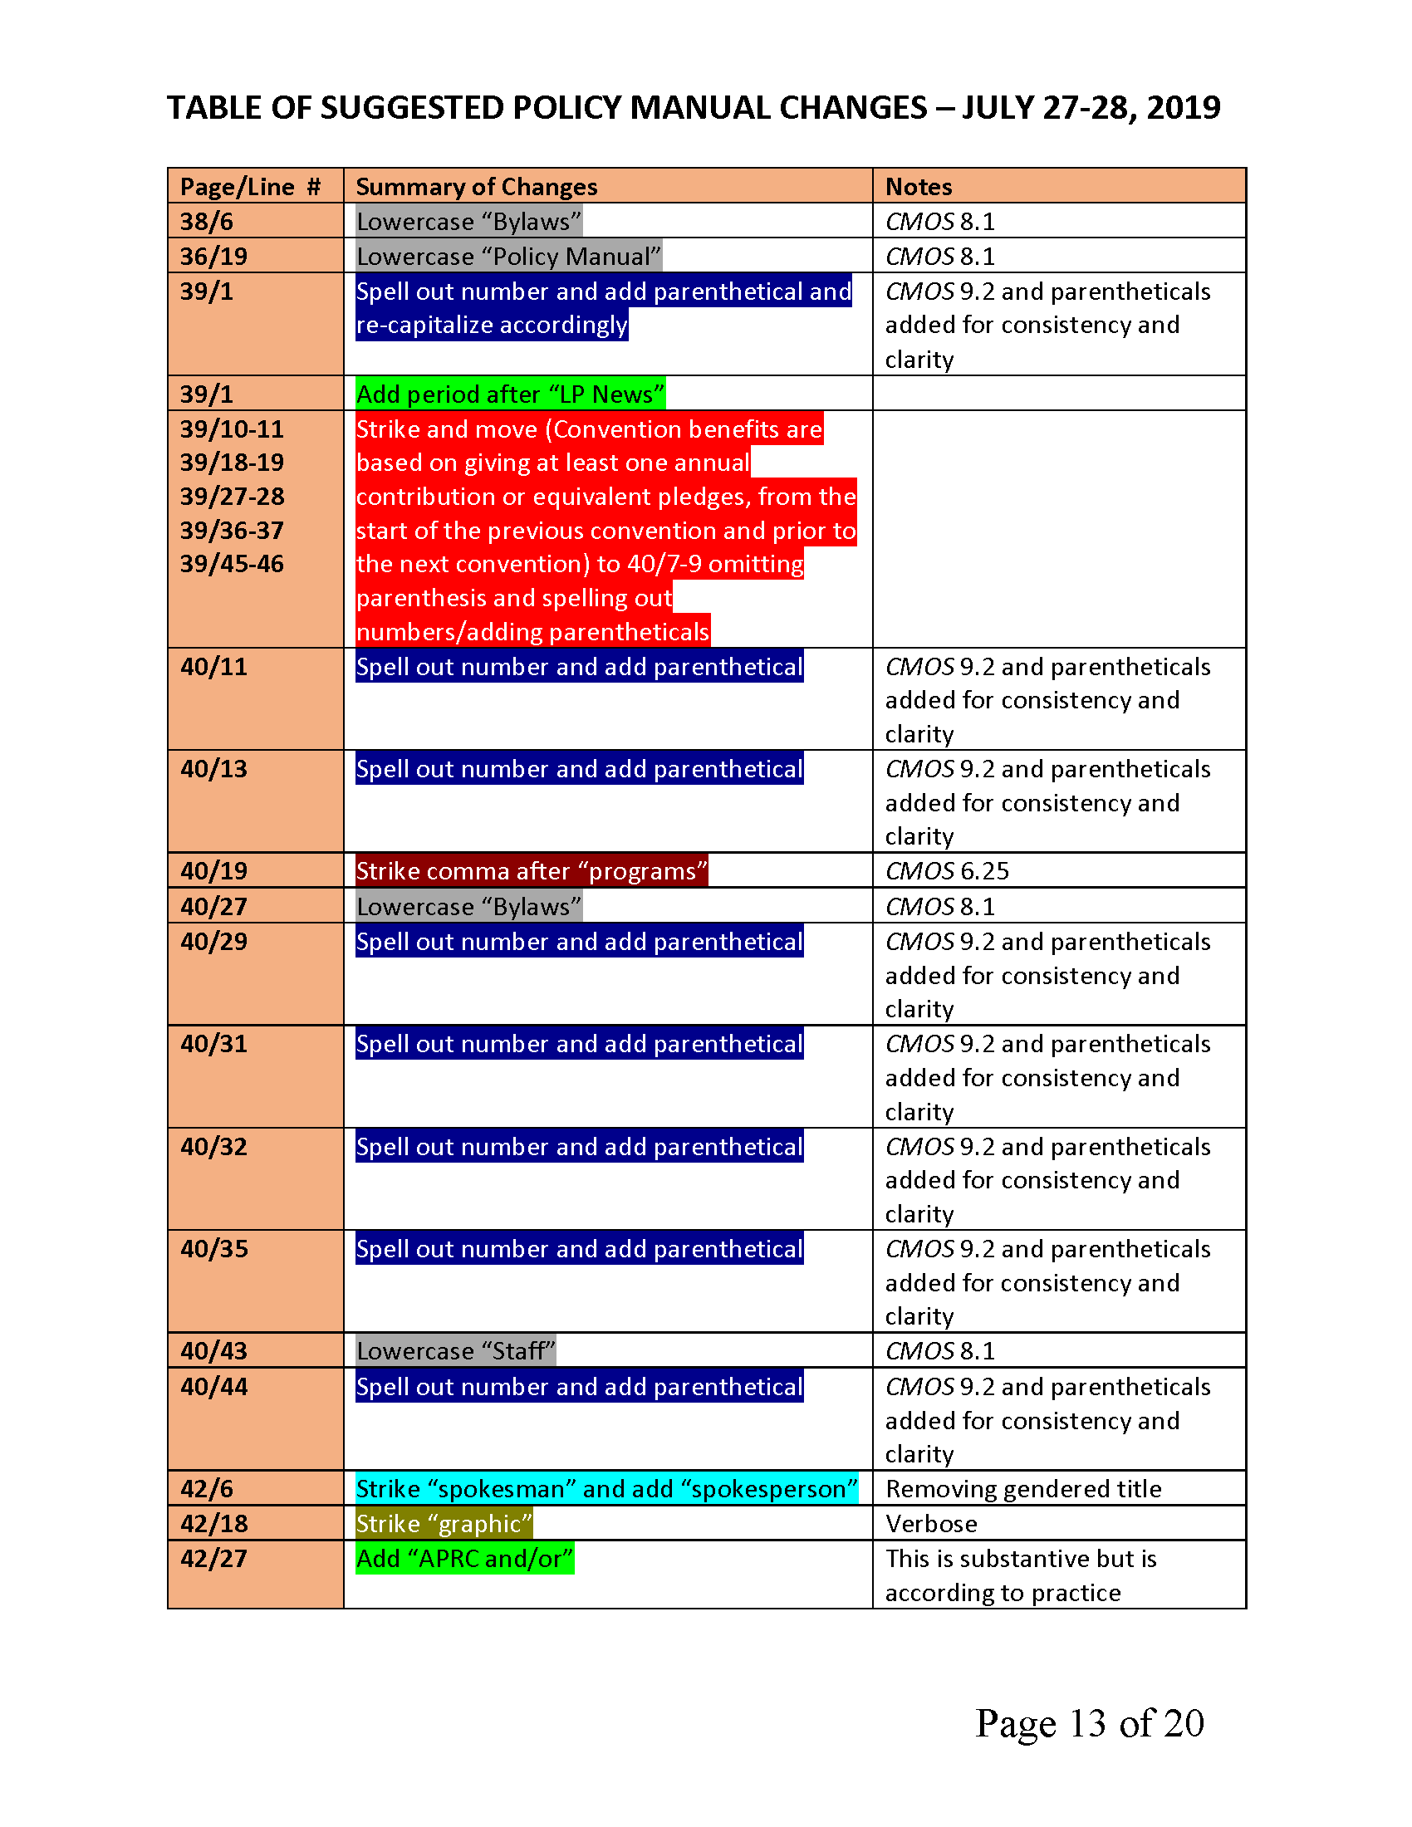

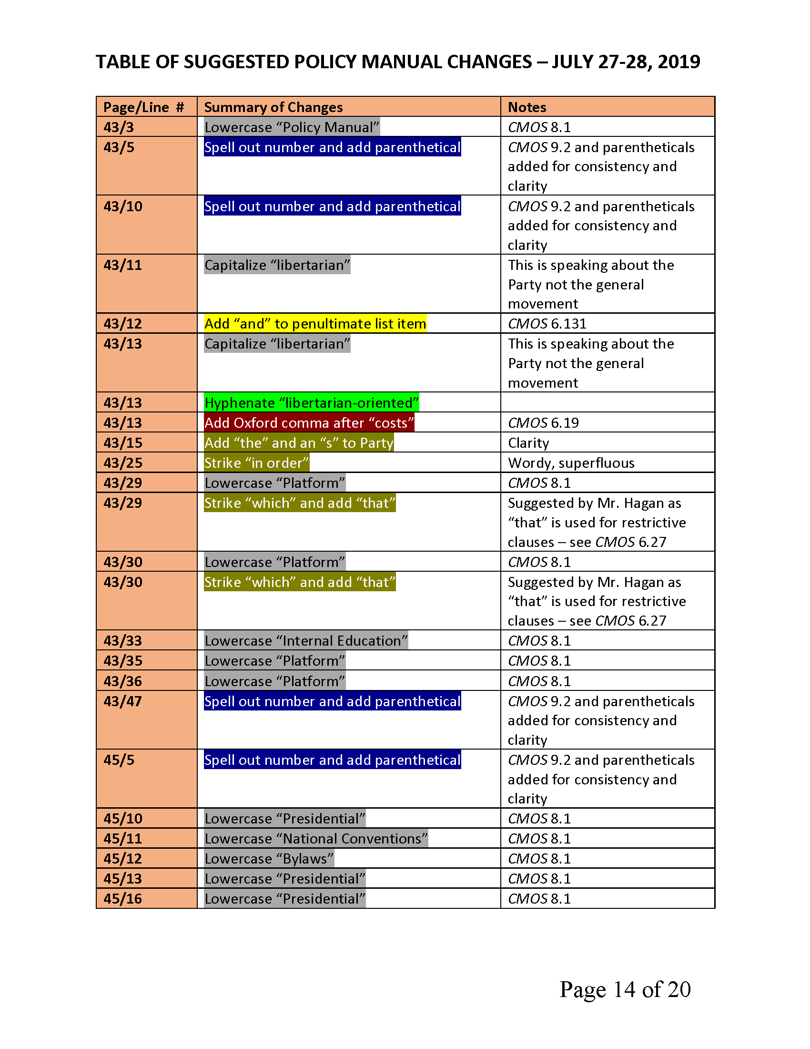

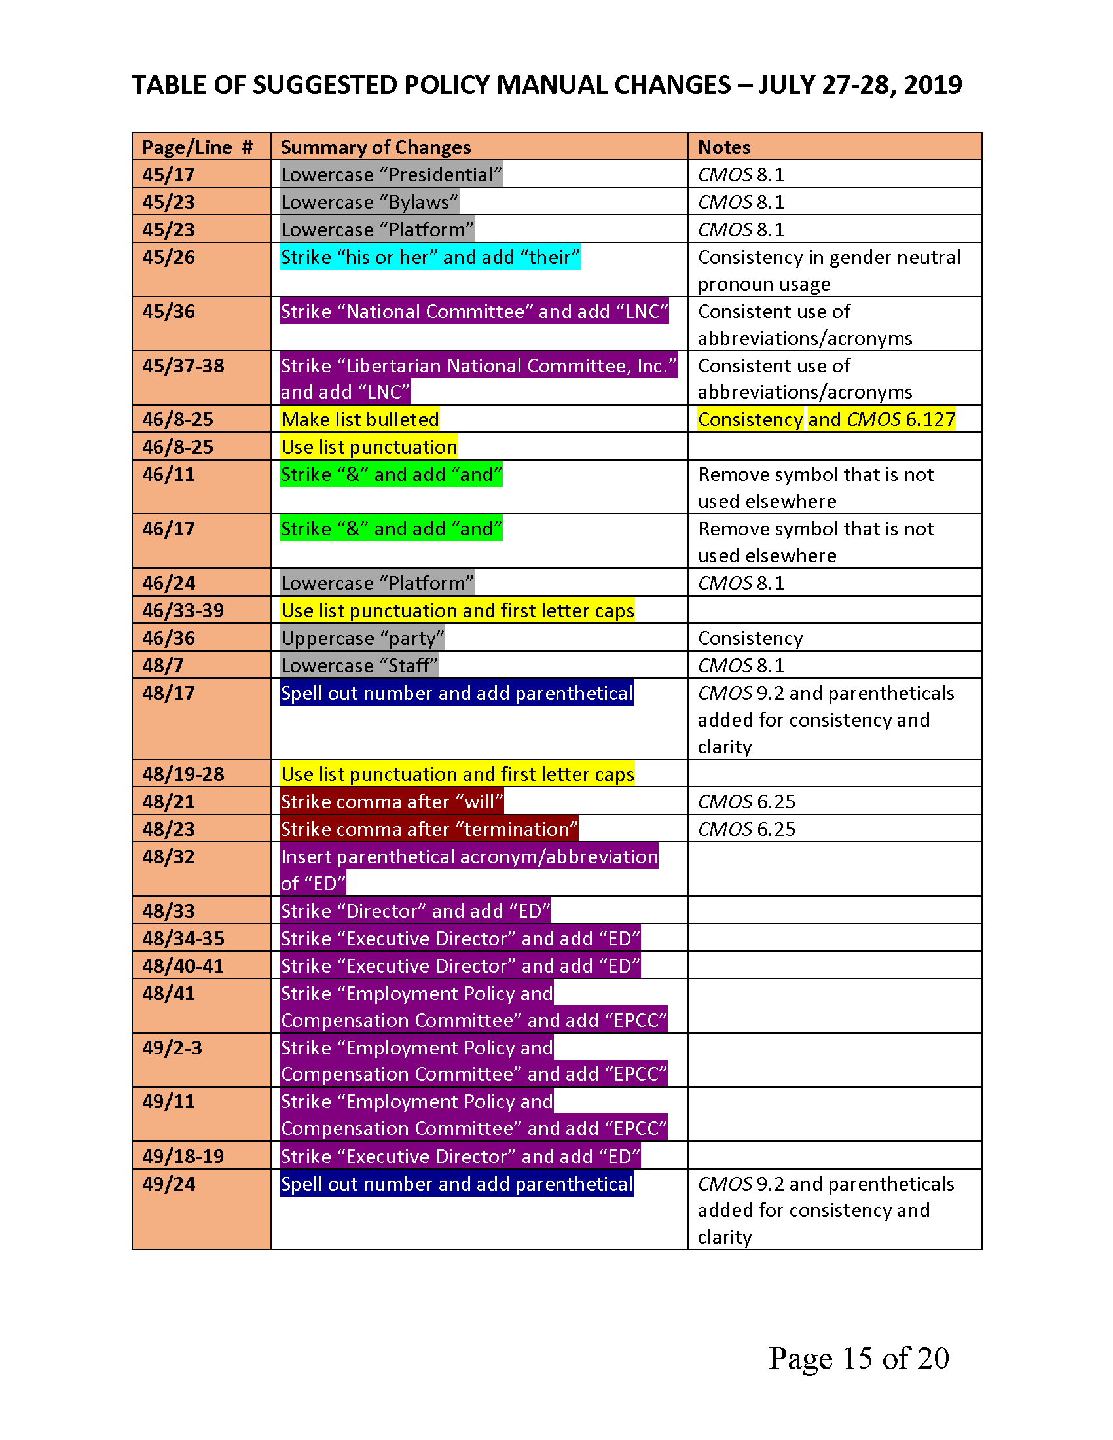

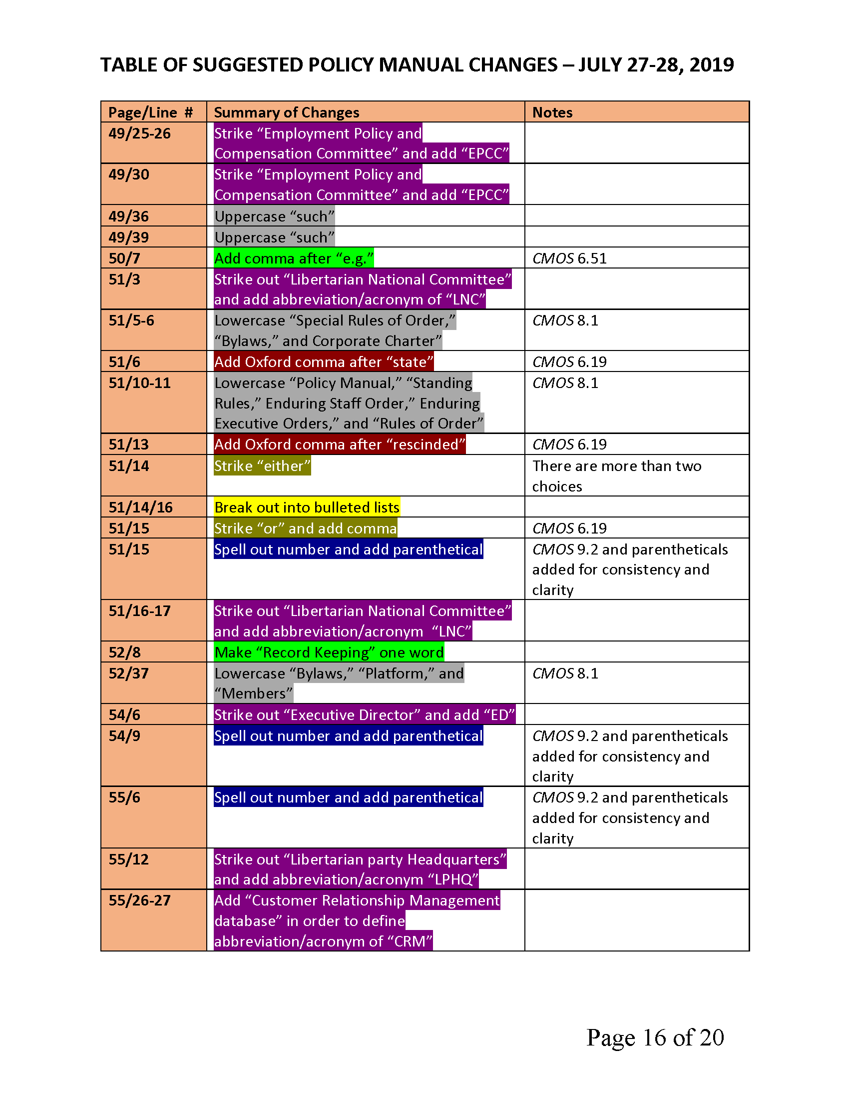

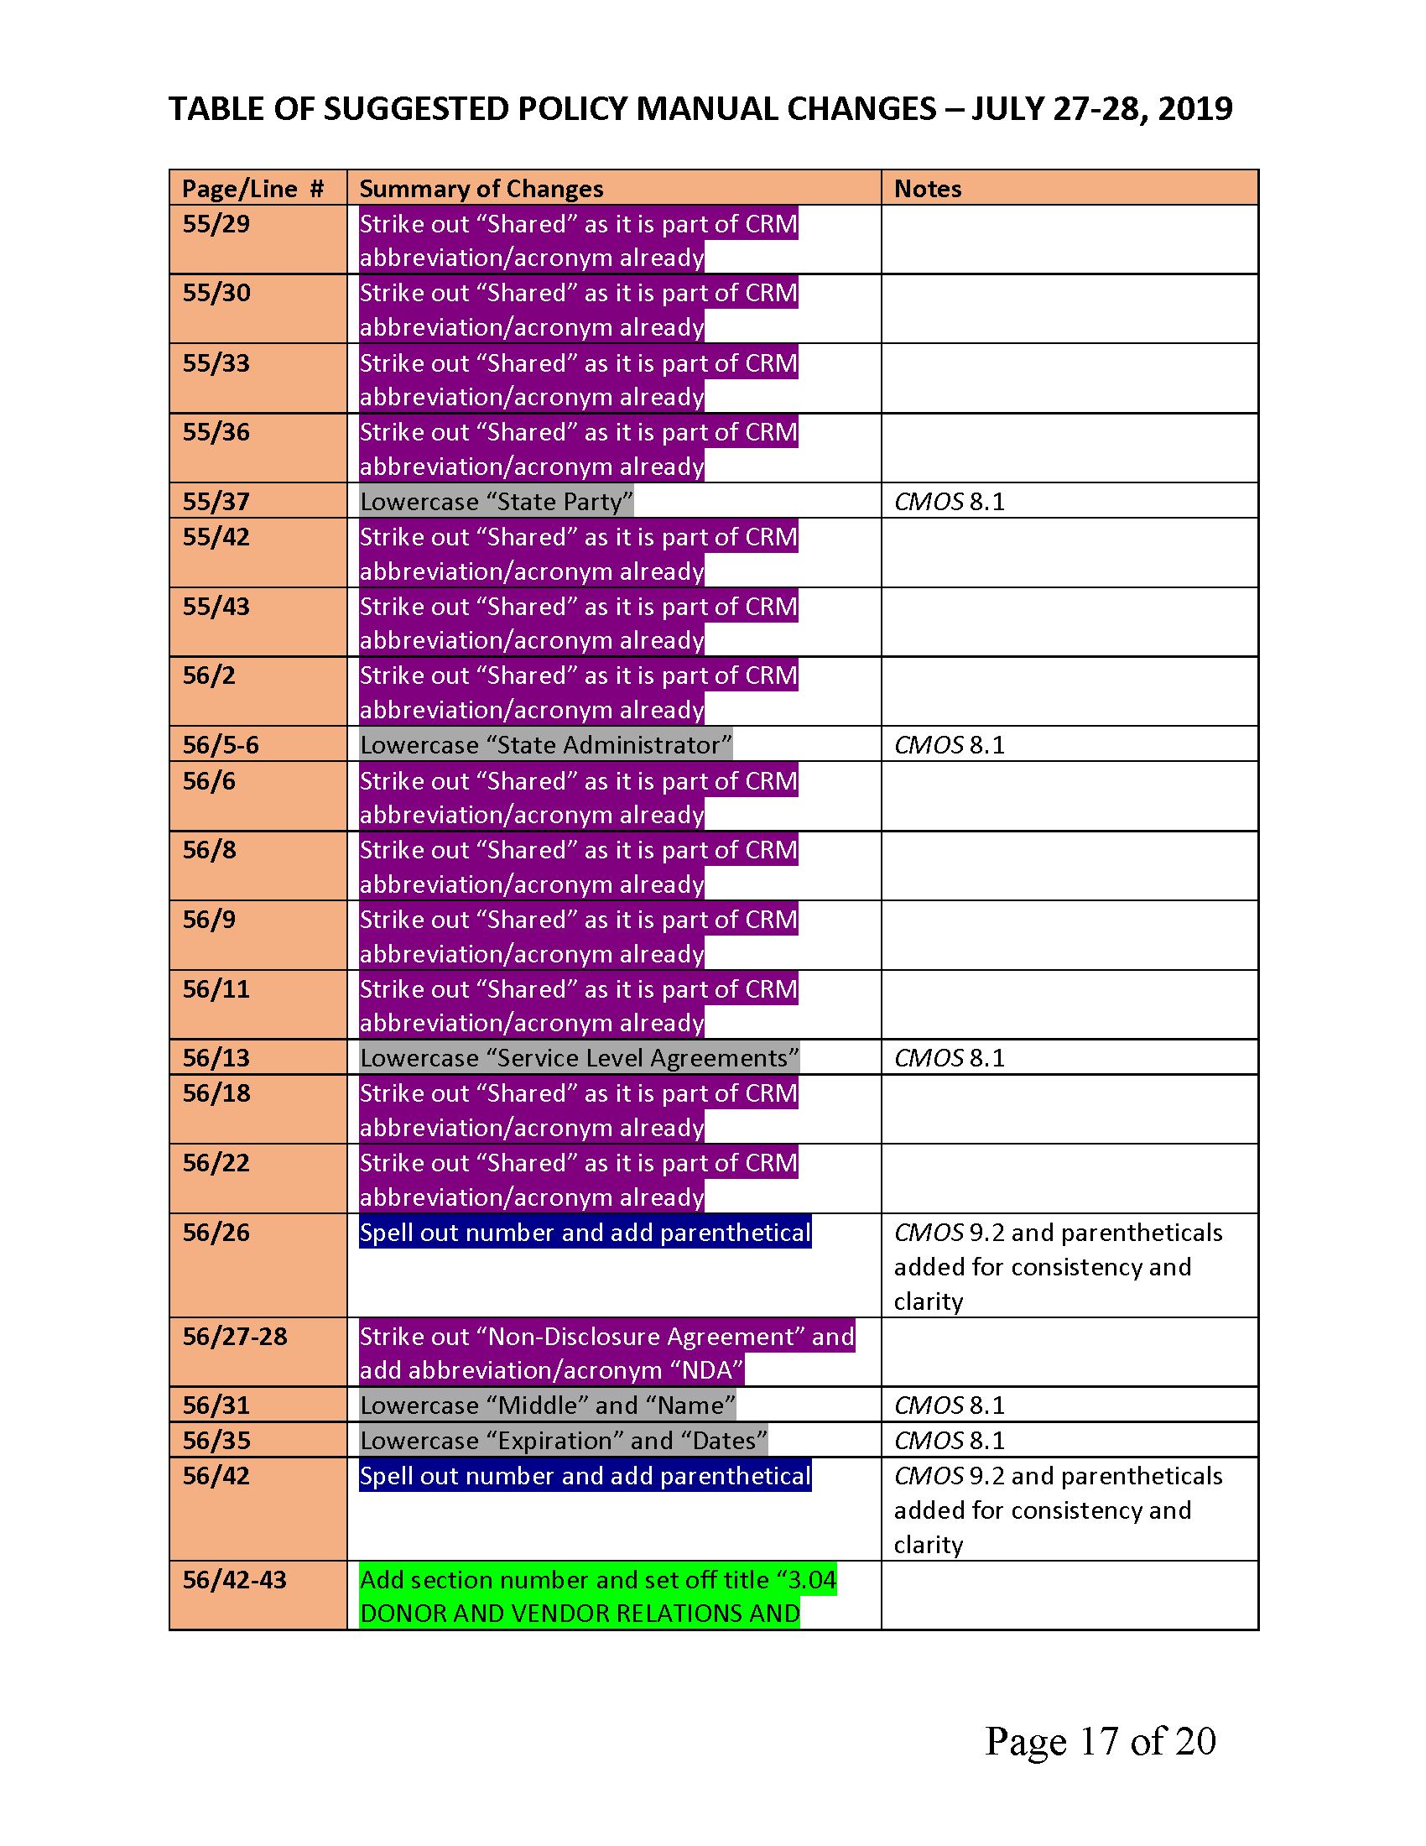

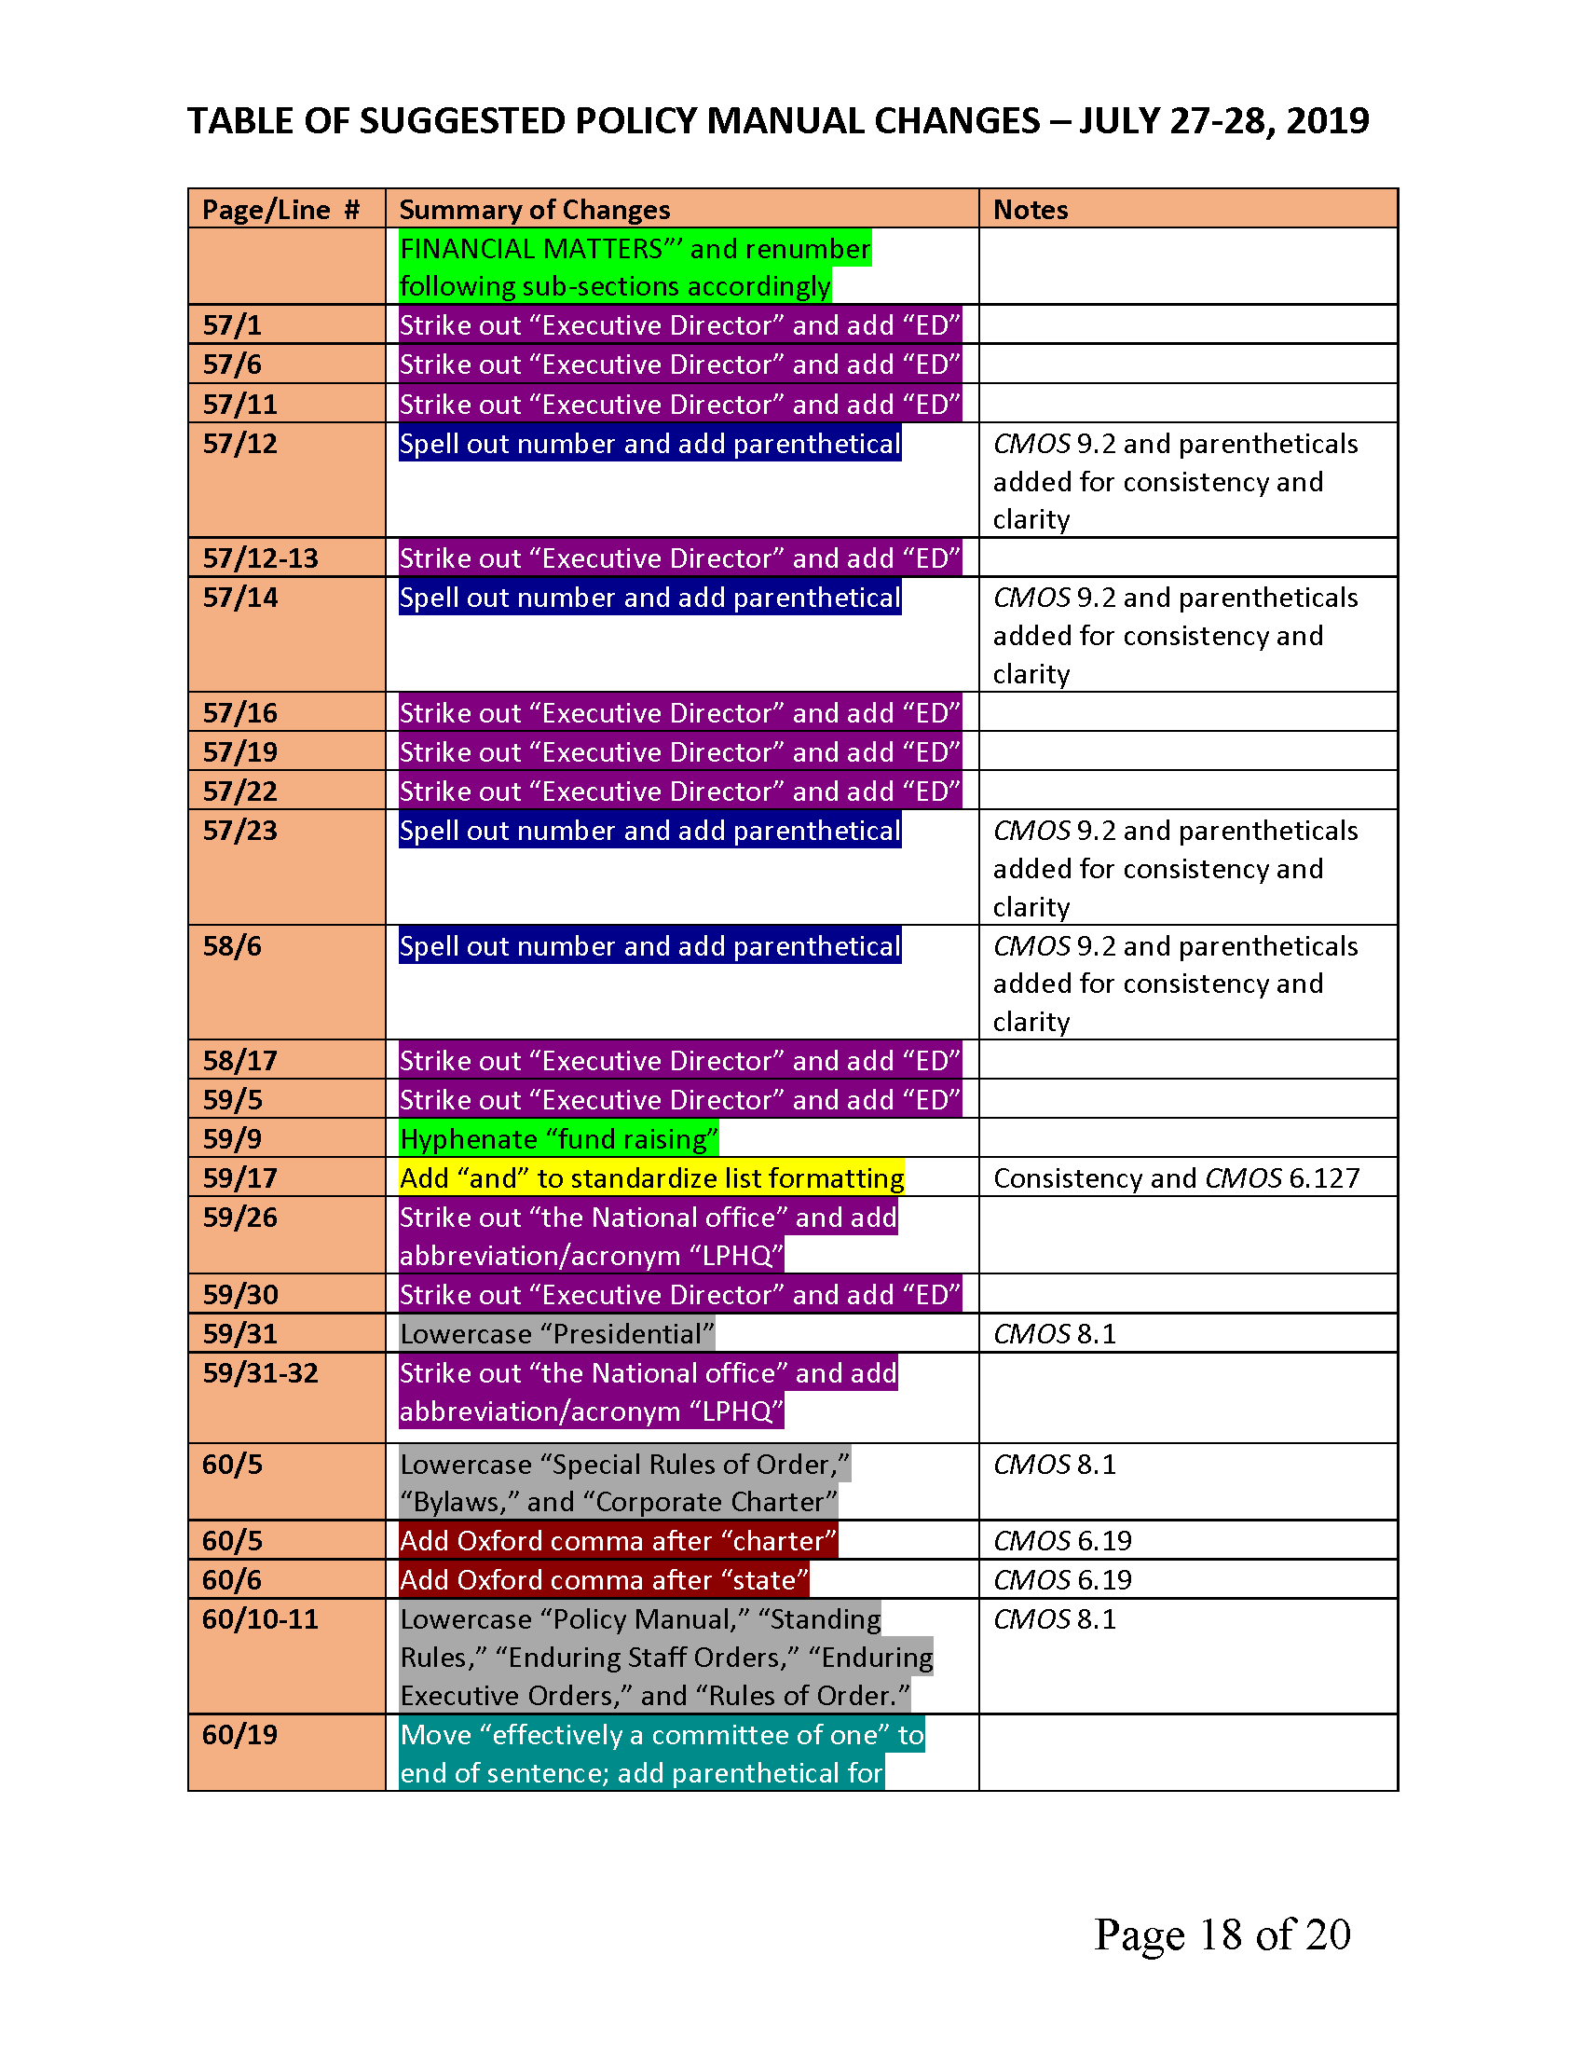

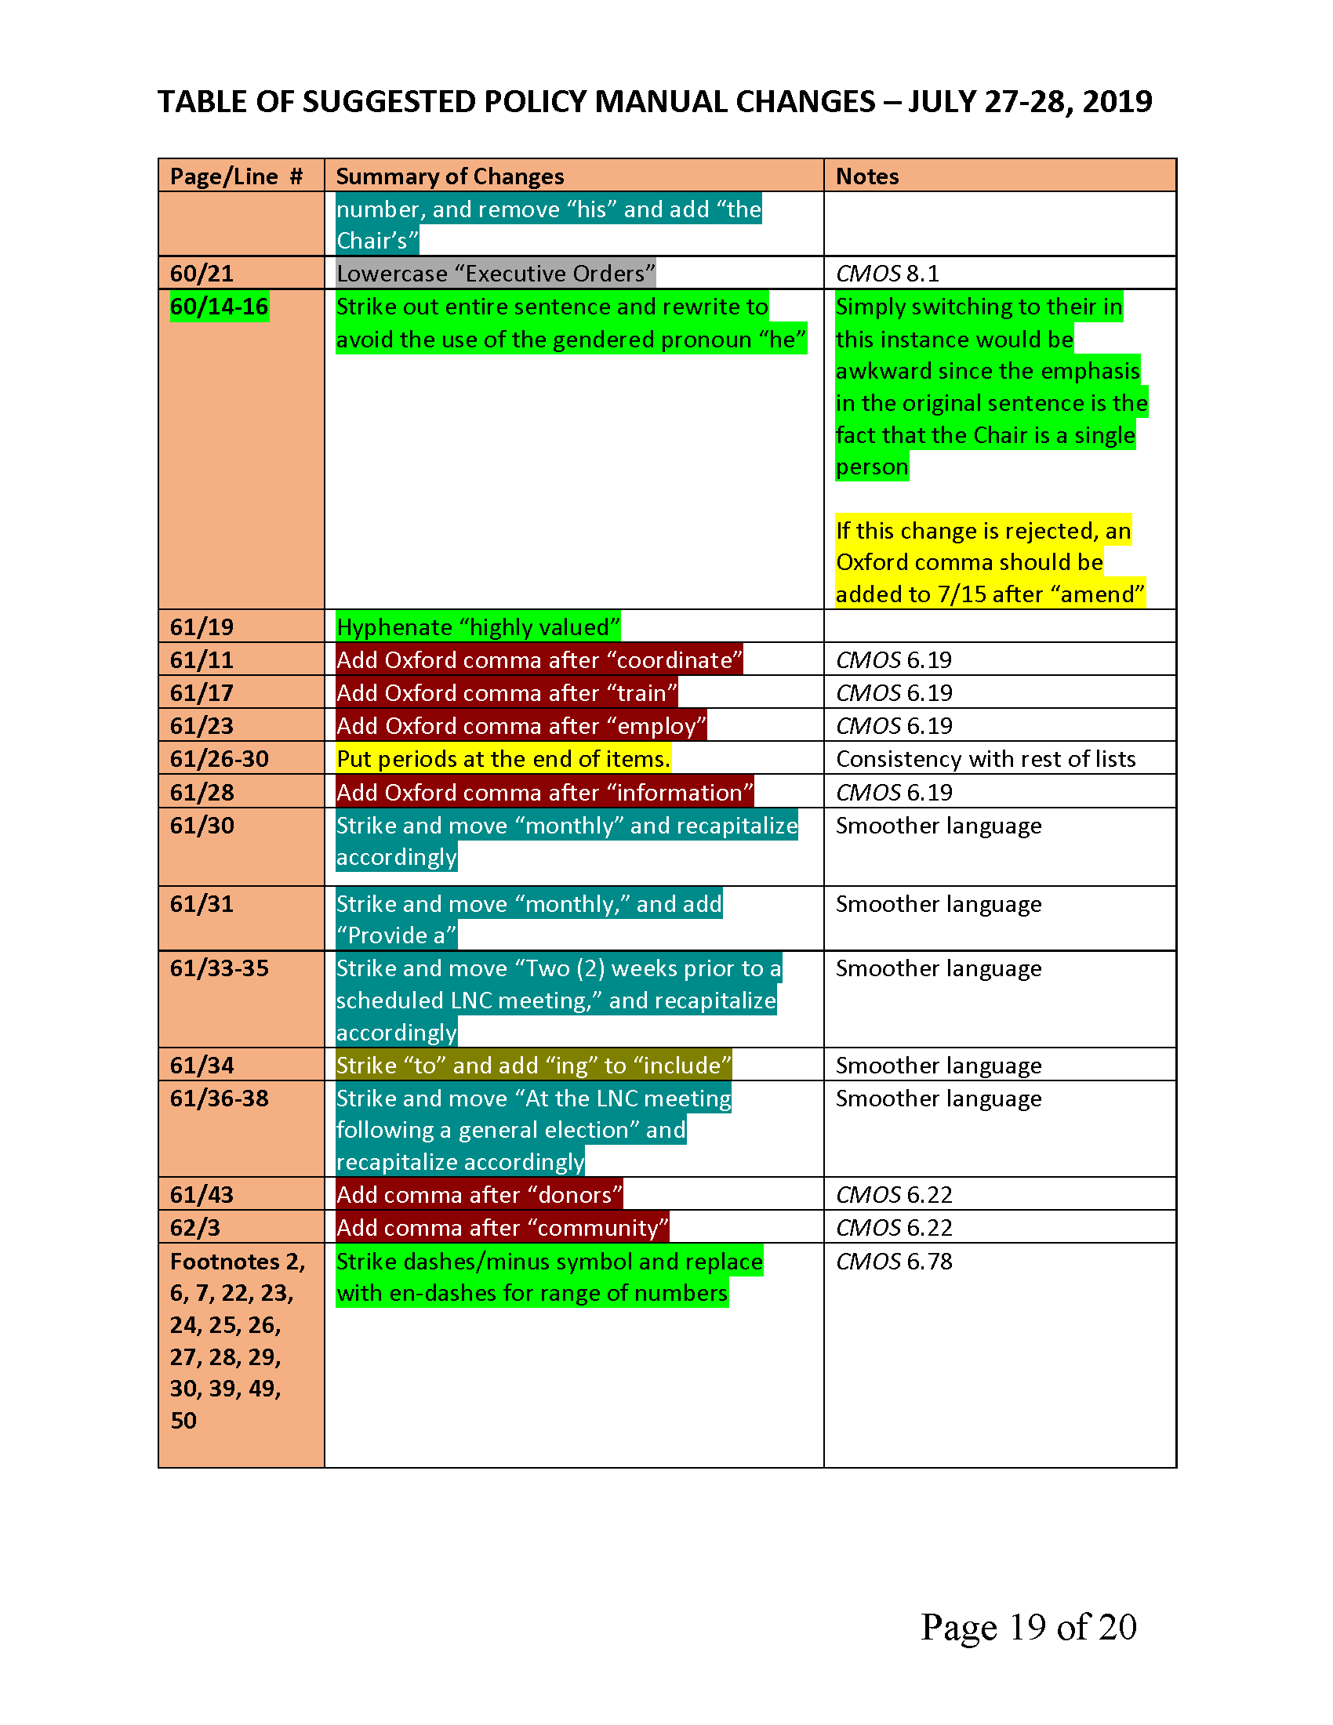

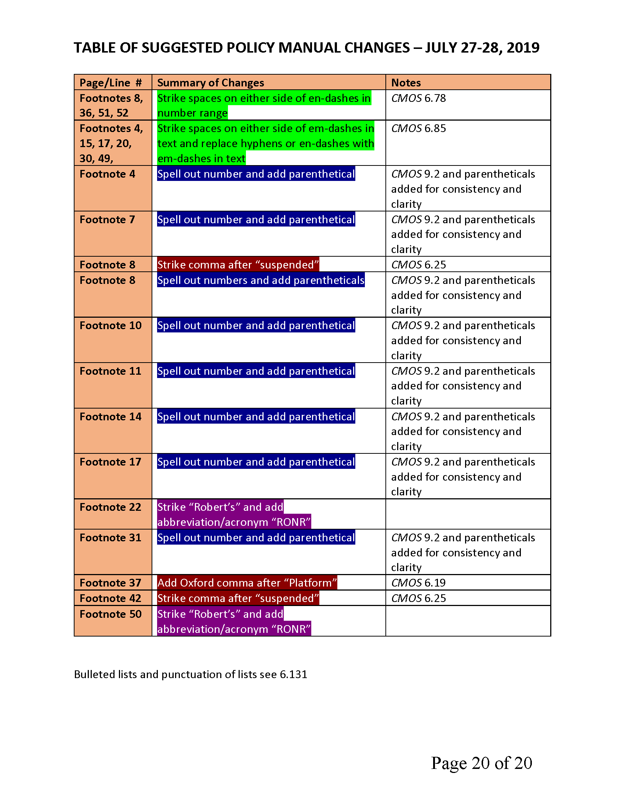

APPENDIX CC – DRAFT BUDGET SUBMITTED PRIOR TO MEETING

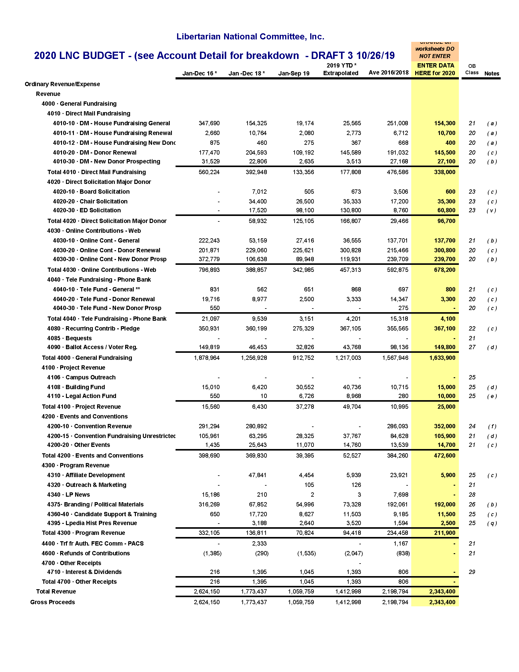

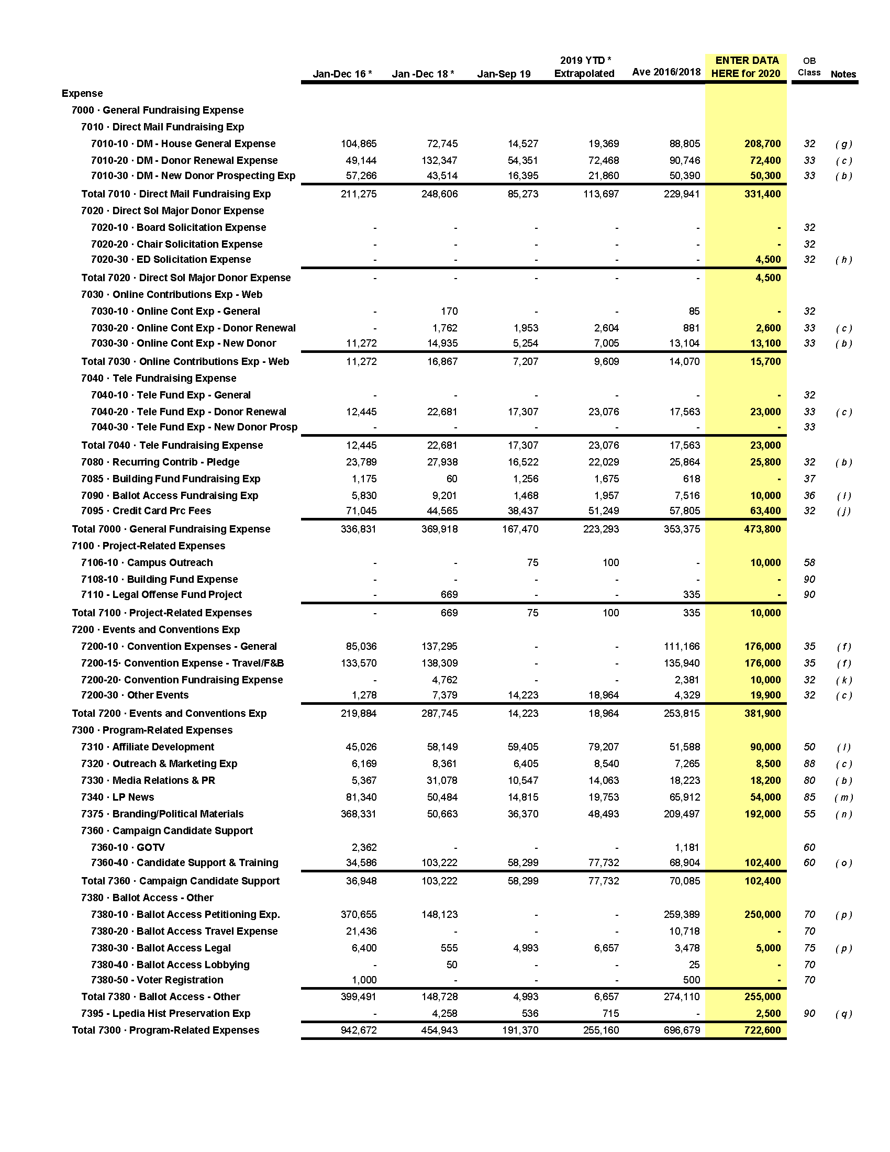

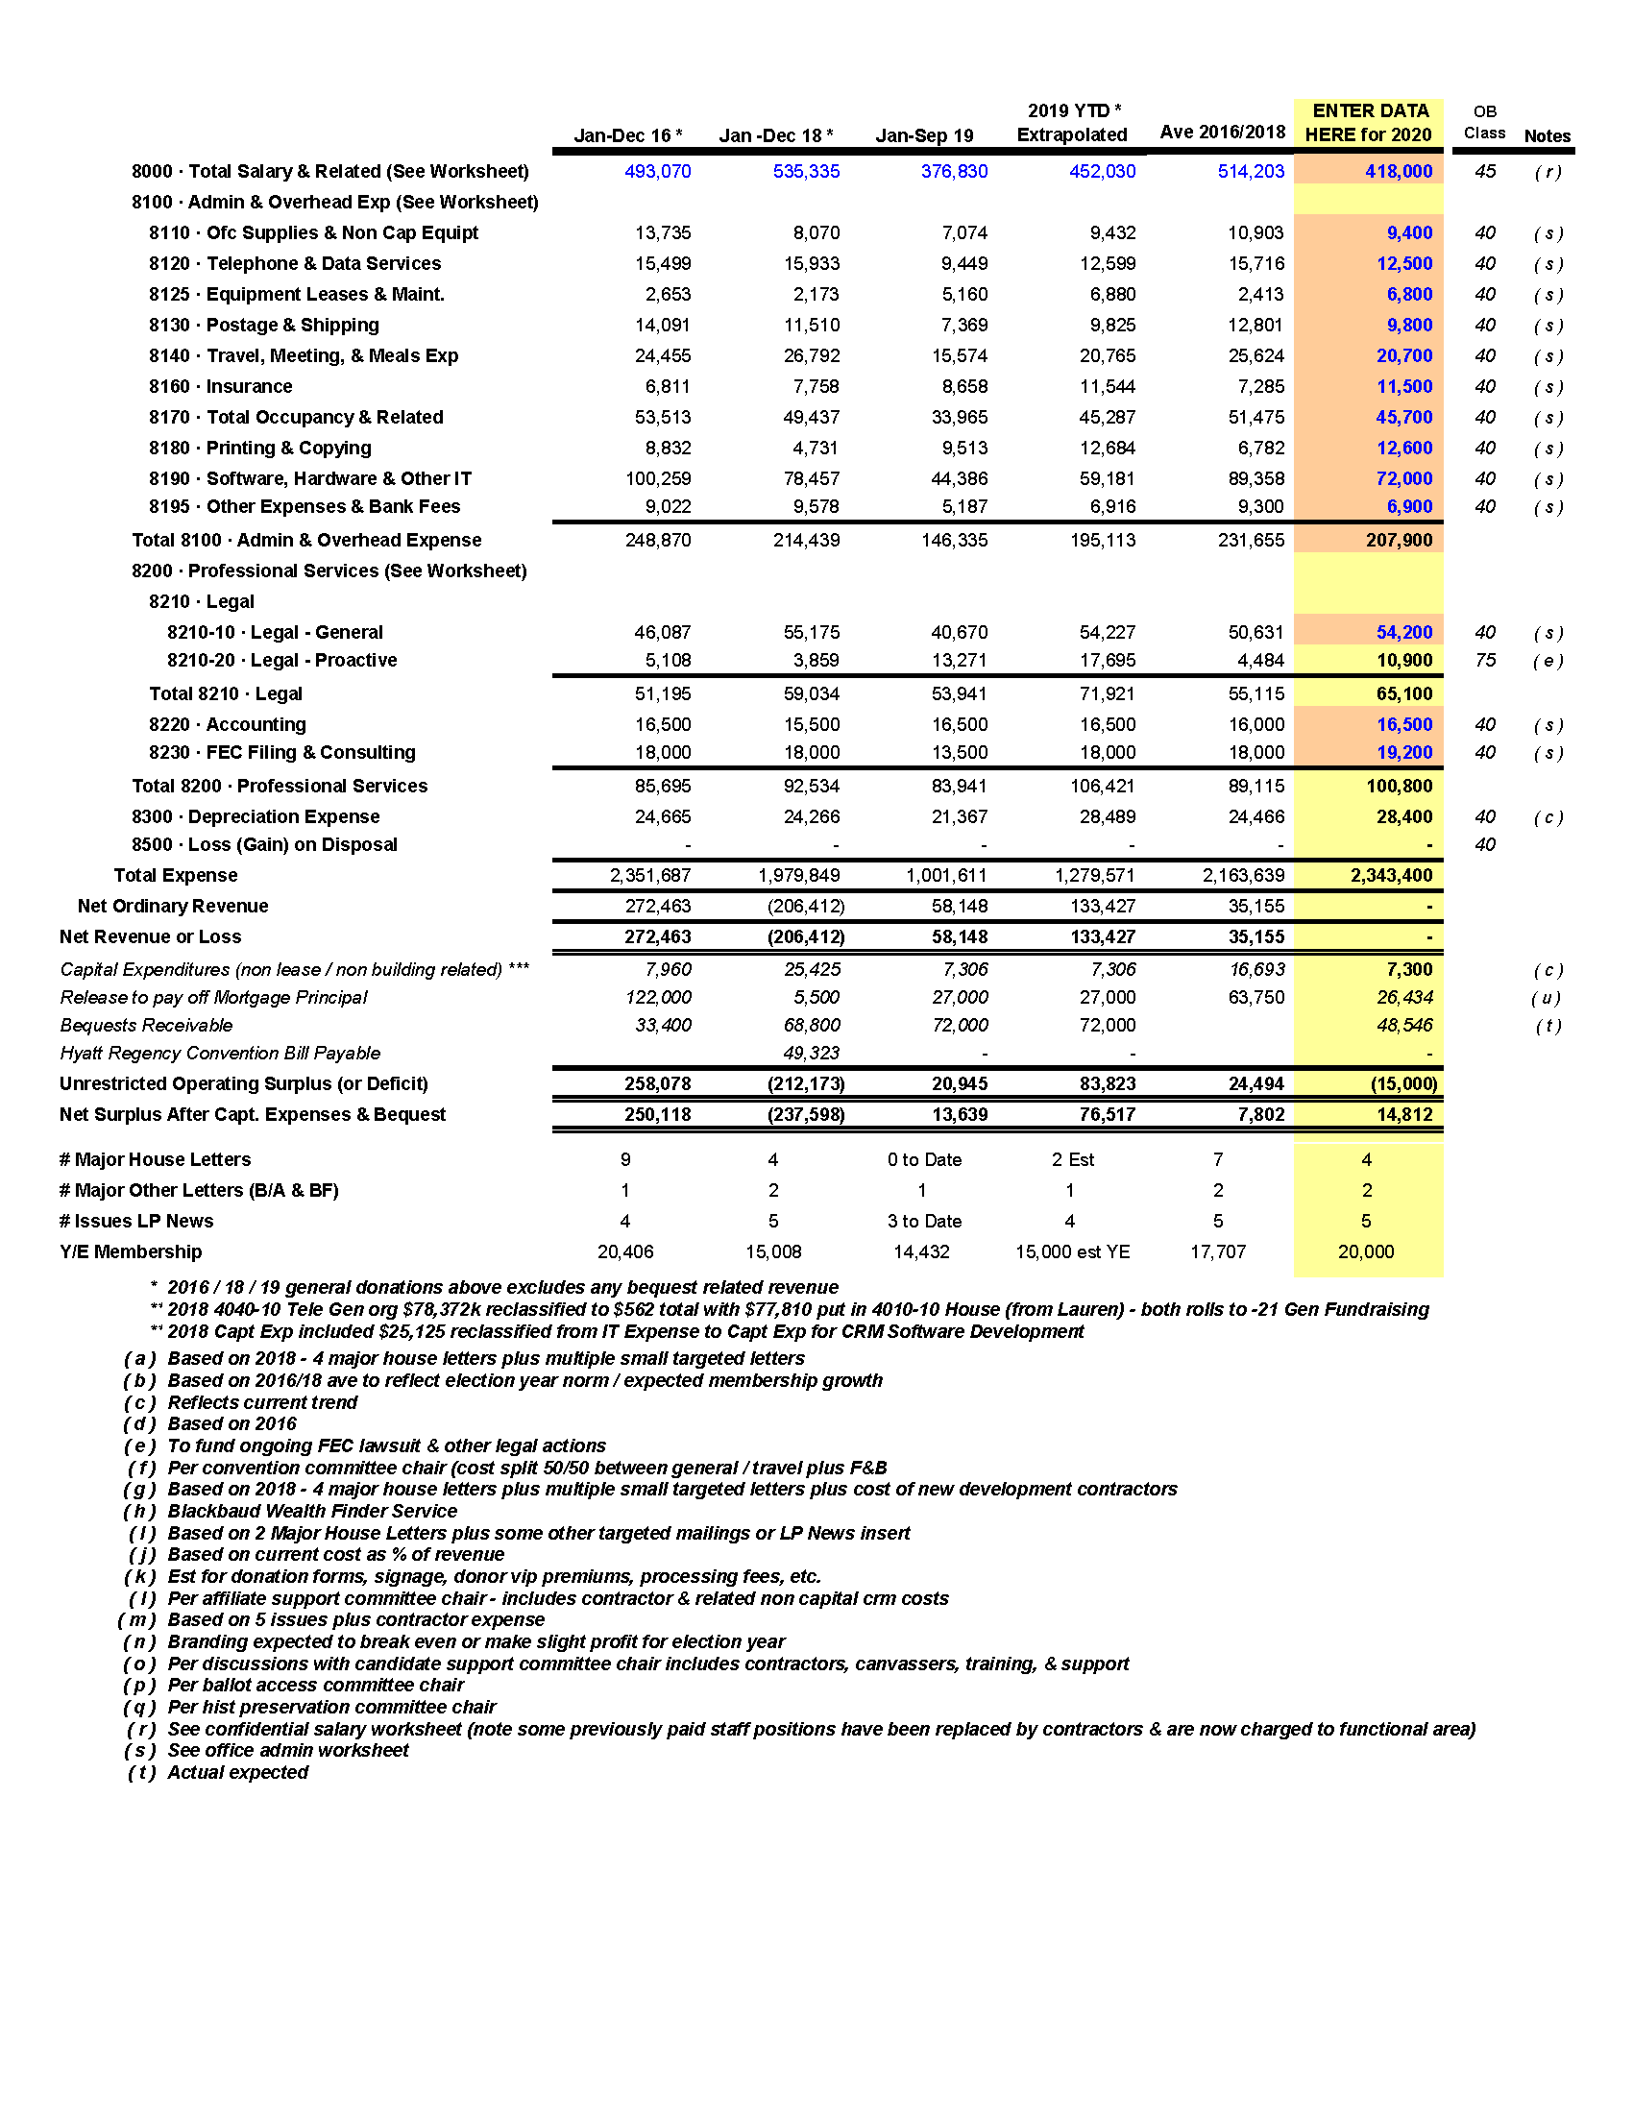

APPENDIX DD – MEMBERSHIP GRAPHICS

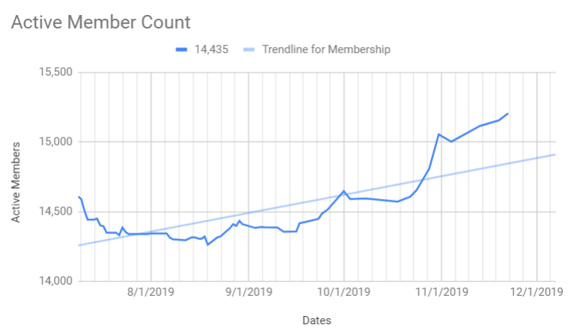
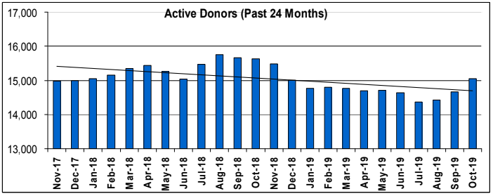

APPENDIX EE – ELECTION OF AWARDS COMMITTEE

SAMPLE AWARDS COMMITTEE BALLOT

 | DANIEL HAYES |  | LARRY GILLIS |  | STEVE RAVET
 | NOTA

TOTAL VOTES CAST:

* the names on the individual electronic ballots were randomized

WHITNEY BILYEU

- DANIEL HAYES |  | - LARRY GILLIS |  | - STEVE RAVET
 | NOTA

TOTAL VOTES CAST: 3

JOSEPH BISHOP-HENCHMAN

- DANIEL HAYES |  | - LARRY GILLIS |  | - STEVE RAVET
 | NOTA

TOTAL VOTES CAST: 2

SAM GOLDSTEIN

- DANIEL HAYES |  | - LARRY GILLIS |  | - STEVE RAVET
 | NOTA

TOTAL VOTES CAST: 2

TIM HAGAN

- DANIEL HAYES |  | - LARRY GILLIS |  | - STEVE RAVET
 | NOTA

TOTAL VOTES CAST: 2

CARYN ANN HARLOS

- DANIEL HAYES |  | - LARRY GILLIS |  | - STEVE RAVET
 | NOTA

TOTAL VOTES CAST: 2

JEFF HEWITT

- DANIEL HAYES |  | - LARRY GILLIS |  | - STEVE RAVET
 | NOTA

TOTAL VOTES CAST: 2

JIM LARK

- DANIEL HAYES |  |  | LARRY GILLIS |  | STEVE RAVET
 | NOTA

TOTAL VOTES CAST: 1

RICHARD LONGSTRETH

- DANIEL HAYES |  | - LARRY GILLIS |  | - STEVE RAVET
 | NOTA

TOTAL VOTES CAST: 3

ALICIA MATTSON

- DANIEL HAYES |  | - LARRY GILLIS |  | - STEVE RAVET
 | NOTA

TOTAL VOTES CAST: 2

STEVEN NEKHAILA

- DANIEL HAYES |  | - LARRY GILLIS |  | - STEVE RAVET
 | NOTA

TOTAL VOTES CAST: 2

JUSTIN O’DONNELL

- DANIEL HAYES |  | - LARRY GILLIS |  | - STEVE RAVET
 | NOTA

TOTAL VOTES CAST: 3

JOHN PHILLIPS

 | DANIEL HAYES | - LARRY GILLIS |  | - STEVE RAVET
 | NOTA

TOTAL VOTES CAST: 2

BILL REDPATH

- DANIEL HAYES |  | - LARRY GILLIS |  | - STEVE RAVET
 | NOTA

TOTAL VOTES CAST: 2

NICHOLAS SARWARK

- DANIEL HAYES |  | - LARRY GILLIS |  | - STEVE RAVET
 | NOTA

TOTAL VOTES CAST: 2

JOSHUA SMITH

- DANIEL HAYES |  | - LARRY GILLIS |  | - STEVE RAVET
 | NOTA

TOTAL VOTES CAST: 2

ELIZABETH VAN HORN

- DANIEL HAYES |  |  | LARRY GILLIS |  | STEVE RAVET
 | NOTA

TOTAL VOTES CAST: 1

APPENDIX FF – ELECTION OF CREDENTIALS COMMITTEE

SAMPLE CREDENTIALS COMMITTEE BALLOT

 | KENNTH BURGESS |  | ANTHONY BUSH |  | JOSEPH DAVIS
 | ANDREW FORRESTER |  | NATHAN GALL |  | GARY GERSTEIN
 | ART GIBSON |  | SUSAN HOGARTH |  | LEIGH LACHINE
 | JAMES MARSH |  | RONALD MILLER |  | PETER MOULDS
 | MARGO NYMAN |  | CY PERRY |  | ELSPETH POMPANIO
 | MARK POTWORA |  | STEVEN RAVETS |  | EMILY SALVETTE
 | PAUL SCHLEIFER |  | MICHAEL R. SEETO |  | RICK TUCKER
 | SUSAN WILSON |  | ARLEN LAWSON WRIGHT |  | BO ZIMMERMAN
 | NOTA

TOTAL VOTES CAST:

* the names on the individual electronic ballots were randomized

WHITNEY BILYEU

 | KENNTH BURGESS |  | ANTHONY BUSH |  | JOSEPH DAVIS
 | ANDREW FORRESTER |  | NATHAN GALL |  | GARY GERSTEIN
 | ART GIBSON | - SUSAN HOGARTH |  | - LEIGH LACHINE
 | JAMES MARSH |  | RONALD MILLER |  | PETER MOULDS
 | MARGO NYMAN |  | CY PERRY |  | ELSPETH POMPANIO
 | MARK POTWORA |  | STEVEN RAVETS | - EMILY SALVETTE
 | PAUL SCHLEIFER |  | MICHAEL R. SEETO |  | RICK TUCKER
 | SUSAN WILSON |  | ARLEN LAWSON WRIGHT | - BO ZIMMERMAN
 | NOTA

TOTAL VOTES CAST: 4

JOSEPH BISHOP-HENCHMAN

 | KENNTH BURGESS |  | ANTHONY BUSH |  | JOSEPH DAVIS
 | ANDREW FORRESTER |  | NATHAN GALL | - GARY GERSTEIN
 | ART GIBSON | - SUSAN HOGARTH |  | - LEIGH LACHINE
 | JAMES MARSH |  | RONALD MILLER |  | PETER MOULDS
 | MARGO NYMAN |  | CY PERRY |  | ELSPETH POMPANIO
 | MARK POTWORA |  | STEVEN RAVETS | - EMILY SALVETTE
 | PAUL SCHLEIFER |  | MICHAEL R. SEETO |  | RICK TUCKER
 | SUSAN WILSON |  | ARLEN LAWSON WRIGHT | - BO ZIMMERMAN
 | NOTA

TOTAL VOTES CAST: 5

SAM GOLDSTEIN

 | KENNTH BURGESS |  | ANTHONY BUSH |  | JOSEPH DAVIS
 | ANDREW FORRESTER | - NATHAN GALL |  |  | GARY GERSTEIN
 | ART GIBSON | - SUSAN HOGARTH |  | - LEIGH LACHINE
 | JAMES MARSH |  | RONALD MILLER |  | PETER MOULDS
 | MARGO NYMAN |  | CY PERRY |  | ELSPETH POMPANIO
 | MARK POTWORA |  | STEVEN RAVETS | - EMILY SALVETTE
 | PAUL SCHLEIFER |  | MICHAEL R. SEETO |  | RICK TUCKER
 | SUSAN WILSON |  | ARLEN LAWSON WRIGHT | - BO ZIMMERMAN
 | NOTA

TOTAL VOTES CAST: 5

TIM HAGAN

 | KENNTH BURGESS |  | ANTHONY BUSH |  | JOSEPH DAVIS
 | ANDREW FORRESTER | - NATHAN GALL |  |  | GARY GERSTEIN
 | ART GIBSON | - SUSAN HOGARTH |  | - LEIGH LACHINE
 | JAMES MARSH |  | RONALD MILLER |  | PETER MOULDS
 | MARGO NYMAN |  | CY PERRY | - ELSPETH POMPANIO
- MARK POTWORA |  |  | STEVEN RAVETS | - EMILY SALVETTE
 | PAUL SCHLEIFER |  | MICHAEL R. SEETO |  | RICK TUCKER
 | SUSAN WILSON |  | ARLEN LAWSON WRIGHT | - BO ZIMMERMAN
 | NOTA

TOTAL VOTES CAST: 7

CARYN ANN HARLOS

 | KENNTH BURGESS |  | ANTHONY BUSH |  | JOSEPH DAVIS
 | ANDREW FORRESTER | - NATHAN GALL |  |  | GARY GERSTEIN
 | ART GIBSON | - SUSAN HOGARTH |  |  | LEIGH LACHINE
 | JAMES MARSH |  | RONALD MILLER | - PETER MOULDS
 | MARGO NYMAN |  | CY PERRY |  | ELSPETH POMPANIO
- MARK POTWORA |  | - STEVEN RAVETS |  | - EMILY SALVETTE
 | PAUL SCHLEIFER |  | MICHAEL R. SEETO |  | RICK TUCKER
 | SUSAN WILSON |  | ARLEN LAWSON WRIGHT |  | BO ZIMMERMAN
 | NOTA

TOTAL VOTES CAST: 6

JEFF HEWITT

 | KENNTH BURGESS |  | ANTHONY BUSH |  | JOSEPH DAVIS
 | ANDREW FORRESTER |  | NATHAN GALL |  | GARY GERSTEIN
 | ART GIBSON | - SUSAN HOGARTH |  |  | LEIGH LACHINE
 | JAMES MARSH |  | RONALD MILLER |  | PETER MOULDS
 | MARGO NYMAN |  | CY PERRY |  | ELSPETH POMPANIO
 | MARK POTWORA |  | STEVEN RAVETS | - EMILY SALVETTE
 | PAUL SCHLEIFER |  | MICHAEL R. SEETO |  | RICK TUCKER
 | SUSAN WILSON |  | ARLEN LAWSON WRIGHT |  | BO ZIMMERMAN
 | NOTA

TOTAL VOTES CAST: 2

JIM LARK

 | KENNTH BURGESS |  | ANTHONY BUSH |  | JOSEPH DAVIS
 | ANDREW FORRESTER | - NATHAN GALL |  | - GARY GERSTEIN
 | ART GIBSON | - SUSAN HOGARTH |  | - LEIGH LACHINE
 | JAMES MARSH |  | RONALD MILLER | - PETER MOULDS
 | MARGO NYMAN |  | CY PERRY |  | ELSPETH POMPANIO
- MARK POTWORA |  | - STEVEN RAVETS |  | - EMILY SALVETTE
 | PAUL SCHLEIFER |  | MICHAEL R. SEETO |  | RICK TUCKER
 | SUSAN WILSON |  | ARLEN LAWSON WRIGHT | - BO ZIMMERMAN
 | NOTA

TOTAL VOTES CAST: 9

RICHARD LONGSTRETH

 | KENNTH BURGESS |  | ANTHONY BUSH |  | JOSEPH DAVIS
 | ANDREW FORRESTER |  | NATHAN GALL |  | GARY GERSTEIN
 | ART GIBSON | - SUSAN HOGARTH |  |  | LEIGH LACHINE
 | JAMES MARSH |  | RONALD MILLER | - PETER MOULDS
 | MARGO NYMAN |  | CY PERRY |  | ELSPETH POMPANIO
 | MARK POTWORA |  | STEVEN RAVETS | - EMILY SALVETTE
 | PAUL SCHLEIFER |  | MICHAEL R. SEETO |  | RICK TUCKER
 | SUSAN WILSON |  | ARLEN LAWSON WRIGHT |  | BO ZIMMERMAN
 | NOTA

TOTAL VOTES CAST: 3

ALICIA MATTSON

 | KENNTH BURGESS |  | ANTHONY BUSH |  | JOSEPH DAVIS
 | ANDREW FORRESTER |  | NATHAN GALL |  | GARY GERSTEIN
 | ART GIBSON | - SUSAN HOGARTH |  | - LEIGH LACHINE
 | JAMES MARSH |  | RONALD MILLER | - PETER MOULDS
 | MARGO NYMAN |  | CY PERRY |  | ELSPETH POMPANIO
 | MARK POTWORA |  | STEVEN RAVETS | - EMILY SALVETTE
 | PAUL SCHLEIFER |  | MICHAEL R. SEETO |  | RICK TUCKER
 | SUSAN WILSON |  | ARLEN LAWSON WRIGHT | - BO ZIMMERMAN
 | NOTA

TOTAL VOTES CAST: 5

STEVEN NEKHAILA

 | KENNTH BURGESS |  | ANTHONY BUSH |  | JOSEPH DAVIS
 | ANDREW FORRESTER |  | NATHAN GALL |  | GARY GERSTEIN
 | ART GIBSON | - SUSAN HOGARTH |  |  | LEIGH LACHINE
 | JAMES MARSH |  | RONALD MILLER |  | PETER MOULDS
 | MARGO NYMAN |  | CY PERRY |  | ELSPETH POMPANIO
 | MARK POTWORA |  | STEVEN RAVETS | - EMILY SALVETTE
 | PAUL SCHLEIFER |  | MICHAEL R. SEETO |  | RICK TUCKER
 | SUSAN WILSON |  | ARLEN LAWSON WRIGHT |  | BO ZIMMERMAN
 | NOTA

TOTAL VOTES CAST: 2

JUSTIN O’DONNELL

 | KENNTH BURGESS |  | ANTHONY BUSH |  | JOSEPH DAVIS
 | ANDREW FORRESTER |  | NATHAN GALL |  | GARY GERSTEIN
 | ART GIBSON | - SUSAN HOGARTH |  |  | LEIGH LACHINE
 | JAMES MARSH |  | RONALD MILLER |  | PETER MOULDS
 | MARGO NYMAN |  | CY PERRY |  | ELSPETH POMPANIO
 | MARK POTWORA |  | STEVEN RAVETS | - EMILY SALVETTE
 | PAUL SCHLEIFER |  | MICHAEL R. SEETO |  | RICK TUCKER
 | SUSAN WILSON |  | ARLEN LAWSON WRIGHT |  | BO ZIMMERMAN
 | NOTA

TOTAL VOTES CAST: 2

JOHN PHILLIPS

 | KENNTH BURGESS |  | ANTHONY BUSH |  | JOSEPH DAVIS
 | ANDREW FORRESTER | - NATHAN GALL |  |  | GARY GERSTEIN
 | ART GIBSON | - SUSAN HOGARTH |  |  | LEIGH LACHINE
 | JAMES MARSH |  | RONALD MILLER |  | PETER MOULDS
 | MARGO NYMAN |  | CY PERRY |  | ELSPETH POMPANIO
 | MARK POTWORA | - STEVEN RAVETS |  | - EMILY SALVETTE
 | PAUL SCHLEIFER |  | MICHAEL R. SEETO |  | RICK TUCKER
 | SUSAN WILSON |  | ARLEN LAWSON WRIGHT | - BO ZIMMERMAN
 | NOTA

TOTAL VOTES CAST: 5

BILL REDPATH

 | KENNTH BURGESS |  | ANTHONY BUSH |  | JOSEPH DAVIS
 | ANDREW FORRESTER |  | NATHAN GALL |  | GARY GERSTEIN
 | ART GIBSON | - SUSAN HOGARTH |  | - LEIGH LACHINE
 | JAMES MARSH |  | RONALD MILLER |  | PETER MOULDS
 | MARGO NYMAN |  | CY PERRY |  | ELSPETH POMPANIO
 | MARK POTWORA |  | STEVEN RAVETS | - EMILY SALVETTE
 | PAUL SCHLEIFER |  | MICHAEL R. SEETO |  | RICK TUCKER
 | SUSAN WILSON |  | ARLEN LAWSON WRIGHT |  | BO ZIMMERMAN
 | NOTA

TOTAL VOTES CAST: 3

NICHOLAS SARWARK

 | KENNTH BURGESS |  | ANTHONY BUSH |  | JOSEPH DAVIS
 | ANDREW FORRESTER | - NATHAN GALL |  | - GARY GERSTEIN
 | ART GIBSON | - SUSAN HOGARTH |  | - LEIGH LACHINE
 | JAMES MARSH |  | RONALD MILLER | - PETER MOULDS
 | MARGO NYMAN |  | CY PERRY | - ELSPETH POMPANIO
- MARK POTWORA |  |  | STEVEN RAVETS | - EMILY SALVETTE
 | PAUL SCHLEIFER | - MICHAEL R. SEETO |  |  | RICK TUCKER
 | SUSAN WILSON |  | ARLEN LAWSON WRIGHT | - BO ZIMMERMAN
 | NOTA

TOTAL VOTES CAST: 10

JOSHUA SMITH

 | KENNTH BURGESS |  | ANTHONY BUSH |  | JOSEPH DAVIS
 | ANDREW FORRESTER | - NATHAN GALL |  |  | GARY GERSTEIN
 | ART GIBSON | - SUSAN HOGARTH |  |  | LEIGH LACHINE
 | JAMES MARSH |  | RONALD MILLER |  | PETER MOULDS
 | MARGO NYMAN |  | CY PERRY | - ELSPETH POMPANIO
- MARK POTWORA |  |  | STEVEN RAVETS |  | EMILY SALVETTE
 | PAUL SCHLEIFER |  | MICHAEL R. SEETO |  | RICK TUCKER
 | SUSAN WILSON |  | ARLEN LAWSON WRIGHT |  | BO ZIMMERMAN
 | NOTA

TOTAL VOTES CAST: 4

ELIZABETH VAN HORN

 | KENNTH BURGESS |  | ANTHONY BUSH |  | JOSEPH DAVIS
 | ANDREW FORRESTER |  | NATHAN GALL |  | GARY GERSTEIN
 | ART GIBSON | - SUSAN HOGARTH |  |  | LEIGH LACHINE
 | JAMES MARSH |  | RONALD MILLER |  | PETER MOULDS
 | MARGO NYMAN |  | CY PERRY |  | ELSPETH POMPANIO
 | MARK POTWORA |  | STEVEN RAVETS | - EMILY SALVETTE
 | PAUL SCHLEIFER |  | MICHAEL R. SEETO |  | RICK TUCKER
 | SUSAN WILSON |  | ARLEN LAWSON WRIGHT |  | BO ZIMMERMAN
 | NOTA

TOTAL VOTES CAST: 2

APPENDIX GG – ELECTION OF PLATFORM COMMITTEE

SAMPLE PLATFORM COMMITTEE BALLOT

 | GEOFFREY ADAMS |  | WILLIAM ADIN |  | RICHARD ALBRECHT
 | SONA CARMEN ARCELAY |  | DAVID COLBOURNE |  | JOSEPH DAVIS
 | LAURA EBKE |  | ROBERT EHRLICH |  | RICHARD FAST
 | LARRY FREY |  | CHRIS GANNON |  | LORENZO GAZTANGA
 | PATRICK GLASGOW |  | DENNIS GRACE |  | PAUL GRINDLE
 | DAVID GROVER |  | TODD HAGOPIAN |  | CHARLES HALL
 | CARYN ANN HARLOS |  | ROBERT HASELOFF |  | HANK HOLLAND
 | DAVE JONES |  | THOMAS KNAPP |  | WILLIAM KOVACS
 | JOE LEAVENGOOD |  | ELISHIVA LEVIN |  | BRIAN LINDENMEYER
 | RICHARD LONGSTRETH |  | FRANK LOZANO |  | ALICIA MATTSON
 | MAX MCFARLIN |  | DAVID MORAN |  | DUSTIN NANNA
 | ANDREW OLDING |  | STEVE PERKINS |  | DARRYL PERRY
 | JOHN ROBERTSON |  | JOHN ROBINSON |  | DOUGLAS SCHELL
 | MIKE SEEBECK |  | ROBERT BLAIR SMITH |  | JOSE SOTO
 | JAMES STEVENS |  | CLARK STINSON |  | MARK SUAREZ
 | ANDREY SWYSTUN |  | CURRY TAYLOR |  | JOSEPH TROJANO
 | DUKE VAN HORN |  | ALBERT VELDHUYZEN |  | CAROLYN WADE
 | BRENDAN WEST |  | SARAH WHITAKER |  | KENNETH YOST
 | NOTA

TOTAL VOTES CAST:

* the names on the individual electronic ballots were randomized

WHITNEY BILYEU

- GEOFFREY ADAMS |  |  | WILLIAM ADIN |  | RICHARD ALBRECHT
 | SONA CARMEN ARCELAY |  | DAVID COLBOURNE |  | JOSEPH DAVIS
- LAURA EBKE |  |  | ROBERT EHRLICH | - RICHARD FAST
 | LARRY FREY |  | CHRIS GANNON |  | LORENZO GAZTANGA
 | PATRICK GLASGOW |  | DENNIS GRACE |  | PAUL GRINDLE
 | DAVID GROVER |  | TODD HAGOPIAN |  | CHARLES HALL
 | CARYN ANN HARLOS |  | ROBERT HASELOFF |  | HANK HOLLAND
 | DAVE JONES |  | THOMAS KNAPP |  | WILLIAM KOVACS
 | JOE LEAVENGOOD |  | ELISHIVA LEVIN |  | BRIAN LINDENMEYER
 | RICHARD LONGSTRETH | - FRANK LOZANO |  |  | ALICIA MATTSON
 | MAX MCFARLIN |  | DAVID MORAN |  | DUSTIN NANNA
- ANDREW OLDING |  | - STEVE PERKINS |  |  | DARRYL PERRY
 | JOHN ROBERTSON |  | JOHN ROBINSON |  | DOUGLAS SCHELL
 | MIKE SEEBECK |  | ROBERT BLAIR SMITH |  | JOSE SOTO
 | JAMES STEVENS |  | CLARK STINSON |  | MARK SUAREZ
 | ANDREY SWYSTUN | - CURRY TAYLOR |  |  | JOSEPH TROJANO
 | DUKE VAN HORN |  | ALBERT VELDHUYZEN |  | CAROLYN WADE
 | BRENDAN WEST |  | SARAH WHITAKER |  | KENNETH YOST
 | NOTA

TOTAL VOTES CAST: 7

JOSEPH BISHOP-HENCHMAN

 | GEOFFREY ADAMS |  | WILLIAM ADIN |  | RICHARD ALBRECHT
 | SONA CARMEN ARCELAY | - DAVID COLBOURNE |  |  | JOSEPH DAVIS
- LAURA EBKE |  |  | ROBERT EHRLICH |  | RICHARD FAST
 | LARRY FREY |  | CHRIS GANNON |  | LORENZO GAZTANGA
 | PATRICK GLASGOW |  | DENNIS GRACE | - PAUL GRINDLE
 | DAVID GROVER | - TODD HAGOPIAN |  |  | CHARLES HALL
 | CARYN ANN HARLOS |  | ROBERT HASELOFF |  | HANK HOLLAND
 | DAVE JONES | - THOMAS KNAPP |  |  | WILLIAM KOVACS
 | JOE LEAVENGOOD |  | ELISHIVA LEVIN |  | BRIAN LINDENMEYER
- RICHARD LONGSTRETH |  |  | FRANK LOZANO | - ALICIA MATTSON
 | MAX MCFARLIN |  | DAVID MORAN |  | DUSTIN NANNA
 | ANDREW OLDING |  | STEVE PERKINS |  | DARRYL PERRY
 | JOHN ROBERTSON |  | JOHN ROBINSON |  | DOUGLAS SCHELL
 | MIKE SEEBECK |  | ROBERT BLAIR SMITH |  | JOSE SOTO
 | JAMES STEVENS |  | CLARK STINSON |  | MARK SUAREZ
 | ANDREY SWYSTUN |  | CURRY TAYLOR |  | JOSEPH TROJANO
- DUKE VAN HORN |  |  | ALBERT VELDHUYZEN | - CAROLYN WADE
 | BRENDAN WEST |  | SARAH WHITAKER |  | KENNETH YOST
 | NOTA

TOTAL VOTES CAST: 9

SAM GOLDSTEIN

 | GEOFFREY ADAMS |  | WILLIAM ADIN |  | RICHARD ALBRECHT
 | SONA CARMEN ARCELAY |  | DAVID COLBOURNE |  | JOSEPH DAVIS
- LAURA EBKE |  |  | ROBERT EHRLICH | - RICHARD FAST
 | LARRY FREY |  | CHRIS GANNON | - LORENZO GAZTANGA
 | PATRICK GLASGOW |  | DENNIS GRACE |  | PAUL GRINDLE
 | DAVID GROVER |  | TODD HAGOPIAN |  | CHARLES HALL
 | CARYN ANN HARLOS |  | ROBERT HASELOFF |  | HANK HOLLAND
 | DAVE JONES | - THOMAS KNAPP |  |  | WILLIAM KOVACS
 | JOE LEAVENGOOD |  | ELISHIVA LEVIN |  | BRIAN LINDENMEYER
 | RICHARD LONGSTRETH |  | FRANK LOZANO |  | ALICIA MATTSON
 | MAX MCFARLIN |  | DAVID MORAN |  | DUSTIN NANNA
 | ANDREW OLDING |  | STEVE PERKINS | - DARRYL PERRY
 | JOHN ROBERTSON |  | JOHN ROBINSON |  | DOUGLAS SCHELL
 | MIKE SEEBECK |  | ROBERT BLAIR SMITH |  | JOSE SOTO
 | JAMES STEVENS |  | CLARK STINSON |  | MARK SUAREZ
 | ANDREY SWYSTUN |  | CURRY TAYLOR |  | JOSEPH TROJANO
 | DUKE VAN HORN |  | ALBERT VELDHUYZEN |  | CAROLYN WADE
 | BRENDAN WEST |  | SARAH WHITAKER |  | KENNETH YOST
 | NOTA

TOTAL VOTES CAST: 5

TIM HAGAN

- GEOFFREY ADAMS |  |  | WILLIAM ADIN |  | RICHARD ALBRECHT
 | SONA CARMEN ARCELAY | - DAVID COLBOURNE |  |  | JOSEPH DAVIS
- LAURA EBKE |  |  | ROBERT EHRLICH | - RICHARD FAST
 | LARRY FREY |  | CHRIS GANNON | - LORENZO GAZTANGA
 | PATRICK GLASGOW |  | DENNIS GRACE |  | PAUL GRINDLE
 | DAVID GROVER |  | TODD HAGOPIAN |  | CHARLES HALL
- CARYN ANN HARLOS |  |  | ROBERT HASELOFF |  | HANK HOLLAND
 | DAVE JONES | - THOMAS KNAPP |  |  | WILLIAM KOVACS
 | JOE LEAVENGOOD |  | ELISHIVA LEVIN |  | BRIAN LINDENMEYER
 | RICHARD LONGSTRETH |  | FRANK LOZANO |  | ALICIA MATTSON
 | MAX MCFARLIN |  | DAVID MORAN |  | DUSTIN NANNA
 | ANDREW OLDING |  | STEVE PERKINS |  | DARRYL PERRY
 | JOHN ROBERTSON |  | JOHN ROBINSON |  | DOUGLAS SCHELL
 | MIKE SEEBECK |  | ROBERT BLAIR SMITH |  | JOSE SOTO
 | JAMES STEVENS |  | CLARK STINSON |  | MARK SUAREZ
 | ANDREY SWYSTUN |  | CURRY TAYLOR |  | JOSEPH TROJANO
- DUKE VAN HORN |  |  | ALBERT VELDHUYZEN | - CAROLYN WADE
 | BRENDAN WEST |  | SARAH WHITAKER |  | KENNETH YOST
 | NOTA

TOTAL VOTES CAST: 9

CARYN ANN HARLOS

 | GEOFFREY ADAMS |  | WILLIAM ADIN |  | RICHARD ALBRECHT
 | SONA CARMEN ARCELAY |  | DAVID COLBOURNE |  | JOSEPH DAVIS
 | LAURA EBKE |  | ROBERT EHRLICH | - RICHARD FAST
 | LARRY FREY |  | CHRIS GANNON |  | LORENZO GAZTANGA
 | PATRICK GLASGOW |  | DENNIS GRACE |  | PAUL GRINDLE
 | DAVID GROVER |  | TODD HAGOPIAN |  | CHARLES HALL
- CARYN ANN HARLOS |  |  | ROBERT HASELOFF |  | HANK HOLLAND
 | DAVE JONES | - THOMAS KNAPP |  |  | WILLIAM KOVACS
 | JOE LEAVENGOOD |  | ELISHIVA LEVIN |  | BRIAN LINDENMEYER
- RICHARD LONGSTRETH |  |  | FRANK LOZANO |  | ALICIA MATTSON
 | MAX MCFARLIN |  | DAVID MORAN | - DUSTIN NANNA
 | ANDREW OLDING |  | STEVE PERKINS | - DARRYL PERRY
 | JOHN ROBERTSON |  | JOHN ROBINSON |  | DOUGLAS SCHELL
- MIKE SEEBECK |  |  | ROBERT BLAIR SMITH |  | JOSE SOTO
 | JAMES STEVENS |  | CLARK STINSON |  | MARK SUAREZ
 | ANDREY SWYSTUN |  | CURRY TAYLOR |  | JOSEPH TROJANO
 | DUKE VAN HORN |  | ALBERT VELDHUYZEN |  | CAROLYN WADE
 | BRENDAN WEST |  | SARAH WHITAKER |  | KENNETH YOST
 | NOTA

TOTAL VOTES CAST: 7

JEFF HEWITT

 | GEOFFREY ADAMS |  | WILLIAM ADIN |  | RICHARD ALBRECHT
 | SONA CARMEN ARCELAY |  | DAVID COLBOURNE |  | JOSEPH DAVIS
- LAURA EBKE |  |  | ROBERT EHRLICH | - RICHARD FAST
 | LARRY FREY |  | CHRIS GANNON |  | LORENZO GAZTANGA
 | PATRICK GLASGOW |  | DENNIS GRACE |  | PAUL GRINDLE
 | DAVID GROVER |  | TODD HAGOPIAN |  | CHARLES HALL
 | CARYN ANN HARLOS |  | ROBERT HASELOFF |  | HANK HOLLAND
 | DAVE JONES |  | THOMAS KNAPP |  | WILLIAM KOVACS
 | JOE LEAVENGOOD |  | ELISHIVA LEVIN |  | BRIAN LINDENMEYER
- RICHARD LONGSTRETH |  |  | FRANK LOZANO | - ALICIA MATTSON
 | MAX MCFARLIN |  | DAVID MORAN |  | DUSTIN NANNA
 | ANDREW OLDING |  | STEVE PERKINS |  | DARRYL PERRY
 | JOHN ROBERTSON |  | JOHN ROBINSON |  | DOUGLAS SCHELL
 | MIKE SEEBECK |  | ROBERT BLAIR SMITH |  | JOSE SOTO
 | JAMES STEVENS |  | CLARK STINSON |  | MARK SUAREZ
 | ANDREY SWYSTUN |  | CURRY TAYLOR |  | JOSEPH TROJANO
- DUKE VAN HORN |  |  | ALBERT VELDHUYZEN |  | CAROLYN WADE
 | BRENDAN WEST |  | SARAH WHITAKER |  | KENNETH YOST
 | NOTA

TOTAL VOTES CAST: 5

JIM LARK

 | GEOFFREY ADAMS |  | WILLIAM ADIN |  | RICHARD ALBRECHT
 | SONA CARMEN ARCELAY | - DAVID COLBOURNE |  |  | JOSEPH DAVIS
- LAURA EBKE |  |  | ROBERT EHRLICH | - RICHARD FAST
 | LARRY FREY |  | CHRIS GANNON | - LORENZO GAZTANGA
 | PATRICK GLASGOW |  | DENNIS GRACE |  | PAUL GRINDLE
 | DAVID GROVER | - TODD HAGOPIAN |  |  | CHARLES HALL
- CARYN ANN HARLOS |  |  | ROBERT HASELOFF |  | HANK HOLLAND
 | DAVE JONES | - THOMAS KNAPP |  |  | WILLIAM KOVACS
 | JOE LEAVENGOOD |  | ELISHIVA LEVIN |  | BRIAN LINDENMEYER
- RICHARD LONGSTRETH |  | - FRANK LOZANO |  | - ALICIA MATTSON
 | MAX MCFARLIN | - DAVID MORAN |  | - DUSTIN NANNA
- ANDREW OLDING |  |  | STEVE PERKINS | - DARRYL PERRY
 | JOHN ROBERTSON |  | JOHN ROBINSON |  | DOUGLAS SCHELL
 | MIKE SEEBECK |  | ROBERT BLAIR SMITH |  | JOSE SOTO
 | JAMES STEVENS |  | CLARK STINSON |  | MARK SUAREZ
 | ANDREY SWYSTUN | - CURRY TAYLOR |  |  | JOSEPH TROJANO
- DUKE VAN HORN |  | - ALBERT VELDHUYZEN |  |  | CAROLYN WADE
 | BRENDAN WEST |  | SARAH WHITAKER |  | KENNETH YOST
 | NOTA

TOTAL VOTES CAST: 17

RICHARD LONGSTRETH

 | GEOFFREY ADAMS |  | WILLIAM ADIN |  | RICHARD ALBRECHT
 | SONA CARMEN ARCELAY |  | DAVID COLBOURNE |  | JOSEPH DAVIS
- LAURA EBKE |  |  | ROBERT EHRLICH |  | RICHARD FAST
 | LARRY FREY |  | CHRIS GANNON |  | LORENZO GAZTANGA
 | PATRICK GLASGOW |  | DENNIS GRACE |  | PAUL GRINDLE
 | DAVID GROVER |  | TODD HAGOPIAN |  | CHARLES HALL
- CARYN ANN HARLOS |  |  | ROBERT HASELOFF |  | HANK HOLLAND
 | DAVE JONES | - THOMAS KNAPP |  |  | WILLIAM KOVACS
 | JOE LEAVENGOOD |  | ELISHIVA LEVIN |  | BRIAN LINDENMEYER
- RICHARD LONGSTRETH |  |  | FRANK LOZANO | - ALICIA MATTSON
 | MAX MCFARLIN |  | DAVID MORAN |  | DUSTIN NANNA
- ANDREW OLDING |  |  | STEVE PERKINS |  | DARRYL PERRY
 | JOHN ROBERTSON |  | JOHN ROBINSON |  | DOUGLAS SCHELL
- MIKE SEEBECK |  |  | ROBERT BLAIR SMITH |  | JOSE SOTO
 | JAMES STEVENS |  | CLARK STINSON |  | MARK SUAREZ
 | ANDREY SWYSTUN |  | CURRY TAYLOR |  | JOSEPH TROJANO
 | DUKE VAN HORN |  | ALBERT VELDHUYZEN |  | CAROLYN WADE
 | BRENDAN WEST |  | SARAH WHITAKER |  | KENNETH YOST
 | NOTA

TOTAL VOTES CAST: 7

ALICIA MATTSON

 | GEOFFREY ADAMS |  | WILLIAM ADIN |  | RICHARD ALBRECHT
 | SONA CARMEN ARCELAY |  | DAVID COLBOURNE |  | JOSEPH DAVIS
 | LAURA EBKE |  | ROBERT EHRLICH |  | RICHARD FAST
 | PATRICK GLASGOW |  | DENNIS GRACE |  | PAUL GRINDLE
 | DAVID GROVER |  | TODD HAGOPIAN |  | CHARLES HALL
 | CARYN ANN HARLOS |  | ROBERT HASELOFF |  | HANK HOLLAND
 | DAVE JONES |  | THOMAS KNAPP |  | WILLIAM KOVACS
- JOE LEAVENGOOD |  |  | ELISHIVA LEVIN |  | BRIAN LINDENMEYER
 | RICHARD LONGSTRETH |  | FRANK LOZANO | - ALICIA MATTSON
 | MAX MCFARLIN |  | DAVID MORAN |  | DUSTIN NANNA
 | ANDREW OLDING | - STEVE PERKINS |  |  | DARRYL PERRY
 | JOHN ROBERTSON |  | JOHN ROBINSON |  | DOUGLAS SCHELL
 | MIKE SEEBECK |  | ROBERT BLAIR SMITH |  | JOSE SOTO
 | JAMES STEVENS |  | CLARK STINSON |  | MARK SUAREZ
 | ANDREY SWYSTUN |  | CURRY TAYLOR | - JOSEPH TROJANO
- DUKE VAN HORN |  | - ALBERT VELDHUYZEN |  | - CAROLYN WADE
 | BRENDAN WEST |  | SARAH WHITAKER |  | KENNETH YOST
 | NOTA

TOTAL VOTES CAST: 8

STEVEN NEKHAILA

 | GEOFFREY ADAMS |  | WILLIAM ADIN |  | RICHARD ALBRECHT
 | SONA CARMEN ARCELAY |  | DAVID COLBOURNE |  | JOSEPH DAVIS
- LAURA EBKE |  |  | ROBERT EHRLICH | - RICHARD FAST
 | LARRY FREY |  | CHRIS GANNON |  | LORENZO GAZTANGA
 | PATRICK GLASGOW |  | DENNIS GRACE |  | PAUL GRINDLE
 | DAVID GROVER |  | TODD HAGOPIAN |  | CHARLES HALL
- CARYN ANN HARLOS |  | - ROBERT HASELOFF |  |  | HANK HOLLAND
 | DAVE JONES | - THOMAS KNAPP |  |  | WILLIAM KOVACS
 | JOE LEAVENGOOD |  | ELISHIVA LEVIN |  | BRIAN LINDENMEYER
- RICHARD LONGSTRETH |  |  | FRANK LOZANO |  | ALICIA MATTSON
 | MAX MCFARLIN |  | DAVID MORAN |  | DUSTIN NANNA
 | ANDREW OLDING |  | STEVE PERKINS | - DARRYL PERRY
 | JOHN ROBERTSON |  | JOHN ROBINSON |  | DOUGLAS SCHELL
 | MIKE SEEBECK |  | ROBERT BLAIR SMITH |  | JOSE SOTO
 | JAMES STEVENS |  | CLARK STINSON |  | MARK SUAREZ
 | ANDREY SWYSTUN |  | CURRY TAYLOR |  | JOSEPH TROJANO
 | DUKE VAN HORN |  | ALBERT VELDHUYZEN |  | CAROLYN WADE
 | BRENDAN WEST |  | SARAH WHITAKER |  | KENNETH YOST
 | NOTA

TOTAL VOTES CAST: 7

JUSTIN O’DONNELL

 | GEOFFREY ADAMS |  | WILLIAM ADIN |  | RICHARD ALBRECHT
 | SONA CARMEN ARCELAY |  | DAVID COLBOURNE |  | JOSEPH DAVIS
 | LAURA EBKE |  | ROBERT EHRLICH |  | RICHARD FAST
 | LARRY FREY | - CHRIS GANNON |  |  | LORENZO GAZTANGA
 | PATRICK GLASGOW |  | DENNIS GRACE |  | PAUL GRINDLE
 | DAVID GROVER |  | TODD HAGOPIAN |  | CHARLES HALL
- CARYN ANN HARLOS |  |  | ROBERT HASELOFF |  | HANK HOLLAND
 | DAVE JONES |  | THOMAS KNAPP |  | WILLIAM KOVACS
 | JOE LEAVENGOOD |  | ELISHIVA LEVIN |  | BRIAN LINDENMEYER
 | RICHARD LONGSTRETH |  | FRANK LOZANO |  | ALICIA MATTSON
 | MAX MCFARLIN |  | DAVID MORAN |  | DUSTIN NANNA
- ANDREW OLDING |  |  | STEVE PERKINS |  | DARRYL PERRY
 | JOHN ROBERTSON |  | JOHN ROBINSON |  | DOUGLAS SCHELL
- MIKE SEEBECK |  |  | ROBERT BLAIR SMITH |  | JOSE SOTO
 | JAMES STEVENS |  | CLARK STINSON |  | MARK SUAREZ
 | ANDREY SWYSTUN |  | CURRY TAYLOR |  | JOSEPH TROJANO
 | DUKE VAN HORN |  | ALBERT VELDHUYZEN |  | CAROLYN WADE
 | BRENDAN WEST |  | SARAH WHITAKER |  | KENNETH YOST
 | NOTA

TOTAL VOTES CAST: 4

JOHN PHILLIPS

 | GEOFFREY ADAMS |  | WILLIAM ADIN |  | RICHARD ALBRECHT
 | SONA CARMEN ARCELAY |  | DAVID COLBOURNE |  | JOSEPH DAVIS
 | LAURA EBKE |  | ROBERT EHRLICH | - RICHARD FAST
 | LARRY FREY |  | CHRIS GANNON |  | LORENZO GAZTANGA
 | PATRICK GLASGOW |  | DENNIS GRACE |  | PAUL GRINDLE
 | DAVID GROVER |  | TODD HAGOPIAN |  | CHARLES HALL
- CARYN ANN HARLOS |  |  | ROBERT HASELOFF |  | HANK HOLLAND
 | DAVE JONES |  | THOMAS KNAPP |  | WILLIAM KOVACS
 | JOE LEAVENGOOD |  | EISHIVA LEVIN |  | BRIAN LINDENMEYER
- RICHARD LONGSTRETH |  |  | FRANK LOZANO |  | ALICIA MATTSON
 | MAX MCFARLIN |  | DAVID MORAN | - DUSTIN NANNA
 | ANDREW OLDING |  | STEVE PERKINS | - DARRYL PERRY
 | JOHN ROBERTSON |  | JOHN ROBINSON |  | DOUGLAS SCHELL
 | MIKE SEEBECK |  | ROBERT BLAIR SMITH |  | JOSE SOTO
 | JAMES STEVENS |  | CLARK STINSON |  | MARK SUAREZ
 | ANDREY SWYSTUN |  | CURRY TAYLOR |  | JOSEPH TROJANO
- DUKE VAN HORN |  |  | ALBERT VELDHUYZEN |  | CAROLYN WADE
 | BRENDAN WEST |  | SARAH WHITAKER |  | KENNETH YOST
 | NOTA

TOTAL VOTES CAST: 6

BILL REDPATH

 | GEOFFREY ADAMS |  | WILLIAM ADIN |  | RICHARD ALBRECHT
 | SONA CARMEN ARCELAY |  | DAVID COLBOURNE |  | JOSEPH DAVIS
- LAURA EBKE |  |  | ROBERT EHRLICH |  | RICHARD FAST
 | LARRY FREY |  | CHRIS GANNON | - LORENZO GAZTANGA
- PATRICK GLASGOW |  |  | DENNIS GRACE |  | PAUL GRINDLE
 | DAVID GROVER |  | TODD HAGOPIAN |  | CHARLES HALL
- CARYN ANN HARLOS |  |  | ROBERT HASELOFF |  | HANK HOLLAND
 | DAVE JONES |  | THOMAS KNAPP |  | WILLIAM KOVACS
 | JOE LEAVENGOOD |  | ELISHIVA LEVIN |  | BRIAN LINDENMEYER
 | RICHARD LONGSTRETH |  | FRANK LOZANO | - ALICIA MATTSON
 | MAX MCFARLIN | - DAVID MORAN |  | - DUSTIN NANNA
 | ANDREW OLDING |  | STEVE PERKINS |  | DARRYL PERRY
 | JOHN ROBERTSON |  | JOHN ROBINSON |  | DOUGLAS SCHELL
 | MIKE SEEBECK |  | ROBERT BLAIR SMITH |  | JOSE SOTO
 | JAMES STEVENS |  | CLARK STINSON |  | MARK SUAREZ
 | ANDREY SWYSTUN |  | CURRY TAYLOR |  | JOSEPH TROJANO
- DUKE VAN HORN |  | - ALBERT VELDHUYZEN |  |  | CAROLYN WADE
 | BRENDAN WEST |  | SARAH WHITAKER |  | KENNETH YOST
 | NOTA

TOTAL VOTES CAST: 9

NICHOLAS SARWARK

 | GEOFFREY ADAMS |  | WILLIAM ADIN |  | RICHARD ALBRECHT
 | SONA CARMEN ARCELAY | - DAVID COLBOURNE |  |  | JOSEPH DAVIS
- LAURA EBKE |  |  | ROBERT EHRLICH | - RICHARD FAST
 | LARRY FREY |  | CHRIS GANNON | - LORENZO GAZTANGA
- PATRICK GLASGOW |  |  | DENNIS GRACE | - PAUL GRINDLE
- DAVID GROVER |  |  | TODD HAGOPIAN |  | CHARLES HALL
 | CARYN ANN HARLOS |  | ROBERT HASELOFF | - HANK HOLLAND
- DAVE JONES |  | - THOMAS KNAPP |  | - WILLIAM KOVACS
- JOE LEAVENGOOD |  | - ELISHIVA LEVIN |  |  | BRIAN LINDENMEYER
- RICHARD LONGSTRETH |  | - FRANK LOZANO |  |  | ALICIA MATTSON
 | MAX MCFARLIN | - DAVID MORAN |  |  | DUSTIN NANNA
- ANDREW OLDING |  | - STEVE PERKINS |  | - DARRYL PERRY
 | JOHN ROBERTSON |  | JOHN ROBINSON |  | DOUGLAS SCHELL
 | MIKE SEEBECK |  | ROBERT BLAIR SMITH | - JOSE SOTO
 | JAMES STEVENS |  | CLARK STINSON |  | MARK SUAREZ
 | ANDREY SWYSTUN | - CURRY TAYLOR |  |  | JOSEPH TROJANO
- DUKE VAN HORN |  |  | ALBERT VELDHUYZEN |  | CAROLYN WADE
 | BRENDAN WEST |  | SARAH WHITAKER |  | KENNETH YOST
 | NOTA

TOTAL VOTES CAST: 22

JOSHUA SMITH

 | GEOFFREY ADAMS |  | WILLIAM ADIN |  | RICHARD ALBRECHT
 | SONA CARMEN ARCELAY |  | DAVID COLBOURNE |  | JOSEPH DAVIS
- LAURA EBKE |  |  | ROBERT EHRLICH |  | RICHARD FAST
 | LARRY FREY | - CHRIS GANNON |  |  | LORENZO GAZTANGA
 | PATRICK GLASGOW |  | DENNIS GRACE |  | PAUL GRINDLE
 | DAVID GROVER |  | TODD HAGOPIAN |  | CHARLES HALL
- CARYN ANN HARLOS |  | - ROBERT HASELOFF |  |  | HANK HOLLAND
 | DAVE JONES | - THOMAS KNAPP |  |  | WILLIAM KOVACS
 | JOE LEAVENGOOD |  | ELISHIVA LEVIN |  | BRIAN LINDENMEYER
- RICHARD LONGSTRETH |  |  | FRANK LOZANO |  | ALICIA MATTSON
 | MAX MCFARLIN |  | DAVID MORAN |  | DUSTIN NANNA
 | ANDREW OLDING |  | STEVE PERKINS |  | DARRYL PERRY
 | JOHN ROBERTSON |  | JOHN ROBINSON |  | DOUGLAS SCHELL
 | MIKE SEEBECK |  | ROBERT BLAIR SMITH |  | JOSE SOTO
 | JAMES STEVENS |  | CLARK STINSON |  | MARK SUAREZ
 | ANDREY SWYSTUN |  | CURRY TAYLOR |  | JOSEPH TROJANO
 | DUKE VAN HORN |  | ALBERT VELDHUYZEN |  | CAROLYN WADE
 | BRENDAN WEST |  | SARAH WHITAKER |  | KENNETH YOST
 | NOTA

TOTAL VOTES CAST: 6

ELIZABETH VAN HORN

 | GEOFFREY ADAMS |  | WILLIAM ADIN |  | RICHARD ALBRECHT
 | SONA CARMEN ARCELAY | - DAVID COLBOURNE |  |  | JOSEPH DAVIS
- LAURA EBKE |  |  | ROBERT EHRLICH |  | RICHARD FAST
 | LARRY FREY |  | CHRIS GANNON |  | LORENZO GAZTANGA
- PATRICK GLASGOW |  |  | DENNIS GRACE |  | PAUL GRINDLE
 | DAVID GROVER |  | TODD HAGOPIAN |  | CHARLES HALL
 | CARYN ANN HARLOS | - ROBERT HASELOFF |  |  | HANK HOLLAND
 | DAVE JONES |  | THOMAS KNAPP |  | WILLIAM KOVACS
 | JOE LEAVENGOOD |  | ELISHIVA LEVIN |  | BRIAN LINDENMEYER
 | RICHARD LONGSTRETH |  | FRANK LOZANO |  | ALICIA MATTSON
 | MAX MCFARLIN |  | DAVID MORAN | - DUSTIN NANNA
 | ANDREW OLDING | - STEVE PERKINS |  |  | DARRYL PERRY
 | JOHN ROBERTSON |  | JOHN ROBINSON |  | DOUGLAS SCHELL
 | MIKE SEEBECK |  | ROBERT BLAIR SMITH |  | JOSE SOTO
 | JAMES STEVENS |  | CLARK STINSON |  | MARK SUAREZ
 | ANDREY SWYSTUN |  | CURRY TAYLOR |  | JOSEPH TROJANO
- DUKE VAN HORN |  |  | ALBERT VELDHUYZEN |  | CAROLYN WADE
 | BRENDAN WEST |  | SARAH WHITAKER |  | KENNETH YOST
 | NOTA

TOTAL VOTES CAST: 7

Mr. Smith arrived during the latter portion of the adoption of the agenda due to a confusion as to the location of the meeting. He did advise the LNC once the mistake was discovered.
See https://www.cato-unbound.org/2019/10/07/nicholas-sarwark/be-libertarian-case-our-own-party for his lead essay out of a series of four (4) essays.
Mr. Hayes credits the 2008 Convention Oversight Committee Chair Bette Rose Ryan (CO) for this lesson.
Ms. Harlos has been recently struggling with a newly diagnosed thyroid condition that has not yet been fully controlled by medication.
Note from Ms. Harlos: I never have OpaVote automatically end a ballot but manually end them as we frequently change end times or encounter other exigent circumstances, including the lp.org email addresses not properly delivering ballots.
Key for name abbreviations: WB = Whitney Bilyeu | JBH = Joseph Bishop-Henchman | SG = Sam Goldstein | TH = Tim Hagan | CAH = Caryn Ann Harlos | JH = Jeff Hewitt | JL = Jim Lark | RTL = Richard T. Longstreth | AM = Alicia Mattson | SN = Steve Nekhaila | JO = Justin O’Donnell | JP = John Phillips | BR = Bill Redpath | NS = Nick Sarwark | JS = Joshua Smith | EVH = Elizabeth Van Horn
In viewing the video recording for this section, it appears that there was some confusion in this vote, but in any event, there was not the super-majority required to pass.
Ms. Harlos confirmed that this seat is not required to be occupied by an LNC member.
Also included are persons observed to be in attendance but did not sign in on the attendance sheet.
Notation of these comments does not entail approval by the LNC. The video recording of the commentary can be viewed at http://www.ustream.tv/channel/libertarian-party1.
The complete history of minutes and reports can be found at: http://lpedia.org/National_Historical_Preservation_Committee
As per the requirements of the Policy Manual Section 2.02.1, the above-linked minutes contain the dates and attendance rosters for each of the Committee’s meetings since the previous regular LNC Meeting.
Last report statistics: - 3,165 Articles - 30 Active Editors - 3,611 Document/Image Uploads

