Libertarian National Committee

Region 1 Report

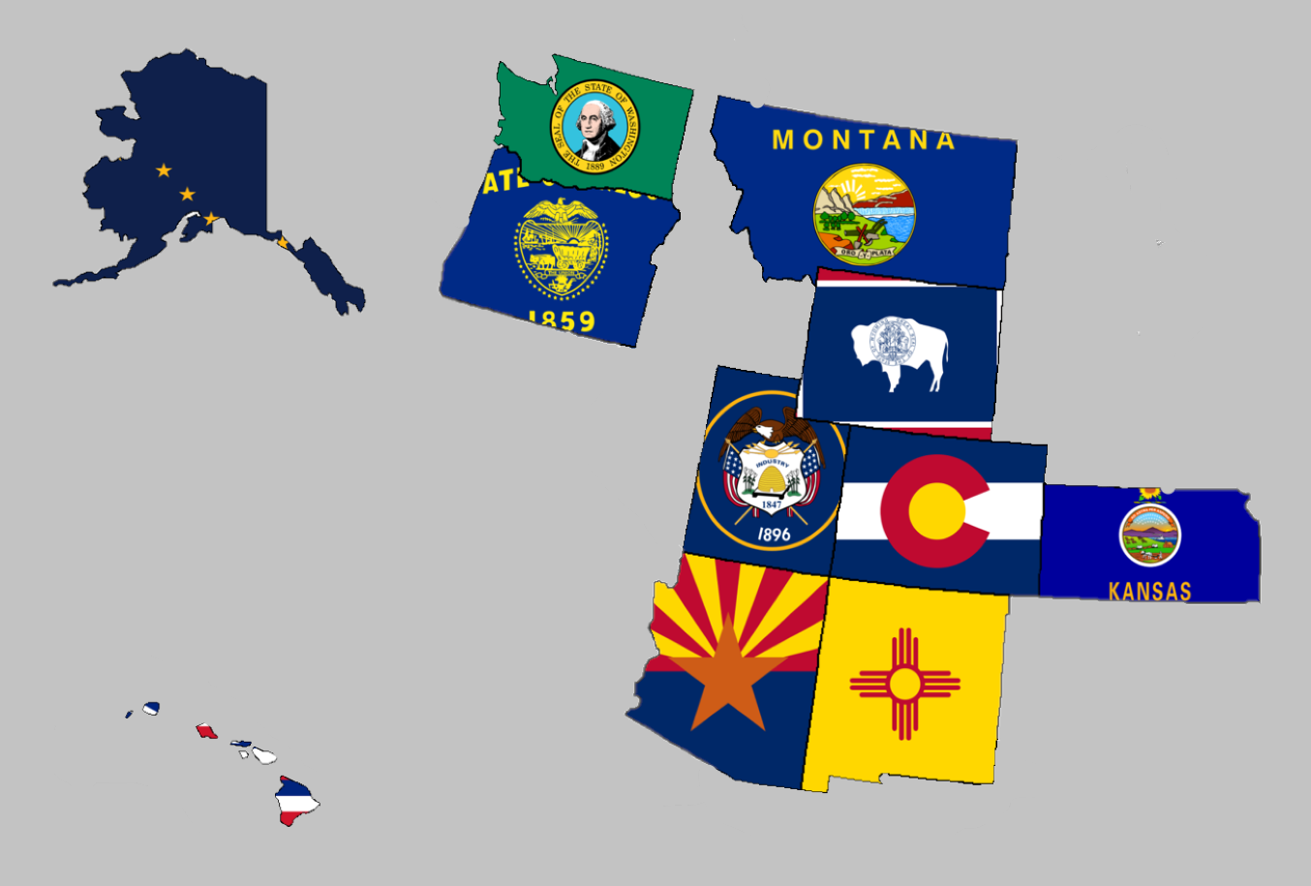

Regional Report for Region 1

Alaska, Arizona, Colorado, Hawaii, Kansas, Montana,

New Mexico, Oregon, Utah, Washington, and Wyoming

Libertarian National Committee Meeting  
November 16-17, 2019

**Region 1 Representative**

Mr. Richard Longstreth, Arizona

Libertarian National Committee

**T:** 931.538.9300 **E:** Richard.Longstreth@LP.org

**Region 1 Alternate**

Mr. Johnny “Rocket” Adams  
Libertarian National Committee

**T:** 253.625.3854 **E:** Johnny.Adams@lp.org

# Region 1 Overview/ Representative Report

As of the 2018 National Libertarian Convention in New Orleans, the eleven affiliates that comprise Region 1 are: Alaska, Arizona, Colorado, Hawaii, Kansas, Montana, New Mexico, Oregon, Utah, Washington, and Wyoming. At the Convention, Richard Longstreth, Arizona, was elected to serve as the Region 1 Representative and Craig Bowden, Utah, was elected to serve as the Region 1 Alternate. As of February 2019, Craig resigned his position and an application process is in place to fill his vacancy. Both the Region 1 Representative and the Alternate will be re-elected at the 2020 National Libertarian Convention.

Due to the geographical nature of this region, spanning five time zones and extending from 19 to 71 degrees north latitude (some 3,000 x 3,000 miles), in-person contact between the Regional and Alternate Representatives and the individual affiliates will be infrequent. It is my intention to attend 2019/2020 affiliate conventions in each affiliate. Regular contact is attempted with the affiliates and members through email, telephone, a dedicated Facebook discussion group and page, and informational website. There is also a chat group open for quick communications between the Regional Representatives and the Chairs of each state. I make myself available by appointment as necessary whenever I am approached about scheduling some time to talk.

For the purposes of this report, State Chairs were emailed on October 20th requesting convention information, goals, and any other updates/ goings on in their affiliates. Regular follow-up was done to remind State Chairs to submit a written report and encouraged them to schedule a time to talk if they preferred. Reminders were sent out on October 31st and November 8. While I did not receive a response from everyone, any responses I received will be reflected in the Region 1 Report. If a State Chair chose to not respond I have attempted to pull data from other sources to give a high-level overview of what is happening in the state. Contact information is supplied so that direct contact may be made by any member seeking any clarification directly from that specific State Chair.

Any updates or modifications to this report will occur at the next LNC meeting.

Activities of the Region 1 Representative since the last Quarterly Report:

* Had several conversations with candidates, state chairs, and general membership in relation to plans for 2019 and 2020 elections. There is a lot of interest in local elections especially given the presidential election year in 2020. I am encouraging people to really focus on local elections were possible as this helps build a stronger ground game for the future.
* Answered and addressed questions about the National Party’s State CRM Project.
  + I’ve realized an issue with the rollout in Arizona and am working with Andy Binns to attempt to resolve. If needed, I will give the LNC more information.
* Participated in the following committees for the Libertarian National Party:
  + Affiliate Support Committee
  + Candidate Support Committee
  + Bylaws and Rules Committee
  + Platform Committee
* Hosted a search to fill the Alternate role for Region 1. My full report on that specifically has been added to this report as Appendix 1.
* Attended the AZLP annual convention in Tucson, AZ.
* Informed State Chairs and regional members that I will not be seeking re-election as the Region 1 Representative in May but will be campaigning for the Vice Chair role instead.

I encourage all members to regularly review the Regional Agreement for Region 1 to keep myself and the Region 1 Alternate diligent to our duties. This agreement is what was put out as the expectation for us in terms of what you all wanted from leadership on the LNC. Follow the link below to a pdf version on Google Drive to review. If you have trouble with the link, please let me know.

I will be working with the State Chairs in the next several months to finalize the 2020 Regional Agreement. All suggestions are encouraged and it is my sincere hope to have this complete well before the 2020 National Convention in Austin, TX.

[2018 REGIONAL AGREEMENT](https://drive.google.com/file/d/0B2iKd8j9elY0bE45alZwWmdDT2JmeUJEYmIyR3Q3VElFOFFN/view?usp=sharing)

Current and Past Membership Reports can be accessed at any time via a Google Drive folder. I have not edited these reports at all because I believe it is important to maintain our national perspective as individual affiliates, not just as Regional members. Please let me know if you have trouble or questions when accessing the link or any of the reports.

[MEMBERSHIP REPORTS](https://drive.google.com/drive/folders/1dzb_INbTAAcFHCr91sHKutbZKrScdKjp?usp=sharing)

Your Region 1 Representative,

Richard Longstreth

# Region 1 Alternate Report

*NOTE: Francis had only bene in role for approximately one month at the time this report was due.*

Francis Wendt was elected by the chairs of Region 1’s affiliate parties on December 18, 20919. In a vote of 7 approvals out of 8 voting chairs, with 3 not voting he was elected to the region 1 alternate representative position to fill the remainder of the term until convention in Austin in May of 2020. Give the 5 months available, Wendt has limited his plans to what is attainable in the short term.

Convention and Meeting Schedule

* Jan 31 – Feb 2: LNC Quarterly meeting; Reno, NV
* Feb 22 –23: MTLP Delegate Convention; Billings, MT
* Mar 4 – 5: LPWY State Convention; Cheyenne, WY
* Mar 28 – 29: LPWA State Convention; TBD
* Apr 25 – 26: LPUT State Convention; Provo, UT
* May 21 – 25: National Convention; Austin, TX

Goals for remaining term

* Draft regional agreement per LP Bylaw requirements.
* Submit bylaws amendments to the Bylaws Committee.
* Assist regional affiliates in strategic planning for the 2020 cycle.

These goals are manageable in the current term with consideration to my state and county level duties. More long-term goals will be determined depending on the outcome of the regional agreement, and the business in Austin.

# Alaska



Chair: Jon Watts

Email: [joelhadley907@gmail.com](mailto:joelhadley907@gmail.com)

Phone: (907) 687-4884

Website: <http://www.alaskalp.org>

Facebook: <https://www.facebook.com/pg/AlaskaLiberty/>

From the Chair: Nothing submitted by the Chair for this report.

Requests to the LNC: No requests at this time. **Region 1 Representative Note: This state will need to earn ballot access prior to 2020.**

2020 Convention:

When: March 7, 2020

Where: Aviator Hotel Anchorage, 239 W 4th Ave, Anchorage, Alaska 99501

Website: <https://www.facebook.com/events/164571068185428/>

# Arizona



Chair: Howard Blitz

Email: [chairman@azlp.org](mailto:chairman@azlp.org)

Phone: 833-THE-AZLP

Website: <https://www.azlp.org/>

Facebook: <https://www.facebook.com/LParizona/>

From the Chair:

“AZLP held its Annual State Convention January 25, 2020 in Tucson, AZ at the Sea of Glass Center for the Arts from 8 am – 5:30 pm.

There was be a business meeting first followed by three speakers, Dr. Kyle Varner, Zach Foster, and Marc Victor. After lunch there were 8 candidates seeking the Libertarian Party nomination for President of the United States participating in a candidate forum answering questions. After that the convention body selected its delegates to represent the AZLP at the national convention in May.

Following the convention there was a meet and greet the candidates at Irene’s doughnuts at 6pm.

There are now over 32,000 register libertarian voters in Arizona!”

Requests to the LNC: The Region 1 Representative is actively working with staff to resolve issues regarding the CRM. If these cannot be worked out, more details will be shared. I am currently waiting to hear back from Andy directly.

2020 Convention:

When: January 25, 2020 (8-530)

Where: The Sea of Glass Center for the Arts, 332 E 7th St, Tucson, AZ 85705

Pending Agenda: Accessible via Google Drive [LINK](https://drive.google.com/file/d/0B2iKd8j9elY0MlBxdmt0MXVsTk1zRWNFUUhHOENTNzZadklF/view?usp=sharing)

The LNC Region 1 Representative was happy to attend this convention. In total, all delegates were elected with roughly 10 or so alternates also selected. The convention had a great variety of speakers and really held the attention of all membership quite well. While there was a presidential candidate forum, there were no straw polls or otherwise conducted. All candidates did a fantastic job and the Libertarian Party is luck to have such talent vying for the top spot on our ticket!

# Colorado



Chair: Victoria Reynolds

Email: [statechair@lpcolorado.org](mailto:statechair@lpcolorado.org)

Phone: (720) 933-6900

Website: <https://www.lpcolorado.org/>

Facebook: <https://www.facebook.com/pg/lpcolorado/>

From the Chair:

“For 2020, the LPCO is all about growth. Growing affiliates, growing our donor base, growing voter registrations, and growing our footprint throughout the state. A quarterly newsletter has been consistently making it to the mailboxes of registered Libertarians and donors throughout the state, and events like December’s Festivus have brought out presidential candidates and put thousands of dollars in the LPCO coffers.

We once again have an affiliate in our largest county, Denver, and more counties should affiliate throughout the coming year. Camaraderie has replaced gamesmanship and Libertarians are finding good reason to get involved or reengage after an extended absence. February will include outreach to former candidates in order to get the ballot full for this November.

The state board continues to move ahead despite numerous efforts to derail its momentum and countless hours spent in handling complaints which have nothing to do with setting the world free in our lifetimes. Despite this, the LPCO is showing real growth and momentum heading into another election season. We look forward to seeing many of you at our annual convention, April 3rd-5th in Glenwood Springs at the Hotel Colorado.”

Requests to the LNC: No requests at this time.

2020 Convention:

When: April 3-5, 2020

Where: Hotel Colorado, 526 Pine St, Glenwood Springs, Colorado 81601

Website: <https://www.facebook.com/events/2723266381233122/>

# Hawaii

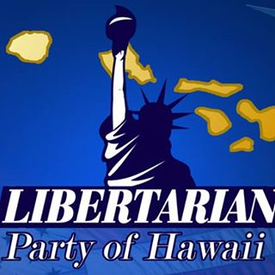

Chair: Tracy Ryan

Email: [tracyar@hawaiiantel.net](mailto:tracyar@hawaiiantel.net)

Phone: (808) 927-1126

Website: <http://www.libertarianpartyofhawaii.org>

Facebook: <https://www.facebook.com/pg/LibertarianPartyOfHawaii/>

From the Chair: Nothing submitted by the Chair for this report.

Requests to the LNC: No requests at this time.

2019/20 Convention:

When: 9am – 5pm, November 23, 2019

Where: Ala Moana Hotel, 410 Atkinson Dr, Honolulu, HI 96814

Website: https://www.libertarianpartyofhawaii.com/

Notable Speakers: Larry Sharpe, Dr. Kyle Varner

The Regional Representative was unable to attend this convention outside of electronic means, however I look forward to seeing all of the delegates in Austin, TX!

# Kansas

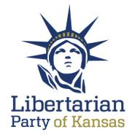

Chair: Ned Kelley

Email: [Chair@lpks.org](mailto:Chair@lpks.org) Alt Email: [ned.kelley1@gmail.com](mailto:ned.kelley1@gmail.com)

Phone: (816) 810-5818

Website: <http://www.LPKS.org>

Facebook: <https://www.facebook.com/pg/KansasLP/>

From the Chair: Nothing submitted by the Chair for this report.

Requests to the LNC: No requests at this time.

2020 Convention:

When: April 18, 2020

Where: Hampton Inn Gardner, 151 S Cedar Niles Rd, Gardner, Kansas 66030

Website: <https://www.facebook.com/events/1248532442004561/>

The Region 1 Representative intends to attend this convention in April as part of his commitment to attend as many Region 1 Conventions as possible.

# Montana

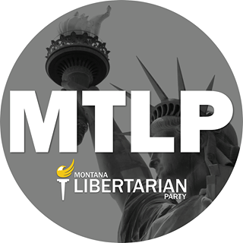

Chair: Sid Daoud

Email: [Chair@mtlp.org](mailto:Chair@mtlp.org) Alt. Email: [Sid.daoud@rspike.com](mailto:Sid.daoud@rspike.com)

Phone: (406) 471-6723

Website: <https://www.mtlp.org/>

Facebook: <https://www.facebook.com/pg/MontanaLibertarianParty/>

From the Chair: Nothing submitted by the Chair for this report.

Requests to the LNC: No Requests at this time.

2020 Convention:

When: February 22-23, 2020

Where: Ledgestone Hotel Billings, 4863 King Ave E, Billings, Montana 59101

Website: <https://www.facebook.com/events/768873023604678/>

The Region 1 Representative is working to setup travel arrangements for this convention. If those arrangements do not pan out, the Region 1 Alternate does plan on attending this convention.

# New Mexico



Chair: Chris Luchini

Email: [chair@lpnm.us](mailto:chair@lpnm.us)

Phone: 888-LPNM-NOW

Website: <https://lpnm.us/>

Facebook: <https://www.facebook.com/LPNewMexico/>

From the Chair:

“We're in there final few weeks of getting petition signatures to get our candidates on the ballot. It's a critical time for us because we need a statewide candidate (US senator, two supreme Court positions and 2 appellate court positions are available) to earn 5% of the vote to stay a major party in New Mexico.

We have a US Senate candidate and I believe we have just found a court candidate that qualifies. We are trying to find volunteers to get signatures from our registered libertarians.

It seems that about 1/3 of the returns are “get off my lawn” libertarians and will not sign. We believe we will barely be able to make the February 4th deadline.

It looks like we will have 15 to 20 statehouse and state senate candidates as well with more being added.

Our convention is March 6th and 7th and we're looking at adding March 8th as a presidential candidate forum day. We are trying to get the top contenders to commit and that is still being negotiated.”

Requests to the LNC: No requests at this time.

2020 Convention:

When: March 6-7, 2020

Other Details TBD

# Oregon



Chair: Timothy Perkins

Email: [chair@lporegon.org](mailto:chair@lporegon.org)

Website: <https://lporegon.org/>

Facebook: <https://www.facebook.com/pg/LibertarianPartyOfOregon/>

From the Chair: Nothing submitted by the Chair for this report.

Requests to the LNC: No requests at this time.

2020 Convention:

TBD

# Utah

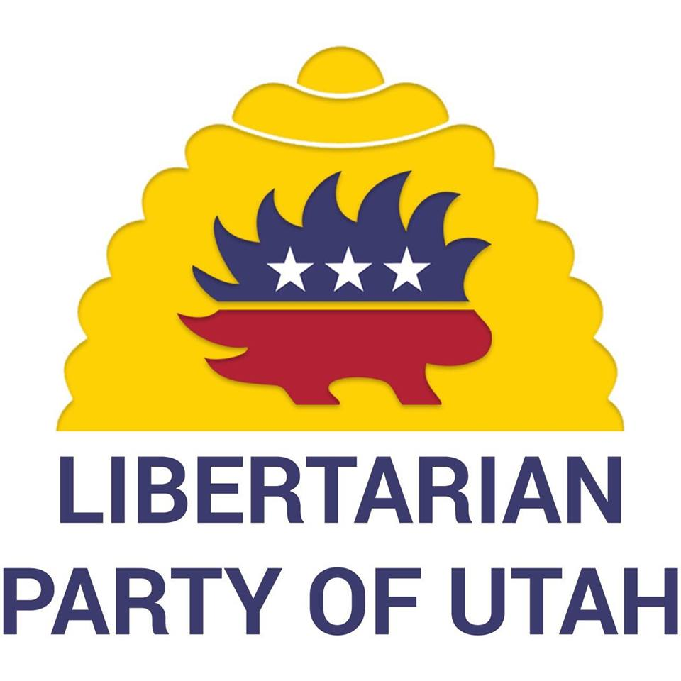

Chair: Amber Beltran

Email: [chair@libertarianutah.org](mailto:chair@libertarianutah.org)

Phone: (801) 613-8034

Website: <http://www.libertarianutah.org/>

Facebook: <https://www.facebook.com/lputah/>

From Utah State Chair:

“UTLP members have been assisting (signing, advertising, volunteering to gather signatures) with a recent Tax Referendum effort.

We hosted a fundraiser on January 23st ; Lincoln Chaffee headlined the event for us.

Still working on candidate recruitment, with Cara Schulz assistance, and coordinating target race efforts with the Libertarian Frontier”

Requests to the LNC: No requests at this time.

2020 Convention:

When: April 24-25, 2020

Where: Comfort Suites Ogden Conference Center, 2250 S. 1200 W., Ogden, Utah 84401

Website: <https://www.facebook.com/events/1387249214781478/>

The Region 1 Representative intends to attend this convention.

# Washington



Chair: Randy McGlenn

Email: [info@lpwa.org](mailto:info@lpwa.org)

Website: <https://lpwa.org/>

Facebook: <https://www.facebook.com/pg/libertarianpartyofWA/>

From the Chair: Nothing submitted by the Chair for this report.

Requests to the LNC: No requests at this time.

2020 Convention:

When: March 28-29

Other Details TBD

The Region 1 Representative is working on attending this convention, although plans are not firm due to some pending details.

# Wyoming

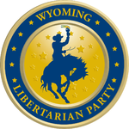

Chair: Shawn Johnson

Email: [shjohnson310@hotmail.com](mailto:shjohnson310@hotmail.com)

Website: <https://lpwy.org/>

Facebook: <https://www.facebook.com/libertariansWY/>

From the Chair: Nothing submitted by the Chair for this report.

Requests to the LNC: No requests at this time.

2020 Convention:

When: April 4, 2020

Where: Historic Plains Hotel, 1600 Central Ave, Cheyenne, Wyoming 82001

Website: <https://www.facebook.com/events/2751445928273931/>

# Appendix I:

# Region 1 Alternate Search Overview, Procedures, and Methodologies

On Saturday, November 16, 2019 Region 1 Alternate Johnny “Rocket” Adams notified Richard Longstreth, Region 1 Representative, that he wished to resign his role as the Regional Alternate. The LNC and State Chairs of Region 1 were notified on November 17.

Input was sought from State Chairs as to requirements, methodology, and application questions they wanted on the Region 1 Alternate Application. Ultimately, all criteria used from the March Region 1 Alternate search was agreed upon. Applications were sought between November 27 and December 10. The following individuals applied during this time period (alphabetically listed):

* Craig Bowden (UT)
* Wayne Harlos (CO)
* David Howman (AZ)
* Robert Pepiton (AZ)
* C Michael Pickens (WA)
* Francis Wendt (MT)

State Chairs were encouraged to discuss among themselves and with each candidate to ensure the best candidate was selected. None of the Above (NOTA) was added as a candidate with the understanding that a vote for NOTA meant the Alternate role would not be filled until such a time when the State Chairs initiated another search or until the 2020 Libertarian National Convention in Austin, TX, whichever came first. Voting for candidates began Monday, December 16, 2019 and continued through Wednesday, December 18, 2019 via the Opavote platform under approval voting rules.

The Region 1 Agreement requires that a majority of the Region’s State Chairs must elect an individual to fill vacancies in the Region 1 Representative or Region 1 Alternate roles. This mean that a minimum of 6 votes had to be cast for a candidate to be elected. Of the 11 State Chairs, 8 states cast a ballot; 3 did not:

**States with Ballots**

* Alaska
* Arizona
* Colorado
* Kansas
* Montana
* Oregon
* Utah
* Washington

**States without Ballots**

* Hawaii
* New Mexico
* Wyoming

# Region 1 Alternate Results

There were 7 candidates competing for 1 seat. The number of voters is 8 out of a possible 11.

Counted votes using Approval Voting. These results include adjustments made to ballots after they were cast but before voting ended (marked with ‘*’). Supporting documentation to change the ballots is attached in this report.

Candidate | Vote Count

================================

Bowden, Craig | 3

Harlos, Wayne | 3*

Howman, David | 1

Pepiton, Robert | 2

Pickens, C Michael | 2*

Wendt, Francis | 7

None of the Above (NOTA) | 0

Winner is Wendt, Francis who has been elected until the 2020 Libertarian Party National Convention in Austin, TX. Richard Longstreth will work with staff at LPHQ to get Francis his email address and other necessary items quickly so that he may fully participate in his role on the Libertarian National Committee.

# Region 1 Alternate Ballots

Voter: Alaska – Jon Watts

☐ Bowden, Craig

☐ Harlos, Wayne

☐ Howman, David

☐ Pepiton, Robert

☑ Pickens, C Michael

☐ Wendt, Francis

☐ None of the Above (NOTA)

Voter: Arizona – Howard Blitz

☐ Bowden, Craig

☑ Harlos, Wayne

☐ Howman, David

☑ Pepiton, Robert

☐ Pickens, C Michael

☑ Wendt, Francis

☐ None of the Above (NOTA)

Voter: Colorado – Victoria Reynolds

☐ Bowden, Craig

☐ Harlos, Wayne

☐ Howman, David

☐ Pepiton, Robert

☑ Pickens, C Michael*

☑ Wendt, Francis

☐ None of the Above (NOTA)

* Victoria sent an email after her initial ballot was cast changing her ballot to only vote for Francis Wendt. Documentation attached.

Voter: Kansas – Ned Kelley

☑ Bowden, Craig

☐ Harlos, Wayne

☑ Howman, David

☑ Pepiton, Robert

☐ Pickens, C Michael

☑ Wendt, Francis

☐ None of the Above (NOTA)

Voter: Montana – Sid Daoud

☐ Bowden, Craig

☐ Harlos, Wayne

☐ Howman, David

☐ Pepiton, Robert

☐ Pickens, C Michael

☑ Wendt, Francis

☐ None of the Above (NOTA)

Voter: Oregon – Timothy Perkins

☐ Bowden, Craig

☑ Harlos, Wayne

☐ Howman, David

☐ Pepiton, Robert

☑ Pickens, C Michael

☑ Wendt, Francis

☐ None of the Above (NOTA)

Voter: Utah – Amber Beltran

☑ Bowden, Craig

☐ Harlos, Wayne

☐ Howman, David

☐ Pepiton, Robert

☐ Pickens, C Michael

☑ Wendt, Francis

☐ None of the Above (NOTA)

Voter: Washington – Randy McGlenn

☑ Bowden, Craig

☐ Harlos, Wayne*

☐ Howman, David

☐ Pepiton, Robert

☐ Pickens, C Michael

☑ Wendt, Francis

☐ None of the Above (NOTA)

* Randy sent an email after his initial ballot was cast changing his ballot to add a vote for Wayne Harlos. Documentation attached.

# Region 1 Alternate Ballot Adjustments

1. Colorado’s original ballot was adjusted per this email received from Victoria Reynolds during the voting time:

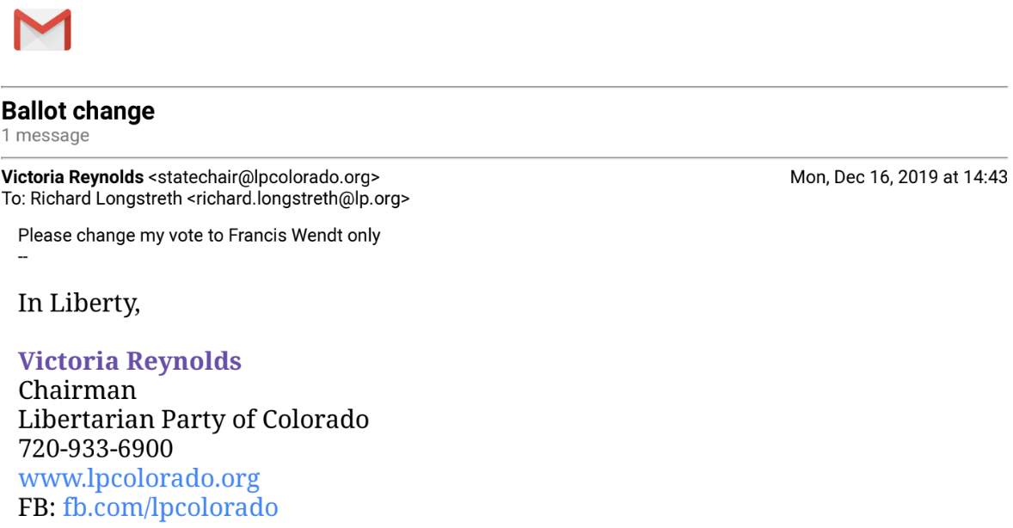

1. Washington’s original ballot was adjusted per this email received from Randy McGlenn during the voting time:

