Libertarian National Committee

Region 7

*Region Representative - Whitney Bilyeu*

*Region Alternate - Erin Adams*

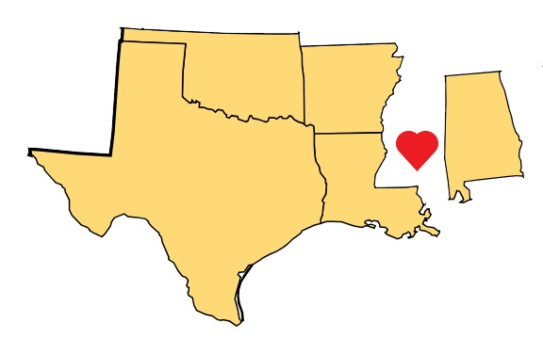

February 1-2, 2020

RENO, NV

### ALABAMA - **Laura Lane**

#### STATE ORGANIZATION

* + - Elijah Boyd - VC, Paul Frankel - Secretary, Scott Hammond - Treasurer. Region 2 Representative is now Justin Campbell.

#### MEMBERSHIP

* + - 137 current "active" members; 9 new members in January
    - Weekly emails about state convention encouraging people to join or renew in order to be delegates have increased renewals.

#### COUNTY NEWS

* + - Montgomery has just formed a new county affiliate. The Wiregrass Region (Houston, Geneva, Coffee, Dale, and Henry Counties) will caucus Jan 25th to form an affiliate.
    - Two county affiliates (Baldwin and Etowah) appear to have become inactive.

#### ELECTIONS

* + - Currently pushing for petitioners to help gather signatures for John Page running for Alabama's US House Dist 2.
    - Frank Dillman is gathering signatures for another run at a Macon County Commission seat.

#### BALLOT ACCESS

* + - Absolutely concerned. The Chair’s goal is to continue pushing for legislative reform of the ballot access laws. The current lawsuit regarding discrimination over access to the voter registration list is the first step.

#### EVENTS

* + - State Convention will be held Feb 28th-Mar 1st in Birmingham. We are having a Presidential Candidate debate with 7 of the candidates and moderators from the Molinari Institute, Samford University, and life member Dr. Jimmy Blake.
    - PRs and invitations to the media are going out regularly. A small team has come together for lobbying efforts and will begin on Feb 5th.
    - Mobile and Baldwin counties will host an outreach booth during Mardi Gras celebrations in Mobile.

#### FINANCE/FUNDRAISING

* + - LPAL has contracted with a fundraiser to take on all fundraising efforts; they are beginning effort this week.

#### IT

* + - Still learning the ropes of CiviCRM, but getting better.

#### MEDIA

* + - We continue to see small media groups pick up articles regarding our lawsuit and it's progress.

#### OTHER

* + - One of our members in the Huntsville area is allowing us to use a small room in his company for workspace, storage of literature, tee shirts, etc…
    - The Chair personally donated an older laptop and a printer for use on putting together new member packages and recruited some volunteers to handle this and trained them on using the membership card printer. They were able to catch up on a backlog of over 6 months.

### ARKANSAS - **Michael Pakko**

### STATE LEVEL MEMBERSHIP

* + - Holding steady, and they have three new members wanting to be delegates to the national convention.

#### ELECTIONS

* + - The old parties have a primary coming up March 3.
    - There is a special election for the State House on March 3, in which we have a candidate, Judy Bowers, running against a Republican in a two-way race.

#### BALLOT ACCESS

* + - No word from the federal appeals court. A hearing was held in mid-December on the State's motion to overturn the preliminary injunction that allowed us ballot access. I expect the status quo will continue. We still have a full trial date scheduled for May.

#### EVENTS

* + - Our annual state convention will be on February 22.

### LOUISIANA - **Rufus Craig**

#### STATE ORGANIZATION

* + - Michael Dodd - VC; Shannon Thomas - Secretary; Matt Fotsch - Treasurer; Marcel Graugnard - Membership Coordinator; Eric Hailar - Elections Officer; Keith Thompson - Communications Officer

#### EVENTS

* + - Our state convention is scheduled for April 4th and 5th
      * Holiday Inn in Alexandria - 701 4th St., Alexandria, LA 71301

### OKLAHOMA - **Chad Williams**

#### STATE ORGANIZATION

* + - Kevin Hobbie - Vice Chair; Cherise Norton - Secretary; David Greer - Treasurer.
  + BALLOT ACCESS
    - We are secure until 2022.

#### COUNTY NEWS

* + - Delaware and Washington counties are in the exploratory stages of the chartering process.
    - Southeast Region just passed its bylaws and elected officers and will be officially recognized at our meeting later this month.

#### MEMBERSHIP

* + - We have 60 current members and 12 Lifetime members.

#### MEDIA

* + - The Muskogee Politico highlighted our voter registration numbers that have more than doubled since January 2018.
    - The Chairman was interviewed by KOSU, the OKC NPR affiliate, about our decision to close our primaries to independent voters..

#### EVENTS

* + - The Northeast Region is doing some passive marketing with Adopt-A-Highway and patient drives for medical cannabis.
    - State Convention will be held March 21-22, and will include a POTUS debate and an LNC Chair debate.

#### FINANCE/FUNDRAISING

* + - Three of our regions are building baskets to be auctioned off at the convention.

### TEXAS - **John Wilford**

#### STATE ORGANIZATION

* + - Treasurer - Cassie Villela, Vice Chair - Steven Harris, Secretary - Gary Johnson

#### COUNTY NEWS

* + - Affiliating new counties all the time.

#### ELECTIONS

* + - We have over 100 candidates filed for nominations in various races at the state level, as well as many county level filings. Some candidates paid the filing fees, and others did not, so we have yet to see how that plays out, as the state continues to meddle in our nomination process.

#### EVENTS

* + - LPTexas will hold its 2020 convention April 17 - 19
      * McAllen Convention Center - McAllen, TX

#### BALLOT ACCESS

* + - We did not get the preliminary injunction, nor did the state get their dismissal. So, we are moving forward with the federal suit covering multiple ballot access barrier issues.
    - The state lawsuit is still pending. The plaintiffs had won an injunction on the filing fees, but the SoS filed an appeal and have declared they will enforce the fees.