Libertarian National Committee

Region 1 Report

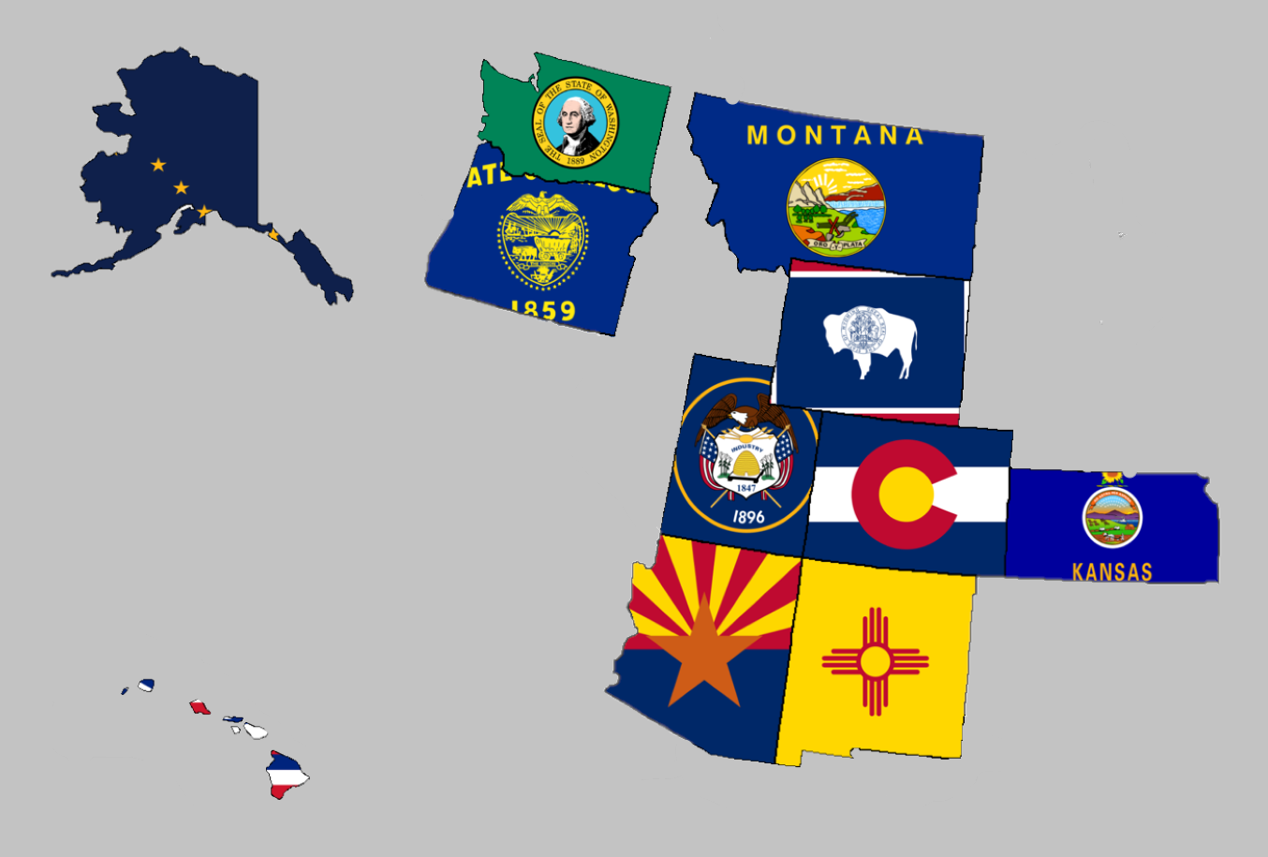

Regional Report for Region 1

Alaska, Arizona, Colorado, Hawaii, Kansas, Montana,

New Mexico, Oregon, Utah, Washington, and Wyoming

Libertarian National Committee Meeting  
July 8, 2020

**Region 1 Representative**

Mr. Richard Longstreth, Arizona

Libertarian National Committee

**T:** 931.538.9300 **E:** Richard.Longstreth@LP.org

**Region 1 Alternate**

Mr. Francis Wendt  
Libertarian National Committee

**T:** 406.595.5111 **E:** Francis.Wendt@lp.org

# Region 1 Overview/ Representative Report

As of the 2018 National Libertarian Convention in New Orleans, the eleven affiliates that comprise Region 1 are: Alaska, Arizona, Colorado, Hawaii, Kansas, Montana, New Mexico, Oregon, Utah, Washington, and Wyoming. At the Convention, Richard Longstreth, Arizona, was elected to serve as the Region 1 Representative and Craig Bowden, Utah, was elected to serve as the Region 1 Alternate. As of February 2019, Craig resigned his position and an application process is in place to fill his vacancy. Currently the Region 1 Alternate role is held by Francis Wendt, following an election by the state chairs. Both the Region 1 Representative and the Alternate will be re-elected at the 2020 National Libertarian Convention.

Due to the geographical nature of this region, spanning five time zones and extending from 19 to 71 degrees north latitude (some 3,000 x 3,000 miles), in-person contact between the Regional and Alternate Representatives and the individual affiliates will be infrequent. It is my intention to attend 2019/2020 affiliate conventions in each affiliate. Regular contact is attempted with the affiliates and members through email, telephone, a dedicated Facebook discussion group and page, and informational website. There is also a chat group open for quick communications between the Regional Representatives and the Chairs of each state. I make myself available by appointment as necessary whenever I am approached about scheduling some time to talk.

For the purposes of this report, State Chairs were not contacted with enough notice to provide a report. There is a lot of activity occurring in several states given this election year and I would encourage reaching out to the state chairs directly for an update in absence of one here.

Any updates or modifications to this report will occur at the next LNC meeting.

Activities of the Region 1 Representative since the last Quarterly Report:

* Had several conversations with candidates, state chairs, and general membership in relation to plans for 2019 and 2020 elections. There is a lot of interest in local elections especially given the presidential election year in 2020. I am encouraging people to really focus on local elections were possible as this helps build a stronger ground game for the future.
* Answered and addressed questions about the National Party’s State CRM Project.
* Participated in the following committees for the Libertarian National Party:
  + Advertising and Publications Review Committee
  + Affiliate Support Committee
  + Candidate Support Committee
  + Bylaws and Rules Committee
  + Platform Committee
* Hosted the Regional Caucus to elect the next Regional Representative and Alternate:
  + State Chairs submitted names and emails of delegates expected to participate in advance of our meeting held on June 27, 2020.
  + All elections were done via approval voting according to the rules established in the 2020 Regional Agreement
  + Nominations for Region 1 Representative were: Craig Bowden, Alex Flores, Chris Luchini, and Francis Wendt
  + One round of balloting was conducted for Region 1 Representative.
    - Ballots cast: 104
    - Bowden – 20
    - Flores – 30
    - Luchini – 45
    - Wendt – 55
    - NOTA – 11
    - Francis Wendt was elected.
  + Nominations for Region 1 Alternate were: Craig Bowden, Alex Flores (withdrew), David Howman, and Chris Luchini
  + One round of balloting was conducted for Region 1 Alternate.
    - Ballots cast: 103
    - Bowden – 27
    - Howman – 49
    - Luchini – 57
    - NOTA – 11
    - Chris Luchini was elected
  + Francis Wendt (Rep) and Chris Luchini (Alt) are prepared to take their roles after August 31, 2020 or after the close of the 2020 National Convention, whichever comes first.
* Attended the following state conventions (either electronically or in person):
  + California
  + Montana
  + Nevada
  + New Mexico
  + Illinois
  + Colorado
  + Wyoming
  + Kansas
  + Utah
  + North Carolina
  + Michigan
  + Wisconsin
  + Oklahoma (Virtual portion only)
  + New Jersey
* Continued my campaign for LNC Vice Chair.

I encourage all members to regularly review the Regional Agreement for Region 1 to keep myself and the Region 1 Alternate diligent to our duties. This agreement is what was put out as the expectation for us in terms of what you all wanted from leadership on the LNC.

The 2020 Agreement was completed by the May sitting of the convention. Nevada has been added as a member of the Region and no affiliates opted to leave the agreement. Very few other modifications were made between 2018 and 2020. Both are linked below for review:

[2018 REGIONAL AGREEMENT](https://drive.google.com/file/d/0B2iKd8j9elY0bE45alZwWmdDT2JmeUJEYmIyR3Q3VElFOFFN/view?usp=sharing)

[2020 REGIONAL AGREEMENT](https://drive.google.com/file/d/1uHIsA0YdZTdDIrAGNsBScrMguMzYgG_i/view?usp=sharing)

Current and Past Membership Reports can be accessed at any time via a Google Drive folder. I have not edited these reports at all because I believe it is important to maintain our national perspective as individual affiliates, not just as Regional members. Please let me know if you have trouble or questions when accessing the link or any of the reports.

[MEMBERSHIP REPORTS](https://drive.google.com/drive/folders/1dzb_INbTAAcFHCr91sHKutbZKrScdKjp?usp=sharing)

Your Region 1 Representative,

Richard Longstreth

# Region 1 2020 Contact Information

Region 1 Representative

Mr. Francis Wendt

T: 406.595.5111

E: Francis.Wendt@lp.org

Region 1 Alternate

Mr. Chris Luchini

T: 505.690.5008

E: Chris.Luchini@lp.org

Alaska State Chair

Mr. Jon Watts

T: 907.687.4884

E: jon.watts@alaskan.com

Website: <http://www.alaskalp.org/>

Facebook: <https://www.facebook.com/pg/AlaskaLiberty/>

Arizona State Chair

Mr. Howard Blitz

T: 833.THE.AZLP

E: chairman@azlp.org

Website: <https://www.azlp.org/>

Facebook: <https://www.facebook.com/LParizona/>

Colorado State Chair

Ms. Victoria Reynolds

T: 720.933.6900

E: statechair@lpcolorado.org

Website: <https://www.lpcolorado.org/>

Facebook: <https://www.facebook.com/pg/lpcolorado/>

Hawaii State Chair

Ms. Tracy Ryan

T: 808.927.1126

E: tracyar@hawaiiantel.net

Website: <http://www.libertarianpartyofhawaii.org>

Facebook: <https://www.facebook.com/pg/LibertarianPartyOfHawaii/>

Kansas State Chair

Mr. Ned Kelley

T: 816.810.5818

E: chair@lpks.org

Website: <http://www.LPKS.org>

Facebook: <https://www.facebook.com/pg/KansasLP/>

Montana State Chair

Mr. Sid Daoud

T: 406.471.6723

E: chair@mtlp.org

Website: <https://www.mtlp.org/>

Facebook: <https://www.facebook.com/pg/MontanaLibertarianParty/>

Nevada State Chair

Mr. Jason Smith

T: Not Currently Available

E: jason.smith@lpnevada.org

Website: <https://www.lpnevada.org/>

Facebook: <https://www.facebook.com/lpnevada/>

New Mexico State Chair

Mr. Chris Luchini

T: 888.LPNM.NOW

E: chair@lpnm.us

Website: <https://lpnm.us/>

Facebook: <https://www.facebook.com/LPNewMexico/>

Oregon State Chair

Mr. Timothy Perkins

T: 503.569.9048

E: [chair@lporegon.org](mailto:chair@lporegon.org)

Website: <https://lporegon.org/>

Facebook: <https://www.facebook.com/pg/LibertarianPartyOfOregon/>

Utah State Chair

Mr. Barry Short

T: Not Currently Available

E: [chair@libertarianutah.org](mailto:chair@libertarianutah.org)

Website: <http://www.libertarianutah.org/>

Facebook: <https://www.facebook.com/lputah/>

Washington State Chair

Mr. Randy McGlenn

T: 509.252.1723

E: [info@lpwa.org](mailto:info@lpwa.org)

Website: <https://lpwa.org/>

Facebook: <https://www.facebook.com/pg/libertarianpartyofWA/>

Wyoming State Chair

Mr. Shawn Johnson

T: 307.277.7377

E: [shjohnson310@hotmail.com](mailto:shjohnson310@hotmail.com)

Website: <https://lpwy.org/>

Facebook: <https://www.facebook.com/libertariansWY/>